PAGE 1 – Windows 7 – Open the Computer and Local Disk
Topic: Windows 7 – Open the Computer and Local Disk
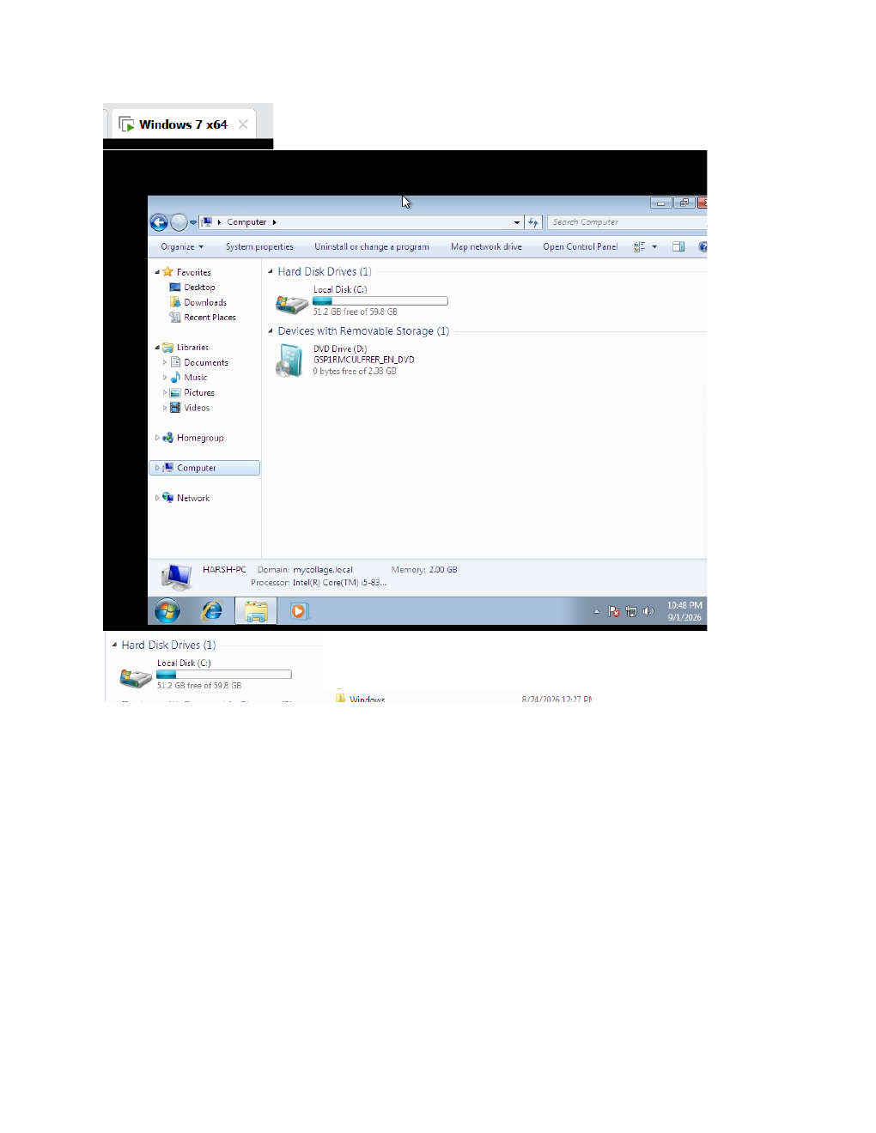
What I did: I opened the Windows 7 system and accessed the Local Disk (C:) from Computer.
Explanation: This screenshot shows the Windows 7 file system and the starting point for navigating to the Windows system folders.

PAGE 2 – Windows System32 – Navigate Through the Windows Folders
Topic: Windows System32 – Navigate Through the Windows Folders
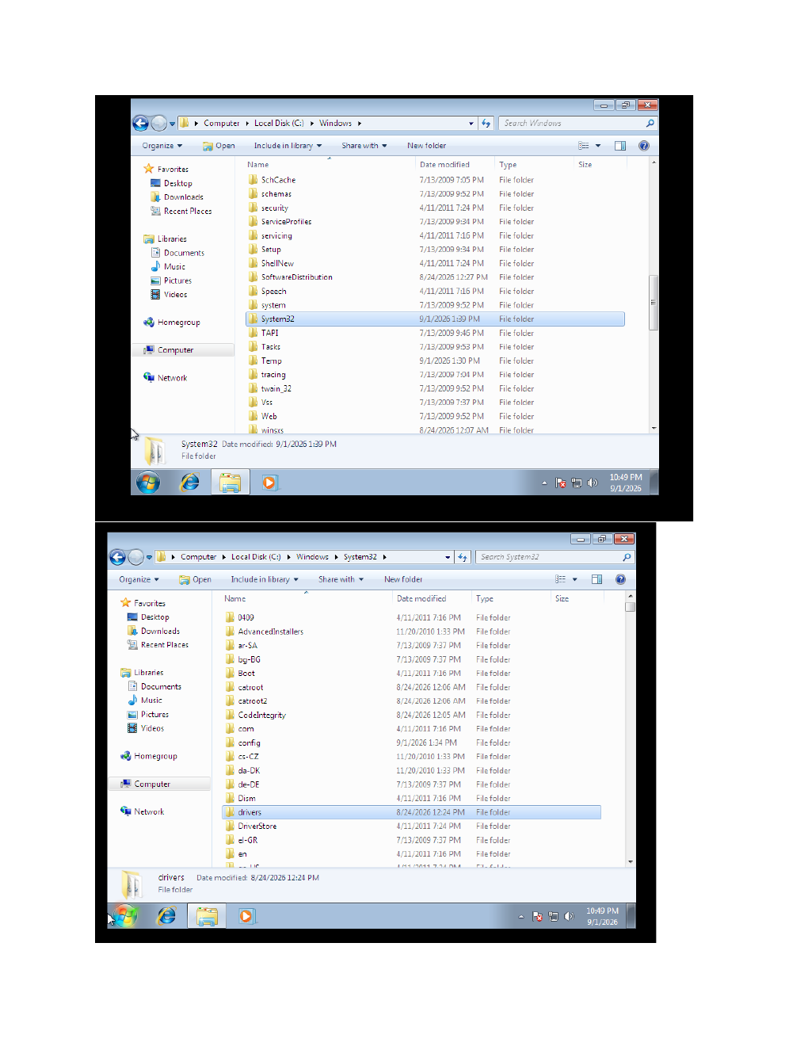
What I did: I navigated from the Windows folder into System32 and continued toward the drivers\etc location.
Explanation: The screenshots show the folder-by-folder navigation used to reach the Windows networking configuration files.

PAGE 3 – Windows System32 – Locate the Required System File
Topic: Windows System32 – Locate the Required System File
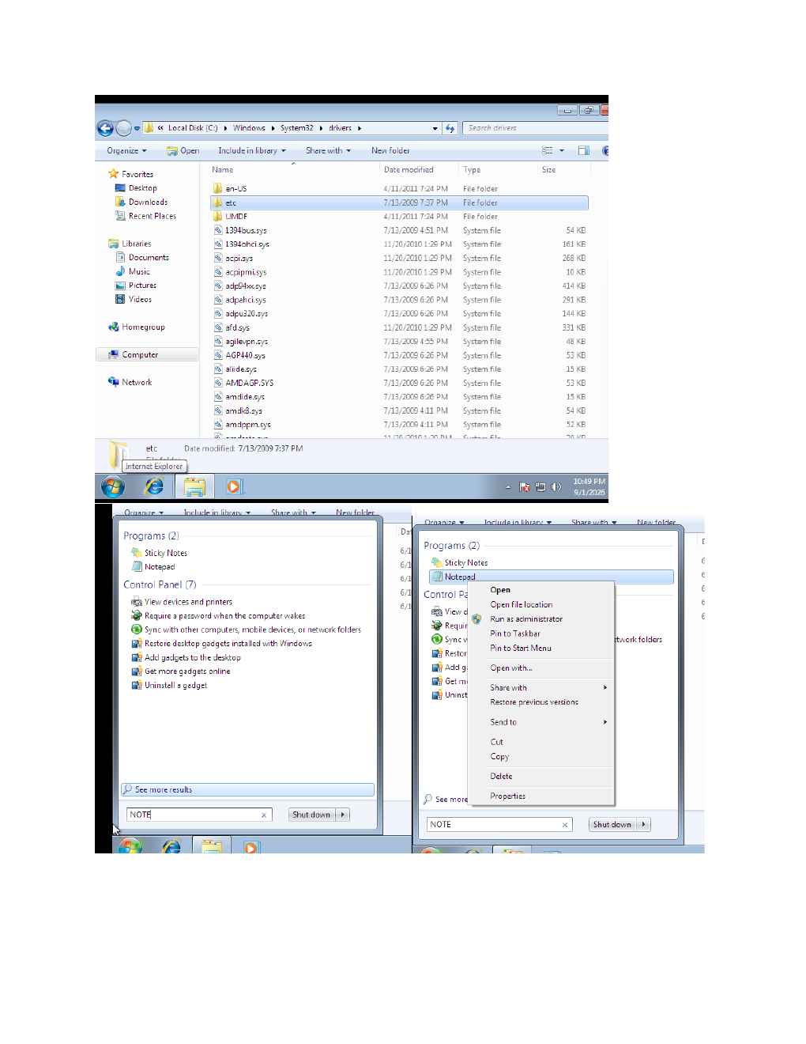
What I did: I opened the System32 area, reviewed the available files, and continued locating the required configuration file.
Explanation: The screenshot shows the system directory and the file-selection/navigation work being performed.

PAGE 4 – Notepad – Open the hosts File with Administrator Access
Topic: Notepad – Open the hosts File with Administrator Access
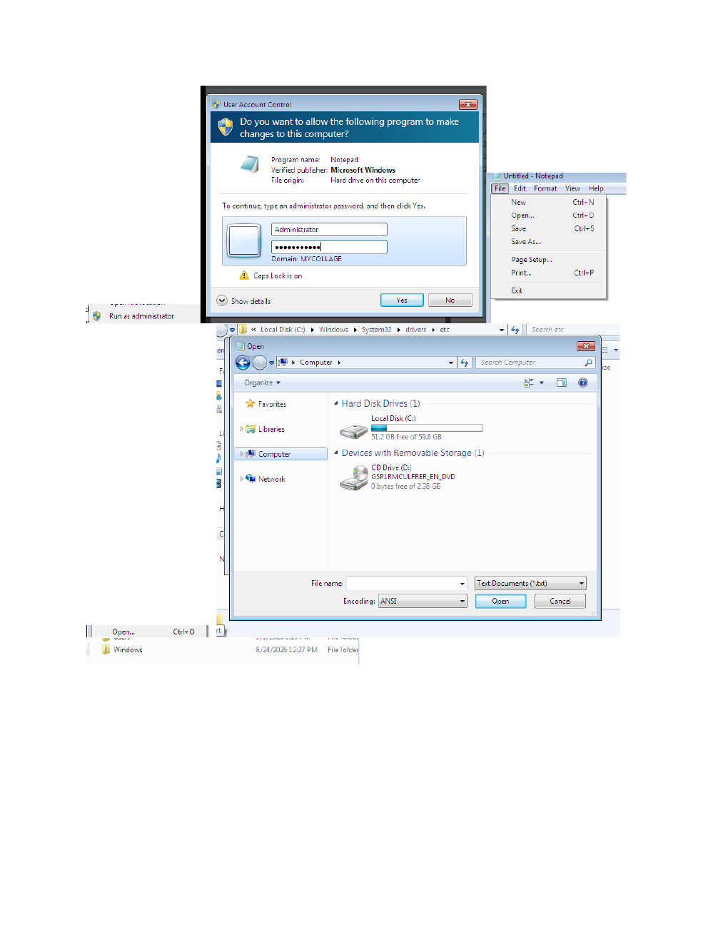
What I did: I launched Notepad with administrator permission, opened the File > Open window, and navigated to System32\drivers\etc.
Explanation: The administrator prompt and Open dialog show that I was preparing to open the protected hosts file for editing.

PAGE 5 – Windows Open Dialog – Navigate to the hosts File
Topic: Windows Open Dialog – Navigate to the hosts File
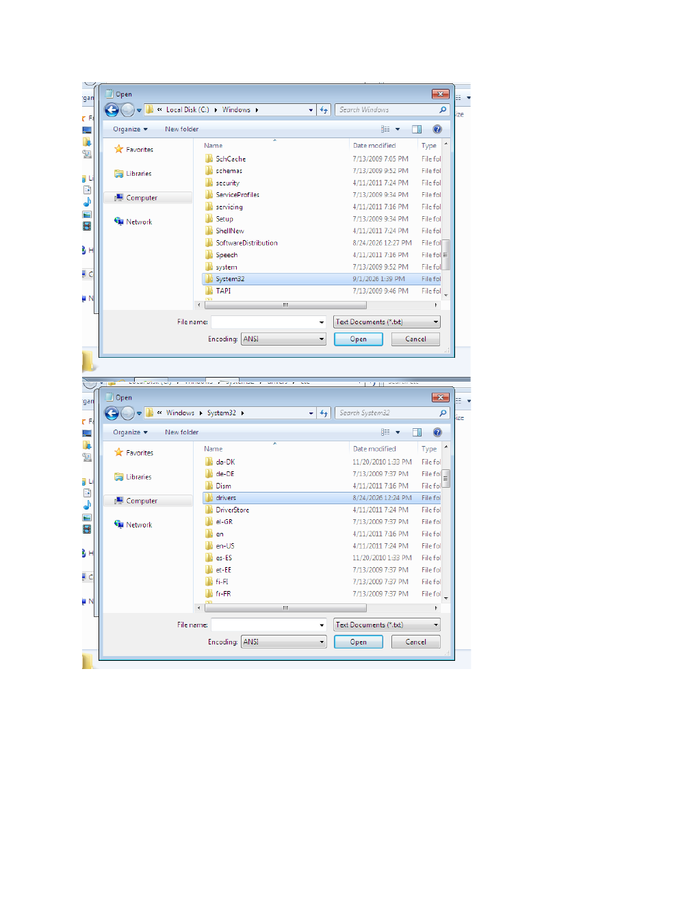
What I did: I used the Open dialog to move through the Windows folders and locate the hosts file.
Explanation: The screenshots show the folder navigation used to reach the hosts file inside the system directory.

PAGE 6 – Open Dialog – Search for the hosts File
Topic: Open Dialog – Search for the hosts File
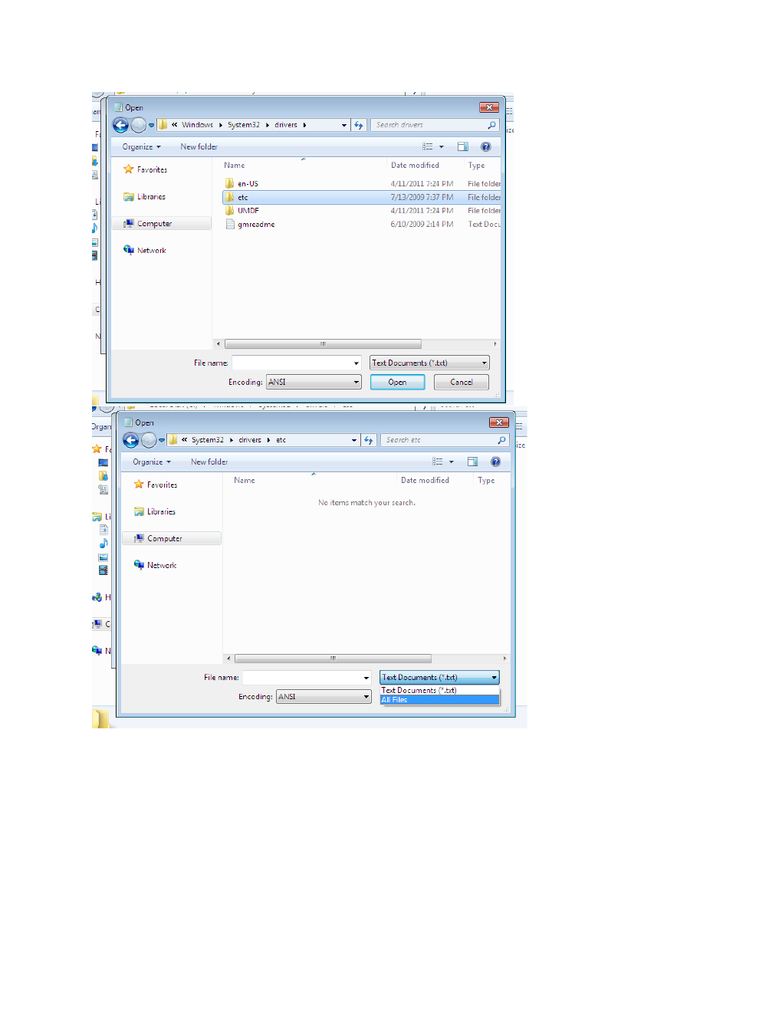
What I did: I continued the file search in the system location and selected the required hosts file.
Explanation: The Open dialog shows the selected file/path being prepared for opening in Notepad.

PAGE 7 – Notepad – Review the hosts File and Run the Network Command
Topic: Notepad – Review the hosts File and Run the Network Command
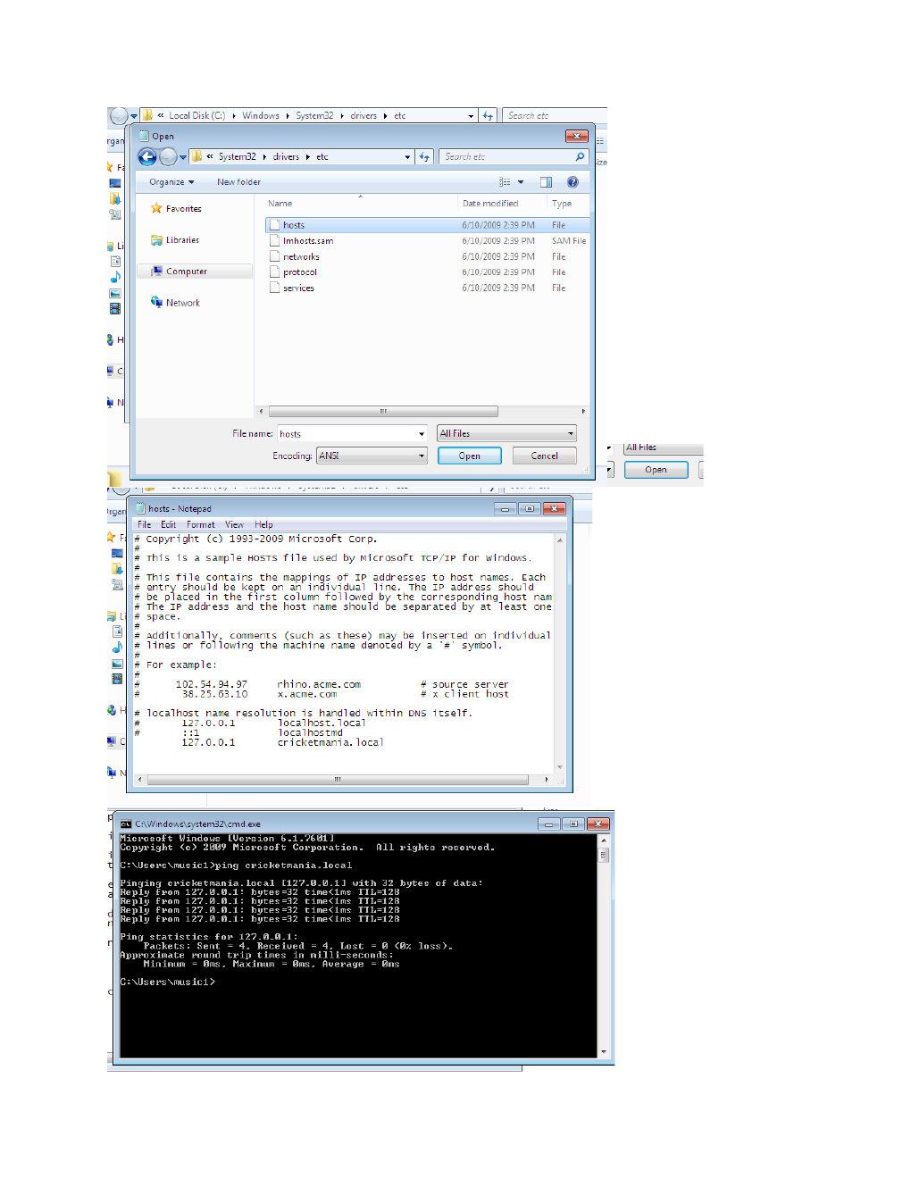
What I did: I opened the hosts file in Notepad and then used Command Prompt to check the local network/DNS information.
Explanation: The screenshots show the hosts-file contents followed by the command-line verification step.

PAGE 8 – Command Prompt – Test DNS Resolution with nslookup
Topic: Command Prompt – Test DNS Resolution with nslookup

What I did: I ran nslookup commands for the required websites and checked the DNS server responses and returned IP addresses.
Explanation: The command output confirms the DNS resolution results returned for the tested domain names.

PAGE 9 – DNS – Review Resolution Flow and Record Types
Topic: DNS – Review Resolution Flow and Record Types
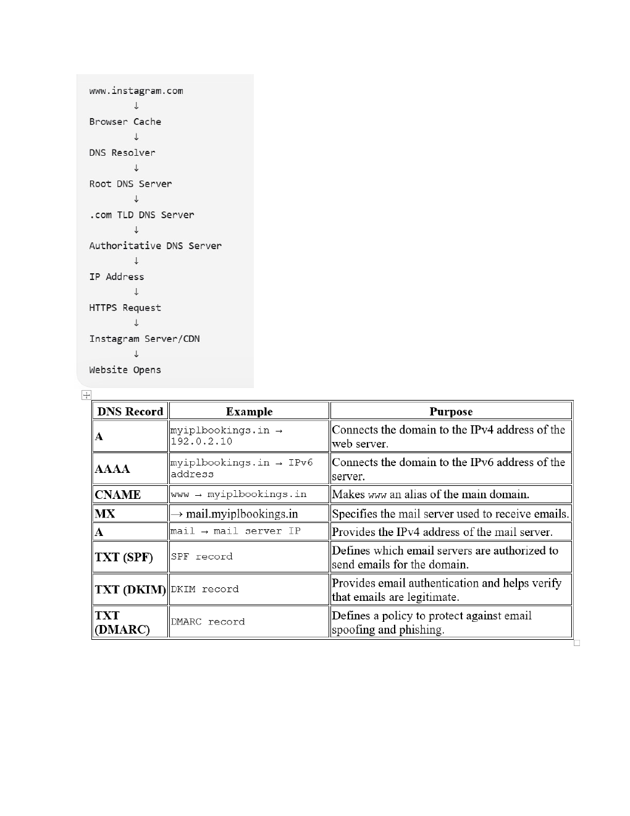
What I did: I reviewed the DNS resolution flow from the browser through the resolver and authoritative server, along with the main DNS record types.
Explanation: The diagram explains how a domain is resolved to an IP address, while the table summarizes A, AAAA, CNAME, MX, SPF, DKIM, and DMARC records.

