PAGE 1 – Server Manager – Open Server Manager
Topic: Server Manager – Open Server Manager
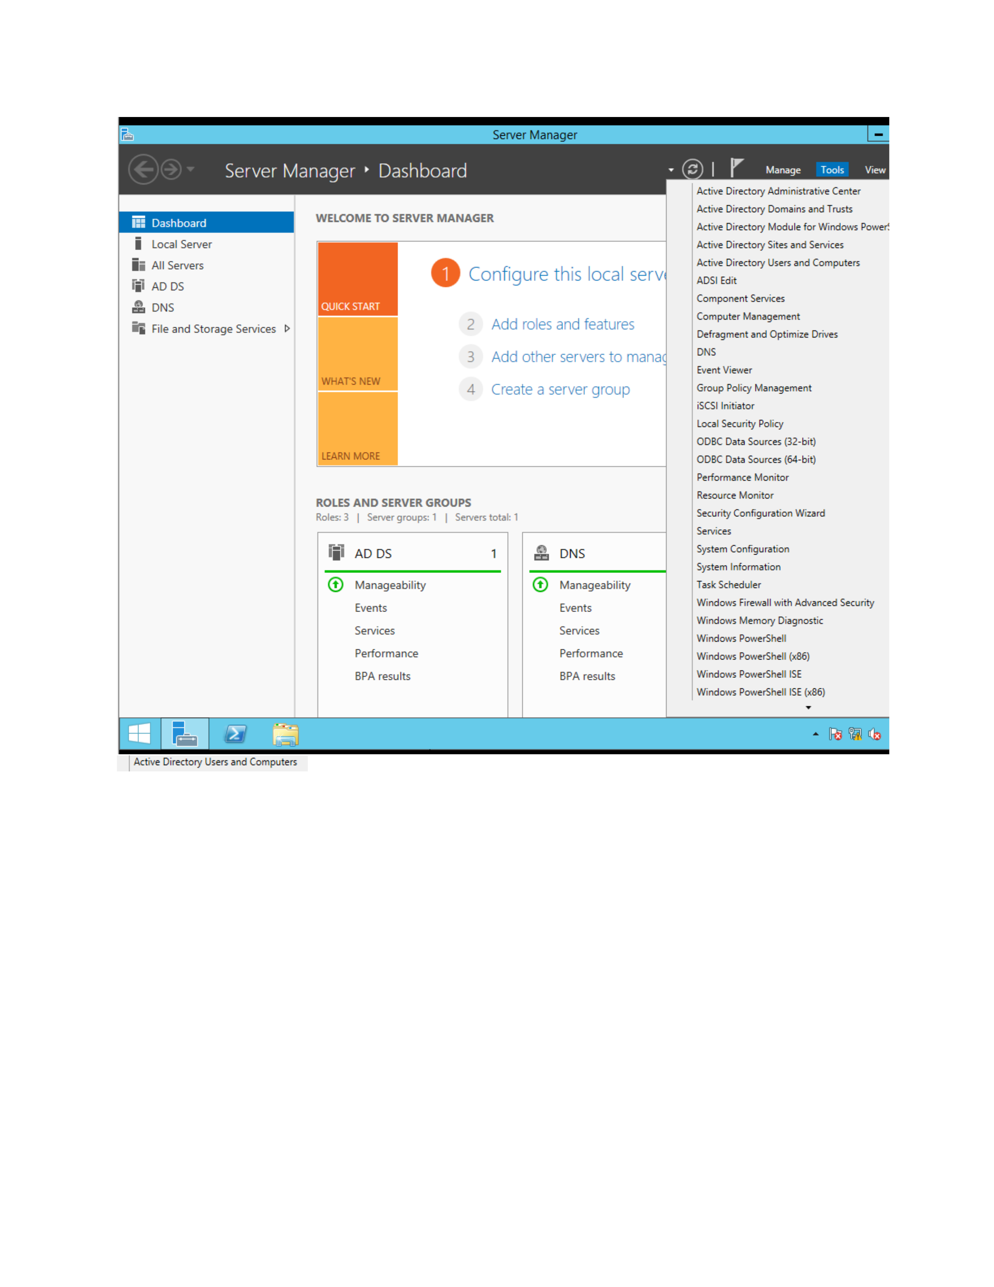
What I did: I opened Server Manager and reached the main dashboard where the server roles and management options are shown.
Explanation: This is the starting point for the Windows Server administration work.

PAGE 2 – Active Directory – Review the Domain
Topic: Active Directory – Review the Domain
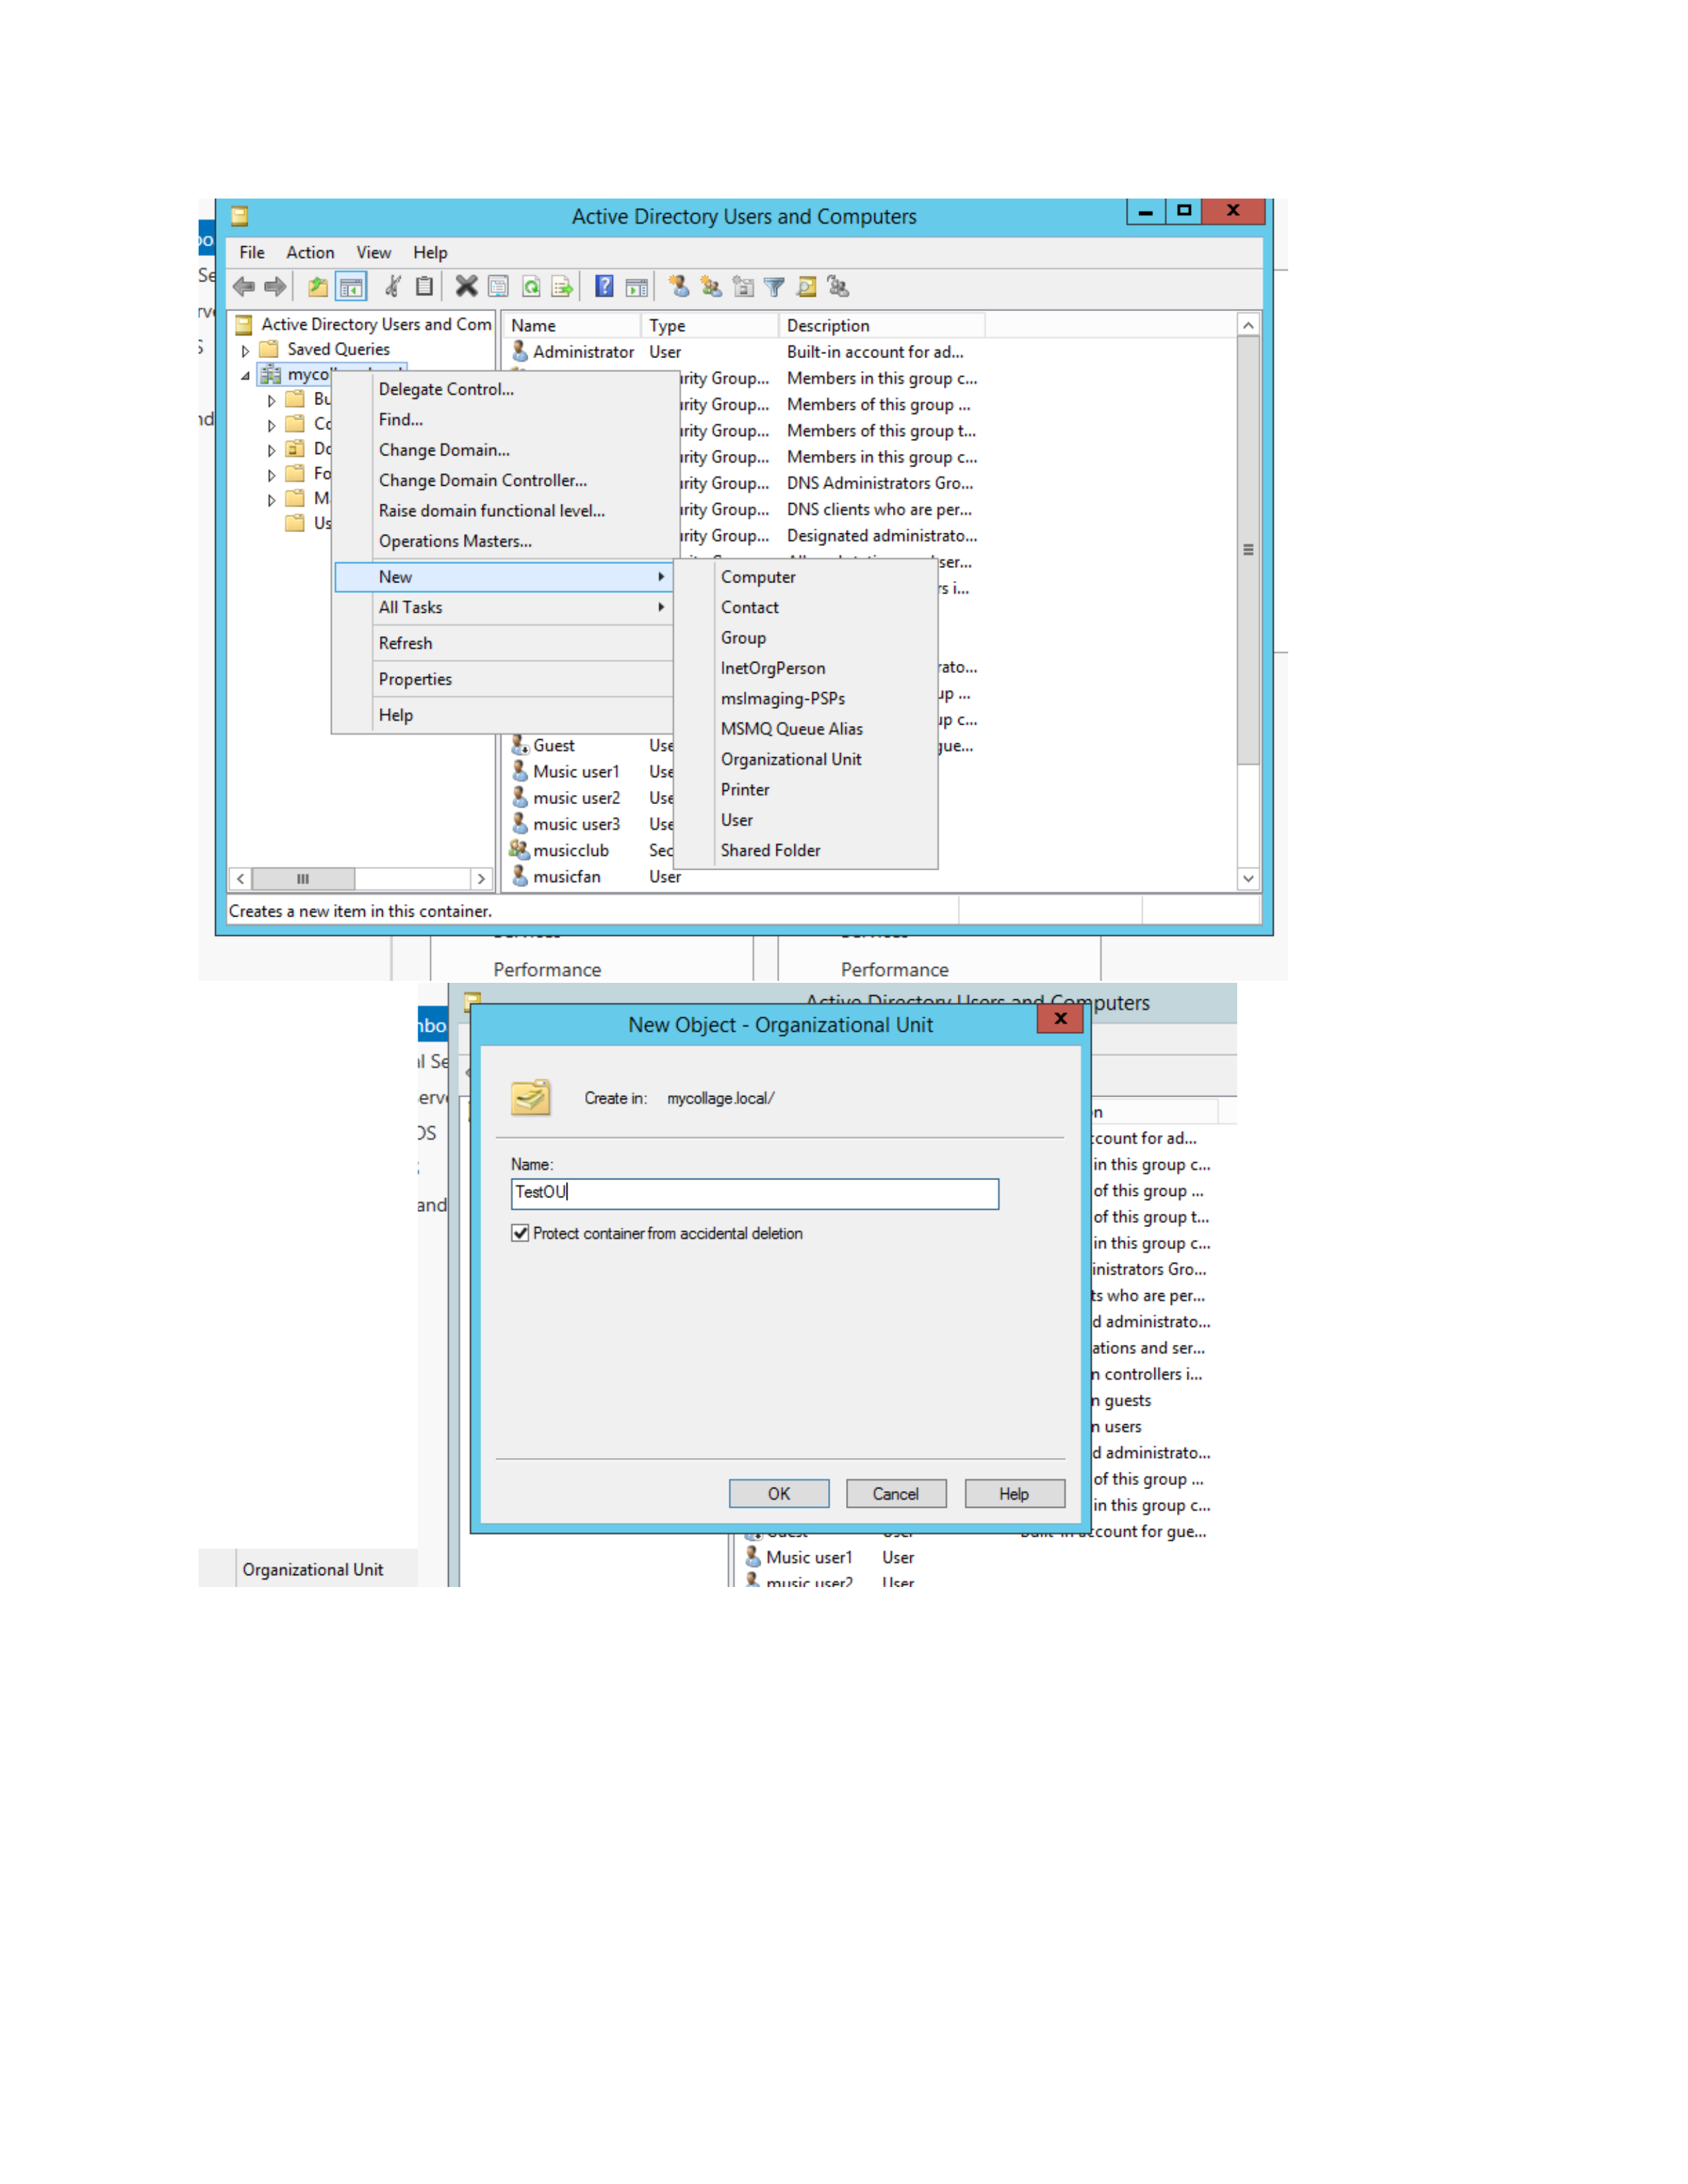
What I did: I opened the Active Directory management view and reviewed the domain objects and built-in groups.
Explanation: The domain tree and administrative groups are visible for further management.

PAGE 3 – Active Directory Users and Computers – Open the Domain
Topic: Active Directory Users and Computers – Open the Domain
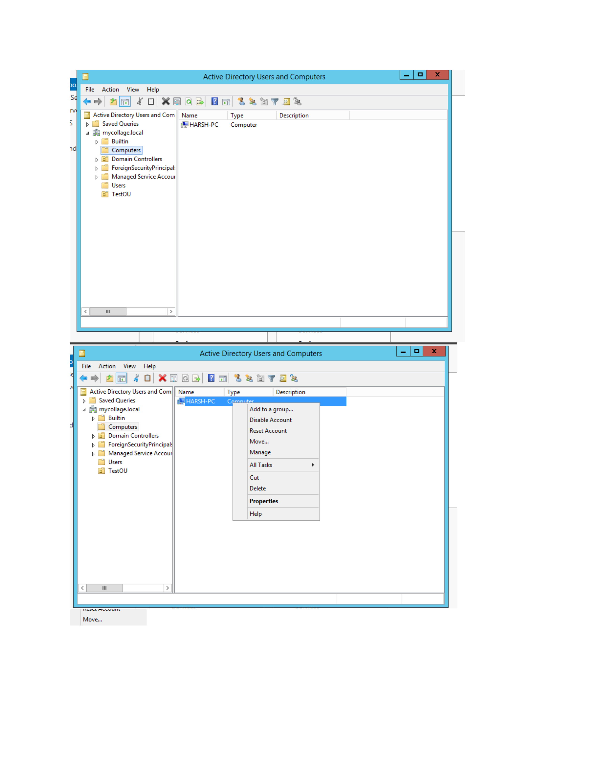
What I did: I opened Active Directory Users and Computers and expanded the mycollage.local domain.
Explanation: The domain containers, users, and organizational objects are displayed.

PAGE 4 – Active Directory – Select the Required Container
Topic: Active Directory – Select the Required Container
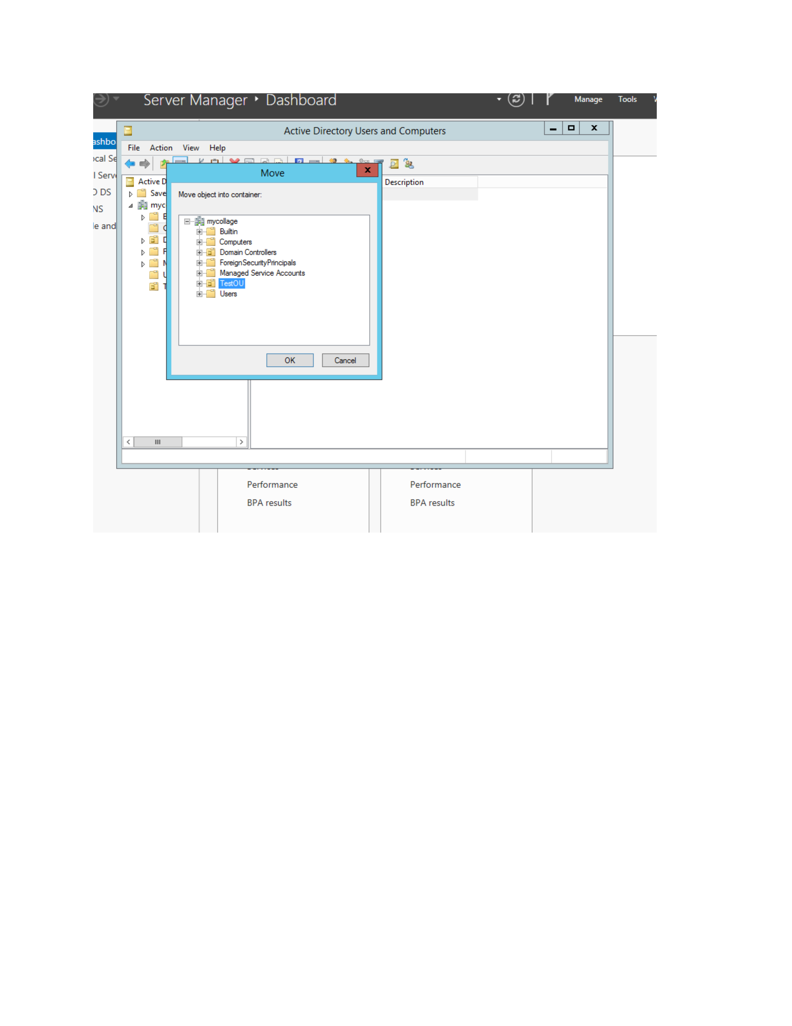
What I did: I navigated through the domain tree and selected the required container for the next configuration step.
Explanation: The selected location in the Active Directory hierarchy is ready for configuration.

PAGE 5 – Active Directory – Select TestOU
Topic: Active Directory – Select TestOU
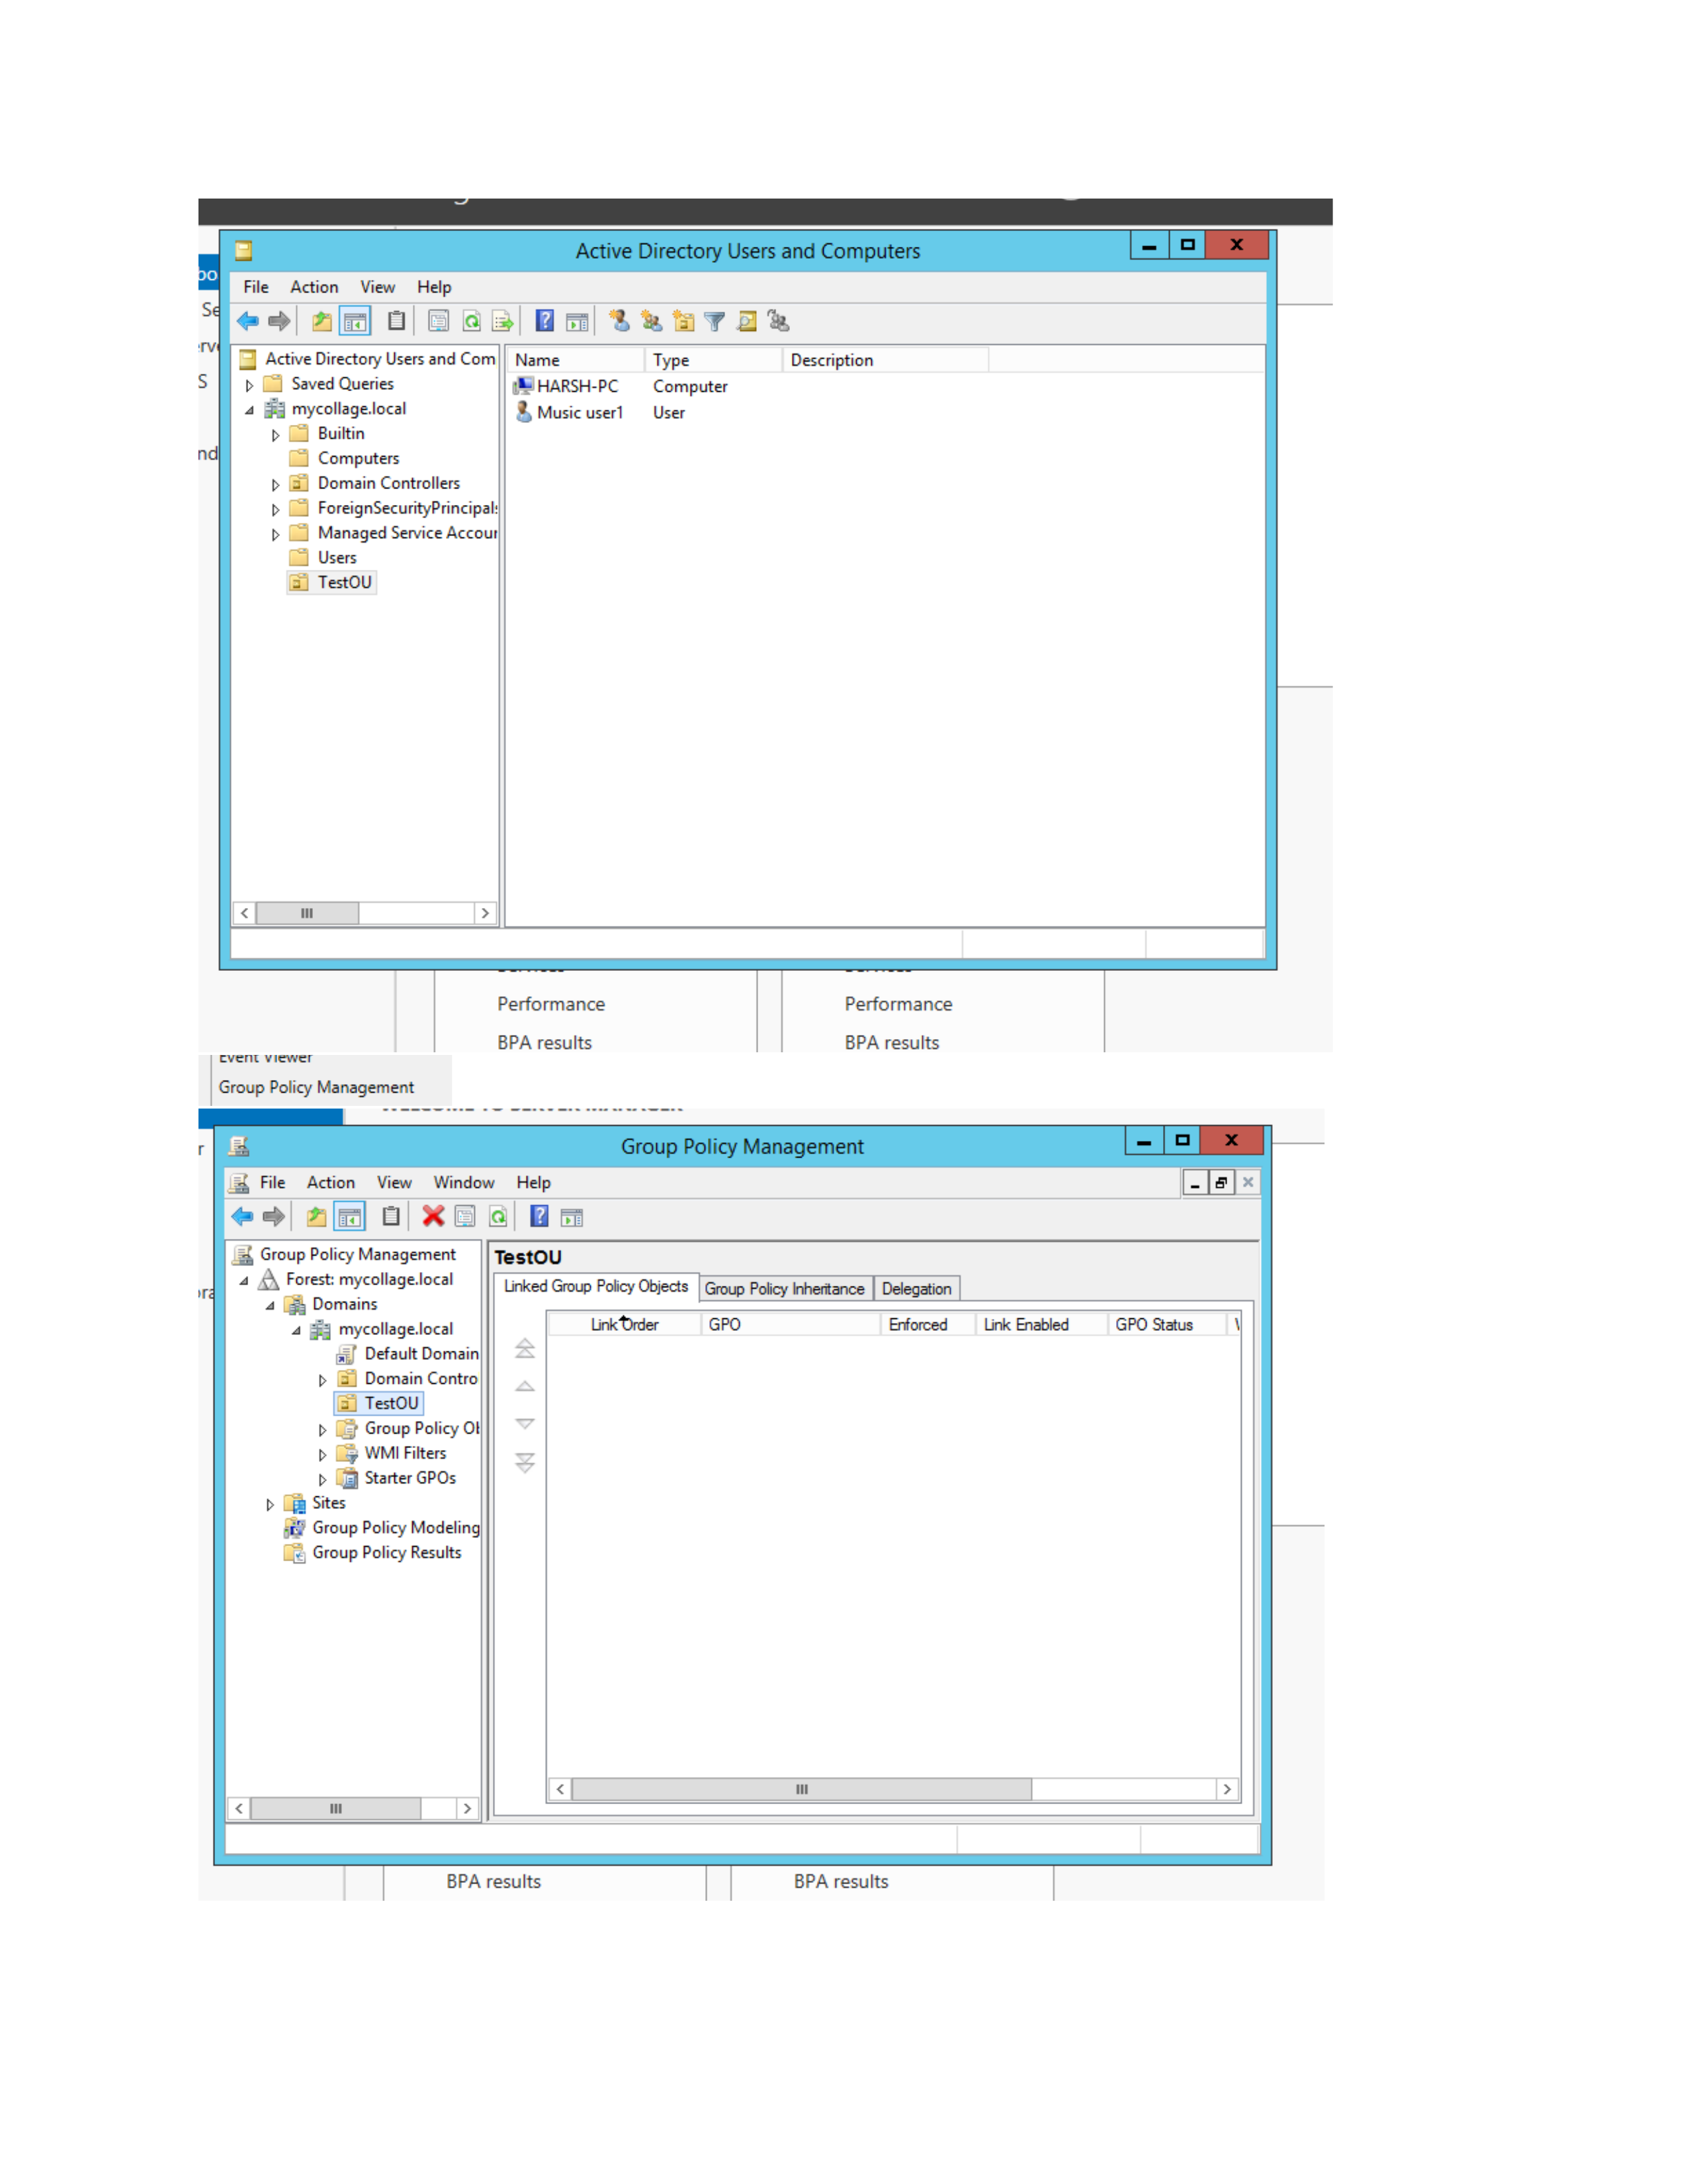
What I did: I selected TestOU in Active Directory Users and Computers and opened its management options.
Explanation: The configuration is being performed for the TestOU organizational unit.

PAGE 6 – Group Policy Management – Open GPOs
Topic: Group Policy Management – Open GPOs
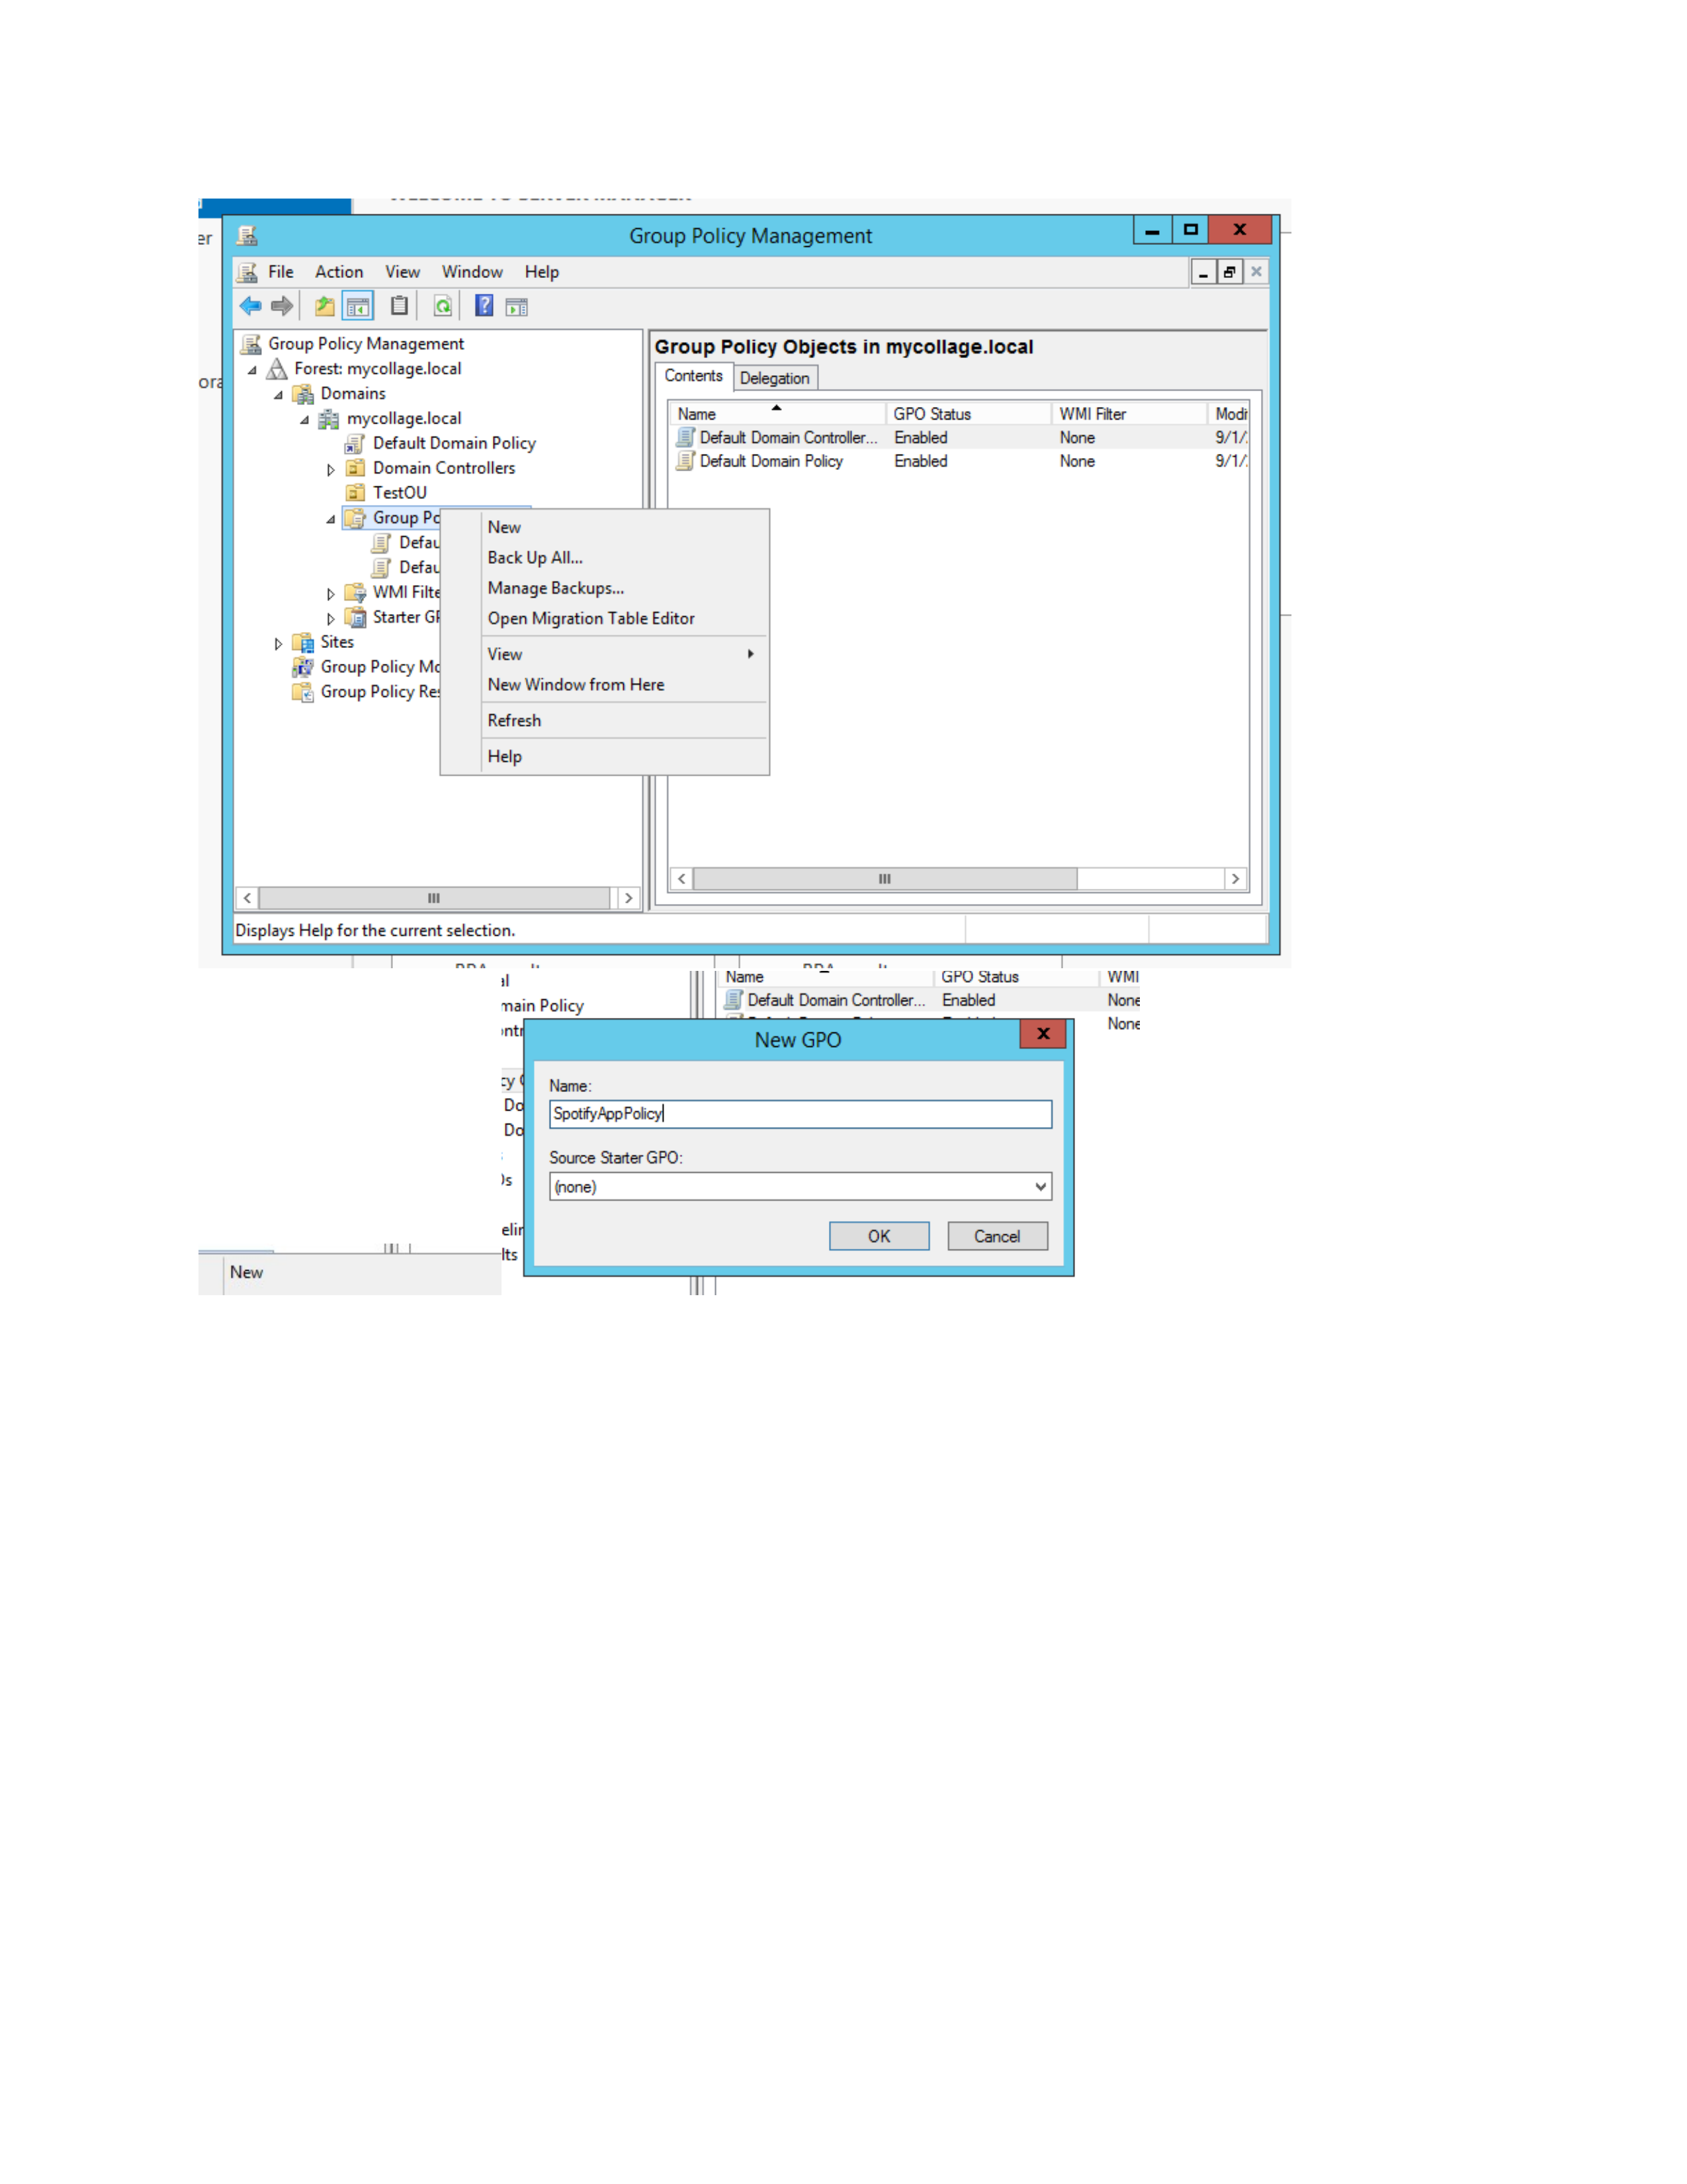
What I did: I opened Group Policy Management and selected Group Policy Objects for the domain.
Explanation: The available GPOs are displayed so the required policy can be configured.

PAGE 7 – Group Policy Management – Open SpotifyAppPolicy
Topic: Group Policy Management – Open SpotifyAppPolicy
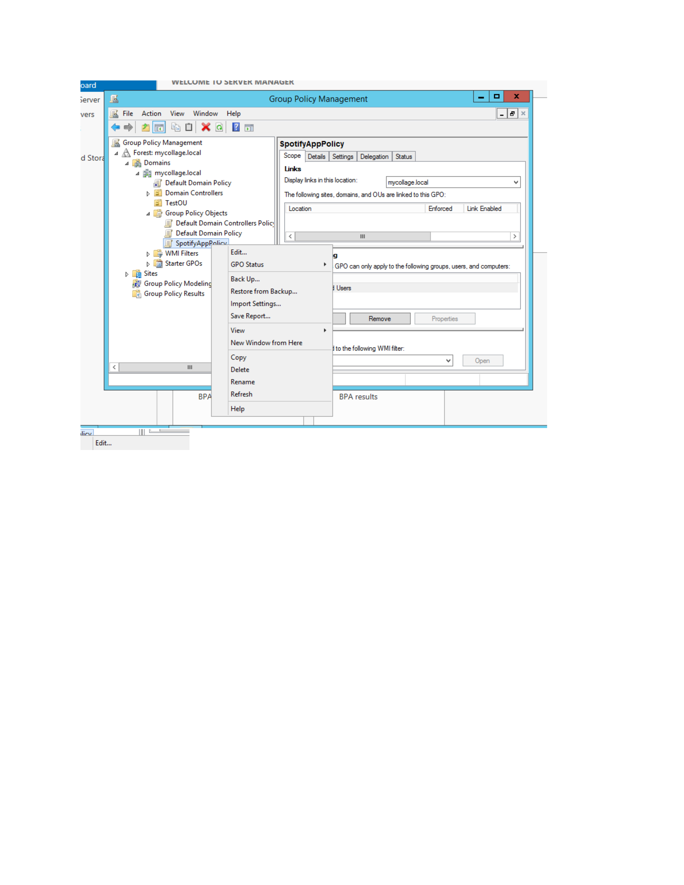
What I did: I selected SpotifyAppPolicy and opened its management options.
Explanation: The screenshot shows the policy selected for further configuration.

PAGE 8 – SpotifyAppPolicy – Review Configuration
Topic: SpotifyAppPolicy – Review Configuration
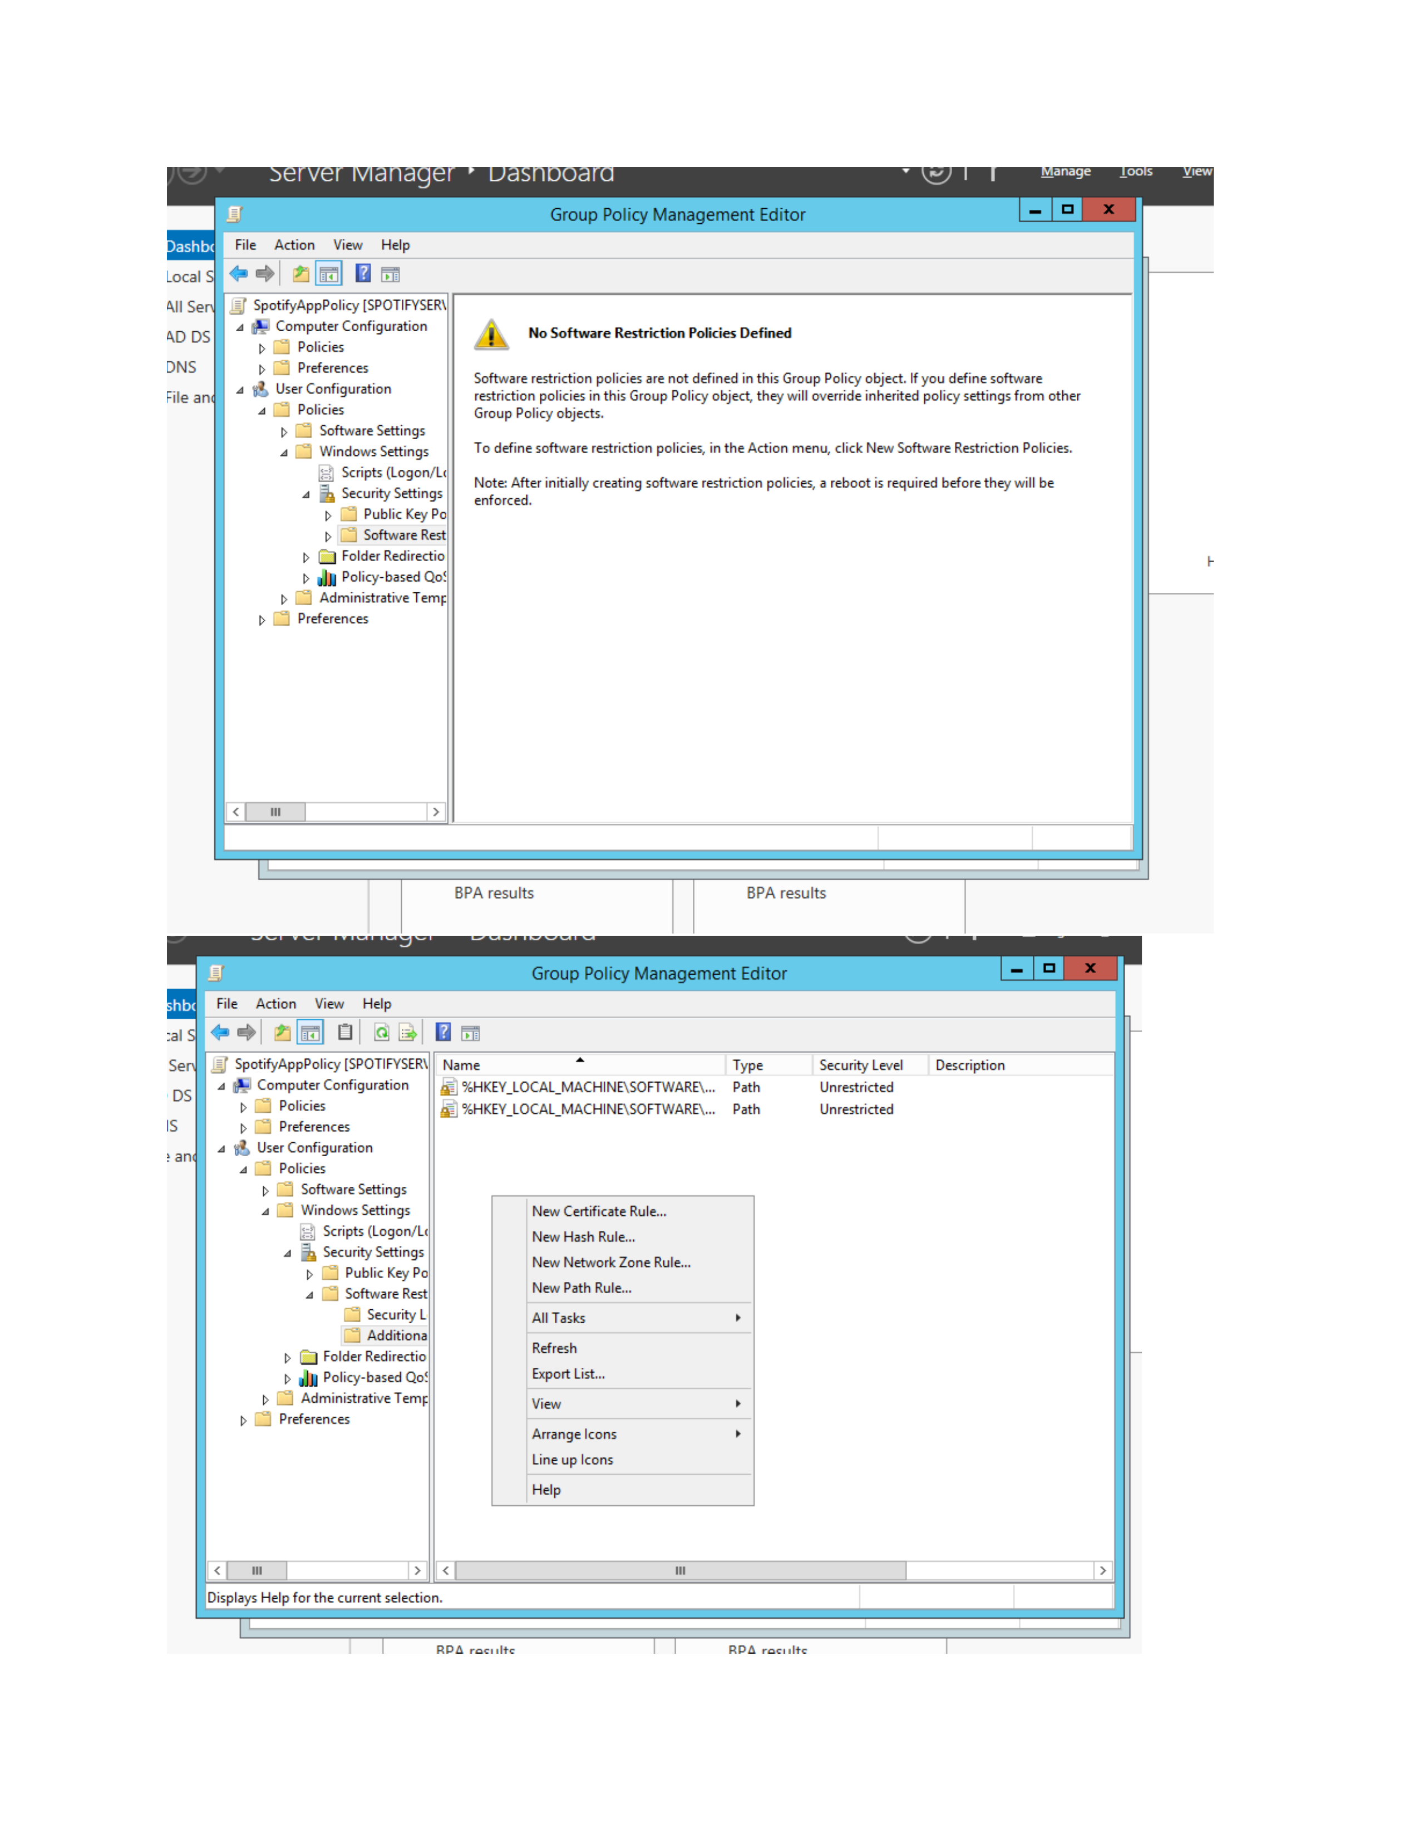
What I did: I expanded SpotifyAppPolicy and reviewed the Computer Configuration and User Configuration sections.
Explanation: These sections contain the settings used to control the required Windows behavior.

PAGE 9 – SpotifyAppPolicy – Create a Path Rule
Topic: SpotifyAppPolicy – Create a Path Rule
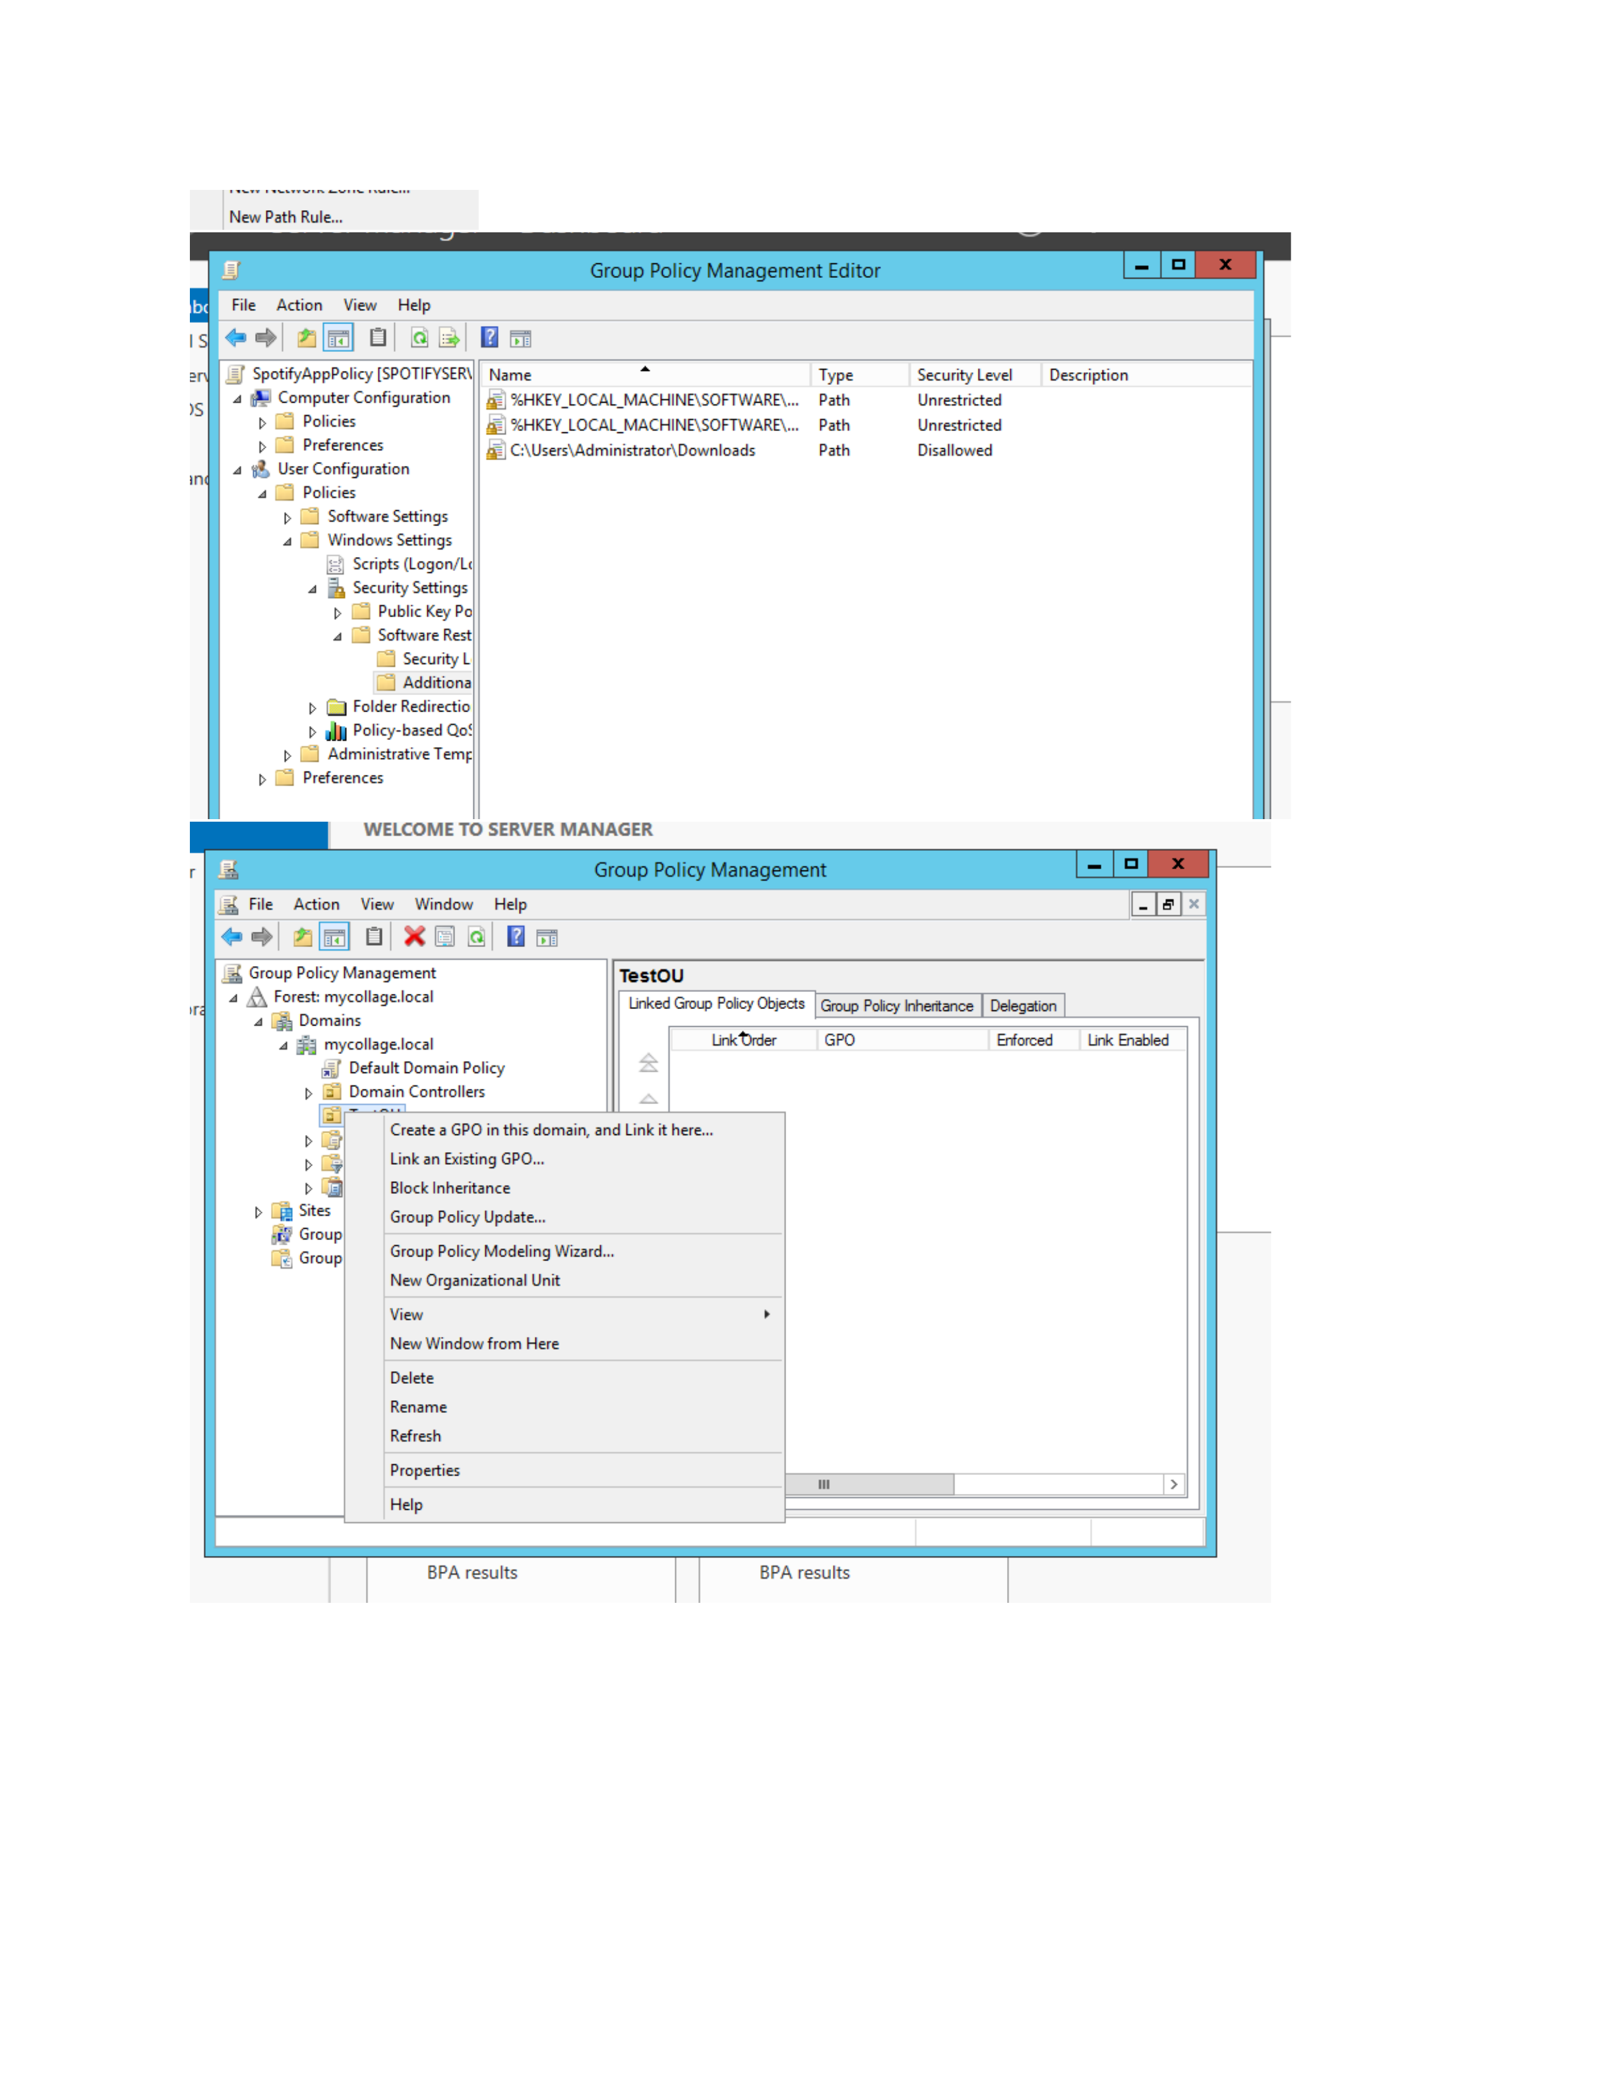
What I did: I opened the Software Restriction Policy path-rule area and created a rule for the specified path.
Explanation: The rule list shows the configured path and its selected security level/action.

PAGE 10 – Windows – Work with the Existing GPO
Topic: Windows – Work with the Existing GPO
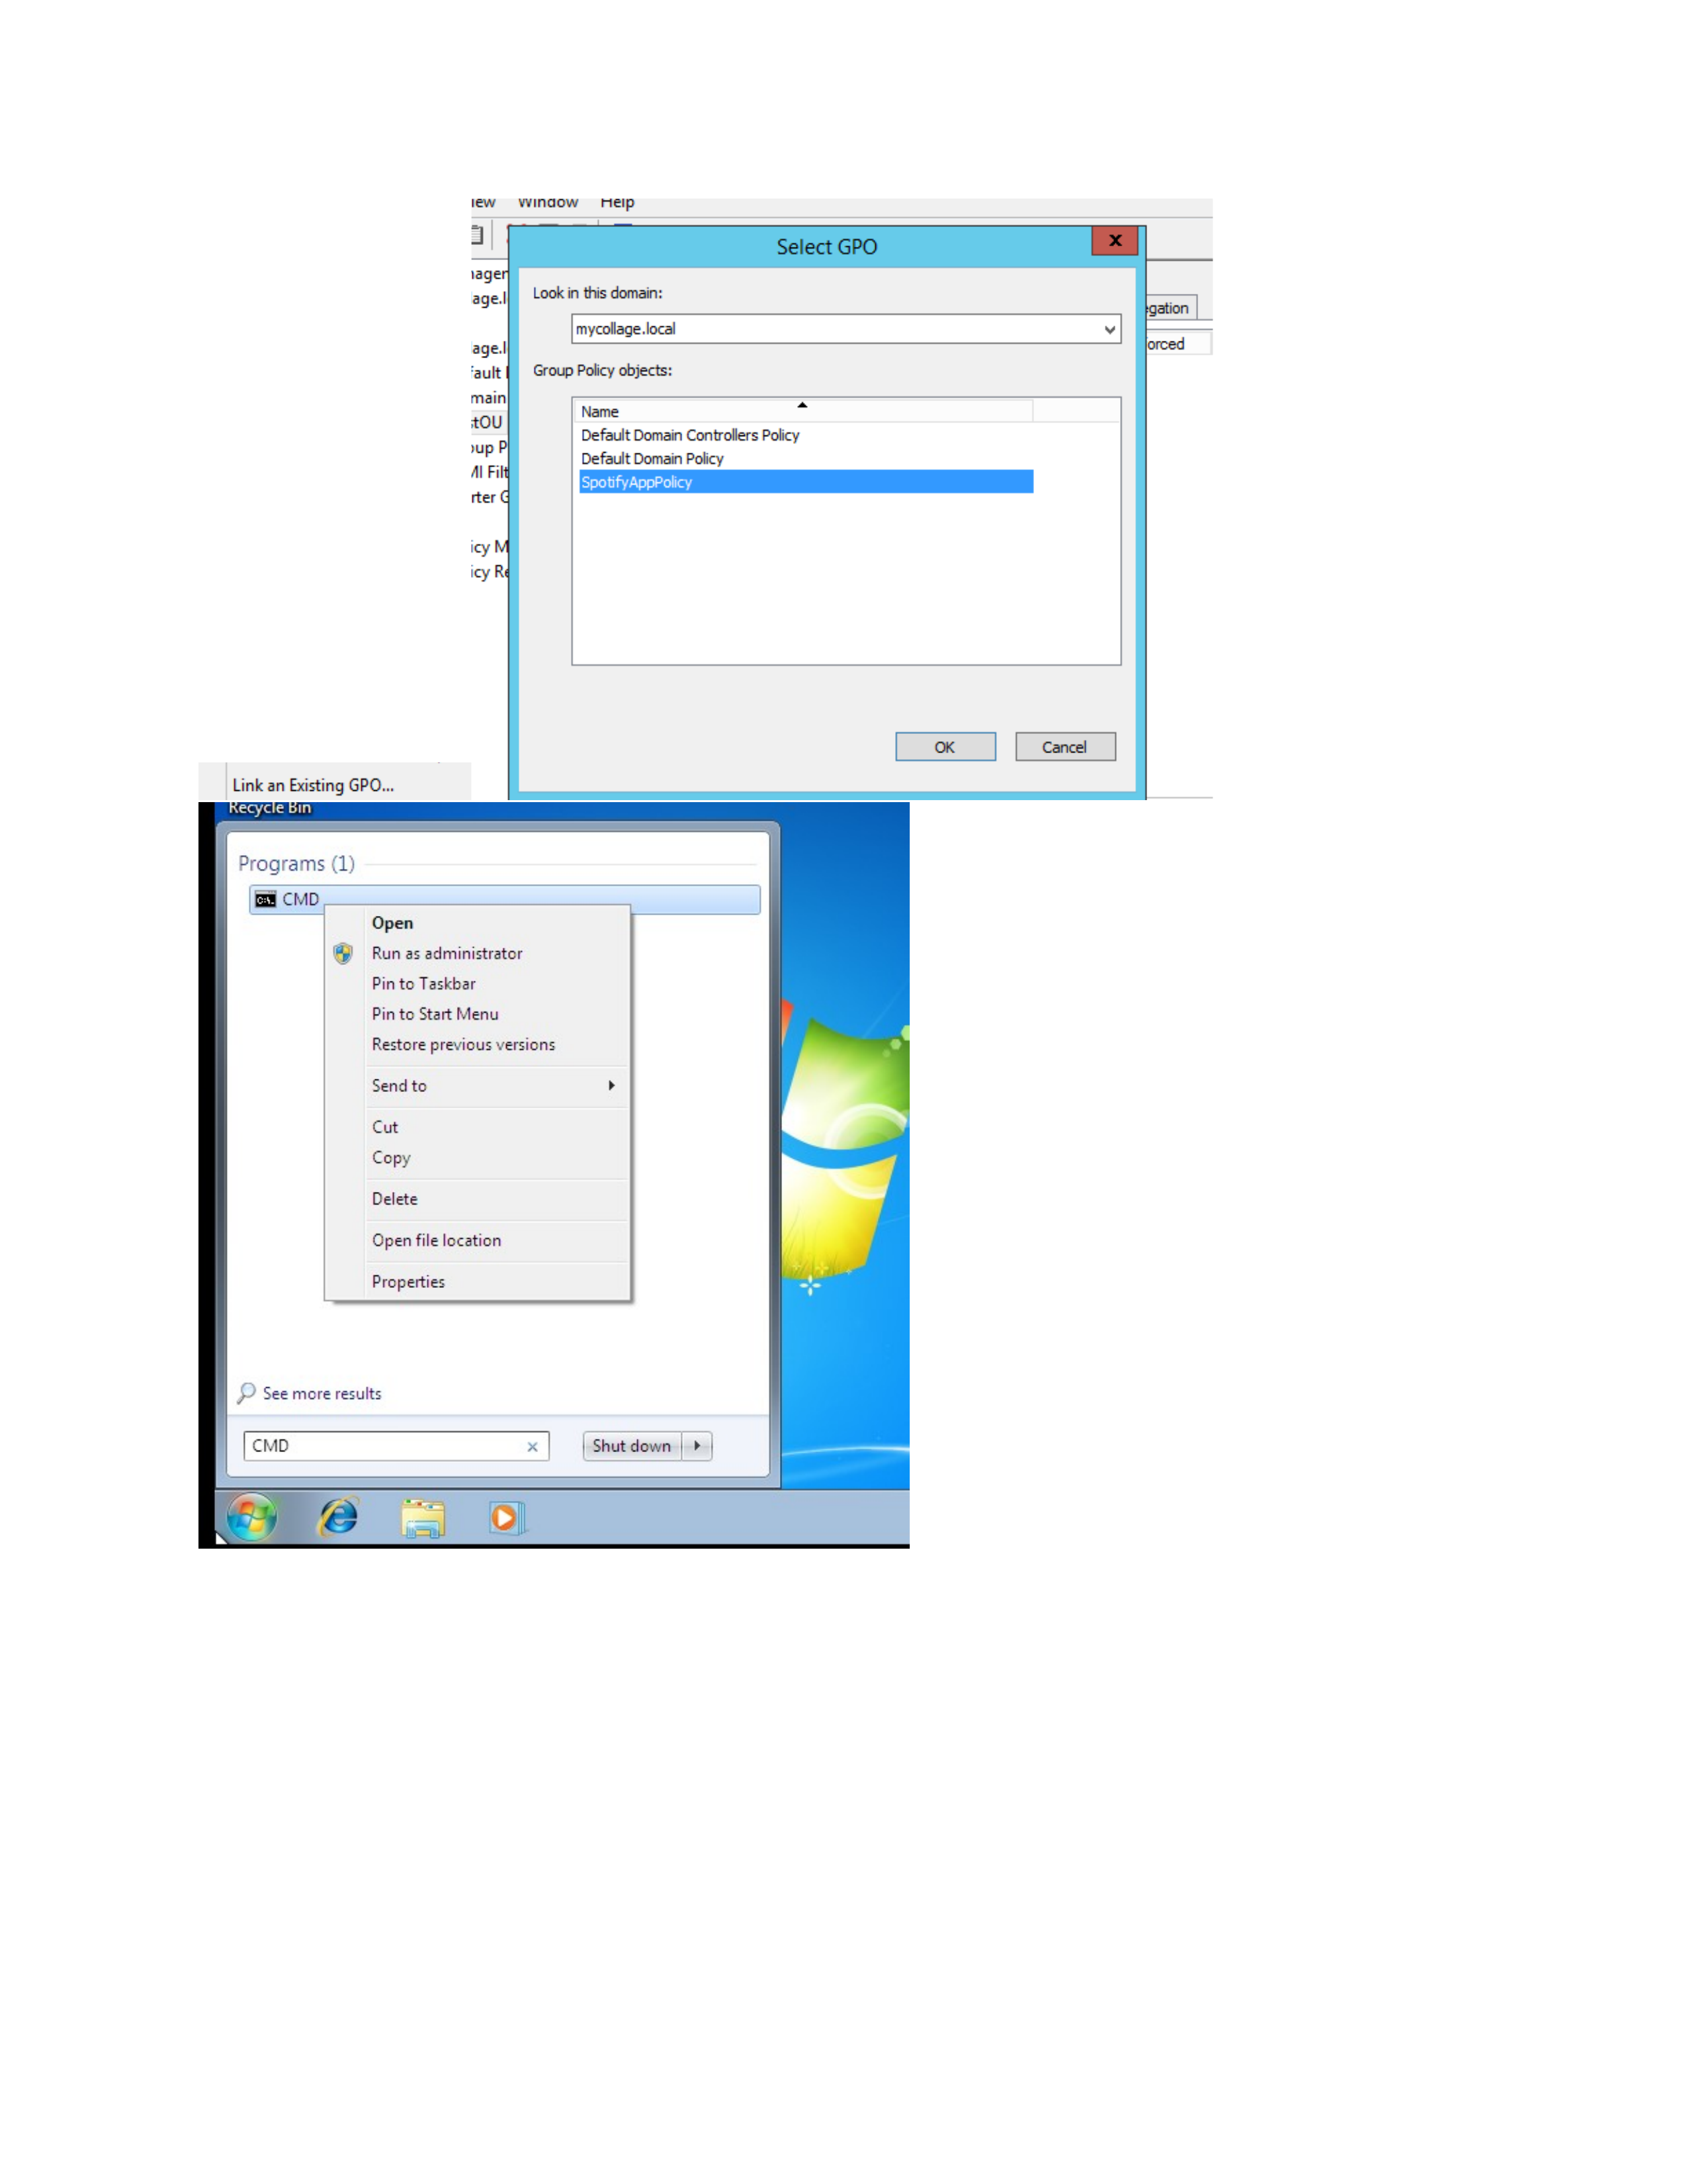
What I did: I opened the available Group Policy options for the existing GPO.
Explanation: The context menu shows the administrative actions available for the policy.

PAGE 11 – Windows – Approve Administrator Prompt
Topic: Windows – Approve Administrator Prompt
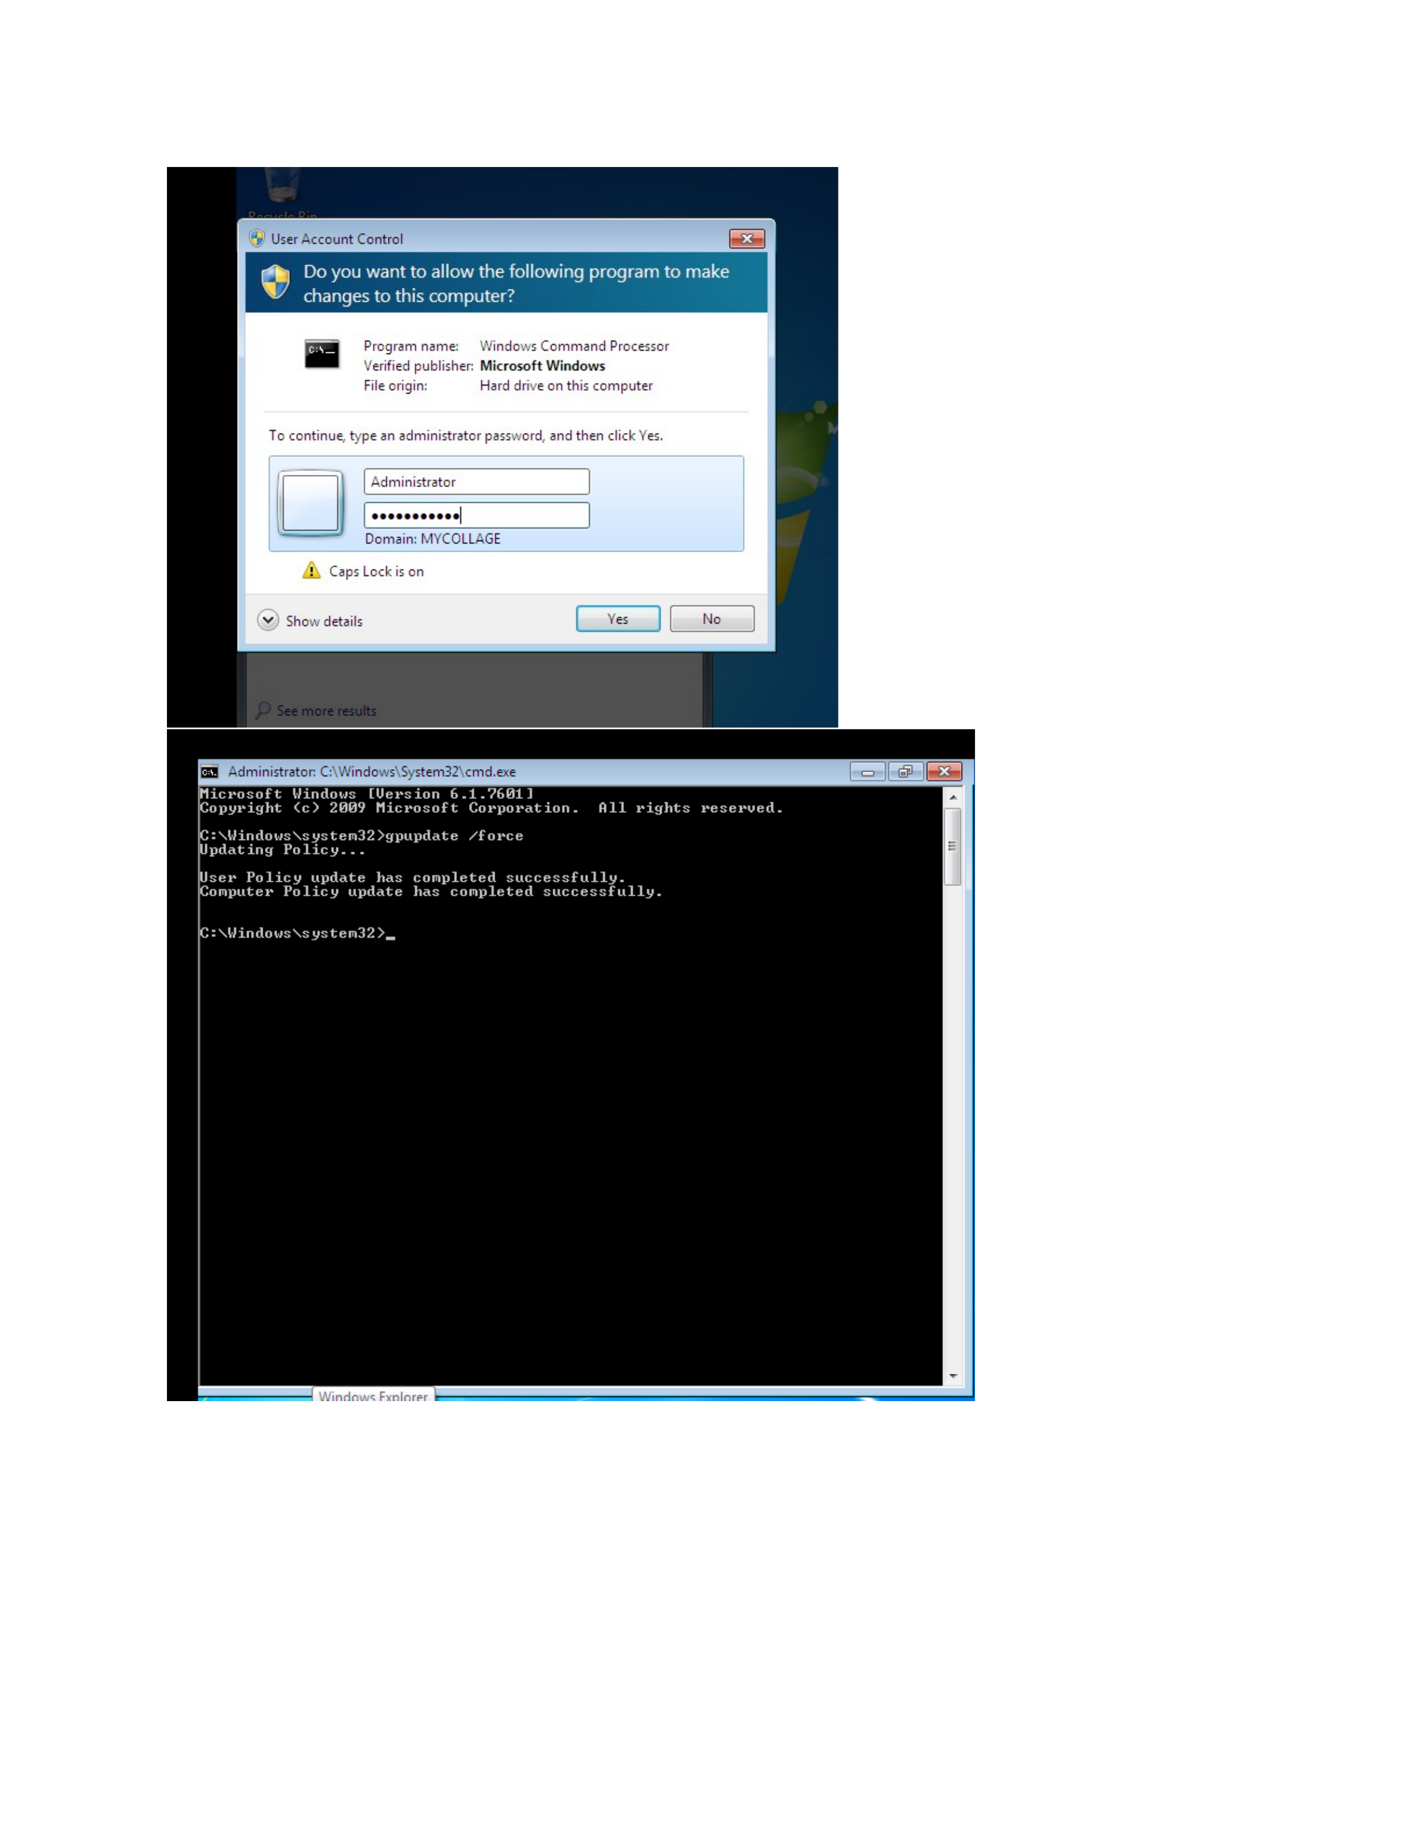
What I did: I approved the User Account Control prompt using administrator authorization.
Explanation: Windows requested elevated permission before continuing the administrative operation.

PAGE 12 – Group Policy Management – Verify SpotifyAppPolicy
Topic: Group Policy Management – Verify SpotifyAppPolicy
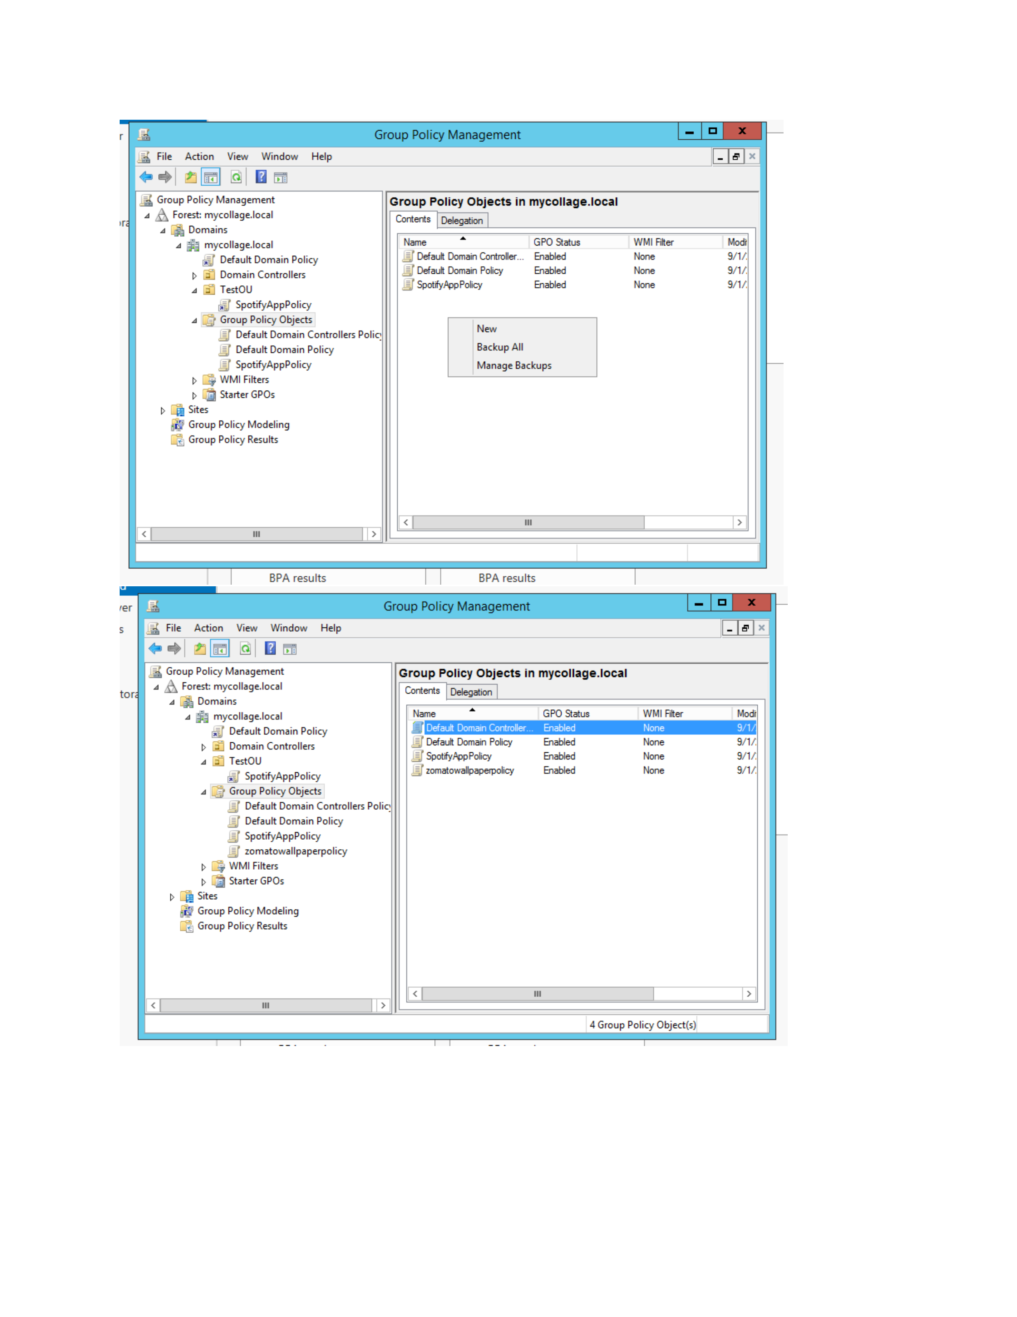
What I did: I returned to Group Policy Management and verified SpotifyAppPolicy in the domain GPO list.
Explanation: The configured policy is visible with the other Group Policy Objects.

PAGE 13 – Windows – Find the Wallpaper File
Topic: Windows – Find the Wallpaper File
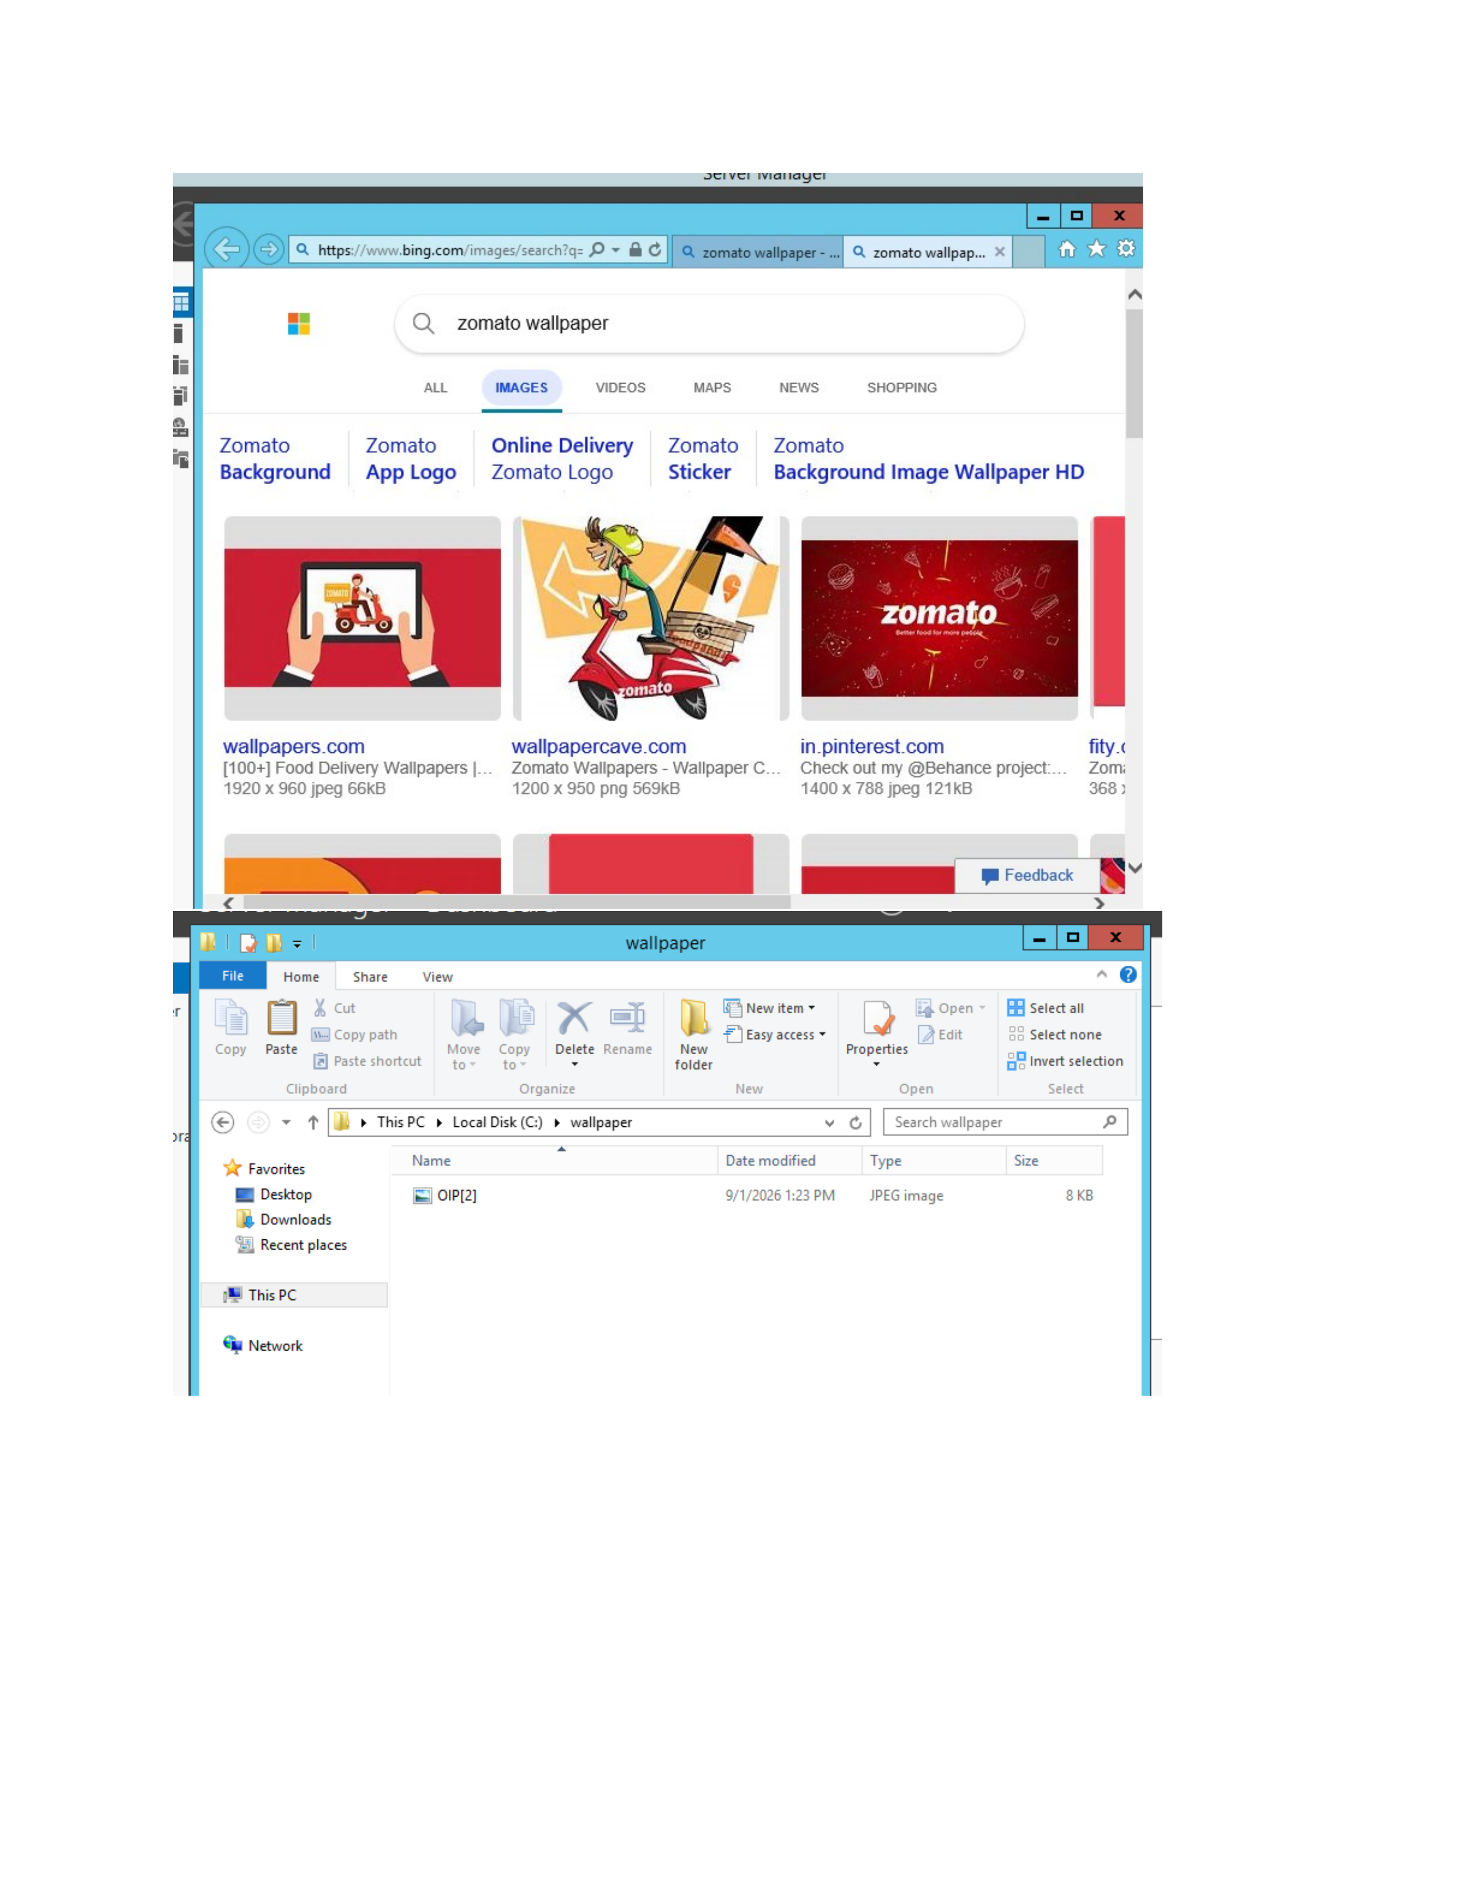
What I did: I searched for the wallpaper image and opened the folder containing the downloaded file.
Explanation: The selected wallpaper image is shown in the wallpaper folder.

PAGE 14 – Windows – Open Folder Properties
Topic: Windows – Open Folder Properties
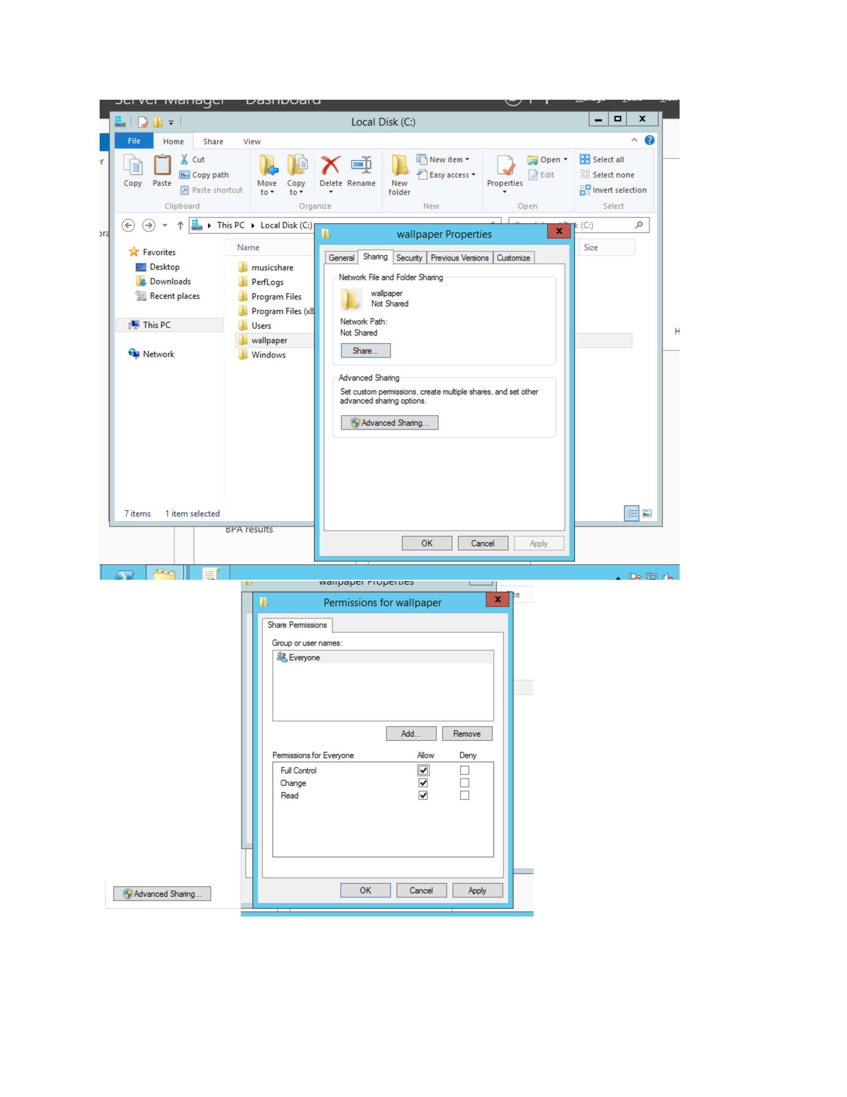
What I did: I opened the wallpaper folder properties and moved to the sharing/security configuration area.
Explanation: The folder properties are being prepared for access and sharing configuration.

PAGE 15 – Windows – Configure Folder Sharing
Topic: Windows – Configure Folder Sharing
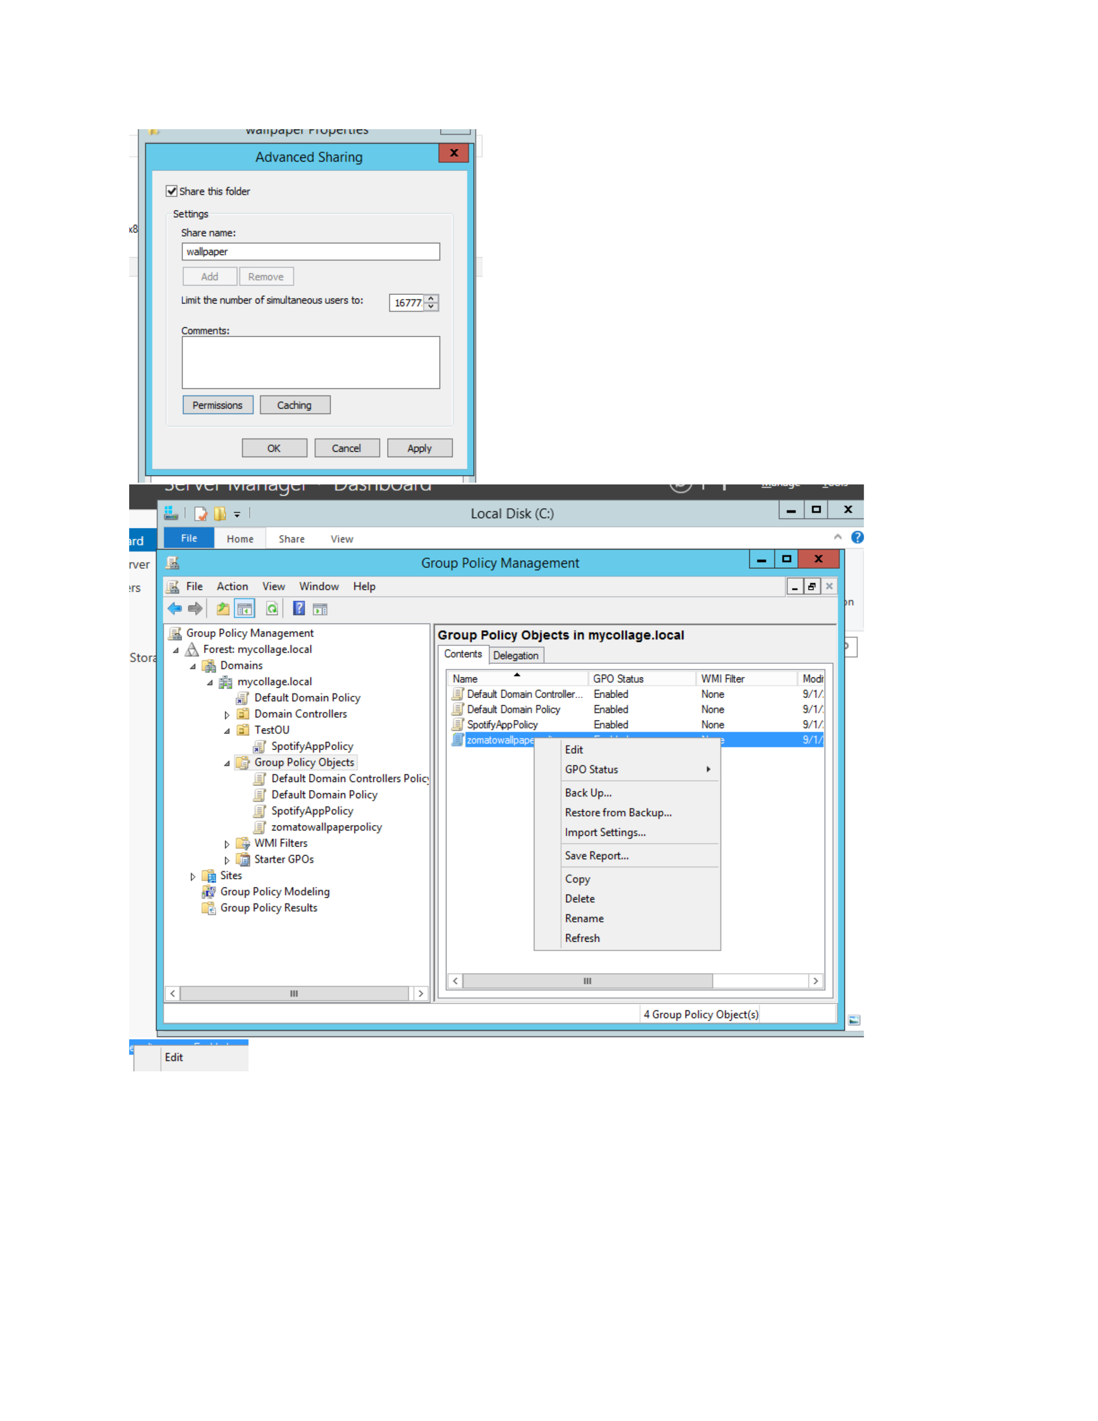
What I did: I configured the folder sharing settings and selected the users/groups that can access the shared folder.
Explanation: The sharing dialog shows the access settings applied to the wallpaper folder.

PAGE 16 – Group Policy – Configure Desktop Wallpaper
Topic: Group Policy – Configure Desktop Wallpaper
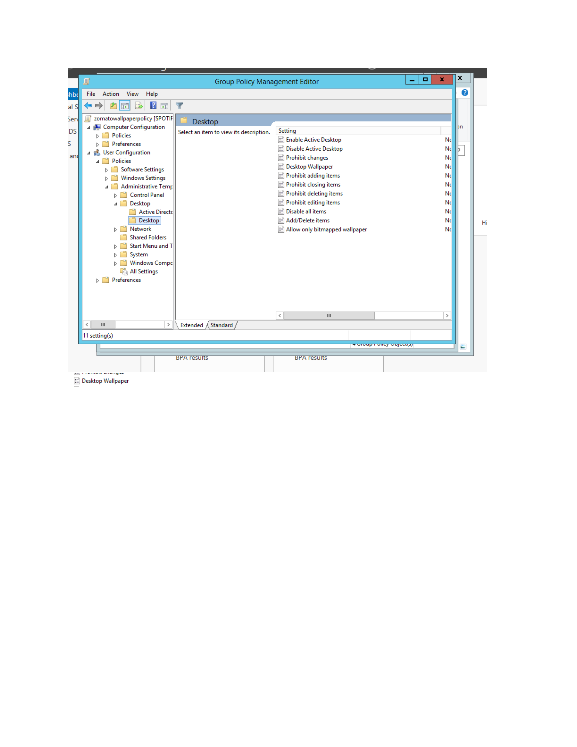
What I did: I opened the Desktop Wallpaper policy setting and enabled it for configuration.
Explanation: This policy controls the desktop background applied through Group Policy.

PAGE 17 – Group Policy – Enter Wallpaper Path
Topic: Group Policy – Enter Wallpaper Path
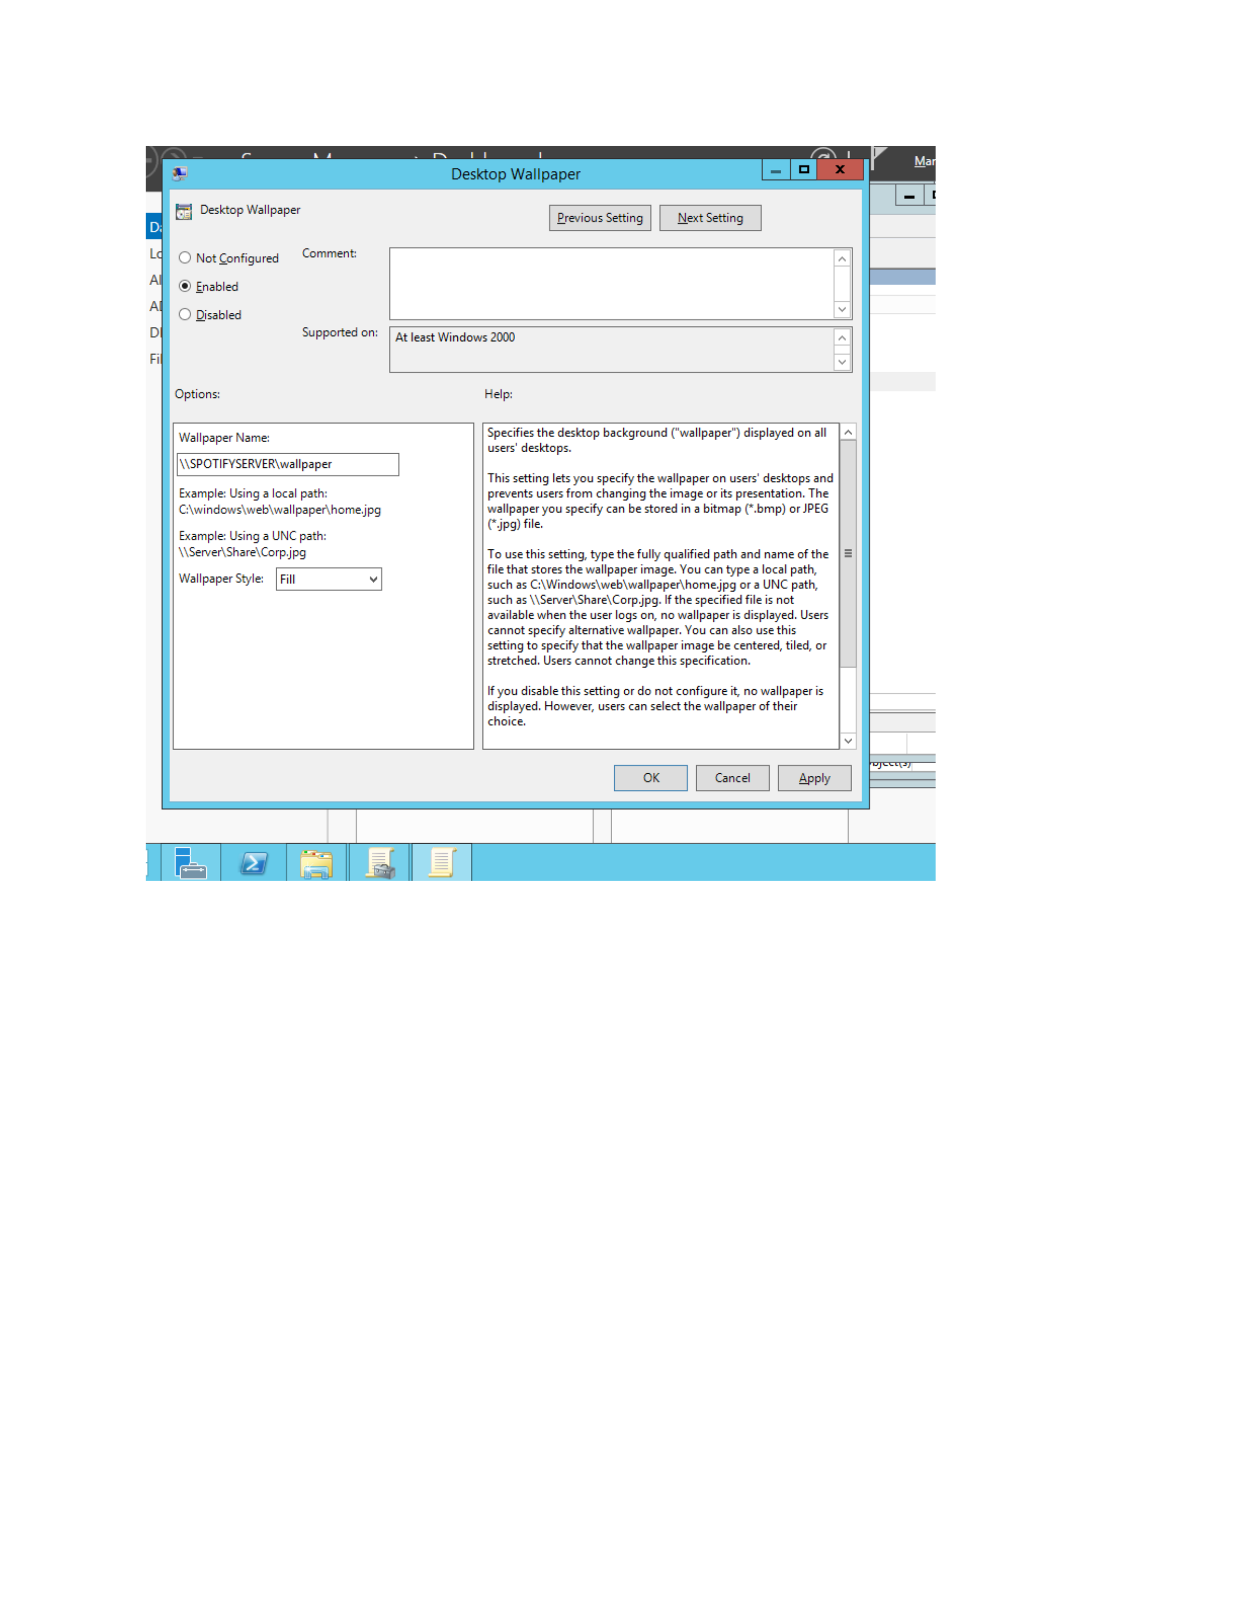
What I did: I entered the wallpaper location in the Desktop Wallpaper policy and selected the required wallpaper style.
Explanation: The policy now contains the wallpaper path that clients will use.

PAGE 18 – Group Policy – Link the GPO to TestOU
Topic: Group Policy – Link the GPO to TestOU
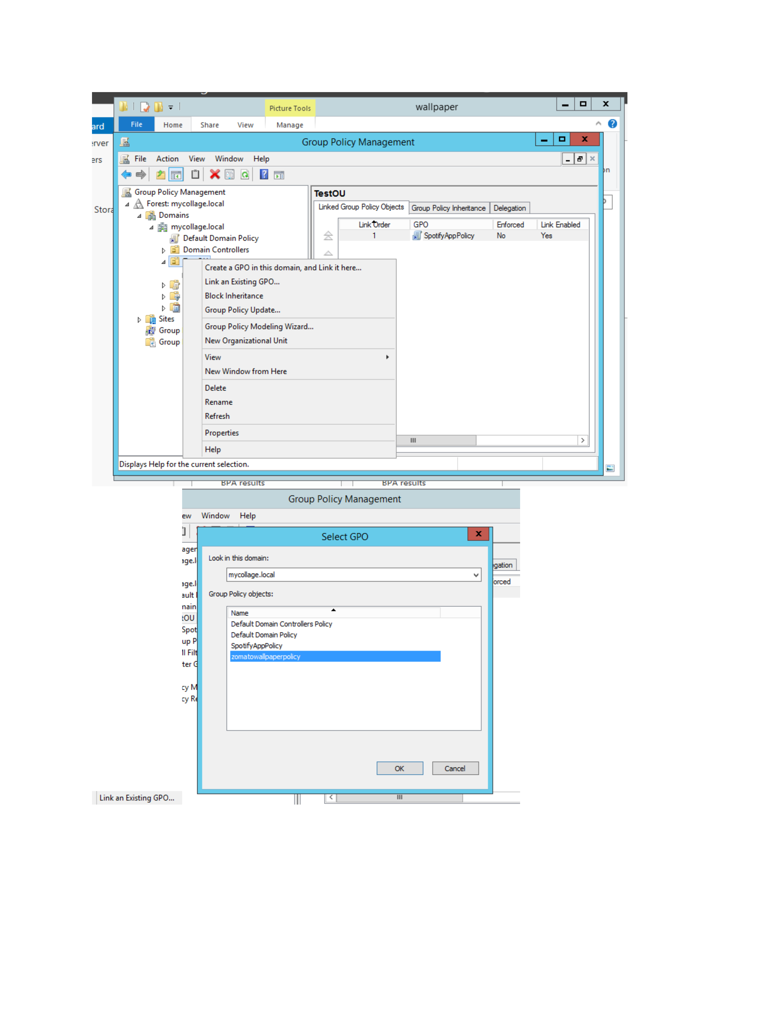
What I did: I linked the configured GPO to TestOU and verified the link settings.
Explanation: The GPO is associated with TestOU so its settings can apply to the organizational unit.

PAGE 19 – Security – Review Wallpaper Permissions
Topic: Security – Review Wallpaper Permissions
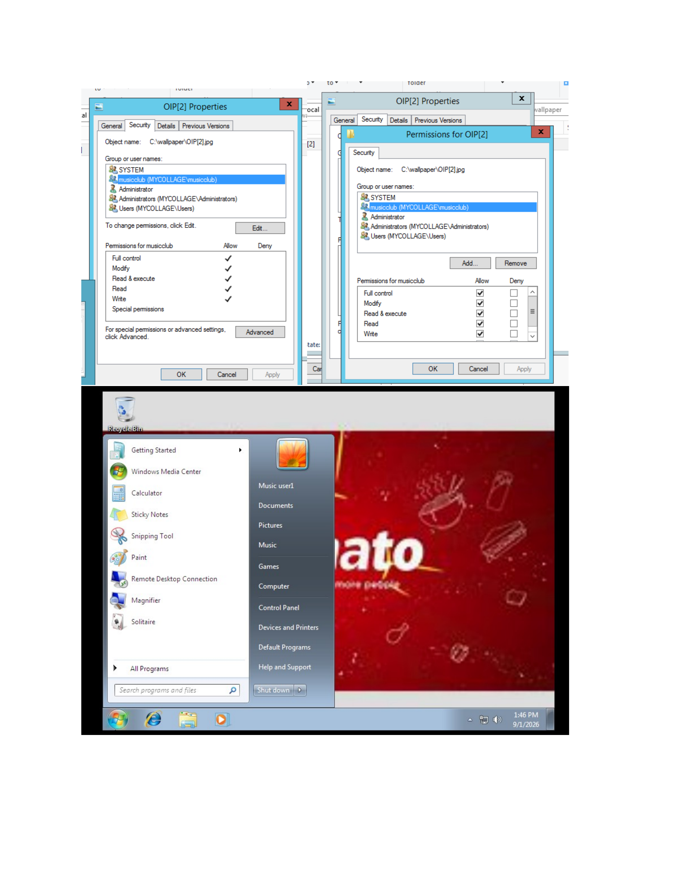
What I did: I reviewed the wallpaper file permissions for SYSTEM, administrators, and users.
Explanation: The security settings show which accounts and groups have access to the wallpaper file.

