Project Consulting Report
Generated on June 23, 2026

1. Executive Summary
The project aims to deliver an AI‑driven coaching platform that standardizes onboarding training, provides real‑time competency insights, and automates reporting for retail associates. Scope includes a web portal, mobile app, AI coach engine, document ingestion with OCR, analytics dashboards, and integration with existing LMS and Microsoft SSO. The proposed hybrid cloud SaaS architecture leverages Azure services to meet strict audit, retention, and compliance requirements while supporting mobile‑first adoption. Recommendation: proceed with the Azure‑centric serverless solution, focusing on an MVP that validates core coaching, authentication, and reporting capabilities before scaling.
2. Background Summary
The client currently experiences fragmented onboarding training, manual data aggregation, and low retention of learning content. Managers are overloaded, and inconsistent documentation hampers accurate coaching and executive visibility. The organization seeks a unified, compliant platform to automate coaching, enforce auditability, and deliver actionable analytics across regions.
3. Problem / Need Analysis
Problem / Need | Business Impact
Inconsistent training experiences across managers | Variable execution leads to uneven store performance and reduced brand consistency.
Manual aggregation of spreadsheets, emails, and chats for reporting | High labor costs and delayed insights hinder timely decision‑making.
Rapid forgetting of training content | Decreased associate productivity and increased retraining expenses.
Managers lack time for daily role‑play training | Missed coaching opportunities and lower competency development.
Unreliable internet affecting voice interactions | Poor user experience in low‑bandwidth stores reduces adoption.
Coaching recommendations must be auditable and role‑based | : Non‑compliance risk and potential regulatory penalties.
Customer data must never appear in AI prompts | Compliance breach risk and loss of customer trust.
Duplicate and poorly named PDFs in repositories | Inefficient document retrieval and inconsistent AI context.
API limits during document ingestion and retrieval | Service throttling could delay coaching and reporting pipelines.
OCR quality concerns on scanned manuals | Inaccurate searchable text leads to irrelevant AI responses.
Risk of AI hallucinations in coaching feedback | Misguided guidance could damage associate performance and compliance.
Low adoption due to lack of mobile access | Training underutilized, limiting skill development.
Budget constraints | Need for cost‑effective, scalable solution.
Executives receive only simple completion percentages | Lack of contextual analytics hampers strategic insight.

4. Requirements Analysis
Functional Requirements
ID | Requirement
FR-001 | AI coach must behave like an impatient customer, change mood, negotiate discounts and evaluate confidence, empathy and compliance.
FR-002 | All AI responses must be drawn exclusively from approved company documentation that is kept up‑to‑date.
FR-003 | The platform should automatically identify weak competencies and recommend personalized practice paths.
FR-004 | Provide contextual analytics that factor in regional staffing differences rather than simple completion percentages.
FR-005 | Visibility dashboards showing onboarding completion, regional performance and competency scores are a primary objective.
FR-006 | Automation of reporting is secondary to visibility but still required.
FR-007 | Generated coaching feedback must be reviewable and receive manager approval before release.
FR-008 | Audit logs, retention policies and role‑based access control must be enforced for all coaching recommendations.
FR-009 | Microsoft Single Sign‑On (SSO) integration is mandatory.
FR-010 | Export of data to the existing Learning Management System (LMS) is mandatory.
FR-011 | Executives expect downloadable PDF reports every Monday morning.
FR-012 | Voice interactions must gracefully fall back to text when internet connectivity is poor.
FR-013 | Mobile experience must allow associates to practice on a phone during travel or quiet hours.

Non-Functional Requirements
Category | Requirement
Performance | AI response latency must be under 2 seconds for real‑time coaching.
Security | All data must be protected by Azure AD SSO, conditional access, and RBAC; audit logs must be immutable.
Scalability | Serverless services must auto‑scale to support peak coaching sessions across all stores.
Availability | System uptime of 99.9% with geo‑redundant deployment via Azure Front Door.
Maintainability | Modular architecture and CI/CD pipelines must enable rapid updates without downtime.

Technology Context
- Preferred Cloud: Azure
- Existing CRM: Salesforce
5. Assumptions
- Azure subscription is available and provisioned.
- Client will provide API credentials for third‑party integrations.
- Existing infrastructure remains unchanged during the POC phase.
6. Feature & Module Breakdown
Module | Feature / Functionality | Technologies Used
Frontend Web | Responsive UI for dashboards and coaching interaction | React 18, Azure Front Door CDN
Mobile App | On‑the‑go practice and coaching access | React Native (Expo)
API Gateway | Unified entry point, rate limiting, request transformation | Azure API Management
Backend Service | Business logic, workflow orchestration, API handlers | Azure Functions (Node.js 20) with Durable Functions
AI Coach Engine | Generate coaching dialogues constrained to approved docs | Azure OpenAI Service (GPT‑4o)
Vector Store & Retrieval | Hybrid semantic search over ingested documents | Azure Cognitive Search + Semantic Kernel
OCR Service | Extract searchable text from scanned manuals | Azure Document Intelligence
File & Metadata Storage | Immutable document storage and metadata management | Azure Blob Storage, Azure Cosmos DB
Authentication & RBAC | SSO and role‑based permissions | Azure AD, Conditional Access, Cosmos DB RBAC
Logging & Audit | Compliance‑grade logging and retention | Azure Monitor Log Analytics, Azure Purview
Reporting Engine | Scheduled PDF report generation | Azure Logic Apps, Power Automate, Power BI
LMS Integration | Export competency data to existing LMS | Azure Logic Apps connector
Voice/Text Fallback | Adaptive speech interaction with fallback to chat | Azure Speech Service

7. Solution Architecture
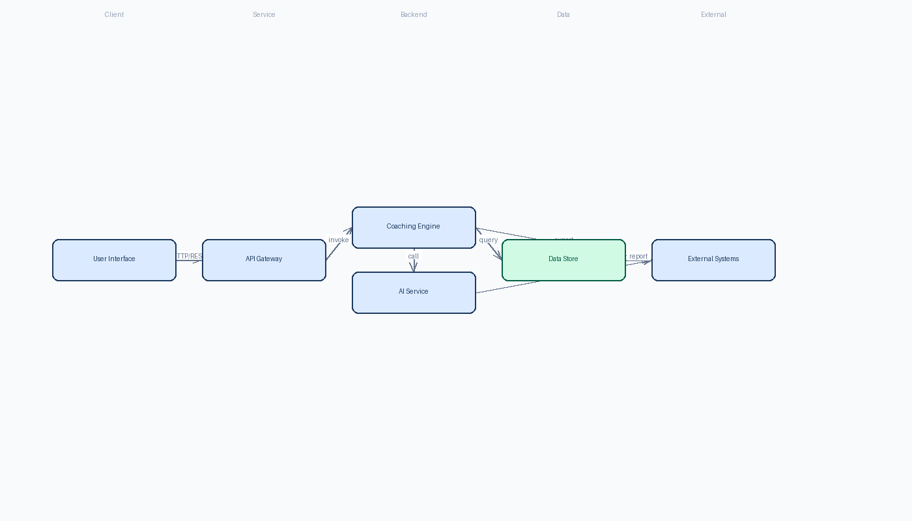

8. Feasibility Assessment
Metric | Rating | Justification
Complexity | High | Multiple managed services and intricate workflow orchestration increase implementation difficulty.
Architecture Confidence | High | Chosen Azure services are proven, compliant, and align with mandatory SSO and audit requirements.
Feasibility Confidence | Medium | Budget and API‑rate limits present uncertainties despite technical viability.

9. Risk Assessment
Risk | Impact | Mitigation Strategy
Azure OpenAI token and Cognitive Search vector query rate limits could be exceeded during bulk document ingestion and high‑frequency coaching sessions. | Service throttling would cause delays in AI responses and ingestion failures, breaking the real‑time coaching and weekly reporting pipelines. | Implement a staged ingestion queue with Azure Service Bus, batch OCR and indexing, and configure APIM throttling policies plus exponential back‑off retries. monitor usage dashboards and negotiate higher quota with Microsoft early in the project.
OCR inaccuracies and duplicate/poorly named PDFs may produce low‑quality searchable text, leading to irrelevant AI context and hallucinated coaching advice. | Incorrect or missed document fragments will reduce coaching relevance, increase manual correction effort, and jeopardize compliance (unaudited content). | Create a pre‑ingest metadata pipeline that de‑duplicates files using hash comparison, enforces a naming convention, and validates OCR confidence scores. Flag low‑confidence pages for manual review before indexing.
Fallback from voice to text in low‑bandwidth stores may not trigger reliably, causing a poor user experience and abandonment of the mobile app. | Associates in locations with spotty connectivity could lose access to coaching, defeating the adoption goal. | Integrate Azure Speech Service with network quality detection on the client side; if latency > threshold, automatically switch UI to text‑only mode and cache audio locally for later upload. Conduct field testing in representative stores before full rollout.

10. Recommendations & Next Steps
Initiate a short‑term discovery sprint to finalize document ingestion pipelines, establish SSO configuration, and prototype the core coaching flow. Assemble a cross‑functional team (Solution Architect, Azure DevOps Engineer, Frontend lead, Mobile lead, Data Engineer, QA). Deliver an MVP covering authentication, document upload with OCR, vector indexing, AI coach interaction, and Monday PDF report generation within 10 weeks. Follow with phased enhancements: advanced analytics, role‑based approval workflow, and broader LMS integration, while continuously monitoring API usage and refining prompts to eliminate hallucinations.
11. Architecture Summary
The hybrid cloud SaaS design leverages Azure's serverless and AI services to meet strict audit, retention, and SSO mandates while keeping operational costs low. By separating the compliance layer (immutable Blob storage and Cosmos DB audit logs) from the scalable coaching engine (Azure Functions, OpenAI, Cognitive Search), the architecture delivers fast, secure, and globally performant experiences for both web and mobile users. This alignment ensures consistent training, reliable analytics, and future‑proof extensibility within the client’s budget and governance constraints.

