Project Consulting Report
Generated on June 22, 2026

1. Executive Summary
This project will deliver an AI‑driven conversational role‑play training platform for sales associates, enabling rapid, on‑demand practice on tablets or computers. Leveraging a multi‑tenant, white‑label SaaS architecture on Microsoft Azure, the solution provides content ingestion, real‑time scoring, and manager dashboards while meeting ISO 27001 and SOC2 compliance. Key decisions include using Azure OpenAI for the LLM engine, React with TypeScript for the UI, and Azure Functions with API Management for a serverless, scalable backend. The recommendation is to proceed with the proposed Azure‑centric design, targeting a pilot MVP by end‑June and full launch before October, staying within the $500k‑$800k budget.
2. Background Summary
The client currently conducts sales training manually, relying on a single trainer to manage 135 accounts, resulting in inconsistent role‑playing experiences and limited visibility into training effectiveness. There is no integration with the POS system, and the organization seeks a low‑cost, AI‑enabled solution that can be quickly piloted and later expanded across multiple partner accounts.
3. Problem / Need Analysis
Problem / Need | Business Impact
Manual, time‑consuming sales training limited to one person handling 135 accounts. | Reduced training coverage, higher labor costs, and slower onboarding of associates.
Inconsistent role‑playing across stores due to thin staffing and lack of expert role‑players. | Variable associate performance and missed sales opportunities.
Difficulty tracking training effectiveness without POS integration, requiring manual metric comparison. | Inability to prove ROI of training programs, leading to uncertain budgeting.
Risk of building a custom solution that may not gain buy‑in or be used by the sales team. | Potential waste of investment and low adoption rates.
Need to keep initial investment low while still delivering functional AI training capabilities. | Budget constraints could limit feature set and delay time‑to‑value.
Rapid evolution of AI technology creates uncertainty about long‑term support and updates. | Future cost and maintenance risk if the platform cannot evolve.
Uncertainty about the existing cloud provider makes early architectural decisions harder. | Potential re‑architecting costs and project delays.

4. Requirements Analysis
Functional Requirements
ID | Requirement
FR-001 | The platform must provide AI‑driven conversational role‑play simulations for sales associates.
FR-002 | Users must be able to upload training content such as brochures, PowerPoint decks, and pitch scripts for the AI to learn from.
FR-003 | The system must generate real‑time scoring and feedback on associate performance.
FR-004 | Managers need a dashboard to view practice frequency, scores, attach‑rate uplift, and individual associate transcripts.
FR-005 | The solution must support difficulty levels and objection‑handling scenarios.
FR-006 | A transcript of each role‑play interaction must be stored and accessible for review.
FR-007 | The MVP must operate as a separate tool without POS integration, using manual comparison for effectiveness.
FR-008 | The platform must be white‑labelable so the client can retain IP and resale it to other partners.
FR-009 | The solution should be duplicable for multiple partner accounts (e.g., Assurant, Amazon, Samsung).
FR-010 | Support basic multimodal input (voice via ElevenLabs, text) for the MVP, with future expansion to audio/video.
FR-011 | The system must be able to run on tablets or computers during short lull periods (3–5 minutes per associate).
FR-012 | Provide a scoring engine that can be tuned by managers to ensure AI evaluation aligns with expert judgment.
FR-013 | Generate reports that correlate associate practice data with ESP attach‑rate metrics.
FR-014 | The platform must be hosted on a cloud environment (preferably Azure) and take advantage of hyperscaler funding programs where possible.
FR-015 | Deliver a proof‑of‑concept with defined KPIs (attach‑rate uplift, practice frequency, score improvement).

Non-Functional Requirements
Category | Requirement
Performance | System must respond to user interactions within 2 seconds for text and 3 seconds for voice synthesis.
Security | Comply with ISO 27001 and SOC2; all secrets stored in Azure Key Vault; data encrypted at rest and in transit.
Scalability | Architecture must handle bursty training sessions from multiple tenants, scaling automatically via Azure Functions and Cosmos DB.
Availability | Achieve 99.9% uptime across all services using Azure regional redundancy and health monitoring.
Maintainability | Infrastructure defined as code (Bicep) to enable repeatable tenant provisioning and easy updates.

Constraints
- Budget for the MVP is approximately $500,000 to $800,000.
- The MVP must be ready for pilot testing by the end of June and support a launch before October.
- Final decision and proposal comparison must be completed by the end of next week.
- No POS system integration is required for the initial proof of concept.
- The solution must comply with ISO 27001 and SOC2 standards as required by the provider.
- The client currently d
Technology Context
- Preferred Cloud: Azure
- Existing CRM: Salesforce
5. Assumptions
- Azure subscription is available and provisioned.
- Client will provide API credentials for third‑party integrations.
- Existing infrastructure remains unchanged during the POC phase.
- Azure OpenAI service quota will be approved before the pilot.
- ElevenLabs API key will be supplied by the client.
6. Feature & Module Breakdown
Module | Feature / Functionality | Technologies Used
Frontend | Responsive UI for role‑play, content upload, scoring feedback, and manager dashboards. | React 18, TypeScript, Azure Static Web Apps, MSAL.js
Backend API | Orchestrates LLM calls, scoring, content ingestion, and tenant routing. | Azure Functions (Node.js 20), Azure API Management
LLM Engine | Generates conversational responses and handles objection scenarios. | Azure OpenAI Service (GPT‑4o mini), Azure AI Studio fine‑tuning
Voice Synthesis | Produces realistic voice output for role‑play interactions. | ElevenLabs REST API, Azure Functions wrapper, Blob Storage cache
Knowledge Ingestion | Parses brochures, PDFs, PowerPoint decks and indexes content for retrieval. | Azure Form Recognizer, Azure AI Document Intelligence, Azure Cognitive Search
Scoring Engine | Evaluates associate responses against configurable rule sets and provides real‑time feedback. | Azure Functions, LangChain (Node), JSON‑based rule engine
Database | Stores tenant‑isolated transcripts, scores, user profiles, and configuration data. | Azure Cosmos DB (SQL API) with per‑tenant containers
Blob Storage | Keeps uploaded training assets and cached audio files. | Azure Blob Storage (Hot tier)
Analytics Dashboard | Provides managers with KPI visualisations, practice frequency, and attach‑rate correlation. | Power BI Embedded, Azure AD B2C authentication
Authentication & Authorization | Multi‑tenant user sign‑in, SSO, and role‑based access control. | Azure AD B2C with custom policies
CI/CD | Automated build, test, and deployment pipelines. | GitHub Actions, Azure CLI, ARM/Bicep templates
Infrastructure as Code | Repeatable provisioning of tenant resources and compliance policies. | Bicep modules, Azure Policy
Security & Compliance | Policy enforcement, secret management, continuous security monitoring. | Azure Policy, Azure Key Vault, Microsoft Defender for Cloud
Monitoring & Logging | Centralised logs, usage metrics, alerts for SLA adherence. | Azure Monitor, Log Analytics workspace
Multi‑Tenancy Strategy | Ensures data isolation and white‑label branding per partner. | Cosmos DB per‑tenant containers, Azure AD B2C tenant‑aware claims

7. Solution Architecture
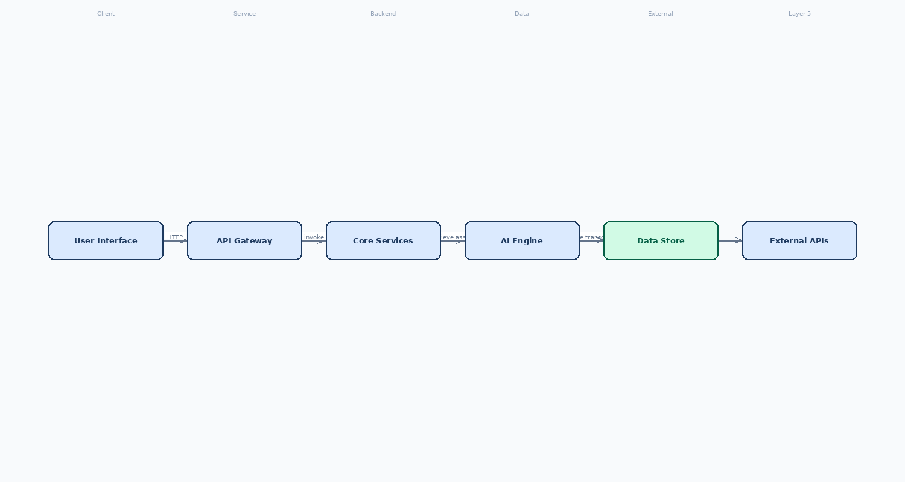

8. Feasibility Assessment
Metric | Rating | Justification
Complexity | Medium | The architecture uses managed Azure services and serverless components, reducing custom code but requires careful tenant provisioning and LLM cost modeling.
Architecture Confidence | High | Azure‑centric design aligns with client expertise, compliance requirements, and funding programs, and leverages proven services.
Feasibility Confidence | Medium | Budget and timeline are realistic, but Azure OpenAI fine‑tuning and Power BI licensing introduce uncertainty.

9. Risk Assessment
Risk | Impact | Mitigation Strategy
Azure OpenAI fine‑tuning latency and pricing uncertainty could exceed budget and delay MVP delivery. | High – core conversational capability may be unavailable or too expensive for pilot scale. | Start with pre‑trained GPT‑4o mini model without fine‑tuning for the pilot, and validate cost using Azure cost calculators; defer custom fine‑tuning to post‑pilot phase.
Multi‑tenant data isolation using Cosmos DB containers and AD B2C claims can become complex to manage at scale, risking data leakage between partners. | Medium – violates IP protection and compliance requirements. | Implement automated Bicep scripts that create a dedicated Cosmos DB database per tenant and enforce strict Azure Policy checks; conduct penetration testing before launch.
Power BI Embedded licensing and per‑tenant workspace provisioning may inflate operational costs and extend the timeline for dashboard rollout. | Medium – manager dashboards could be delayed, reducing proof‑of‑concept KPI visibility. | Use embedded Power BI “App owns data” model with shared capacity for MVP; negotiate volume licensing early and build a fallback custom React charting layer using Azure Monitor metrics if Power BI provisioning stalls.
Dependency on external ElevenLabs API for voice synthesis introduces third‑party availability and latency risks. | Low to Medium – voice output quality is a key feature but can fallback to text‑only. | Cache generated audio files in Blob Storage and define a graceful degradation path to text‑only mode if ElevenLabs response exceeds latency SLA; monitor API health with Azure Monitor alerts.

10. Recommendations & Next Steps
Immediately initiate Azure subscription validation, set up the Azure AD B2C tenant, and spin up a pilot environment using the Bicep IaC scripts. Assemble a cross‑functional delivery team (product owner, AI specialist, front‑end, back‑end, DevOps, security). Follow an MVP‑first approach: deliver core role‑play, content upload, real‑time scoring, and a lightweight manager view by end‑June. Parallelly run cost‑modeling for Azure OpenAI usage and negotiate Power BI licensing. After pilot validation, iterate to add fine‑tuned LLMs, expanded multimodal input, and full Power BI dashboards, outlining a roadmap for Q4 rollout and subsequent partner onboarding.
11. Architecture Summary
The chosen Azure‑centric, serverless multi‑tenant SaaS architecture meets the client’s need for rapid deployment, cost efficiency, and strict compliance. Managed services such as Azure Functions, Cosmos DB, and Azure OpenAI dramatically reduce operational overhead while supporting bursty 3‑5 minute training sessions across many tenants. Azure AD B2C provides secure, white‑label authentication, and Power BI Embedded delivers per‑tenant analytics. This design aligns with business goals of low upfront investment, quick time‑to‑value, and the ability to duplicate the platform for multiple partners.

