Project Consulting Report
Generated on June 22, 2026

1. Executive Summary
The client seeks an AI‑powered conversational role‑play platform to modernize sales associate training across up to 73 stores, with a white‑labelable SaaS offering for future partner expansion. The proposed solution is a multi‑tenant, Azure‑native architecture leveraging React front‑end, NestJS APIs, Azure OpenAI for conversational AI, and Azure services for storage, authentication, and observability. Key decisions include Azure as the cloud provider, Azure AD B2C for secure identity, Cosmos DB for tenant‑scoped data, and an external ElevenLabs TTS integration via Azure Functions. The recommendation is to proceed with the outlined MVP, delivering core training, scoring, and reporting capabilities before the October launch while maintaining compliance and cost transparency.
2. Background Summary
The retailer currently relies on a single expert to conduct role‑playing training, resulting in inconsistent coaching and limited scalability. Manual tracking of attach‑rate improvements and the absence of integrated POS data further hinder performance measurement. The organization needs a repeatable, technology‑driven solution that can be piloted in a test market by June and scaled thereafter.
3. Problem / Need Analysis
Problem / Need | Business Impact
Inconsistent, expert‑driven training across stores | Variable associate performance and missed sales opportunities
Limited associate time for training | Reduced skill development and lower attach‑rate growth
Lack of expert role‑players in many stores | Inability to provide real‑time coaching, impacting sales quality
Cumbersome manual tracking of attach‑rate improvements | Slow insight generation and delayed ROI measurement
No POS integration for MVP | Reliance on manual comparisons, increasing error risk
Uncertainty around cloud costs | Budget overruns and difficulty securing executive buy‑in
Need for proof‑of‑concept before executive commitment | Potential delay in adoption if concept fails to demonstrate value
Potential high recurring costs versus off‑the‑shelf alternatives | Risk of unfavorable total cost of ownership
Requirement to maintain and update AI models | Ongoing operational expense and skill requirements
Need for manager‑level feedback and score validation | Ensures AI assessments are trusted and actionable

4. Requirements Analysis
Functional Requirements
ID | Requirement
FR-001 | Build an AI‑powered conversational role‑play platform for sales training.
FR-002 | Support uploading of training content such as brochures, PowerPoint decks, and pitch scripts.
FR-003 | Provide real‑time scoring, feedback, and transcript logs for each role‑play session.
FR-004 | Track practice frequency, scores, and associate‑level performance metrics.
FR-005 | Generate reports that correlate AI training scores with attach‑rate improvements.
FR-006 | Allow managers to view individual associate activity, scores, and feedback.
FR-007 | Include a mechanism for manager review and adjustment of AI scoring.
FR-008 | Offer difficulty levels and objection‑handling scenarios in the training flow.
FR-009 | Enable white‑labeling so the solution can be sold to other partner accounts.
FR-010 | Support a pilot of up to 73 stores with the ability to scale to additional accounts.
FR-011 | Operate as a standalone tool without POS system integration for the MVP.
FR-012 | Allow occasional (monthly or less) updates to training content during the pilot.
FR-013 | Provide a cost‑transparent deployment on the client’s cloud environment.
FR-014 | Ensure compliance with ISO 27001 and SOC2 standards.
FR-015 | Deliver a proof‑of‑concept MVP within the timeline leading up to an October rollout.

Non-Functional Requirements
Category | Requirement
Performance | Real‑time AI response latency must stay under 2 seconds for scoring and feedback.
Security | All data must comply with ISO 27001 and SOC2; authentication via Azure AD B2C; encryption at rest and in transit.
Scalability | Architecture must support multi‑tenant scaling to 73 stores initially and add further tenants without code changes.
Availability | 99.9% uptime for core training and scoring services using Azure managed services.
Maintainability | Modular codebase with CI/CD pipelines for rapid updates and easy incorporation of new AI models.

Constraints
- Budget is limited to approximately 500‑800K USD.
- Initial MVP must be delivered before an October product launch, with a test market in June.
- Client expects a proposal by the end of next week and a decision shortly thereafter.
- No POS integration is to be included in the initial proof‑of‑concept.
- Content updates are expected only infrequently (approximately monthly).
- Solution must be white‑labelable for reuse across multiple partner accounts.
- Vendor must adhere to ISO 27001 and SOC2 compliance requirements.
Business Goals
- Accelerate associate skill development while reducing reliance on a single expert.
- Demonstrate measurable impact on attach‑rate through data‑driven reporting.
Technology Context
- Preferred Cloud: Azure
- Existing CRM: Salesforce
5. Assumptions
- Azure subscription is available and provisioned.
- Client will provide API credentials for third‑party integrations.
- Existing infrastructure remains unchanged during the POC phase.
6. Feature & Module Breakdown
Module | Feature / Functionality | Technologies Used
Frontend | User interface for login, training sessions, score display, and manager dashboards. | React 18, Vite, Azure Static Web Apps
Backend API | RESTful services for authentication, content management, session orchestration, and scoring. | NestJS (Node.js 20), Azure Container Apps
Authentication & Authorization | Secure sign‑in, role‑based access, tenant isolation. | Azure AD B2C, OAuth2/OIDC
Database | Tenant‑scoped metadata, user profiles, session logs. | Azure Cosmos DB (Core SQL API), Azure SQL Managed Instance
Blob Storage | Storage of training assets and session recordings. | Azure Blob Storage (Hot tier)
AI Engine | Conversational role‑play, embeddings, scoring logic. | Azure OpenAI Service (GPT‑4o), Azure Speech Service (STT), ElevenLabs API via Azure Functions
Orchestration | Content approval workflow, manager review flow. | Azure Logic Apps
CI/CD | Automated build, test, and deployment pipelines. | Azure DevOps Pipelines, Azure Container Registry
Monitoring & Observability | Application health, performance metrics, security alerts. | Azure Monitor, Application Insights

7. Solution Architecture
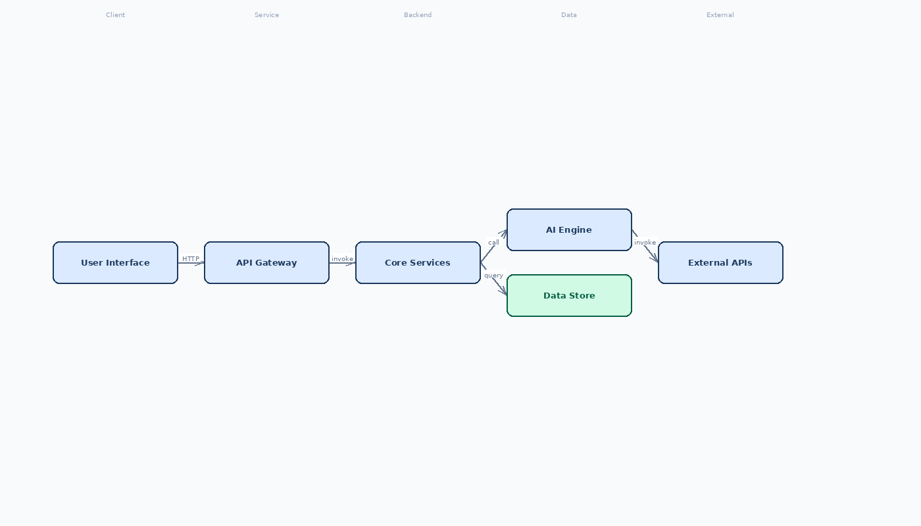

8. Feasibility Assessment
Metric | Rating | Justification
Complexity | Medium | Reliance on Azure Container Apps and Logic Apps adds moderate complexity for a small team.
Architecture Confidence | High | Azure native services meet compliance, multi‑tenant needs, and budget constraints.
Feasibility Confidence | Medium | External ElevenLabs TTS and OpenAI token limits introduce modest risk that requires mitigation.

9. Risk Assessment
Risk | Impact | Mitigation Strategy
External ElevenLabs TTS calls via Azure Functions may breach data residency/compliance constraints and add latency. | Potential non‑compliance with ISO 27001/SOC2 and degraded user experience during real‑time role‑play. | Implement a proxy Function that encrypts payloads, logs audit trails, and evaluate Azure Speech TTS as a fallback; negotiate a data processing addendum with ElevenLabs.
Multi‑tenant data isolation using Cosmos DB and Azure AD B2C can be misconfigured, leading to cross‑tenant data leakage. | Violation of privacy expectations and loss of trust, especially for white‑labeled partners. | Enforce tenant‑level RBAC policies, use Cosmos DB partition keys per tenant, and add automated security tests in CI pipeline to verify isolation.
Azure OpenAI token limits and request latency may become bottlenecks when dozens of stores run concurrent role‑play sessions. | Reduced real‑time scoring accuracy and possible service throttling, impacting pilot performance metrics. | Design async processing with queue (Azure Service Bus) for non‑critical scoring, provision higher RUs or reserved capacity for OpenAI, and conduct load testing prior to October rollout.

10. Recommendations & Next Steps
Immediately refine the proposal to address the identified risks and submit it by the end of next week. Assemble a cross‑functional delivery team comprising a solution architect, lead frontend and backend developers, an AI specialist, and a DevOps engineer. Adopt an MVP approach that delivers core role‑play, scoring, and reporting features for the pilot stores, with a staged rollout: June pilot, August feedback incorporation, and full October launch. Establish a two‑week sprint cadence, set up Azure DevOps pipelines, and begin environment provisioning. Post‑MVP, prioritize adding optional multimodal processing, optional POS integration, and expanding the white‑label partner onboarding workflow.
11. Architecture Summary
The Azure‑native multi‑tenant SaaS design was chosen because it aligns with the client’s existing Azure expertise, meets ISO 27001 and SOC2 compliance, and provides cost‑transparent consumption. Azure AD B2C handles secure, scalable identity without custom code; Cosmos DB ensures isolated tenant data while Azure SQL supports rich reporting. Leveraging Azure OpenAI and Speech services delivers the AI capabilities required for real‑time coaching, and the modular container‑based backend simplifies future feature expansion. This architecture directly supports the business goals of rapid associate upskilling and measurable sales impact while staying within budget and timeline constraints.

