Project Consulting Report
Generated on June 18, 2026

1. Executive Summary
The project aims to deliver an AI‑powered conversational training platform that enables sales associates to practice role‑play scenarios during downtime, capture performance data, and provide actionable scores to improve upsell attach rates. The proposed solution is an Azure‑based serverless web application leveraging Azure OpenAI, Azure AD B2C, and 11 Labs TTS, with a lean MVP architecture that meets the client’s budget ($500K‑$800K) and timeline constraints (test market by end of June, rollout in Q4). Key decisions include using Azure Static Web Apps for the frontend, Azure App Service (or Functions) for the backend API, and Azure services for storage, analytics, and CI/CD, while avoiding over‑engineering and ensuring duplicability across partner accounts. The recommendation is to proceed with the MVP using the approved Azure stack, incorporate the defined scoring and manager dashboard, and validate cost versus build/buy options early.
2. Background Summary
The client currently relies on a single trainer to manage role‑play training for 135 accounts, resulting in inconsistent coaching, limited feedback, and missed opportunities during lull periods on the sales floor. Existing processes lack automated tracking, scoring, and scalable content management, driving the need for a modern, AI‑driven solution that can be quickly piloted and duplicated across partners.
3. Problem / Need Analysis
Problem / Need | Business Impact
Limited training capacity due to being only one person responsible for 135 accounts | Bottlenecks in skill development, slower sales performance, higher training costs
Inconsistent role-play training because stores are thinly staffed and managers are asked to do 100 things | Variable associate competency, uneven customer experience
Sales associates lack time for consistent role‑playing practice as they must get right on the floor | Missed skill reinforcement, lower attach rates
Missed opportunity to use lull periods on sales floor for training | Inefficient use of downtime, reduced productivity
Current training frequency is insufficient | Slower learning curves, lower sales conversion
Lack of detailed feedback/transcripts for coaching and manager oversight | Limited ability to track improvement and provide targeted coaching
Need for manager validation of AI scoring accuracy | Risk of unreliable performance metrics, low user trust
Desire to avoid building an elaborate solution that won't get used or buy‑in | Potential waste of resources and low adoption
Uncertainty about current cloud provider hindering technology strategy decisions | Delays in architecture selection and procurement
Need to evaluate build vs. buy/white label options before making investment decision | Risk of sub‑optimal spend and longer time‑to‑market

4. Requirements Analysis
Functional Requirements
ID | Requirement
FR-001 | AI-powered conversational platform for sales role-play training
FR-002 | Enable sales associates to practice role-playing scenarios during lull periods
FR-003 | Track practice frequency and consistency of training usage
FR-004 | Provide scoring system for role-play performance improvement
FR-005 | Ability to upload training content including brochure data, PowerPoint presentations, and sales pitches
FR-006 | Knowledge base that can be updated periodically (monthly/bi-monthly)
FR-007 | Reporting capabilities for individual sales associate and store-level performance metrics
FR-008 | Track attach rates (ESP upsell) as primary effectiveness metric
FR-009 | Support multiple difficulty levels for role‑play scenarios

Non-Functional Requirements
Category | Requirement
Performance | Low latency response for AI and TTS to support brief practice sessions during floor lull periods
Security | Secure authentication via Azure AD B2C and JWT token validation for all API calls
Scalability | Serverless components must scale automatically to handle variable usage across accounts
Cost | Solution must stay within $500K‑$800K budget, using pay‑per‑use services and avoiding over‑provisioned resources
Availability | 99.9% uptime for the web app during pilot and rollout phases

Constraints
- Budget range of $500K-$800K mentioned as 'a good budget like 500 to 100, 800 K'
- Timeline: Test market by end of June, official rollout in Q4 (October timeframe)
- No POS integration for initial POC - manual comparison will be made for effectiveness measurement
- Explicit goal to 'keep the cost down' for the solution
- Requirement for proof of concept before full investment to avoid building unused elaborate solution
- Need to evaluate build vs. buy/white label options for cost comparison
- Target to present proposals to management for decision by end of next week
- Currently uncertain about cloud provider (AWS or other) requiring discovery
- Preference for lean/basic MVP: 'Nothing elaborate and just basic'
- Avoid over-engineering that wouldn't get user buy-in or adoption
- Requirement for duplicatable solution across partner accounts: 'hey, it works in this account, let's duplicate the same thing in the other account'
- Need for IP rights to market/sell solution to potential partners: 'we are looking for only the IP so we could, you know, be able to market it to our potential partners'
- Plan to start with basic model and add partner-specific features: 'only difference would be if the particular partner would want some additional features'
Technology Context
- Preferred Cloud: Azure
- Existing CRM: Salesforce
5. Assumptions
- Azure subscription is available and provisioned.
- Client will provide API credentials for third-party integrations.
- Existing infrastructure remains unchanged during the POC phase.
- Azure OpenAI Service and 11 Labs voice API are accessible and budgeted per usage.
- Partner accounts will use the same multi‑tenant Azure AD B2C tenant for authentication.
6. Feature & Module Breakdown
Module | Feature / Functionality | Technologies Used
Frontend | SPA UI for scenario selection, conversation view, and score display | Azure Static Web Apps, JavaScript/TypeScript, React
Backend API | Orchestrates AI calls, scoring logic, session persistence, and metric logging | Azure App Service (Standard S1) or Azure Functions (Consumption), .NET Core
Authentication | User sign‑up, sign‑in, multi‑tenant management | Azure Active Directory B2C
Database | Stores user profiles, session transcripts, scores | Azure SQL Database (serverless tier)
Integration Layer | Exports practice metrics to existing attach‑rate reporting system | Azure Logic Apps
Content Storage | Hosts scenario assets, PowerPoints, brochures | Azure Blob Storage
AI Engine | Generates conversational responses and evaluates user input | Azure OpenAI Service (GPT‑4)
Voice Service | Text‑to‑speech for AI responses | 11 Labs API
DevOps / CI‑CD | Automated build, test, and deployment pipelines | Azure DevOps Pipelines
Analytics & Reporting | Collects usage telemetry, provides dashboards for managers | Azure Application Insights, Azure Data Explorer (optional), Power BI

7. Solution Architecture
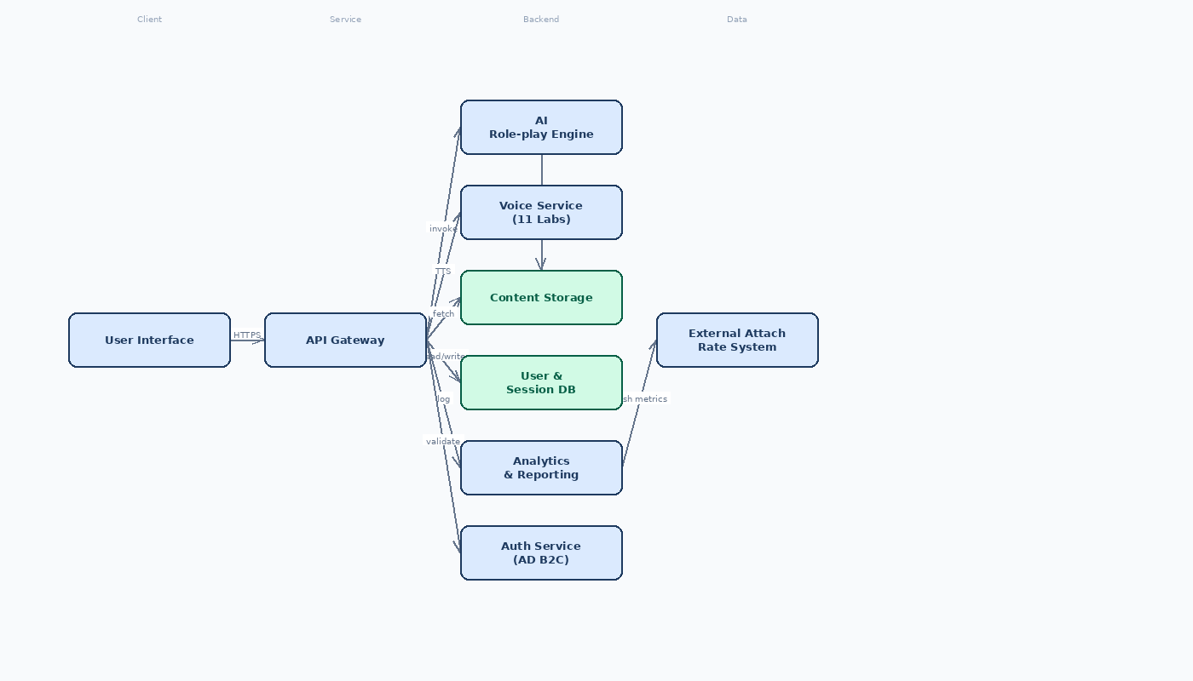

8. Feasibility Assessment
Metric | Rating | Justification
Complexity | Medium | Architecture uses managed Azure services; MVP scope limits custom code.
Architecture Confidence | Medium | Proposed Azure stack aligns with client preferences but includes components that may be over‑engineered for MVP.
Feasibility Confidence | Medium | Schedule pressure for June test market and need for scoring/manager UI are critical gaps but mitigatable.

9. Risk Assessment
Risk | Impact | Mitigation Strategy
Azure Data Explorer and Azure App Service Standard S1 may lead to excessive operational costs during the test phase, potentially exceeding the $500K-$800K budget. | Budget overrun could jeopardize the project's approval for full rollout and limit funds for future enhancements. | Replace Azure Data Explorer with a cost-effective analytics pipeline using Application Insights export to Azure Blob Storage and Azure Synapse serverless for querying. Shift the backend to Azure Functions (Consumption plan) to eliminate fixed costs and scale to zero during idle periods.
The architecture lacks a defined scoring mechanism for role-play performance and a manager interface for validating AI scores and reviewing transcripts, which are explicit requirements. | Without these features, the solution cannot meet the core objectives of providing performance improvement tracking and manager oversight, reducing its effectiveness and adoption. | Define a clear scoring rubric in the API backend that evaluates user responses against scenario objectives. Develop a simple manager dashboard (using Azure Static Web Apps or Power BI) to view session transcripts, AI scores, and provide manual feedback or overrides.
Dependency on third-party voice service (11 Labs) introduces latency and cost variability risks, which could degrade user experience during brief sales floor lull periods and lead to unexpected expenses. | High latency may make the tool impractical for quick practice sessions, while variable usage could cause costs to spiral, undermining the cost-effectiveness goal. | Implement response caching for common AI utterances to reduce 11 Labs calls. Set up usage monitoring with automatic alerts for cost and latency thresholds. Evaluate Azure Cognitive Services Text-to-Speech as a lower-cost, lower-latency fallback option.

10. Recommendations & Next Steps
Begin immediate proof‑of‑concept work by validating Azure OpenAI and 11 Labs integration (Task A.1) and establishing the Azure DevOps CI/CD pipeline (Task A.0). Assemble a cross‑functional team with a technical lead, AI/ML specialist, backend and frontend developers, and a security officer. Deliver an MVP that includes scenario selection, voice‑enabled conversation, basic scoring, and a simple manager view within the June test‑market deadline. Follow with a phased rollout plan: pilot in July, incorporate feedback, add partner‑specific extensions, and prepare a full‑scale Q4 launch with enhanced analytics and optional POS integration. Throughout, monitor cost metrics and adjust architecture (e.g., move to Functions) to stay within the $500K‑$800K budget.
11. Architecture Summary
The selected Azure‑based serverless architecture delivers a low‑cost, globally accessible web app that meets the core training, scoring, and reporting needs while respecting budget and timeline constraints. Managed services such as Azure Static Web Apps, Azure AD B2C, and Azure OpenAI provide rapid development and enterprise‑grade security, and the modular design (frontend, API, AI engine, voice, storage, analytics) ensures the solution can be duplicated across partner accounts and extended with partner‑specific features without re‑architecting. This alignment of technology with business goals—speed to market, cost control, and scalability—supports the client’s objective of a lean MVP that can be validated quickly and scaled for broader adoption.

