

**SCHOOL OF COMPUTER SCIENCE AND ENGINEERING**

REPORT OF THE PROJECT FOR CSE326

TITLE: PROPERTY WEBSITE

Submitted to Lovely Professional University

In partial fulfilment of the requirement for the

“CONTINUOS ASSESMENT “

Submitted By

|  |  |  |
| --- | --- | --- |
| SECTION : K19HZ | | |
| Roll Number | Name | Registration No |
| 01 | K.Kondanda Ramarao | 11910022 |
| 02 | Vrinda Aggarwal | 11910042 |
| 03 | G.Nikita | 11910045 |

Submitted to

Manu Bali-UID 25722

**TABLE OF CONTENTS**

1. Introduction.
2. Project Description
3. Concept used
4. Project implementation
5. Screenshots of website
6. Work done by team member

**HTML**

[HTML elements](https://en.wikipedia.org/wiki/HTML_element) are the building blocks of HTML pages. With HTML constructs, [images](https://en.wikipedia.org/wiki/HTML_element#Images_and_objects) and other objects such as [interactive forms](https://en.wikipedia.org/wiki/Fieldset) may be embedded into the rendered page. HTML provides a means to create [structured documents](https://en.wikipedia.org/wiki/Structured_document) by denoting structural [semantics](https://en.wikipedia.org/wiki/Semantics) for text such as headings, paragraphs, lists, [links](https://en.wikipedia.org/wiki/Hyperlink), quotes and other items. HTML elements are delineated by *tags*, written using [angle brackets](https://en.wikipedia.org/wiki/Bracket#Angle_brackets). Tags such as <**img** /> and <**input** /> directly introduce content into the page. Other tags such as <**p**> surround and provide information about document text and may include other tags as sub-elements. Browsers do not display the HTML tags, but use them to interpret the content of the page.

**CSS**

CSS is designed to enable the separation of presentation and content, including [layout](https://en.wikipedia.org/wiki/Page_layout), [colors](https://en.wikipedia.org/wiki/Color), and [fonts](https://en.wikipedia.org/wiki/Typeface).[[3]](https://en.wikipedia.org/wiki/Cascading_Style_Sheets#cite_note-3) This separation can improve content [accessibility](https://en.wikipedia.org/wiki/Accessibility), provide more flexibility and control in the specification of presentation characteristics, enable multiple [web pages](https://en.wikipedia.org/wiki/Web_page) to share formatting by specifying the relevant CSS in a separate .css file, and reduce complexity and repetition in the structural content.

**JAVA SCRIPT**

As a multi-paradigm language, JavaScript supports [event-driven](https://en.wikipedia.org/wiki/Event-driven_programming), [functional](https://en.wikipedia.org/wiki/Functional_programming), and [imperative](https://en.wikipedia.org/wiki/Imperative_programming) [programming styles](https://en.wikipedia.org/wiki/Programming_paradigm). It has [application programming interfaces](https://en.wikipedia.org/wiki/Application_programming_interface) (APIs) for working with text, dates, [regular expressions](https://en.wikipedia.org/wiki/Regular_expression), standard [data structures](https://en.wikipedia.org/wiki/Data_structure), and the [Document Object Model](https://en.wikipedia.org/wiki/Document_Object_Model) (DOM). However, the language itself does not include any [input/output](https://en.wikipedia.org/wiki/Input/output) (I/O), such as [networking](https://en.wikipedia.org/wiki/Computer_network), [storage](https://en.wikipedia.org/wiki/Data_storage), or [graphics](https://en.wikipedia.org/wiki/Computer_graphics) facilities, as the host environment (usually a web browser) provides those APIs.

**INTRODUCTION**

This is a small project on the Real Estate. The basic idea is that customer can view a wide range of properties at our website, select a particular location.

The user can create their account by using sign up button, and then login using login button.

The user can add filters by choosing location, property type and budget.

Also the user can post property for rent or sale for free.

The user can contact us by clicking on Contact Us button. There he can enter his name and email id and write his message or query and contact us.

This website is very useful and customer friendly and allows easy access to the property and its details.

**PROJECT DESCRIPTION**

This project is basically based on HTML, CSS and Javascript. It covers all the modules like

BUY, RENT, SELL, CONTACT US and SIGN UP.

In this project there are four sections.

First section contains name of website on the left and on the right we have buy, rent, sell, contact us, login, sign up and post property buttons.

Second section contains background image and filters like location, property type, and budget.

Third section contains the project gallery which contains pictures of property and their details.

Fourth section contains information about our website and why we are the most preferred choice.

**CONCEPT USED**

NAME OF TAG & DESCRIPTION

|  |  |
| --- | --- |
| <!DOCTYPE> | This is the document type tag, which is actually not a tag, but a declaration of the version of HTML that is used. It is to help the browser understand the version and type of web page, without which the browser would not be able to even recognize the webpage. The document type tag does not have an end tag. |
| <a> | The anchor tag, as this tag is called, interconnects two pages (unidirectional) with the help of a page address. The link of the interconnected page needs to be inserted as part of the href attribute, which makes the text accessible, and directs you to the said page on clicking the linked text. |

|  |  |
| --- | --- |
| <b> | The bold tag is used, as the name suggests, to make text bold, or stand out from other text on a webpage. Similar to the bold effect found in most word processing programs. |
| <body> | The body tag displays all the content of an HTML document, such as text, hyperlinks, images, tables, lists, etc. |
| <br> | This tag lets you add a line break to the text. It puts anything that comes after it on a new line. The line break tag is an empty tag, meaning it has no end tag. |
| <button> | The button tag defines a clickable button. Inside this tag you can put content, like text or images. |

|  |  |
| --- | --- |
| <form> | The form tag is one of the most important aspects of interactive pages. It is used to create an HTML form for user input. |
| <head> | As the name states, the head tag is mainly responsible for the functioning of the body. The head tag includes all the script and style elements, and must include a title for the document |
| <header> | The header tag specifies a header for a document or section. The header element should be used as a container for introductory content or a set of navigational links. |
| <h1> to <h6> | The h1 to h6 tags are used to define HTML headings. They add highlight and font style to let the heading of the section stand out. h1 defines the most important heading, while h6 defines the least important. |
| <hr> | The hr tag defines a thematic break in an HTML page (e.g., a shift of topic). |
| <html> | The HTML tag tells the browser that this is an HTML document. This tag is the container for all other HTML elements (except for the <!DOCTYPE> tag). |
| <input> | As the name suggests, an author can accept inputs from users making a page interactive, using this tag. It is used within the form tag. |
| <option> | This tag creates the items for selection in the drop down list, i.e., options to be selected from the select tag. |
| <p> | The p tag defines a paragraph on the page. |

|  |  |
| --- | --- |
| <script> | The script tag enables the author to insert scripting language into document, such as JavaScript. This tag lets you validate, manipulate, and affect content dynamically. |
| <Table> | The table tag is one of the most important aspects of interactive pages. It is used to create an HTML table for user input |
| <tr> | The tr tag is used to add table rows in a table |
| <td> | The td tag is used to enter table data int the rows of a table. |
| <div> | The div tag is used to divide page into different sections. |

**SCREEN LAYOUTS**

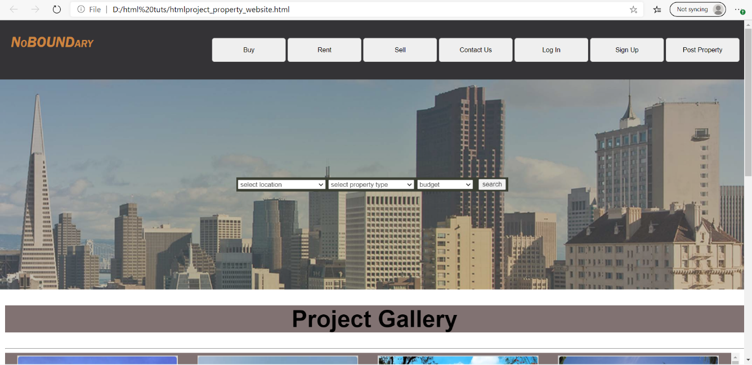

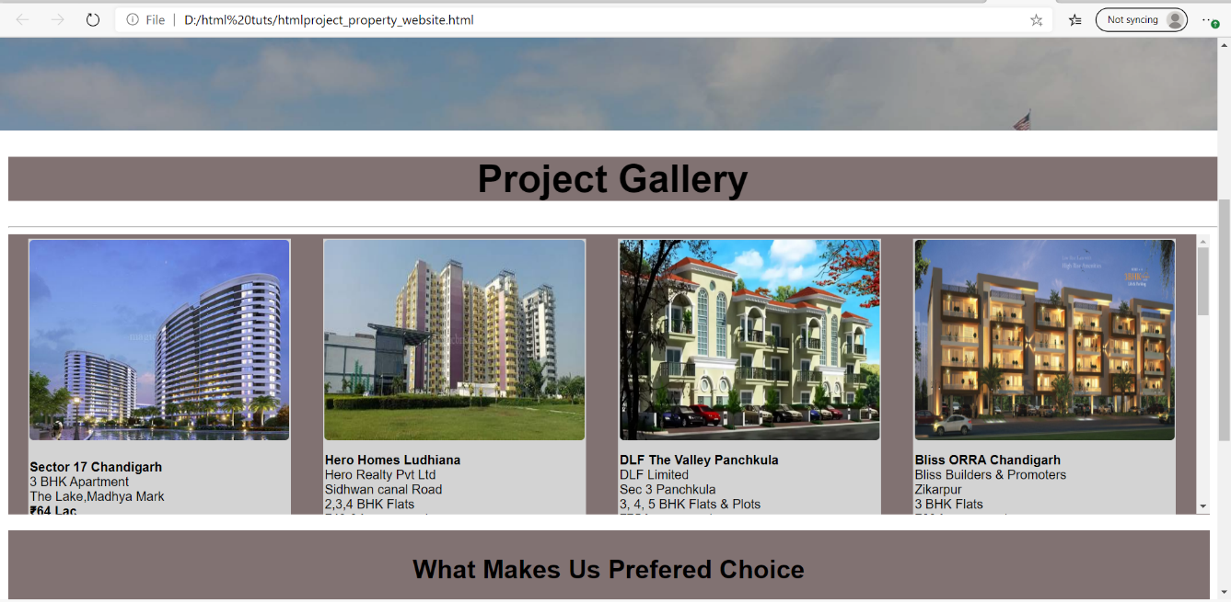

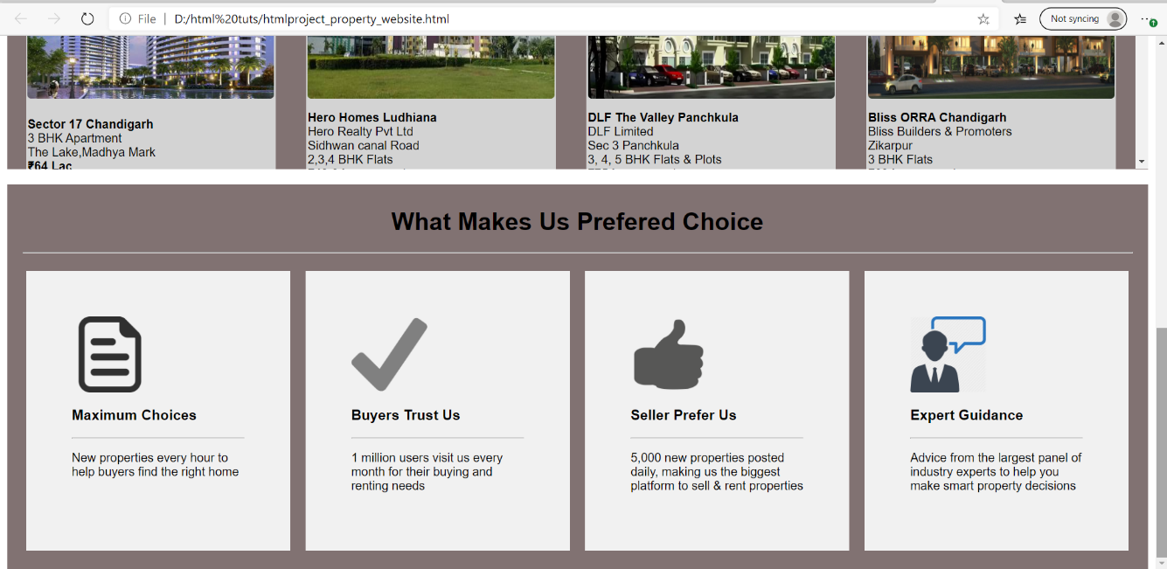

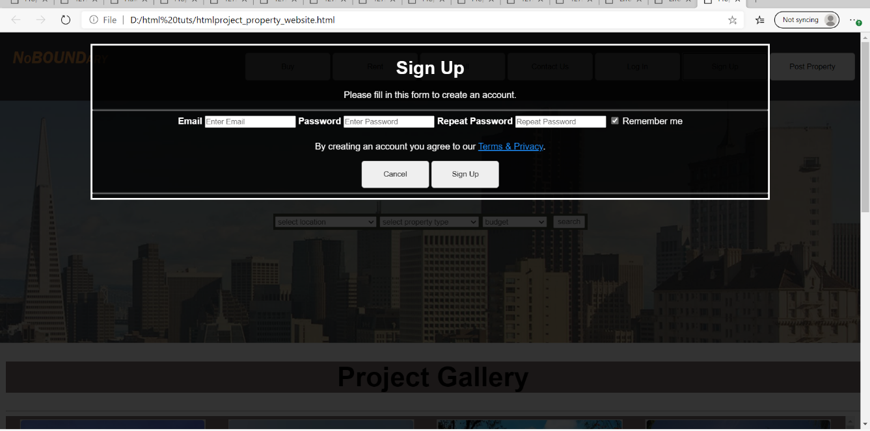

**TEAM WORK**

BY

**K.KODANDA RAMARAO**

I designed the selectors in the second section and added CSS to the whole code, designing of the buttons and modal forms.

**Vrinda Aggarwal**

I designed all the fronted page like adding logo add all the button and use javascrpit to call the function to perform any action like for login page, signup page, contact us, post property, buy, rent, sell and helped Nikita to design the fourth section of the website.

**G.Nikita**

I designed the photo gallery that is the third section of the website and added the details of the property and also designed the fourth section i.e. it contains the information about our website.