Analysis of Finite Word Length Effects and Coefficient Quantization on Fixed-Point IIR Filter Stability
Vrinda Pandey  School of Electronics Engineering  Vellore Institute of Technology  Vellore, India  Reg. No. 25BVD0126 | Ayush Krishna Balabadra  School of Electronics Engineering  Vellore Institute of Technology  Vellore, India  Reg. No. 25BVD0112

Abstract—Digital filters built in fixed-point hardware must store their coefficients in registers of limited width. This paper studies how rounding the coefficients of a recursive (IIR) filter changes its poles, zeros, frequency response, stability and output accuracy. A fourth-order Butterworth low-pass filter (sampling frequency 10 kHz, cutoff 1 kHz) was designed in MATLAB with the bilinear transform and its coefficients were rounded to 16 and 8 bits. The largest pole radius moved only from 0.7954 to 0.7955 and 0.7968, so both filters stayed stable, but the repeated zero at z = −1 split apart and the 8-bit filter lost its stopband null; the signal-to-quantization-noise ratio (SQNR) was 69.32 dB and 41.01 dB. When the integer bits were also counted, a 16-bit direct form reached only about 58.4 dB and became unstable at 4 and 5 bits, whereas a cascade of two biquads stayed stable at every word length and reached 83.11 dB. The cascade was implemented on a Cyclone IV E FPGA in 16-bit fixed point with one shared multiplier. It matched a bit-accurate model on 1,501 simulated samples, reached 79.31 dB SQNR, used 541 logic elements and met timing at 50 MHz with +12.646 ns slack. The same trade-off is shown for a small neural network, whose accuracy stayed at 97.81% with 4-bit integer weights but collapsed below 4 bits.
Index Terms—finite word length, coefficient quantization, IIR filter, Butterworth filter, fixed-point arithmetic, FPGA, SQNR, weight quantization.
I. Introduction
Digital filters are designed on computers that use 64-bit floating-point numbers, but they are often built in fixed-point hardware such as FPGAs, microcontrollers and DSP processors, where every coefficient and sample is stored in 8 to 16 bits [1], [2]. Rounding the coefficients changes the filter that is actually built. In a recursive (IIR) filter the poles can move onto or outside the unit circle, and then the filter is unstable [1], [3].
These finite word length effects are described in textbooks [1]–[3] and in early papers [4]–[7], but their size depends on the filter, on the realization structure and on the number of integer bits. In this paper we measure them for a fourth-order Butterworth low-pass filter and then check the conclusions on an FPGA. The same rounding idea is used today in machine learning, where networks are stored with 8 or even 4 bits [8]–[12], so we also report a short experiment on a small neural network.
The main contributions are: (i) the pole-zero drift, frequency response and SQNR of the filter with 16-bit and 8-bit coefficients; (ii) a word-length sweep that counts the integer bits and compares the direct form with a cascade of biquads; (iii) a 16-bit fixed-point FPGA implementation of the cascade, verified by simulation, timing analysis and a board demonstration; and (iv) a weight-quantization experiment on a CNN.
II. Theory
A. IIR Filters and Stability
A causal IIR filter of order four has the transfer function (1) and the difference equation (2), where b_{k} and a_{k} are the coefficients, a₀ = 1, and the sums run over k = 0 to 4 in the numerator and k = 1 to 4 in the denominator.
H(z) = Σ b_{k}z^{−k} / (1 + Σ a_{k}z^{−k}) (1)
y[n] = Σ b_{k} x[n−k] − Σ a_{k} y[n−k] (2)
The filter is bounded-input bounded-output (BIBO) stable if and only if every pole lies inside the unit circle, that is, max|p| < 1. We call 1 − max|p| the stability margin.
B. Butterworth Design by the Bilinear Transform
The analog Butterworth response [13] in (3) is flat in the passband and −3 dB at the cutoff Ω_{c}. The bilinear transform s = (2/T)(z − 1)/(z + 1) maps the left half of the s-plane into the unit circle, so a stable analog filter gives a stable digital filter. Because the transform warps the frequency axis, the cutoff is pre-warped with (4), which gives Ω_{a} = 6498 rad/s for f_{c} = 1 kHz and f_{s} = 10 kHz. The four analog zeros at infinity become four zeros at z = −1.
|H(jΩ)|² = 1 / (1 + (Ω/Ω_{c})^{2N}) (3)
Ω_{a} = (2/T) tan(Ω_{c}T / 2) (4)
C. Fixed-Point Quantization
In Qm.n format a word has m integer bits (including the sign) and n fractional bits. The step is 2^{−n} and rounding to the nearest step gives a maximum error of 2^{−(n+1)}. A root of multiplicity m moves by about ε^{1/m} when a coefficient has an error ε, so a repeated zero is much more sensitive than poles that are well apart. In the direct form every pole depends on all the denominator coefficients. In a cascade of second-order sections (biquads) each section holds one pole pair, so rounding only affects its own pair, and the coefficients are smaller, which needs fewer integer bits [1], [3], [4].
D. Signal-to-Quantization-Noise Ratio
We measure accuracy with (5), where y_{ideal} is the output of the 64-bit filter and y_{q} is the output of the rounded filter for the same input. Each 6.02 dB corresponds to about one bit.
SQNR = 10 log₁₀ ( Σ y_{ideal}²[n] / Σ (y_{ideal}[n] − y_{q}[n])² ) (5)
III. Methods
A. MATLAB Study
The filter (f_{s} = 10 kHz, f_{c} = 1 kHz) was designed with pre-warping and the bilinear transform. The coefficients were rounded with round(x·2^{n})/2^{n}, using n = 15 for 16-bit and n = 7 for 8-bit. The poles and zeros were found with the roots function and the frequency response was calculated at 1024 frequencies from 0 to 5 kHz. The test signal was a 400 Hz tone (amplitude 1), a 3 kHz tone (amplitude 0.5) and Gaussian noise (standard deviation 0.2), 501 samples long.
B. Word-Length Sweep
The rounding above models only the step size and not the range of the number format: a₁ = −2.37 and a₂ = 2.31 do not fit in a Q1.15 word. We therefore also counted the integer bits. The direct form was rounded to Q3.(B−3) and a cascade of two biquads to Q2.(B−2) for B = 4 to 16 bits. The SQNR was averaged over 20 noise runs, using 64-bit arithmetic so that only the coefficients were rounded.
C. FPGA Implementation
The cascade was written in Verilog as two Direct Form I biquads with Q1.15 data, Q2.14 coefficients, a 36-bit accumulator, round-to-nearest, saturation and one shared 16 × 16 multiplier (3 clock cycles per tap, 33 per sample), as shown in Fig. 1. A top level makes a 10 kHz sample tick from the 50 MHz clock and a two-tone input, 0.5 sin at 400 Hz plus 0.25 sin at 3 kHz, from phase accumulators and a sine ROM. The tones are scaled down because the first biquad has a peak gain of 1.26 near 848 Hz, so a full-scale input could overflow [7]. The design was simulated in Icarus Verilog, compared with an independent bit-accurate Python model, compiled in Quartus Prime 25.1std.0 for the Cyclone IV E EP4CE115F29C7 on a Terasic DE2-115 board with a 20 ns clock constraint [14]–[16], and programmed onto the board.
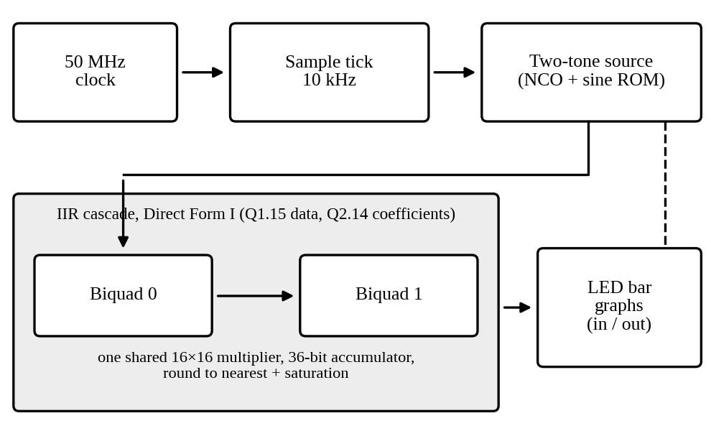
Fig. 1. Block diagram of the FPGA design.
D. CNN Weight Quantization
A CNN with 24,298 parameters (two 3 × 3 convolution layers with 8 and 16 channels, 2 × 2 pooling and one fully connected layer) was trained on MNIST [17] in FP32 with PyTorch [18]. It reached 97.89% test accuracy. The weights and biases were then rounded to FP16 [19], to FP8 (E4M3 and E5M2 [20]) or to signed integers of 2 to 8 bits with one scale per tensor, converted back to FP32 and tested on the 10,000 test images.
IV. Results and Discussion
A. Coefficient Quantization
Table I compares the coefficients. The largest 16-bit error is 1.5×10⁻⁵ (half a step) and the largest 8-bit error is 3.7×10⁻³. The numerator ratio 1:4:6:4:1 becomes 1:2:4:2:1 at 8 bits, and the DC gain stays exactly 0 dB. The small numerator coefficients have the largest relative errors (up to +62%).
TABLE I
Ideal and rounded coefficients
Coeff. | Ideal | 16-bit | 8-bit | 8-bit error
b0 = b4 | 0.0048243 | 0.0048218 | 0.0078125 | +62%
b1 = b3 | 0.019297 | 0.019287 | 0.015625 | −19%
b2 | 0.028946 | 0.028961 | 0.03125 | +8%
a1 | −2.3695 | −2.3695 | −2.3672 | 0.10%
a2 | 2.3140 | 2.3140 | 2.3125 | 0.06%
a3 | −1.0547 | −1.0547 | −1.0547 | 0.002%
a4 | 0.18738 | 0.18738 | 0.1875 | 0.06%

All three filters are stable (Table II). The poles move by at most 0.0013, but the four zeros at z = −1 split into reciprocal pairs, one inside and one outside the unit circle (Fig. 2). As a result the 8-bit response levels off near −54 dB above 3 kHz because the null at the Nyquist frequency is lost (Fig. 3), whereas the 16-bit response cannot be told apart from the ideal one. The −3 dB point stays at 1 kHz. The 8-bit error repeats at the 400 Hz period, so it is a fixed gain and phase error caused by the changed transfer function and not random noise. A Python repeat with three noise seeds gave 69.3 dB (16-bit) and 41.0 to 41.2 dB (8-bit), which agrees with MATLAB.
TABLE II
Pole-zero drift and accuracy
Measure | Ideal | 16-bit | 8-bit
Max pole radius | 0.7954 | 0.7955 | 0.7968
Stability margin | 0.2046 | 0.2045 | 0.2032
Zero radii | 1 (×4) | 1.22, 0.82 | 1.70, 0.59
Gain at 1 kHz (dB) | −3.01 | −3.01 | −3.22
Gain at 5 kHz (dB) | null | −107 | −52.9
SQNR (dB) | – | 69.32 | 41.01
Peak output error | – | ±0.0004 | ±0.0125
Gain at 400 Hz | 0.9997 | 0.9995 | 0.9937

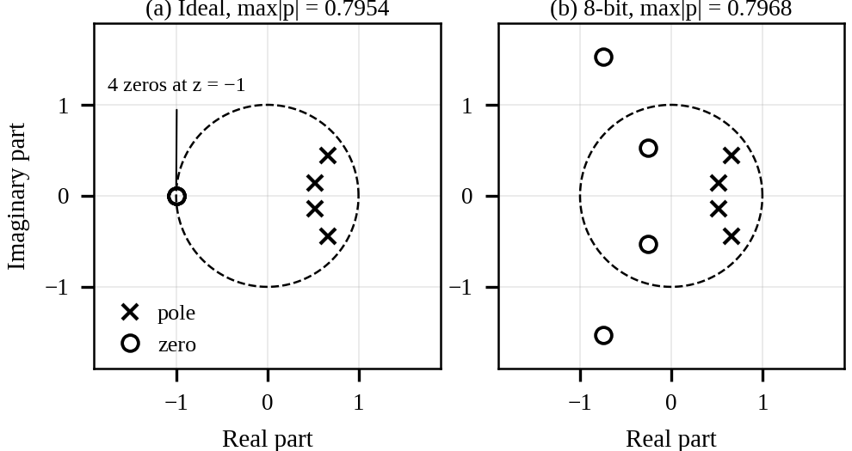
Fig. 2. Pole-zero plots of the ideal and 8-bit filters. The outer pair of 8-bit zeros lies outside the unit circle.
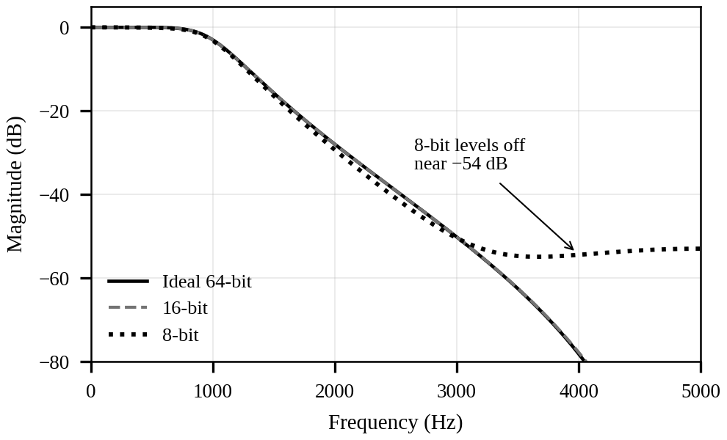
Fig. 3. Magnitude response of the ideal, 16-bit and 8-bit filters.
B. Word-Length Sweep
Counting the integer bits changes the result (Table III, Fig. 4). The direct form is unstable at 4 and 5 bits (max|p| ≥ 1), and at 6 and 7 bits all numerator coefficients (below 0.03) round to zero, so the output is zero. The cascade is stable at every word length. At 8 bits the cascade gives 26.22 dB against 8.24 dB for the direct form, and at 16 bits 83.11 dB against 58.45 dB. SQNR does not always rise with the word length, for example the direct form gives 41.03 dB at 10 bits and 34.00 dB at 12 bits, because it depends on how the particular coefficients round. For the same reason the gap between 16-bit and 8-bit in Table II (28.3 dB) is smaller than the 48 dB suggested by 6.02 dB per bit.
TABLE III
Direct form and cascade for different word lengths
B | Direct max|p| | Direct SQNR | Cascade max|p| | Cascade SQNR
4 | 1.0000 | unstable | 0.8660 | 5.66 dB
5 | 1.0268 | unstable | 0.7906 | −1.52 dB
6 | 0.9809 | 0.00 dB (zero) | 0.7906 | 14.35 dB
7 | 0.7630 | 0.00 dB (zero) | 0.7906 | 15.95 dB
8 | 0.7630 | 8.24 dB | 0.7906 | 26.22 dB
10 | 0.7968 | 41.03 dB | 0.7955 | 35.14 dB
12 | 0.7981 | 34.00 dB | 0.7955 | 53.82 dB
14 | 0.7950 | 43.26 dB | 0.7955 | 52.45 dB
16 | 0.7953 | 58.45 dB | 0.7955 | 83.11 dB

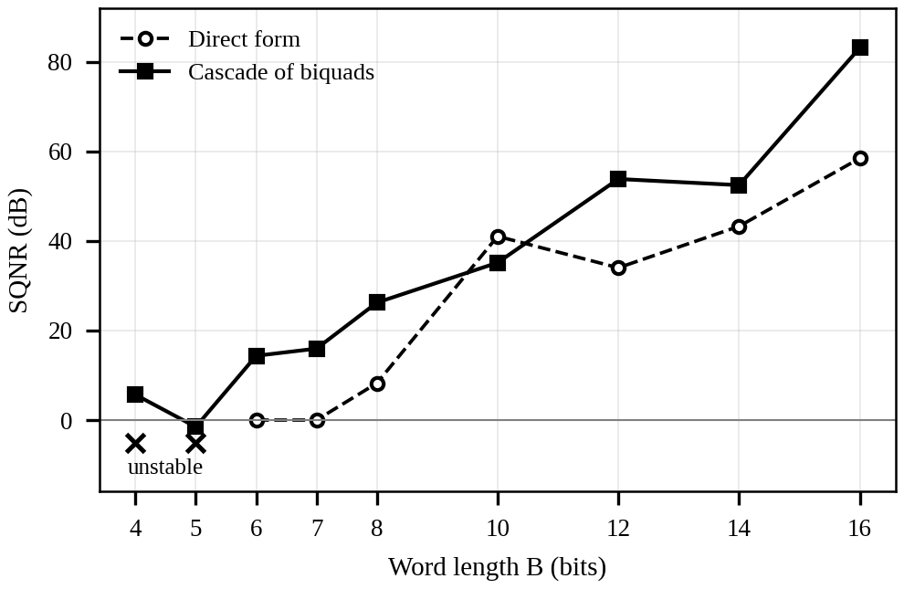
Fig. 4. SQNR against word length for the direct form and the cascade of biquads.
C. FPGA Results
The core matched the bit-accurate model with 0 mismatches over 501 samples and the full top level over 1,000 samples (Table IV). The 400 Hz tone passed with 0.00 dB gain and the 3 kHz tone was attenuated by 50.15 dB, against 50.16 dB for the ideal filter. The SQNR against the ideal 64-bit filter was 79.31 dB, which is 3.8 dB below the 64-bit cascade (83.11 dB). This is the cost of rounding inside the arithmetic [6], which coefficient-only quantization does not show. The design used 541 logic elements and two 9-bit multiplier elements and met the 20 ns constraint with +12.646 ns slack. The slowest path is the rounding and saturation stage, not the multiplier. On the DE2-115 board the sample rate was lowered to 10 Hz so that the eye can follow the tones; the LED bars showed the two-tone input and a filtered output that followed only the slow tone. The real-time 10 kHz mode was verified by simulation and timing analysis. An earlier test design reported a false setup violation of −3.798 ns only because no clock constraint had been given.
TABLE IV
FPGA simulation, resource and timing results
Item | Result
Mismatches vs. bit-accurate model | 0 in 1,501 samples
SQNR vs. ideal 64-bit filter | 79.31 dB
3 kHz tone attenuation | −50.15 dB (ideal −50.16)
Logic elements | 541 (<1%)
Registers | 374
Memory bits | 15,360
9-bit multiplier elements | 2
Worst setup slack (20 ns clock) | +12.646 ns
Fmax (85C / 0C slow model) | 135.98 / 148.77 MHz

D. CNN Weight Quantization
Table V shows that FP16, FP8 and INT8 are within 0.12 points of the FP32 accuracy and INT4 is within 0.08 points, while the model is 8 times smaller. With 10,000 test images, 0.01 points is one image, so differences below about 0.1 points are not meaningful from a single run. Below 4 bits the accuracy falls quickly (89.77% at INT3 and 14.63% at INT2) because at 2 bits only three weight values are left (−1, 0 and +1 times the scale). For this model 4 bits is therefore the smallest width that works, a limit of the same kind as for the IIR filter.
TABLE V
CNN accuracy and model size
Format | Accuracy (%) | Size (KB)
FP32 | 97.89 | 94.9
FP16 | 97.89 | 47.5
FP8 E4M3 | 97.93 | 23.7
FP8 E5M2 | 97.77 | 23.7
INT8 | 97.87 | 23.7
INT4 | 97.81 | 11.9
INT3 | 89.77 | 8.9
INT2 | 14.63 | 5.9

E. Discussion
Rounding moved the zeros much more than the poles, so the poles decide stability while the zeros decide the quality of the stopband. The integer bits matter as much as the fractional bits, and the cascade is the safer structure for fixed-point hardware, although it was not better at every word length (at 10 bits the direct form scored 41.03 dB against 35.14 dB). The study rounds only the coefficients in the MATLAB and sweep parts, uses one filter and one test signal, and rounds only the CNN weights in a single run.
V. Conclusion
Rounding the coefficients of a fourth-order Butterworth filter to 16 and 8 bits left it stable but split the repeated zero at z = −1 and removed the stopband null of the 8-bit filter (SQNR 69.32 dB and 41.01 dB). When the integer bits were counted, a 16-bit direct form reached only about 58.4 dB and became unstable at 4 and 5 bits, whereas a cascade of two biquads stayed stable at every word length and reached 83.11 dB. The cascade was built in 16-bit fixed point on a Cyclone IV E FPGA. It matched a bit-accurate model exactly, reached 79.31 dB SQNR, used 541 logic elements, met timing at 50 MHz and worked on a DE2-115 board. A CNN kept 97.81% accuracy with 4-bit weights but failed below 4 bits. Future work includes an 8-bit FPGA version to measure the area saved, a filter example on real audio or biomedical signals, and quantizing the CNN activations as well as the weights.
Acknowledgment
The authors thank the faculty of the School of Electronics Engineering, VIT, for guidance and laboratory facilities.
References
[1] J. G. Proakis and D. G. Manolakis, Digital Signal Processing: Principles, Algorithms and Applications, 5th ed. Pearson, 2022.
[2] S. K. Mitra, Digital Signal Processing: A Computer-Based Approach, 4th ed. McGraw-Hill, 2013.
[3] A. V. Oppenheim and R. W. Schafer, Discrete-Time Signal Processing, 3rd ed. Pearson, 2010.
[4] J. F. Kaiser, “Some practical considerations in the realization of linear digital filters,” in Proc. 3rd Allerton Conf. Circuit Syst. Theory, 1965, pp. 621–633.
[5] B. Liu, “Effect of finite word length on the accuracy of digital filters—A review,” IEEE Trans. Circuit Theory, vol. CT-18, no. 6, pp. 670–677, Nov. 1971.
[6] A. V. Oppenheim and C. J. Weinstein, “Effects of finite register length in digital filtering and the fast Fourier transform,” Proc. IEEE, vol. 60, no. 8, pp. 957–976, Aug. 1972.
[7] L. B. Jackson, “On the interaction of roundoff noise and dynamic range in digital filters,” Bell Syst. Tech. J., vol. 49, no. 2, pp. 159–184, Feb. 1970.
[8] B. Jacob et al., “Quantization and training of neural networks for efficient integer-arithmetic-only inference,” in Proc. IEEE/CVF Conf. Comput. Vis. Pattern Recognit. (CVPR), 2018.
[9] A. Gholami, S. Kim, Z. Dong, Z. Yao, M. W. Mahoney, and K. Keutzer, “A survey of quantization methods for efficient neural network inference,” arXiv:2103.13630, 2021.
[10] R. Krishnamoorthi, “Quantizing deep convolutional networks for efficient inference: A whitepaper,” arXiv:1806.08342, 2018.
[11] S. Gupta, A. Agrawal, K. Gopalakrishnan, and P. Narayanan, “Deep learning with limited numerical precision,” in Proc. 32nd Int. Conf. Mach. Learn. (ICML), 2015, pp. 1737–1746.
[12] N. P. Jouppi et al., “In-datacenter performance analysis of a tensor processing unit,” in Proc. 44th Annu. Int. Symp. Comput. Archit. (ISCA), 2017, pp. 1–12.
[13] S. Butterworth, “On the theory of filter amplifiers,” Wireless Engineer, vol. 7, pp. 536–541, Oct. 1930.
[14] U. Meyer-Baese, Digital Signal Processing with Field Programmable Gate Arrays, 4th ed. Springer, 2014.
[15] Terasic Technologies, DE2-115 User Manual.
[16] Altera (Intel), Cyclone IV Device Handbook.
[17] Y. LeCun, L. Bottou, Y. Bengio, and P. Haffner, “Gradient-based learning applied to document recognition,” Proc. IEEE, vol. 86, no. 11, pp. 2278–2324, Nov. 1998.
[18] A. Paszke et al., “PyTorch: An imperative style, high-performance deep learning library,” in Proc. NeurIPS, 2019.
[19] IEEE Standard for Floating-Point Arithmetic, IEEE Std 754-2019.
[20] P. Micikevicius et al., “FP8 formats for deep learning,” arXiv:2209.05433, 2022.

