
Vellore Institute of Technology
Second Year (3rd Semester) Lab Based Project Component Report on the Topic
Analysis of Finite Word Length Effects and Coefficient Quantization on Fixed-Point IIR Filter Stability
Submitted by
Vrinda Pandey: 25BVD0126
Ayush Krishna Balabadra: 25BVD0112
Under the Guidance of
Dr. Shweta B Thomas
Assistant Professor Sr. Grade 2
School of Electronics Engineering
Subject: Signal Processing, BAEVD204
Slot:
Academic Year: Fall 2026 – 2027
- Abstract
In digital hardware, filter coefficients are stored in registers with a fixed number of bits, so they have to be rounded. In this project we looked at what this rounding does to an IIR filter: its poles and zeros, its frequency response, its stability and its output accuracy. We designed a 4th-order Butterworth low-pass filter (fs = 10 kHz, fc = 1 kHz) in MATLAB and rounded its coefficients to 16 bits and 8 bits. The largest pole radius moved from 0.7954 to 0.7955 (16-bit) and 0.7968 (8-bit), so both filters stayed stable. The four zeros at z = −1 split apart, and the 8-bit filter lost its stopband null. The SQNR was 69.32 dB for 16-bit and 41.01 dB for 8-bit coefficients.
When we also counted the integer bits, the 16-bit direct form dropped to about 58.4 dB and became unstable at 4 and 5 bits. A cascade of two biquads stayed stable at every word length and reached 83.11 dB. We built this cascade on a Cyclone IV E FPGA (Terasic DE2-115) in 16-bit fixed point with one shared multiplier. It matched a bit-accurate model on all 1,501 simulated samples, gave 79.31 dB SQNR, used 541 logic elements and met timing at 50 MHz with +12.646 ns slack (Fmax 135.98 MHz). It also filtered a two-tone signal correctly on the board.
As an extra part, we rounded the weights of a small CNN for MNIST digits. With INT4 weights it kept 97.81% accuracy (97.89% in FP32) and the model was 8 times smaller. At INT3 the accuracy fell to 89.77% and at INT2 to 14.63%.
- Introduction
MATLAB works with 64-bit floating-point numbers. FPGAs, microcontrollers and fixed-point DSP chips store coefficients in 8 to 16 bits to save area and power. Rounding the coefficients changes the filter that is actually built. In an IIR filter a pole can move onto or outside the unit circle, and then the filter is unstable. We wanted to measure this for a 4th-order Butterworth low-pass filter and then check it on real hardware.
Rounding happens in three places: when the coefficients are stored (coefficient quantization), when the signal is sampled (input quantization), and after every multiplication and addition (round-off and overflow). Together these are the finite word length effects, which are covered in Module 5 of the syllabus [10].
Numbers can be stored as fixed-point or floating-point. Fixed-point numbers have a fixed step size and a small range, but they need little hardware, so DSP chips and FPGAs use them. Floating-point numbers also store an exponent, so they cover a bigger range but need more hardware. Table 1 lists the formats used in this report.
Table 1. Number formats used in this project
Format | Bits | Layout | Largest value | Worst-case rounding error
FP32 | 32 | 1 sign, 8 exponent, 23 mantissa | 3.4 x10³⁸ | about 6 x10⁻⁸ (relative)
FP16 | 16 | 1 sign, 5 exponent, 10 mantissa | 65,504 | about 4.9 x10⁻⁴ (relative)
FP8 E4M3 | 8 | 1 sign, 4 exponent, 3 mantissa | 448 | 6.25% (relative)
FP8 E5M2 | 8 | 1 sign, 5 exponent, 2 mantissa | 57,344 | 12.5% (relative)
INT8 | 8 | signed integer, one scale per tensor | 127 x scale | half a step (scale / 2)
INT4 | 4 | signed integer, one scale per tensor | 7 x scale | half a step (scale / 2)

For floating point the relative error is 2^{−(m+1)} for m mantissa bits. For integers the step equals the scale. The IIR filter uses fixed-point Qm.n coefficients (Section 6.2).
The same idea is used in machine learning, where phones and accelerators run networks with 16, 8 or even 4 bits [5]–[7]. The report has four parts. Part A is the MATLAB study of an IIR filter. Part B compares the direct form with a cascade of biquads for different word lengths. Part C is the FPGA implementation on a DE2-115 board. Part D is an extra part on the weights of a small CNN. The code and raw data are in the appendices.
- Objectives
The objectives in our project proposal were to:
- Design an ideal high-order IIR Butterworth low-pass filter in MATLAB.
- Quantize the coefficients b and a to 16-bit and 8-bit fixed-point representations.
- Analyze the resulting pole-zero drift on the Z-plane and the effect on stability.
- Compare the frequency-response degradation and measure the signal-to-quantization-noise ratio (SQNR) on a noisy test signal.

We added three more:
- Count the integer bits and compare the direct form with a cascade of biquads for different word lengths (Part B).
- Build the cascade in 16-bit fixed point on an FPGA and check it by simulation, timing analysis and a board demonstration (Part C).
- Round the weights of a CNN to FP16, FP8 and INT8 down to INT2 and see how the accuracy changes (Part D).

- Literature Survey
Textbooks [1]–[3] describe three kinds of error in a filter with a finite word length. Coefficient quantization moves the poles and zeros and so changes the frequency response. Round-off noise comes from every multiplication and addition. Overflow can cause large errors and limit cycles. High-order IIR filters are more sensitive to rounding of the coefficients than second-order sections, so cascade or parallel structures are preferred. An IIR filter is usually designed from an analog Butterworth filter with the bilinear transform and pre-warping. The transform keeps a stable filter stable, so any instability comes from rounding the coefficients.
Fixed-point DSP on FPGAs is covered in [11]. Common methods are to share one multiplier over several clock cycles, to use extra bits in the accumulator, and to round and saturate at the output. The board and the device are described in [12] and [13].
Neural networks can also work with fewer bits. Jacob et al. [5] ran networks with integer-only arithmetic on mobile hardware, and Gholami et al. [6] give a survey of quantization methods. Micikevicius et al. [7] proposed the 8-bit floating-point formats E4M3 and E5M2. MNIST [4] is a set of 70,000 handwritten digit images, and we used PyTorch [8] for the network.
- Methodology

5.1 Overview and tools
Figure 1 shows the steps of the project. Parts A and B were done in MATLAB. In Part C we wrote the filter in Verilog and ran it on the FPGA. In Part D we used Python for the CNN. The tools are listed in Table 2.
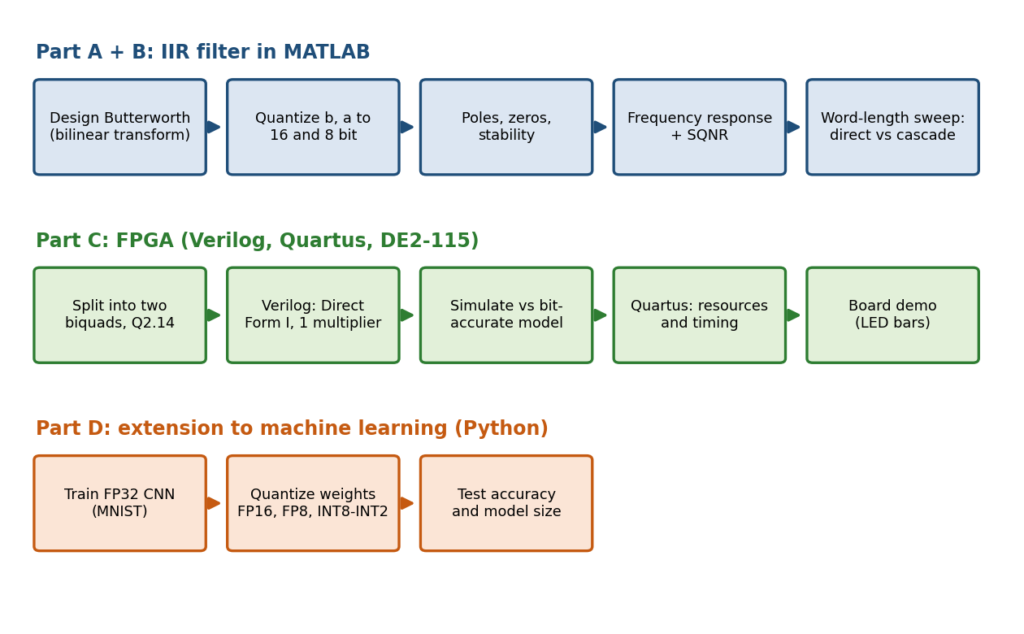
Figure 1. Steps of the project: MATLAB filter study (Parts A and B), FPGA implementation (Part C) and the CNN (Part D).
Table 2. Tools used
Item | Used for
MATLAB | Filter design, quantization, plots, SQNR
Quartus Prime Standard Edition | Compiling, resource and timing reports
Terasic DE2-115 board | Hardware demonstration
Icarus Verilog | Simulation of the FPGA design
Python | Bit-accurate model, CNN, quantization
PyTorch, torchvision | CNN, MNIST, FP16/FP8 types
NumPy, Matplotlib | Numerical work and figures

5.2 Part A: MATLAB design and quantization
The full script is in Appendix A.1. It does the following:
- Designs a 4th-order Butterworth filter (fs = 10 kHz, fc = 1 kHz) with pre-warping and the bilinear transform, finds the coefficients a and b and sets the DC gain to 1.
- Rounds the coefficients with round(x*2^n)/2^n, using n = 15 for 16-bit and n = 7 for 8-bit.
- Finds the poles and zeros with roots, prints the largest pole radius max|p| and plots the Z-plane.
- Calculates the DTFT at 1024 frequencies from 0 to 5 kHz and plots magnitude and phase.
- Filters a test signal (400 Hz tone, 3 kHz tone of amplitude 0.5, and 0.2*randn noise, 501 samples) and calculates the SQNR.
- Saves the coefficients in a CSV file.

5.3 Part B: word-length sweep
The Part A script only rounds to a step size. It does not check whether the number fits in the word, and a1 = −2.37 and a2 = 2.31 do not fit in a Q1.15 or Q1.7 word. So we also counted the integer bits. We rounded the direct form to Q3.(B−3) and a cascade of two biquads to Q2.(B−2), for B = 4, 5, 6, 7, 8, 10, 12, 14 and 16 bits. The SQNR was averaged over 20 noise runs. The arithmetic was 64-bit, so only the coefficients were rounded (Appendix A.2).

5.4 Part C: FPGA procedure
- Split the filter into two biquads, one for each pair of poles, and round the coefficients to Q2.14.
- Write the filter in Verilog as Direct Form I with 16-bit Q1.15 data, a 36-bit accumulator, round-to-nearest, saturation and one shared multiplier (Appendix B).
- Add a top level with a 10 kHz sample tick, a two-tone source (phase accumulators and a 1024-entry sine ROM) and LED bar graphs.
- Simulate in Icarus Verilog and compare with a bit-accurate Python model and with the ideal 64-bit filter.
- Compile in Quartus Prime 25.1std.0 for the Cyclone IV E EP4CE115F29C7 with a 20 ns clock constraint, import the DE2-115 pin assignments and read the resource and timing reports.
- Program the DE2-115 board and watch the filter work on the two-tone input.

5.5 Part D: CNN and weight quantization
We used MNIST handwritten digits (28 x 28 grey-scale images, 60,000 for training and 10,000 for testing). The CNN has 24,298 parameters (Table 3). We trained it in FP32 with the Adam optimiser (learning rate 0.001, batch size 128, 2 epochs, cross-entropy loss). It reached 97.89% test accuracy.
Table 3. Architecture of the CNN
Layer | Output shape | Parameters
Convolution 3 x 3, 1 to 8 channels, ReLU | 8 x 26 x 26 | 80
Convolution 3 x 3, 8 to 16 channels, ReLU | 16 x 24 x 24 | 1,168
Max pooling 2 x 2 | 16 x 12 x 12 | 0
Flatten | 2,304 | 0
Fully connected, 2,304 to 10 | 10 (class scores) | 23,050
Total |  | 24,298

After training we rounded every weight and bias to the chosen format and converted it back to FP32 for the calculation. So only the stored precision changes, and the activations stay in FP32. FP16 and FP8 use the PyTorch types float16, float8_e4m3fn and float8_e5m2. For integers we used one scale per tensor (Section 6.5), from 8 bits down to 2 bits. Accuracy was measured on the 10,000 test images. Model size is parameters x bits / 8 / 1024 (in KB).
- Working Principle

6.1 The IIR filter and stability
An IIR filter is described by a difference equation or by a transfer function H(z). The roots of its numerator and denominator are the zeros and poles:
H(z) = ( b₀ + b₁z⁻¹ + … + b₄z⁻⁴ ) / ( 1 + a₁z⁻¹ + … + a₄z⁻⁴ ) y[n] = Σ b_{k} x[n−k] − Σ a_{k} y[n−k]
The frequency response is H(z) on the unit circle, z = e^{jω}. A causal filter is stable (BIBO) only if all poles are inside the unit circle, that is max|p| < 1. We call 1 − max|p| the stability margin.
The analog Butterworth response is |H(jΩ)|² = 1 / (1 + (Ω/Ω_{c})^{2N}), which is flat in the passband and −3 dB at the cutoff. The bilinear transform s = (2/T)(z − 1)/(z + 1) maps the left half of the s-plane into the unit circle. It squeezes the frequency axis, so the cutoff is pre-warped: Ω_{a} = (2/T) tan(Ω_{c}T/2) = 6498 rad/s for fc = 1 kHz and fs = 10 kHz. The four analog zeros at infinity become four zeros at z = −1, and the gain is set so that the DC gain is 1.

6.2 Fixed-point numbers and coefficient quantization
In Qm.n notation a word has m integer bits (including the sign) and n fractional bits. The step is 2^{−n} and rounding to the nearest step gives a maximum error of 2^{−(n+1)}. Rounding the coefficients gives a slightly different filter. A root that is repeated m times moves by about ε^{1/m} when a coefficient has an error ε, so the fourfold zero at z = −1 is much more sensitive than poles that are well apart.
In the direct form every pole depends on all the denominator coefficients, so rounding one coefficient moves all the poles. In a cascade of second-order sections (biquads) each section has one pole pair and one zero pair, so rounding only affects its own pair, and the coefficients are smaller, so fewer integer bits are needed. This is why the cascade is preferred for fixed-point filters.

6.3 Signal-to-quantization-noise ratio
SQNR = 10 log₁₀ ( Σ y_{ideal}[n]² / Σ ( y_{ideal}[n] − y_{q}[n] )² )
Here y_{ideal} is the output of the 64-bit filter and y_{q} is the output with rounded coefficients for the same input. A higher value is better, and every 6.02 dB is about one bit.

6.4 The FPGA filter
Figure 2 shows the design. The filter is two biquads in Direct Form I that share one 16 x 16 multiplier. A 10 kHz sample tick is made from the 50 MHz clock and starts a calculation of 33 clock cycles, so the design could run at up to 50 MHz / 33 = 1.5 MHz; we use 10 kHz. The input is a two-tone signal, 0.5 sin at 400 Hz plus 0.25 sin at 3 kHz, made by two phase accumulators and a 1024-entry sine ROM. The tones are scaled down because the first biquad has a peak gain of 1.26 near 848 Hz, so a full-scale input could overflow. The input and output are shown on LED bar graphs. Switch SW[0] slows the sample rate to 10 Hz so that the eye can follow the tones (400 Hz looks like 0.4 Hz and 3 kHz like 3 Hz).
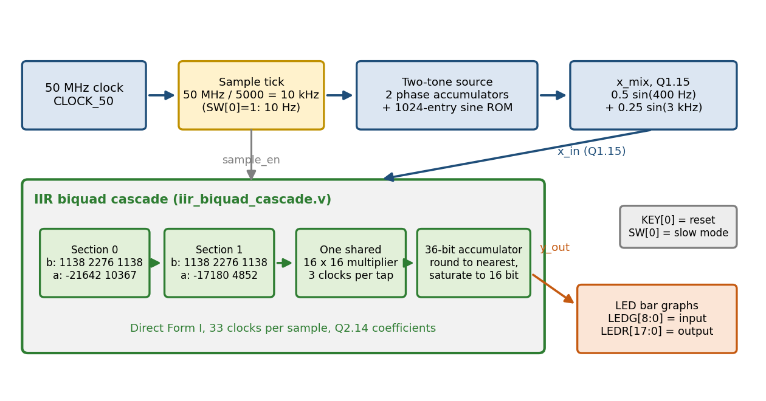
Figure 2. Block diagram of the FPGA design (iir_top.v and iir_biquad_cascade.v).
Table 4. Design choices of the FPGA filter
Choice | Value
Structure | Two cascaded biquads, Direct Form I
Data format | Q1.15, 16 bits
Coefficient format | Q2.14, 16 bits (range ±2)
Multiplier | One shared 16 x 16 multiplier, 3 clocks per tap, 33 clocks per sample
Accumulator | 36 bits, so the sum of five products cannot overflow
Output stage | Round to nearest, then saturate to 16 bits
Sample rate | 50 MHz / 5000 = 10 kHz (SW[0] = 1 selects 10 Hz for slow motion)
Constraint | 20 ns clock in sp_project.sdc

The coefficients are the real values multiplied by 2¹⁴ and rounded to integers (Table 5). The rounded poles differ from the ideal ones by less than 4 x10⁻⁵.
Table 5. Rounded biquad coefficients in the FPGA (integer = value x 2¹⁴)
Section | b0 = b2 | b1 | a1 | a2 | Rounded poles
0 | 1138 | 2276 | −21642 | 10367 | 0.6605 ± 0.4433j
1 | 1138 | 2276 | −17180 | 4852 | 0.5243 ± 0.1458j

6.5 Rounding the weights of a neural network
The CNN part uses the same kind of rounding. For a signed integer with b bits, the largest integer we use is q_{max} = 2^{b−1} − 1 (127 for INT8, 7 for INT4 and 1 for INT2). We pick one scale s for each tensor so that the largest weight maps to q_{max}:
s = max|w| / q_{max} q = clamp( round( w / s ), −q_{max}, +q_{max} ) ŵ = q × s
The error is at most half a step (s / 2). Going from INT8 to INT4 makes the step about 127 / 7 ≈ 18 times bigger. Each bit we remove doubles the step, and the rounding noise power rises about four times (6 dB) [1], [2]. With 2 bits only three values are possible (−1, 0 and +1 times the scale), so most small weights become zero and the network stops working.
For floating point, a number is sign x mantissa x 2^{exponent}. FP16 has 10 mantissa bits (about 0.05% rounding error). FP8 E4M3 has 3 (6.25%) and reaches 448. FP8 E5M2 has 2 (12.5%) and reaches 57,344. Trained weights are small numbers, so precision matters more than range.
- Result

7.1 Part A: MATLAB results
The ideal filter has poles at 0.6605 ± 0.4433j (radius 0.7954) and 0.5243 ± 0.1458j (radius 0.5442) and four zeros at z = −1. The gain is k = b0 = 0.0048243, which gives 0 dB at DC. The cutoff was pre-warped to 6498 rad/s. Without pre-warping (6283 rad/s) the cutoff would be 969 Hz instead of 1000 Hz.
Table 6 compares the coefficients. The biggest 16-bit error is 1.5 x10⁻⁵, which is half a step. The biggest 8-bit error is 3.7 x10⁻³. The numerator ratio 1:4:6:4:1 becomes 1:2:4:2:1 at 8 bits, and the sums of the b values and of the a values are both 10/128, so the DC gain is still exactly 0 dB. The small numerator coefficients have the largest relative errors (up to +62%), while the large denominator coefficients hardly change.
Table 6. Ideal and rounded coefficients
Coeff | Ideal 64-bit | 16-bit (Q15 step) | 8-bit (Q7 step) | 8-bit integer (÷128) | 8-bit relative error
b0 = b4 | 0.0048243 | 0.0048218 | 0.0078125 | 1 | +62%
b1 = b3 | 0.019297 | 0.019287 | 0.015625 | 2 | −19%
b2 | 0.028946 | 0.028961 | 0.03125 | 4 | +8%
a1 | −2.3695 | −2.3695 | −2.3672 | −303 | 0.10%
a2 | 2.3140 | 2.3140 | 2.3125 | 296 | 0.06%
a3 | −1.0547 | −1.0547 | −1.0547 | −135 | 0.002%
a4 | 0.18738 | 0.18738 | 0.1875 | 24 | 0.06%

The integer column is the 8-bit coefficient multiplied by 128 (coefficient = integer / 128). The values of a1, a2 and a3 are outside the range of a true 8-bit integer (−128 to 127), which is why we count the integer bits in Part B.
Table 7 and Figure 3 show the poles and zeros. All three filters are stable. The poles hardly move, but the four zeros at z = −1 split into pairs, one inside and one outside the unit circle. Zeros outside the unit circle do not affect stability. In Figure 3 the outer 8-bit zero pair is outside the plot limit of ±1.5.
Table 7. Pole-zero drift
Model | Max pole radius | Shift | Stability margin | Zeros (radius)
Ideal | 0.7954 | none | 0.2046 | 4 at −1
16-bit | 0.7955 | +0.00006 | 0.2045 | −1.197 ± 0.241j (1.22); −0.803 ± 0.162j (0.82)
8-bit | 0.7968 | +0.0013 | 0.2032 | −0.257 ± 0.529j (0.59); −0.743 ± 1.529j (1.70)

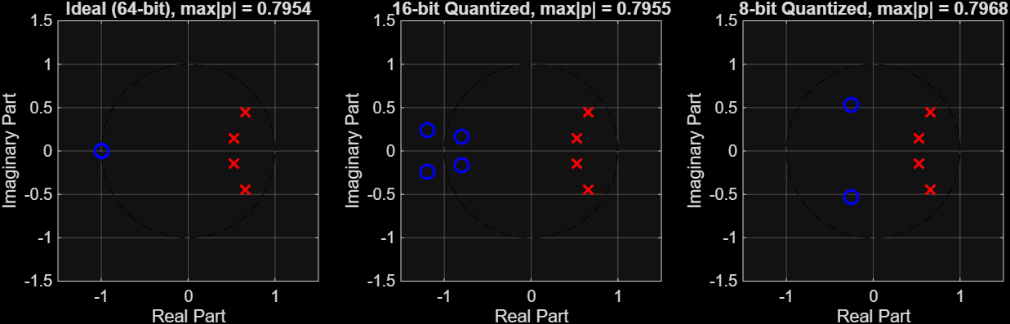
Figure 3. Pole-zero plots of the ideal, 16-bit and 8-bit filters. The title of each plot gives the maximum pole radius.
Figure 4 shows the magnitude and phase. The passband is flat up to about 800 Hz and the −3 dB point is at 1000 Hz (−3.01 dB for the ideal and 16-bit filters, −3.22 dB for 8-bit). The ideal filter reaches −15.7 dB at 1.5 kHz, −28.0 dB at 2 kHz, −50.2 dB at 3 kHz and −78 dB at 4 kHz, which is about 25 dB per octave. From about 3 kHz the 8-bit response levels off near −54 dB (−52.9 dB at 5 kHz) because its zeros left z = −1 and the null at the Nyquist frequency is gone. The 16-bit response cannot be told apart from the ideal one (gain at Nyquist −107 dB). The phase curves overlap: −76° at 500 Hz, −180° at 1 kHz, −291° at 2 kHz and −360° at 5 kHz.
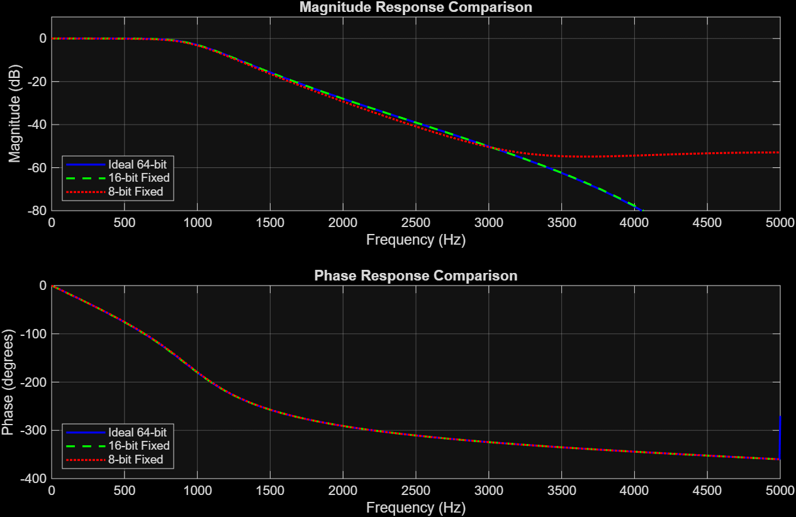
Figure 4. Magnitude and phase response of the ideal, 16-bit and 8-bit filters.
The test signal was a 400 Hz tone (amplitude 1), a 3 kHz tone (amplitude 0.5) and 0.2*randn noise, 501 samples (50 ms). Table 8 and Figure 5 give the results. The 8-bit error repeats every 400 Hz period, so it is a fixed gain and phase error from the changed transfer function and not random noise. The 3 kHz tone is reduced by 50.2 dB in all three filters. We repeated the test in Python with three noise seeds and got 69.3 dB for 16-bit and 41.0 to 41.2 dB for 8-bit, which agrees with MATLAB.
Table 8. Time-domain results
Metric | 16-bit | 8-bit
SQNR | 69.32 dB | 41.01 dB
Peak output error | ±0.0004 | ±0.0125
Gain at 400 Hz (ideal 0.9997) | 0.9995 | 0.9937

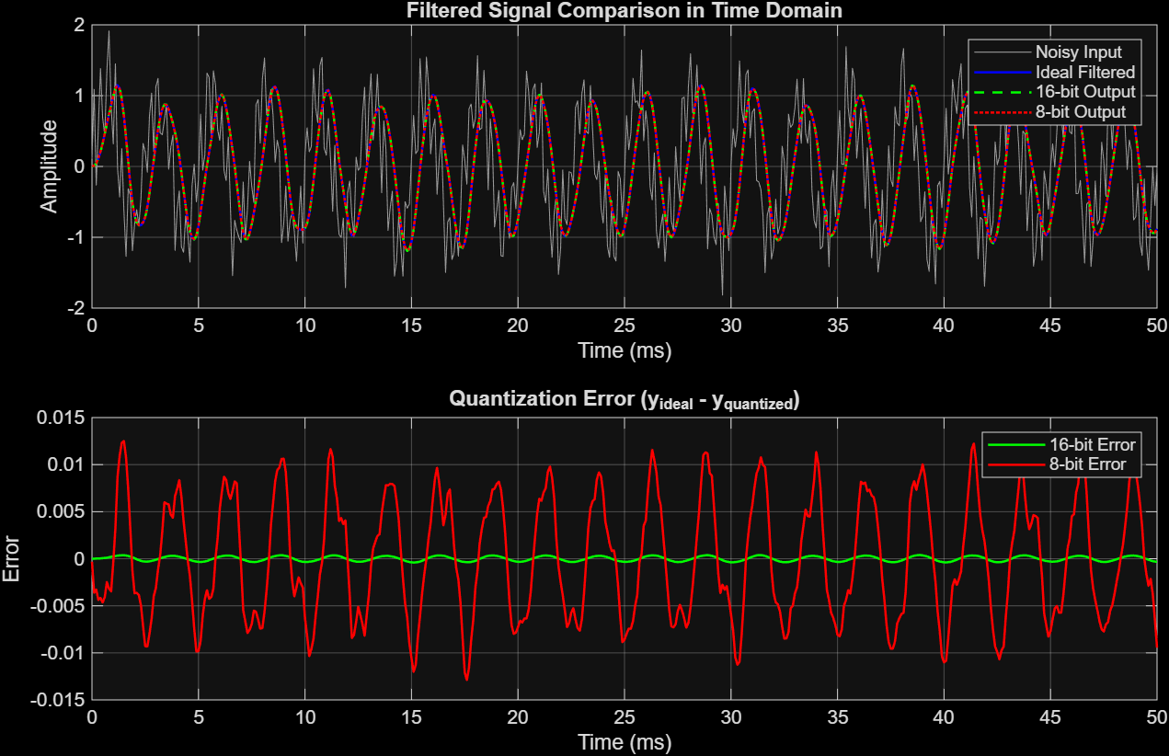
Figure 5. Filtered signals in the time domain and the error of the 16-bit and 8-bit filters.

7.2 Part B: word-length sweep
The results change when the integer bits are counted (Table 9, Figure 6). The direct form is unstable at 4 and 5 bits (max|p| is 1 or more), as we expected in the proposal. At 6 and 7 bits all the numerator coefficients (below 0.03) round to zero, so the output is zero. The cascade is stable at every word length. At 8 bits the cascade gives 26.2 dB and the direct form 8.2 dB. At 16 bits they give 83.1 dB and about 58.4 dB. The SQNR does not always rise with the word length (the direct form gives 41.0 dB at 10 bits and 34.0 dB at 12 bits) because it depends on how the particular coefficients happen to round. For the same reason the gap between 16-bit and 8-bit in Part A is 28.3 dB, much less than the 48 dB that 6.02 dB per bit would suggest.
Table 9. Direct form and cascade of biquads for word lengths of 4 to 16 bits
Bits | Direct max|p| | Direct SQNR | Cascade max|p| | Cascade SQNR
4 | 1.0000 | unstable | 0.8660 | 5.66 dB
5 | 1.0268 | unstable | 0.7906 | −1.52 dB
6 | 0.9809 | 0.00 dB (output is zero) | 0.7906 | 14.35 dB
7 | 0.7630 | 0.00 dB (output is zero) | 0.7906 | 15.95 dB
8 | 0.7630 | 8.24 dB | 0.7906 | 26.22 dB
10 | 0.7968 | 41.03 dB | 0.7955 | 35.14 dB
12 | 0.7981 | 34.00 dB | 0.7955 | 53.82 dB
14 | 0.7950 | 43.26 dB | 0.7955 | 52.45 dB
16 | 0.7953 | 58.45 dB | 0.7955 | 83.11 dB

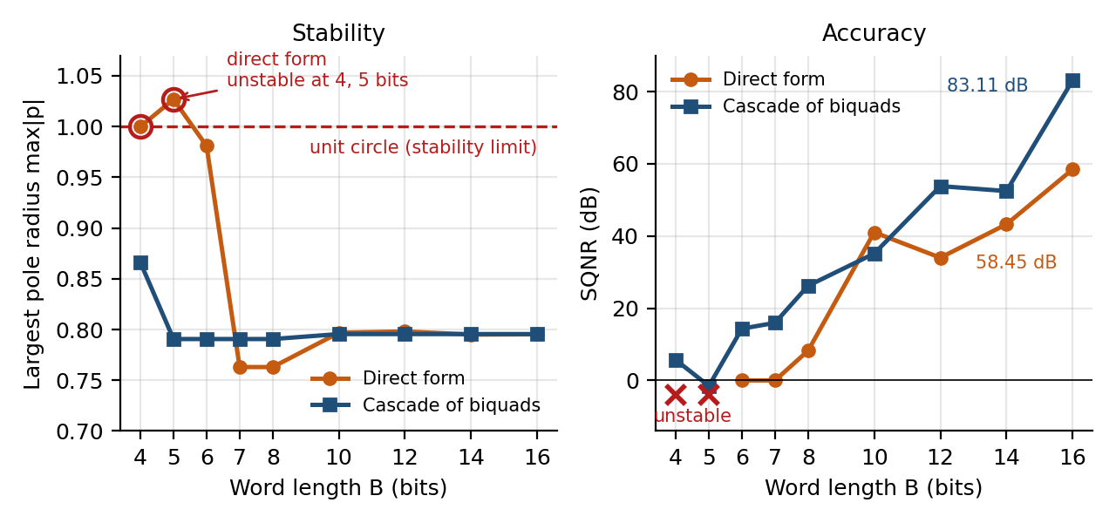
Figure 6. Largest pole radius (left) and SQNR (right) against word length for the direct form and the cascade.

7.3 Part C: FPGA results
We simulated the design in Icarus Verilog and compared it with a bit-accurate Python model and with the ideal 64-bit filter (Table 10). The SQNR against the ideal filter was 79.31 dB, and the 3 kHz tone was reduced by 50.15 dB against 50.16 dB for the ideal filter.
Table 10. FPGA simulation results
Test | Result
Core against the bit-accurate model, 501 samples | 0 mismatches
Full top level against the model, 1000 samples | 0 mismatches
400 Hz tone (input amplitude 0.4997) | Output 0.4996, gain 0.00 dB
3 kHz tone (input amplitude 0.2499) | Output 0.00078, gain −50.15 dB (ideal −50.16 dB)
SQNR against the ideal 64-bit filter | 79.31 dB; largest error 0.000092, about 3 LSB

Table 11 compares four 16-bit versions of the same filter on the same test signal. The FPGA result is 3.8 dB below the 64-bit cascade (83.11 dB). This is the cost of rounding inside the arithmetic, which coefficient-only rounding in MATLAB does not show.
Table 11. SQNR of four 16-bit versions of the filter
Version | Arithmetic | SQNR
Direct form, Q15 step size (MATLAB script) | 64-bit | 69.32 dB
Direct form, Q3.13 (integer bits counted) | 64-bit | 58.44 dB
Cascade, Q2.14 | 64-bit | 83.11 dB
Cascade, Q2.14 with Q1.15 data (FPGA design) | Fixed point | 79.31 dB

The design compiled in Quartus Prime Standard Edition 25.1std.0 on Wed Oct 7 2026 at 13:20:58 with 0 errors and 40 warnings in 23 s. The warnings are mostly about unused pins and the unused least significant bit of the ROM. Two 9-bit multiplier elements make up the single 16 x 16 multiplier, and the 15,360 memory bits are the 1024-entry sine ROM (Table 12, Figure 7).
Table 12. Quartus resource use (Cyclone IV E EP4CE115F29C7)
Resource | Used | Available
Logic elements | 541 (<1%) | 114,480
Registers | 374 | –
Pins | 50 (9%) | 529
Memory bits | 15,360 (<1%) | 3,981,312
Embedded multiplier 9-bit elements | 2 (<1%) | 532
PLLs | 0 | 4

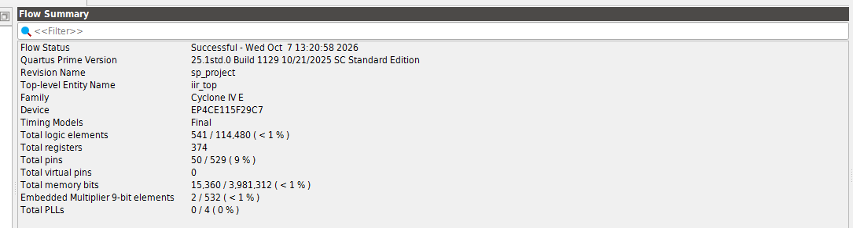
Figure 7. Quartus Flow Summary for the iir_top design.
For timing we loaded the constraint file sp_project.sdc, which gives a 20.000 ns setup relationship on CLOCK_50. All ten reported setup paths are met. The worst slack is +12.646 ns and Fmax is 135.98 MHz, which is 2.7 times the 50 MHz clock (Table 13, Figure 8). The slowest path is the rounding and saturation stage after the accumulator, not the multiplier, because the multiplier work is spread over several clock cycles.
Table 13. Timing results
Item | Result
Setup paths reported / violated | 10 / 0
Worst setup slack (Slow 1200mV 85C) | +12.646 ns
Worst path | acc[13] to y_out[11] (rounding and saturation stage)
Data delay, clock skew | 7.263 ns, −0.089 ns
Data arrival time | 10.321 ns (3.058 ns clock path + 7.263 ns data path)
Fmax, Slow 1200mV 85C | 135.98 MHz
Fmax, Slow 1200mV 0C | 148.77 MHz
Margin over the 50 MHz clock | 2.7 times

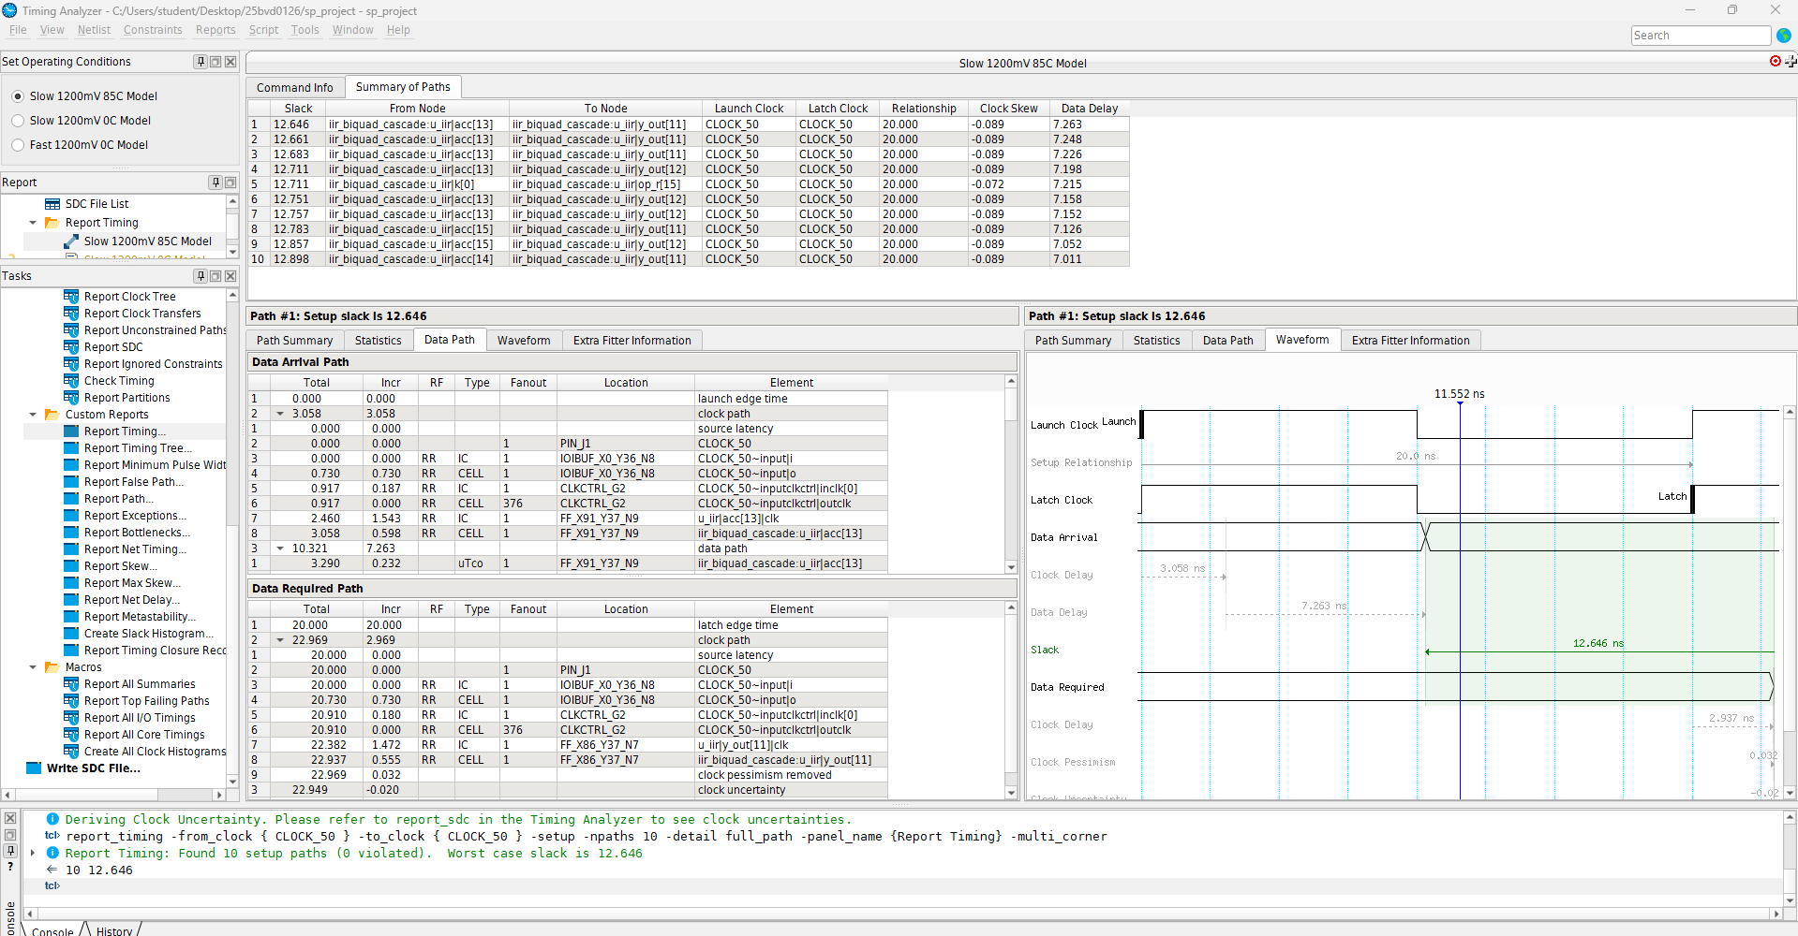
Figure 8. Timing Analyzer report for the Slow 1200mV 85C model: ten setup paths, all met, worst slack 12.646 ns.
For the board demonstration we imported the DE2-115 pin assignments (CLOCK_50 on PIN_Y2), recompiled and programmed the .sof file. With SW[0] up the sample rate drops to 10 Hz, so the 400 Hz tone looks like 0.4 Hz and the 3 kHz tone like 3 Hz. The green LED bar shows the filter input, which has both tones, and the red LED bar shows the output, which follows only the slow tone. This slow-motion mode worked as intended. At 10 kHz the LEDs change too fast to see, so real-time operation was checked by simulation and timing analysis instead.
Our first FPGA test had only a counter and one accumulator (79 logic elements, no multiplier, Fmax 208.42 MHz). It showed a setup violation of −3.798 ns because we had not given a clock constraint and Quartus assumed a 1 ns clock. Adding the 20 ns constraint fixed this, so the final design is reported with a constrained clock.

7.4 Part D: CNN accuracy and model size
Table 14 and Figure 9 compare all the formats on the same 10,000 test images. FP16, FP8 and INT8 are all within 0.12 percentage points of FP32, and INT4 is within 0.08 points. With 10,000 images, 0.01 points is one image, so differences below about 0.1 points (10 images) mean nothing from a single run. The accuracy is about the same while the model is up to 8 times smaller.
Table 14. Test accuracy and model size for each format
Format | Accuracy (%) | Change vs FP32 (points) | Model size (KB) | Size vs FP32
FP32 (baseline) | 97.89 | – | 94.9 | 1×
FP16 | 97.89 | 0.00 | 47.5 | 2× smaller
FP8 E4M3 | 97.93 | +0.04 | 23.7 | 4× smaller
FP8 E5M2 | 97.77 | −0.12 | 23.7 | 4× smaller
INT8 | 97.87 | −0.02 | 23.7 | 4× smaller
INT4 | 97.81 | −0.08 | 11.9 | 8× smaller

Table 15 and Figure 9 show what happens when the integer width is reduced further. Accuracy stays flat from INT8 down to INT4 and then falls fast: INT3 loses 8.12 points and INT2 loses 83.26 points. For this model 4 bits is the smallest width that still works.
Table 15. Accuracy as the integer weight width is reduced
Format | Distinct weight values | Accuracy (%) | Change vs FP32 (points)
INT2 | 3 | 14.63 | −83.26
INT3 | 7 | 89.77 | −8.12
INT4 | 15 | 97.81 | −0.08
INT5 | 31 | 97.85 | −0.04
INT6 | 63 | 97.93 | +0.04
INT7 | 127 | 97.88 | −0.01
INT8 | 255 | 97.87 | −0.02

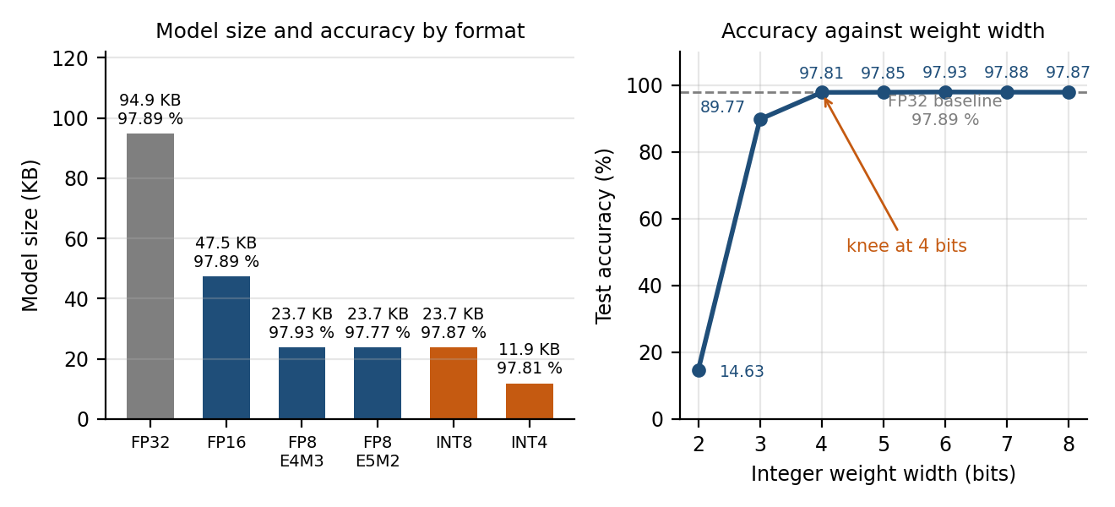
Figure 9. Left: model size (bars) and test accuracy (labels) for each format. Right: test accuracy against integer weight width.

7.5 Discussion
- Rounding moved the zeros much more than the poles. The poles shifted by at most 0.0013, but the four zeros at z = −1 split apart and the 8-bit stopband null disappeared. So the poles decide stability and the zeros decide the stopband.
- The integer bits matter as much as the fractional bits. Counting them took the 16-bit direct form from 69.32 dB to about 58.4 dB and made it unstable at 4 and 5 bits.
- The cascade stayed stable at every word length and was clearly better at 16 bits (83.11 dB against about 58.4 dB). At 10 bits the direct form scored higher (41.03 dB against 35.14 dB), so the cascade is not better at every length.
- Rounding inside the arithmetic costs something too. The FPGA design is 3.8 dB below the 64-bit cascade, and MATLAB with only coefficient rounding does not show this.
- A timing error can come from a missing constraint. Our first FPGA test showed −3.798 ns only because the clock was assumed to be 1 ns.
- The CNN shows the same trade-off. INT4 weights cost only 0.08 points of accuracy for a model 8 times smaller, but below 4 bits the network fails.
- INT4 saves memory but it is not free. With so few levels many small weights round to zero. The network still works, probably because the errors of thousands of weights partly cancel and only the highest score matters.

7.6 Limitations
- Parts A and B round only the coefficients. Arithmetic round-off, overflow and limit cycles are only covered by the FPGA simulation at one word length.
- The noise in the Part A script is not seeded, so the 8-bit SQNR changes by about ±0.1 dB between runs.
- We used one test signal and one filter (order 4, fc/fs = 0.1). Filters with poles closer to the unit circle are more sensitive.
- We did not synthesize an 8-bit FPGA version, so we did not measure the area saved by narrower words. Timing was read for the Slow 85C and Slow 0C models only.
- Real-time operation at 10 kHz was checked by simulation and timing analysis, because the LEDs cannot show it.
- In Part D only the weights were rounded, and we used one model, one run and an easy dataset (MNIST).

- Conclusion
We rounded the coefficients of a 4th-order Butterworth filter to 16 and 8 bits. Both filters stayed stable, with the largest pole radius moving from 0.7954 to 0.7955 and 0.7968, but the four zeros at z = −1 split apart and the 8-bit filter lost its stopband null. The SQNR was 69.32 dB and 41.01 dB. When the integer bits were counted, the 16-bit direct form gave only about 58.4 dB and was unstable at 4 and 5 bits, while a cascade of two biquads was stable at every word length and gave 83.11 dB at 16 bits.
We built the cascade in 16-bit fixed point on a Cyclone IV E FPGA. It matched a bit-accurate model exactly, gave 79.31 dB SQNR, used 541 logic elements and one shared multiplier, met timing at 50 MHz with +12.646 ns slack (Fmax 135.98 MHz) and worked on the DE2-115 board. So short words are fine for a well-behaved filter, but the filter structure and the number of integer bits matter as much as the number of fractional bits.
In the extra part, a CNN kept 97.81% accuracy with INT4 weights (97.89% in FP32) at one eighth of the size and failed below 4 bits.
With more time we would:
- add an FFT of the input and output, and a Chebyshev or FIR filter for comparison;
- filter an audio or biomedical signal (laboratory experiment 7);
- synthesize an 8-bit FPGA version to measure the area saved;
- round the CNN activations as well as the weights, and repeat with several training seeds.

8.1 Course outcomes
Table 16. Course outcomes and where they appear in this project
Course outcome | Where it appears
CO1: signals and systems | Sampled tones and noise at fs = 10 kHz, a causal LTI filter, stability from the pole radius (max|p| = 0.7954 for the ideal filter)
CO2: Fourier, Laplace and Z-transforms | H(z), poles and zeros, DTFT at 1024 frequencies, bilinear s-to-z mapping
CO3: IIR design and realization | Butterworth design with pre-warping, direct form against cascade, FPGA filter as two biquads
CO4: finite word length | Coefficient rounding to 16 and 8 bits, pole-zero drift, SQNR of 69.32 and 41.01 dB, word-length sweep, fixed-point arithmetic with saturation on the FPGA (79.31 dB), FP16/FP8/INT8–INT2 weights of a CNN
CO5: simulation and hardware | MATLAB and Python simulation, Verilog simulation (0 mismatches in 1,501 samples), Quartus compile and timing, board demonstration on the DE2-115

- References
[1] J. G. Proakis and D. G. Manolakis, Digital Signal Processing: Principles, Algorithms and Applications, 5th ed. Pearson, 2022.
[2] S. K. Mitra, Digital Signal Processing: A Computer-Based Approach, 4th ed. McGraw-Hill, 2013.
[3] A. V. Oppenheim and R. W. Schafer, Discrete-Time Signal Processing, 3rd ed. Pearson, 2010.
[4] Y. LeCun, L. Bottou, Y. Bengio and P. Haffner, “Gradient-based learning applied to document recognition,” Proceedings of the IEEE, vol. 86, no. 11, pp. 2278–2324, 1998.
[5] B. Jacob et al., “Quantization and training of neural networks for efficient integer-arithmetic-only inference,” in Proc. IEEE/CVF Conference on Computer Vision and Pattern Recognition (CVPR), 2018.
[6] A. Gholami, S. Kim, Z. Dong, Z. Yao, M. W. Mahoney and K. Keutzer, “A survey of quantization methods for efficient neural network inference,” arXiv:2103.13630, 2021.
[7] P. Micikevicius et al., “FP8 formats for deep learning,” arXiv:2209.05433, 2022.
[8] A. Paszke et al., “PyTorch: An imperative style, high-performance deep learning library,” in Advances in Neural Information Processing Systems (NeurIPS), 2019.
[9] IEEE Standard for Floating-Point Arithmetic, IEEE Std 754-2019, 2019.
[10] Vellore Institute of Technology, BAEVD204 Signal Processing: course syllabus, version 1, approved by the Academic Council (No. 78), 12-06-2025.
[11] U. Meyer-Baese, Digital Signal Processing with Field Programmable Gate Arrays, 4th ed. Springer, 2014.
[12] Terasic Technologies, DE2-115 User Manual.
[13] Altera (Intel), Cyclone IV Device Handbook.

Appendix A: MATLAB code (Parts A and B)
A.1 Main script – filter design, quantization, stability, response and SQNR (Figures 3 to 6).
% Course: BAEVD204 - Signal Processing Lab
% Project: Analysis of Finite Word Length Effects on IIR Filter Stability
% Team: Vrinda Pandey (25BVD0126), Ayush Krishna Balabadra (25BVD0112)

clear all;
close all;
clc;

%% Step 1: Baseline 4th-Order Butterworth Filter Design (Bilinear Transform)
order = 4; % 4th order filter
fs = 10000; % sampling frequency = 10 kHz
fc = 1000; % cutoff frequency = 1 kHz

% Pre-warp analog cutoff frequency
T = 1 / fs;
omega_c = 2 * pi * fc;
omega_a = (2 / T) * tan(omega_c * T / 2);

% S-plane Butterworth poles
k = 0:(order - 1);
s_poles = omega_a * exp(1j * (pi * (2*k + 1) / (2 * order) + pi/2));

% Bilinear transformation: s -> z
z_poles = (1 + s_poles * (T / 2)) ./ (1 - s_poles * (T / 2));
z_zeros = -ones(order, 1); % 4 zeros at z = -1

% Calculate ideal polynomial coefficients
a_ideal = real(poly(z_poles));
b_poly = real(poly(z_zeros));
k_gain = sum(a_ideal) / sum(b_poly); % normalize DC gain to 1 (0 dB)
b_ideal = b_poly * k_gain;

%% Step 2: Fixed-Point Coefficient Quantization (16-bit and 8-bit)
% 16-bit quantization (Q15: 1 sign bit, 15 fractional bits)
scale_16 = 2^15;
b_16 = round(b_ideal * scale_16) / scale_16;
a_16 = round(a_ideal * scale_16) / scale_16;

% 8-bit quantization (Q7: 1 sign bit, 7 fractional bits)
scale_8 = 2^7;
b_8 = round(b_ideal * scale_8) / scale_8;
a_8 = round(a_ideal * scale_8) / scale_8;

%% Step 3: Pole-Zero Distribution and Stability Check
p_ideal = roots(a_ideal);
p_16 = roots(a_16);
p_8 = roots(a_8);

z_ideal = roots(b_ideal);
z_16 = roots(b_16);
z_8 = roots(b_8);

r_ideal = max(abs(p_ideal));
r_16 = max(abs(p_16));
r_8 = max(abs(p_8));

fprintf('STABILITY ANALYSIS \n');
fprintf('Ideal Filter Max Pole Radius : %.4f\n', r_ideal);
fprintf('16-Bit Filter Max Pole Radius: %.4f\n', r_16);
fprintf('8-Bit Filter Max Pole Radius : %.4f\n', r_8);

if r_8 >= 1.0
fprintf('Warning: 8-bit quantized filter is UNSTABLE (|p| >= 1)!\n\n');
else
fprintf('8-bit quantized filter is stable.\n\n');
end

% Plotting Pole-Zero plots on Z-plane (Unit Circle)
theta = linspace(0, 2*pi, 300);
uc_x = cos(theta);
uc_y = sin(theta);

figure(1);
subplot(1, 3, 1);
plot(uc_x, uc_y, 'k--'); hold on;
plot(real(p_ideal), imag(p_ideal), 'rx', 'MarkerSize', 8, 'LineWidth', 1.5);
plot(real(z_ideal), imag(z_ideal), 'bo', 'MarkerSize', 8, 'LineWidth', 1.5);
axis equal; grid on; xlim([-1.5 1.5]); ylim([-1.5 1.5]);
xlabel('Real Part'); ylabel('Imaginary Part');
title(['Ideal (64-bit), max|p| = ', num2str(round(r_ideal, 4))]);

subplot(1, 3, 2);
plot(uc_x, uc_y, 'k--'); hold on;
plot(real(p_16), imag(p_16), 'rx', 'MarkerSize', 8, 'LineWidth', 1.5);
plot(real(z_16), imag(z_16), 'bo', 'MarkerSize', 8, 'LineWidth', 1.5);
axis equal; grid on; xlim([-1.5 1.5]); ylim([-1.5 1.5]);
xlabel('Real Part'); ylabel('Imaginary Part');
title(['16-bit Quantized, max|p| = ', num2str(round(r_16, 4))]);

subplot(1, 3, 3);
plot(uc_x, uc_y, 'k--'); hold on;
plot(real(p_8), imag(p_8), 'rx', 'MarkerSize', 8, 'LineWidth', 1.5);
plot(real(z_8), imag(z_8), 'bo', 'MarkerSize', 8, 'LineWidth', 1.5);
axis equal; grid on; xlim([-1.5 1.5]); ylim([-1.5 1.5]);
xlabel('Real Part'); ylabel('Imaginary Part');
title(['8-bit Quantized, max|p| = ', num2str(round(r_8, 4))]);

%% Step 4: Frequency Response Comparison (DTFT Evaluation)
N_pts = 1024;
f = linspace(0, fs/2, N_pts);
w = 2 * pi * f / fs;

H_ideal = zeros(1, N_pts);
H_16 = zeros(1, N_pts);
H_8 = zeros(1, N_pts);

for idx = 1:N_pts
z_vec = exp(-1j * w(idx) * (0:order));
H_ideal(idx) = sum(b_ideal .* z_vec) / sum(a_ideal .* z_vec);
H_16(idx) = sum(b_16 .* z_vec) / sum(a_16 .* z_vec);
H_8(idx) = sum(b_8 .* z_vec) / sum(a_8 .* z_vec);
end

figure(2);
% Magnitude Response
subplot(2, 1, 1);
plot(f, 20*log10(abs(H_ideal)), 'b', 'LineWidth', 1.5); hold on;
plot(f, 20*log10(abs(H_16)), 'g--', 'LineWidth', 1.5);
plot(f, 20*log10(abs(H_8)), 'r:', 'LineWidth', 1.5);
grid on;
xlabel('Frequency (Hz)');
ylabel('Magnitude (dB)');
title('Magnitude Response Comparison');
legend('Ideal 64-bit', '16-bit Fixed', '8-bit Fixed', 'Location', 'southwest');
ylim([-80 10]);

% Phase Response
subplot(2, 1, 2);
plot(f, unwrap(angle(H_ideal))*180/pi, 'b', 'LineWidth', 1.5); hold on;
plot(f, unwrap(angle(H_16))*180/pi, 'g--', 'LineWidth', 1.5);
plot(f, unwrap(angle(H_8))*180/pi, 'r:', 'LineWidth', 1.5);
grid on;
xlabel('Frequency (Hz)');
ylabel('Phase (degrees)');
title('Phase Response Comparison');
legend('Ideal 64-bit', '16-bit Fixed', '8-bit Fixed', 'Location', 'southwest');

%% Step 5: Test Signal Simulation & SQNR Calculation
t = 0:1/fs:0.05; % 50 ms test window

% Test signal: 400 Hz passband tone + 3000 Hz stopband tone + noise
x = sin(2*pi*400*t) + 0.5*sin(2*pi*3000*t) + 0.2*randn(size(t));

% Built-in direct form filtering (standard in base MATLAB)
y_ideal = filter(b_ideal, a_ideal, x);
y_16 = filter(b_16, a_16, x);
y_8 = filter(b_8, a_8, x);

% Calculate SQNR in dB
sqnr_16 = 10 * log10(sum(y_ideal.^2) / sum((y_ideal - y_16).^2));
sqnr_8 = 10 * log10(sum(y_ideal.^2) / sum((y_ideal - y_8).^2));

fprintf('------ SQNR RESULTS ------\n');
fprintf('16-Bit Output SQNR: %.2f dB\n', sqnr_16);
fprintf('8-Bit Output SQNR : %.2f dB\n', sqnr_8);

% Time domain plots
figure(3);
subplot(2, 1, 1);
plot(t*1000, x, 'Color', [0.6 0.6 0.6]); hold on;
plot(t*1000, y_ideal, 'b', 'LineWidth', 1.2);
plot(t*1000, y_16, 'g--', 'LineWidth', 1.2);
plot(t*1000, y_8, 'r:', 'LineWidth', 1.2);
grid on;
xlabel('Time (ms)');
ylabel('Amplitude');
title('Filtered Signal Comparison in Time Domain');
legend('Noisy Input', 'Ideal Filtered', '16-bit Output', '8-bit Output');

subplot(2, 1, 2);
plot(t*1000, y_ideal - y_16, 'g', 'LineWidth', 1.2); hold on;
plot(t*1000, y_ideal - y_8, 'r', 'LineWidth', 1.2);
grid on;
xlabel('Time (ms)');
ylabel('Error');
title('Quantization Error (y_{ideal} - y_{quantized})');
legend('16-bit Error', '8-bit Error');

%% Step 6: Save Results to CSV for Report
coeff_names = {'b0'; 'b1'; 'b2'; 'b3'; 'b4'; 'a0'; 'a1'; 'a2'; 'a3'; 'a4'};
ideal_vals = [b_ideal(:); a_ideal(:)];
quant16_vals = [b_16(:); a_16(:)];
quant8_vals = [b_8(:); a_8(:)];

T_coeffs = table(coeff_names, ideal_vals, quant16_vals, quant8_vals, ...
'VariableNames', {'Coeff', 'Ideal_64bit', 'Quant_16bit', 'Quant_8bit'});

disp(' ');
disp(T_coeffs);
writetable(T_coeffs, 'filter_coefficients_lab_data.csv');

A.2 Extension script – direct form versus cascade word-length sweep (Table 9, Figure 6).
% sweep_wordlength.m
% Direct form vs cascade of biquads, with the INTEGER bits accounted for.
% direct form : Q3.(B-3) (coefficients reach 2.37, so 3 bits incl. sign are needed)
% cascade : Q2.(B-2) (section coefficients stay below 2)
% SQNR is averaged over 20 noise realisations. Coefficient quantization only.
clear; clc;
order = 4; fs = 10000; fc = 1000; T = 1/fs;
omega_a = (2/T) * tan(2*pi*fc*T/2);
k = 0:(order-1);
s_poles = omega_a * exp(1j*(pi*(2*k+1)/(2*order) + pi/2));
z_poles = (1 + s_poles*(T/2)) ./ (1 - s_poles*(T/2));
a_ideal = real(poly(z_poles));
b_poly = real(poly(-ones(order,1)));
k_gain = sum(a_ideal) / sum(b_poly);
b_ideal = b_poly * k_gain;

p = sort(z_poles(imag(z_poles) > 0), 'descend');
g = sqrt(k_gain);
sec_b = [g, 2*g, g];
sec_a = [[1, -2*real(p(1)), abs(p(1))^2]; [1, -2*real(p(2)), abs(p(2))^2]];

t = 0:1/fs:0.05;
q = @(v, f) round(v * 2^f) / 2^f;
bits = [4 5 6 7 8 10 12 14 16];
nrun = 20;

fprintf('Bits | Direct: max|p| SQNR(dB) | Cascade: max|p| SQNR(dB)\n');
for ib = 1:numel(bits)
B = bits(ib);
bd = q(b_ideal, B-3); ad = q(a_ideal, B-3);
pd = max(abs(roots(ad)));

bc = q(sec_b, B-2);
ac1 = q(sec_a(1,:), B-2); ac2 = q(sec_a(2,:), B-2);
pc = max([max(abs(roots(ac1))), max(abs(roots(ac2)))]);

sd = zeros(1, nrun); sc = zeros(1, nrun);
for r = 1:nrun
rng(r);
x = sin(2*pi*400*t) + 0.5*sin(2*pi*3000*t) + 0.2*randn(size(t));
yi = filter(b_ideal, a_ideal, x);
yd = filter(bd, ad, x);
yc = filter(bc, ac2, filter(bc, ac1, x));
sd(r) = 10*log10(sum(yi.^2) / sum((yi - yd).^2));
sc(r) = 10*log10(sum(yi.^2) / sum((yi - yc).^2));
end

if pd >= 1, sd_txt = 'unstable'; else, sd_txt = sprintf('%.2f', mean(sd)); end
if pc >= 1, sc_txt = 'unstable'; else, sc_txt = sprintf('%.2f', mean(sc)); end
fprintf('%4d | %.4f %9s | %.4f %9s\n', B, pd, sd_txt, pc, sc_txt);
end

Appendix B: Verilog code and constraints (Part C)
The testbenches (tb_iir_core.v, tb_iir_top.v), the sine ROM (sine_lut.hex), the stimulus (x_in.hex) and the MATLAB helper scripts (gen_fpga_files.m, check_fpga_output.m) are supplied with the project files.
B.1 Filter core: iir_biquad_cascade.v
// =============================================================================
// iir_biquad_cascade.v
// 4th-order Butterworth low-pass (fs = 10 kHz, fc = 1 kHz) built as TWO cascaded
// 2nd-order sections (biquads), Direct Form I, 16-bit fixed point.
//
// Data : signed Q1.15 (1 sign bit, 15 fractional bits) range [-1, 1)
// Coeffs : signed Q2.14 (2 integer bits incl. sign, 14 fractional bits)
// Products : Q3.29 (32 bit), accumulator 36 bit (no overflow possible)
// Output : round-to-nearest, then saturate to 16 bit
//
// One shared multiplier is reused for all 10 multiply-accumulates of a sample
// (resource sharing). A sample takes 33 clock cycles, so any sample rate up to
// 50 MHz / 33 = 1.5 MHz is possible; the project uses 10 kHz (5000 cycles).
//
// y[n] = b0*x[n] + b1*x[n-1] + b2*x[n-2] - a1*y[n-1] - a2*y[n-2] (per section)
// =============================================================================
module iir_biquad_cascade (
input wire clk,
input wire rst_n, // active-low synchronous reset
input wire sample_en, // 1-cycle pulse: x_in holds a new sample
input wire signed [15:0] x_in, // Q1.15
output reg signed [15:0] y_out, // Q1.15
output reg y_valid // 1-cycle pulse: y_out is new
);
localparam integer CF = 14; // coefficient fractional bits

// ---- Coefficients (Q2.14 integers = round(value * 2^14)) -----------------
// Section 0: poles 0.6605 +/- 0.4433j (a1 = -1.3209, a2 = 0.6327)
localparam signed [15:0] S0_B0 = 16'sd1138;
localparam signed [15:0] S0_B1 = 16'sd2276;
localparam signed [15:0] S0_B2 = 16'sd1138;
localparam signed [15:0] S0_A1 = -16'sd21642;
localparam signed [15:0] S0_A2 = 16'sd10367;
// Section 1: poles 0.5243 +/- 0.1458j (a1 = -1.0486, a2 = 0.2961)
localparam signed [15:0] S1_B0 = 16'sd1138;
localparam signed [15:0] S1_B1 = 16'sd2276;
localparam signed [15:0] S1_B2 = 16'sd1138;
localparam signed [15:0] S1_A1 = -16'sd17180;
localparam signed [15:0] S1_A2 = 16'sd4852;

// ---- State (delay registers of each section) -----------------------------
reg signed [15:0] x1_0, x2_0, y1_0, y2_0; // section 0
reg signed [15:0] x1_1, x2_1, y1_1, y2_1; // section 1

// ---- Control --------------------------------------------------------------
localparam [1:0] IDLE = 2'd0, MAC = 2'd1, FIN = 2'd2;
reg [1:0] state;
reg [1:0] ph; // MAC micro-phase: 0 load, 1 multiply, 2 accumulate
reg [2:0] k; // tap index 0..4 (b0, b1, b2, a1, a2)
reg sec; // section index 0/1
reg signed [15:0] sec_in; // input of the section being computed
reg signed [15:0] op_r, cf_r;
reg signed [31:0] prod_r;
reg signed [35:0] acc;

// ---- Operand and coefficient selection -----------------------------------
wire signed [15:0] x1_s = sec ? x1_1 : x1_0;
wire signed [15:0] x2_s = sec ? x2_1 : x2_0;
wire signed [15:0] y1_s = sec ? y1_1 : y1_0;
wire signed [15:0] y2_s = sec ? y2_1 : y2_0;

wire signed [15:0] operand = (k == 3'd0) ? sec_in :
(k == 3'd1) ? x1_s :
(k == 3'd2) ? x2_s :
(k == 3'd3) ? y1_s : y2_s;

reg signed [15:0] coef_sel;
always @* begin
case ({sec, k})
4'b0_000: coef_sel = S0_B0;
4'b0_001: coef_sel = S0_B1;
4'b0_010: coef_sel = S0_B2;
4'b0_011: coef_sel = S0_A1;
4'b0_100: coef_sel = S0_A2;
4'b1_000: coef_sel = S1_B0;
4'b1_001: coef_sel = S1_B1;
4'b1_010: coef_sel = S1_B2;
4'b1_011: coef_sel = S1_A1;
4'b1_100: coef_sel = S1_A2;
default : coef_sel = 16'sd0;
endcase
end

// ---- Round to nearest and saturate to Q1.15 ------------------------------
wire signed [35:0] acc_rnd = acc + 36'sd8192; // + 0.5 LSB (2^(CF-1))
wire signed [35:0] acc_shr = acc_rnd >>> CF; // drop 14 fractional bits
wire signed [15:0] y_sat = (acc_shr > 36'sd32767) ? 16'sd32767 :
(acc_shr < -36'sd32768) ? -16'sd32768 :
acc_shr[15:0];

always @(posedge clk) begin
if (!rst_n) begin
state <= IDLE; ph <= 2'd0; k <= 3'd0; sec <= 1'b0;
sec_in <= 16'sd0; op_r <= 16'sd0; cf_r <= 16'sd0;
prod_r <= 32'sd0; acc <= 36'sd0;
x1_0 <= 16'sd0; x2_0 <= 16'sd0; y1_0 <= 16'sd0; y2_0 <= 16'sd0;
x1_1 <= 16'sd0; x2_1 <= 16'sd0; y1_1 <= 16'sd0; y2_1 <= 16'sd0;
y_out <= 16'sd0; y_valid <= 1'b0;
end else begin
y_valid <= 1'b0;
case (state)
IDLE: if (sample_en) begin
sec <= 1'b0; k <= 3'd0; ph <= 2'd0;
acc <= 36'sd0; sec_in <= x_in; state <= MAC;
end

MAC: case (ph)
2'd0: begin // load operand + coefficient
op_r <= operand; cf_r <= coef_sel; ph <= 2'd1;
end
2'd1: begin // 16 x 16 signed multiply
prod_r <= op_r * cf_r; ph <= 2'd2;
end
default: begin // accumulate (feedback taps subtract)
acc <= (k < 3'd3) ? (acc + prod_r) : (acc - prod_r);
ph <= 2'd0;
if (k == 3'd4) state <= FIN; else k <= k + 3'd1;
end
endcase

FIN: begin
if (sec == 1'b0) begin // section 0 done -> start section 1
x2_0 <= x1_0; x1_0 <= sec_in;
y2_0 <= y1_0; y1_0 <= y_sat;
sec <= 1'b1; sec_in <= y_sat;
k <= 3'd0; ph <= 2'd0; acc <= 36'sd0; state <= MAC;
end else begin // section 1 done -> output
x2_1 <= x1_1; x1_1 <= sec_in;
y2_1 <= y1_1; y1_1 <= y_sat;
y_out <= y_sat; y_valid <= 1'b1; state <= IDLE;
end
end

default: state <= IDLE;
endcase
end
end
endmodule

B.2 Top level: iir_top.v
// =============================================================================
// iir_top.v - Top level for Terasic DE2-115 (Cyclone IV E EP4CE115F29C7)
//
// Two-tone test source -> 4th-order Butterworth (2 biquads) -> LED bars
//
// Test source : 0.5*sin(2*pi*400*n/fs) + 0.25*sin(2*pi*3000*n/fs) (fs = 10 kHz)
// Filter : fc = 1 kHz, so the 400 Hz tone passes and the 3 kHz tone is
// attenuated by about 50 dB.
//
// KEY[0] : reset (active low)
// SW[0] : 0 = real time, fs = 10 kHz (use SignalTap / simulation to look)
// 1 = slow motion, fs = 10 Hz (tones appear at 0.4 Hz and 3 Hz)
// LEDG[8:0] : bar graph of the filter INPUT (two tones: wobble visible)
// LEDR[17:0] : bar graph of the filter OUTPUT (clean slow sine)
//
// Needs sine_lut.hex in the Quartus project folder (1024 x 16-bit, hex).
// =============================================================================
module iir_top #(
parameter integer FAST_DIV = 5000, // 50 MHz / 5000 = 10 kHz
parameter integer SLOW_DIV = 5000000 // 50 MHz / 5,000,000 = 10 Hz
)(
input wire CLOCK_50,
input wire [3:0] KEY,
input wire [17:0] SW,
output wire [17:0] LEDR,
output wire [8:0] LEDG
);
// ---- Synchronise the asynchronous inputs ---------------------------------
reg [1:0] rst_sync, slow_sync;
always @(posedge CLOCK_50) begin
rst_sync <= {rst_sync[0], KEY[0]};
slow_sync <= {slow_sync[0], SW[0]};
end
wire rst_n = rst_sync[1];
wire slow = slow_sync[1];

// ---- Sample tick generator ------------------------------------------------
reg [22:0] cnt;
reg tick;
wire [22:0] div_m1 = slow ? (SLOW_DIV - 1) : (FAST_DIV - 1);
always @(posedge CLOCK_50) begin
if (!rst_n) begin
cnt <= 23'd0; tick <= 1'b0;
end else if (cnt >= div_m1) begin
cnt <= 23'd0; tick <= 1'b1;
end else begin
cnt <= cnt + 23'd1; tick <= 1'b0;
end
end

// ---- Two-tone source: two phase accumulators + one sine ROM ---------------
localparam [31:0] INC1 = 32'd171798692; // 0.04 * 2^32 -> 400 Hz at fs = 10 kHz
localparam [31:0] INC2 = 32'd1288490189; // 0.30 * 2^32 -> 3000 Hz at fs = 10 kHz
reg [31:0] ph1, ph2;
always @(posedge CLOCK_50) begin
if (!rst_n) begin ph1 <= 32'd0; ph2 <= 32'd0; end
else if (tick) begin ph1 <= ph1 + INC1; ph2 <= ph2 + INC2; end
end

reg signed [15:0] lut [0:1023];
initial $readmemh("sine_lut.hex", lut);

reg signed [15:0] s1, s2, x_mix;
always @(posedge CLOCK_50) begin
s1 <= lut[ph1[31:22]];
s2 <= lut[ph2[31:22]];
x_mix <= (s1 >>> 1) + (s2 >>> 2); // 0.5*tone1 + 0.25*tone2 (Q1.15)
end

// Delay the tick by 3 clocks so x_mix is valid when the filter latches it.
reg [2:0] tick_sr;
always @(posedge CLOCK_50) tick_sr <= {tick_sr[1:0], tick};
wire sample_en = tick_sr[2];

// ---- The filter -----------------------------------------------------------
wire signed [15:0] y_out;
wire y_valid;
iir_biquad_cascade u_iir (
.clk(CLOCK_50), .rst_n(rst_n),
.sample_en(sample_en), .x_in(x_mix),
.y_out(y_out), .y_valid(y_valid)
);

// ---- LED bar graphs (offset-binary, then scale to 0..17 / 0..8) -----------
wire [15:0] y_u = y_out ^ 16'h8000;
wire [15:0] x_u = x_mix ^ 16'h8000;
wire [20:0] y_scaled = y_u * 5'd18;
wire [19:0] x_scaled = x_u * 4'd9;
wire [4:0] y_lvl = y_scaled[20:16]; // 0..17
wire [3:0] x_lvl = x_scaled[19:16]; // 0..8

genvar i;
generate
for (i = 0; i < 18; i = i + 1) begin : g_r
assign LEDR[i] = (y_lvl >= i);
end
for (i = 0; i < 9; i = i + 1) begin : g_g
assign LEDG[i] = (x_lvl >= i);
end
endgenerate
endmodule

B.3 Timing constraints: sp_project.sdc
# Timing constraints for the DE2-115 filter project.
# Without this file Quartus assumes a 1.0 ns clock and reports a false violation.
create_clock -name CLOCK_50 -period 20.000 [get_ports {CLOCK_50}]
derive_clock_uncertainty

# Switches, keys and LEDs are human-speed signals: exclude them from timing checks.
set_false_path -from [get_ports {KEY[*] SW[*]}]
set_false_path -to [get_ports {LEDR[*] LEDG[*]}]

Appendix C: CNN study workflow and Python code (Part D)
The CNN part was done in Python with PyTorch. It has three steps. Run them in one folder:
- Install torch, torchvision and matplotlib.
- Run train_mnist.py. It downloads MNIST, trains the FP32 CNN for 2 epochs, prints the test accuracy and saves mnist_cnn.pt.
- Run quantize_eval.py. It rounds the weights to FP16, FP8, INT8 and lower, prints the accuracy and size table and saves the plot of accuracy against bits.

Commands used:
python -m pip install --upgrade torch torchvision matplotlib
python train_mnist.py
python quantize_eval.py

The script train_mnist.py (trains the FP32 CNN) is supplied with the project files.
quantize_eval.py – Rounds the weights to FP16 / FP8 / INT8–INT2 and compares accuracy and size.
"""Step 2: load the FP32 model from train_mnist.py, round its weights to
lower-precision formats, and compare accuracy and model size.

Run: python quantize_eval.py (after train_mnist.py has produced mnist_cnn.pt)

Method: "fake quantization". Weights are rounded to the target format and
converted back to FP32 for the math, so this shows the accuracy cost of the
reduced precision. Activations stay in FP32.
"""
import torch
from torchvision import datasets, transforms

from train_mnist import Net, device

def fp_quant(t, dtype):
"""Round to a floating-point format (FP16 / FP8) and back to FP32."""
return t.to(dtype).to(torch.float32)

def int_quant(t, bits):
"""Symmetric per-tensor integer quantization with `bits` bits."""
qmax = 2 ** (bits - 1) - 1
scale = t.abs().max() / qmax
return torch.clamp(torch.round(t / scale), -qmax, qmax) * scale

def load_model(quant_fn=None):
model = Net()
model.load_state_dict(torch.load("mnist_cnn.pt", map_location="cpu"))
if quant_fn is not None:
with torch.no_grad():
for p in model.parameters():
p.copy_(quant_fn(p))
return model.to(device).eval()

tf = transforms.Compose([
transforms.ToTensor(),
transforms.Normalize((0.1307,), (0.3081,)),
])
test_ds = datasets.MNIST("data", train=False, download=True, transform=tf)
test_dl = torch.utils.data.DataLoader(test_ds, batch_size=1000)

def accuracy(model):
correct = 0
with torch.no_grad():
for x, y in test_dl:
x, y = x.to(device), y.to(device)
correct += (model(x).argmax(1) == y).sum().item()
return 100 * correct / len(test_ds)

n_params = sum(p.numel() for p in Net().parameters())

formats = [
("FP32 (baseline)", None, 32),
("FP16", lambda t: fp_quant(t, torch.float16), 16),
("FP8 E4M3", lambda t: fp_quant(t, torch.float8_e4m3fn), 8),
("FP8 E5M2", lambda t: fp_quant(t, torch.float8_e5m2), 8),
("INT8", lambda t: int_quant(t, 8), 8),
("INT4", lambda t: int_quant(t, 4), 4),
]

print(f"{'Format':<18}{'Accuracy %':>12}{'Size (KB)':>12}")
for name, fn, bits in formats:
acc = accuracy(load_model(fn))
size_kb = n_params * bits / 8 / 1024
print(f"{name:<18}{acc:>12.2f}{size_kb:>12.1f}")

# Accuracy vs integer bit-width sweep (this is where you look for the "knee")
sweep_bits = list(range(2, 9))
sweep_acc = []
for b in sweep_bits:
sweep_acc.append(accuracy(load_model(lambda t, b=b: int_quant(t, b))))
print("\nINT bit-width sweep:")
for b, a in zip(sweep_bits, sweep_acc):
print(f" INT{b}: {a:.2f}%")

try:
import matplotlib.pyplot as plt

plt.plot(sweep_bits, sweep_acc, marker="o")
plt.xlabel("Weight bit-width (INT)")
plt.ylabel("Test accuracy (%)")
plt.title("MNIST accuracy vs weight precision")
plt.grid(True)
plt.savefig("accuracy_vs_bits.png", dpi=150, bbox_inches="tight")
print("saved accuracy_vs_bits.png")
except ImportError:
print("matplotlib not installed: run `pip install matplotlib` to get the plot")

