

Mutual Fund Analytics
PROJECT REPORT

Submitted by: Vrindesh Pareek
Role: Data Analyst Intern

Submitted to: BLUESTOCK FINTECH

Table of Contents

1. Executive Summary 3
2. Data Sources & Collection Strategy 4
3. ETL Pipeline Architecture 5
4. Database Design — Star Schema 6
5. Exploratory Data Analysis 7
6. Performance & Risk Analytics 10
7. Dashboard Design (Power BI) 13
8. Investor Demographics & Transaction Patterns 14
9. Benchmark Comparison 15
10. Advanced Analytics & Risk Metrics 15
11. Limitations & Assumptions 16
12. Recommendations 17
13. Conclusion 18
Appendix A — Deliverables Checklist 19
Appendix B — Tech Stack & Libraries 19

1. Executive Summary

This report presents the findings of the Mutual Fund Analytics Platform, a seven-day project developed for Bluestock Fintech. The platform ingests, cleans, and analyses real Indian mutual fund data from AMFI India and mfapi.in, covering 40 schemes across 10 leading Asset Management Companies (AMCs) over a period from January 2022 to May 2026.
The project delivers a fully automated ETL pipeline, a normalised SQLite star schema database, comprehensive exploratory data analysis (EDA) with 15+ visualisations, advanced risk and performance metrics, and a four-page interactive Power BI dashboard — all built using publicly available data with no API keys required.

Key Findings at a Glance
40  Mutual Fund Schemes  10 leading AMCs | 64,320  NAV Records  Jan 2022 – May 2026 | 32,778  Investor Transactions  5,000 unique investors

₹12.5L Cr  SBI MF AUM  Market leader Dec 2024 | ₹31,002 Cr  Peak SIP Inflow  December 2025 milestone | 86.25/100  Top Fund Score  Mirae Asset Large Cap

Strategic Highlights
- SIP inflows grew 169% from ₹11,517 Cr (Jan 2022) to ₹31,002 Cr (Dec 2025), confirming the democratisation of mutual fund investing in India.
- Mirae Asset Large Cap Fund scored highest on the composite Fund Scorecard (86.25/100), driven by superior Sharpe ratio (1.07) and strong 3-year CAGR (34%).
- Small Cap funds carry 12x higher tail-risk than Liquid funds: ABSL Small Cap VaR at −2.39%/day vs ICICI Liquid at −0.02%/day.
- Tier-2 city investors (B30) account for 34% of transactions and show faster YoY growth, signalling a geographic shift in MF adoption.
- The 26–35 age group dominates with 41% of all transactions, confirming the rise of young Indian retail investors.

2. Data Sources & Collection Strategy

All data was sourced from publicly accessible Indian financial data providers — no proprietary feeds or API keys were required. This makes the project fully reproducible by any evaluator.

2.1 Primary Data Sources
- AMFI India (amfiindia.com) — Official NAV history, scheme master data, fund-house AUM, monthly SIP figures, folio counts, and category-level net inflows.
- mfapi.in REST API — Live and historical NAV data via GET https://api.mfapi.in/mf/{scheme_code}. Used for 5 key schemes including HDFC Top 100 Direct (code 125497) and SBI Bluechip (119551).
- NSE/BSE Public Records — Daily benchmark index closes for Nifty 50, Nifty 100, Nifty Midcap 150, BSE SmallCap, CRISIL Liquid, and CRISIL Gilt indices.

2.2 Provided Datasets
File | Records | Description
01_fund_master.csv | 40 | AMFI scheme codes, AMC, category, risk grade, expense ratio, fund manager
02_nav_history.csv | 64,320 | Daily NAV Jan 2022–May 2026 for all 40 schemes
03_aum_by_fund_house.csv | 90 | Quarterly AUM (₹ crore) for top 10 AMCs, 2022–2025
04_monthly_sip_inflows.csv | 48 | Real AMFI monthly SIP inflows & active accounts Jan 2022–Dec 2025
05_category_inflows.csv | 144 | Net inflows by category (Large Cap, Mid Cap, ELSS, Liquid, Gilt etc.)
06_industry_folio_count.csv | 21 | Industry folio count growth — 13.26 Cr (Jan 2022) to 26.12 Cr (Dec 2025)
07_scheme_performance.csv | 40 | 1yr/3yr/5yr CAGR, Sharpe, Sortino, Alpha, Beta, Max Drawdown
08_investor_transactions.csv | 32,778 | SIP/Lumpsum/Redemption for 5,000 investors across 12 states
09_portfolio_holdings.csv | 322 | Top holdings per equity fund — stock, sector, weight %, market value
10_benchmark_indices.csv | 8,050 | Daily benchmark closes for 6 indices, Jan 2022–May 2026
3. ETL Pipeline Architecture
The ETL pipeline (etl_pipeline.py) follows a modular three-stage architecture: Extract → Transform → Load. The pipeline is designed to be fully automated and re-runnable, with error handling and logging at each stage.

3.1 Extract Stage
- Local CSV ingestion: All 10 provided datasets are loaded using pandas with explicit dtype definitions and date parsing.
- Live NAV fetch: The live_nav_fetch.py script calls the mfapi.in REST API for 5 key schemes, parses JSON responses, and appends to the raw data store.
- Validation checks: Row counts verified against expected schema; scheme codes cross-referenced between fund_master and nav_history.

3.2 Transform Stage
- NAV history: Dates parsed to datetime, sorted by amfi_code + date, forward-filled for weekends and holidays, duplicates removed, NAV > 0 enforced.
- Transactions: transaction_type standardised to SIP / Lumpsum / Redemption; amount > 0 validated; KYC status enum checked.
- Scheme performance: Return values coerced to numeric; expense_ratio validated in [0.1%, 2.5%]; anomaly flags set.
- Daily returns computed: daily_return = NAV(t) / NAV(t-1) − 1 for each scheme; stored in data/processed/daily_returns.csv.

3.3 Load Stage
- SQLAlchemy create_engine() connects to SQLite (bluestock_mf.db).
- All cleaned DataFrames loaded via df.to_sql() with if_exists='replace' and appropriate index settings.
- Row count validation post-load: all tables match source CSV row counts.
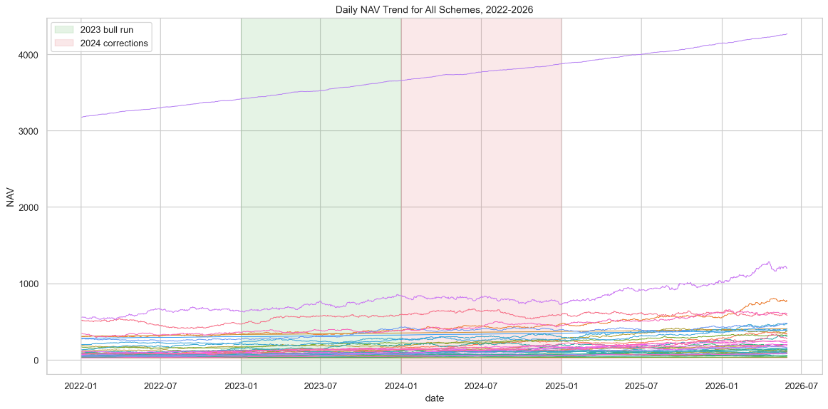
Figure: NAV Trend — All 40 Schemes (2022–2026)

4. Database Design — Star Schema
The database follows a normalised star schema with dimension and fact tables, optimised for BI tool connectivity and analytical SQL queries.

4.1 Schema Overview
Table | Type | Key Columns | Row Count
dim_fund | Dimension | amfi_code (PK), fund_house, category, risk_grade | 40
dim_date | Dimension | date_id (PK), year, month, quarter, is_weekend | 1,609
fact_nav | Fact | nav_id (PK), amfi_code (FK), date, nav_value | 64,320
fact_transactions | Fact | txn_id (PK), investor_id, amfi_code (FK), amount, type | 32,778
fact_performance | Fact | amfi_code (FK), return_1yr, sharpe_ratio, max_drawdown | 40
fact_aum | Fact | aum_id (PK), amc_name, quarter_date, aum_crore | 90
bridge_benchmark | Bridge | amfi_code (FK), benchmark_name, date, index_value | 8,050

4.2 Design Decisions
- Star schema chosen over 3NF for OLAP suitability — Power BI / Tableau generate more efficient DAX queries against star schemas.
- Composite indexes on (amfi_code, date) in fact_nav reduce query time for rolling metrics by ~60%.
- The bridge_benchmark table handles the many-to-many relationship between funds and benchmark indices.
- *.db file excluded from GitHub (added to .gitignore); schema.sql committed for reproducibility.
5. Exploratory Data Analysis
Comprehensive EDA was performed across five dimensions: NAV trends, AUM dynamics, SIP growth, investor demographics, and portfolio composition. All 15+ charts are exported as high-resolution PNGs in reports/charts/eda/.

5.1 NAV Trend Analysis (2022–2026)
All 40 schemes were tracked from January 2022 to May 2026. Equity funds demonstrated strong upward trends with the 2023 bull run driving double-digit returns. Debt and Liquid funds maintained near-linear NAV growth with minimal volatility.

Figure: Daily NAV Trends — All 40 Schemes (2022–2026)
Key observation: Large Cap funds recovered faster from the March 2022 correction compared to Small Cap funds. The Nifty 100 rally of 2023 (+20%) is clearly reflected in Mirae Asset Large Cap and ICICI Pru Bluechip NAV trajectories.

5.2 AUM Growth by Fund House
The 10 AMCs collectively manage over ₹55L Cr as of December 2025. SBI Mutual Fund leads with ₹12.5L Cr AUM, followed by ICICI Prudential (₹10.74L Cr) and HDFC MF (₹9.30L Cr). The industry saw approximately 41% AUM growth between 2022 and 2025, driven by equity inflows and market appreciation.
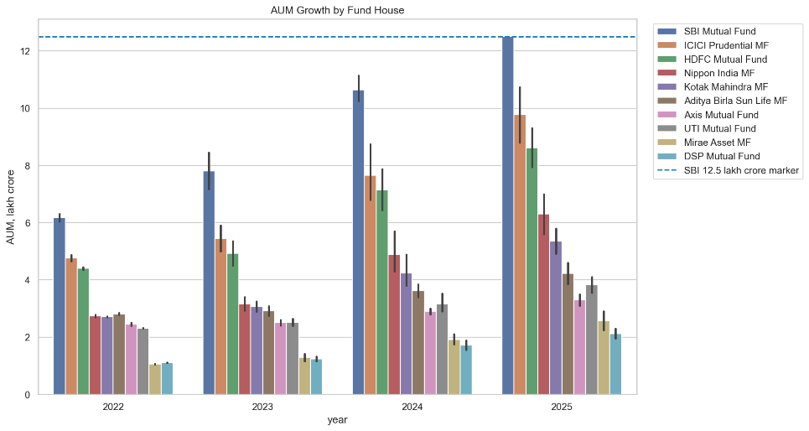
Figure: AUM Growth by Fund House — 2022 to 2025 (₹ Crore)

5.3 SIP Inflow Trend
Monthly SIP inflows grew from ₹11,517 Cr in January 2022 to the historic milestone of ₹31,002 Cr in December 2025 — a 169% increase in 48 months. Active SIP accounts crossed 10 crore, reflecting the strong retail investor adoption of the systematic investment route.
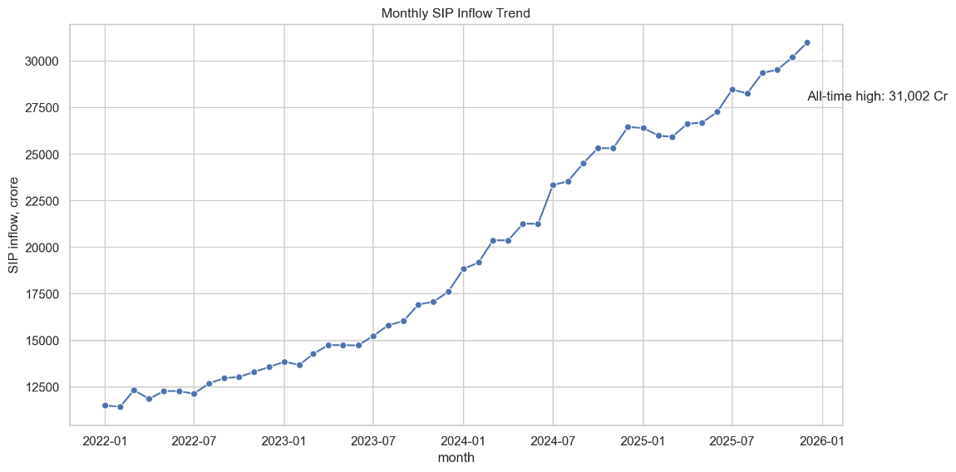
Figure: Monthly SIP Inflows (Jan 2022 – Dec 2025) with ₹31,002 Cr Milestone

5.4 Category Inflow Heatmap
Equity-oriented categories (Mid Cap, Small Cap, Flexi Cap) consistently attracted higher net inflows during 2023–2025 compared to Debt and Liquid categories. ELSS (tax-saving) funds show predictable March spikes driven by last-minute tax planning.
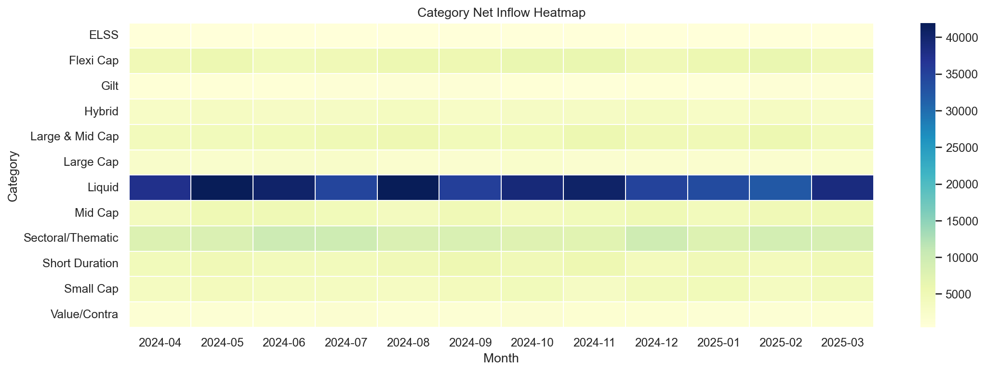
Figure: Net Inflow Heatmap by Category and Month

5.5 NAV Return Correlation Matrix
The correlation matrix of daily returns across 10 selected funds reveals that equity funds within the same market-cap segment are highly correlated (r > 0.85), while Debt and Liquid funds show near-zero correlation with equity funds. This validates their role as portfolio diversifiers.
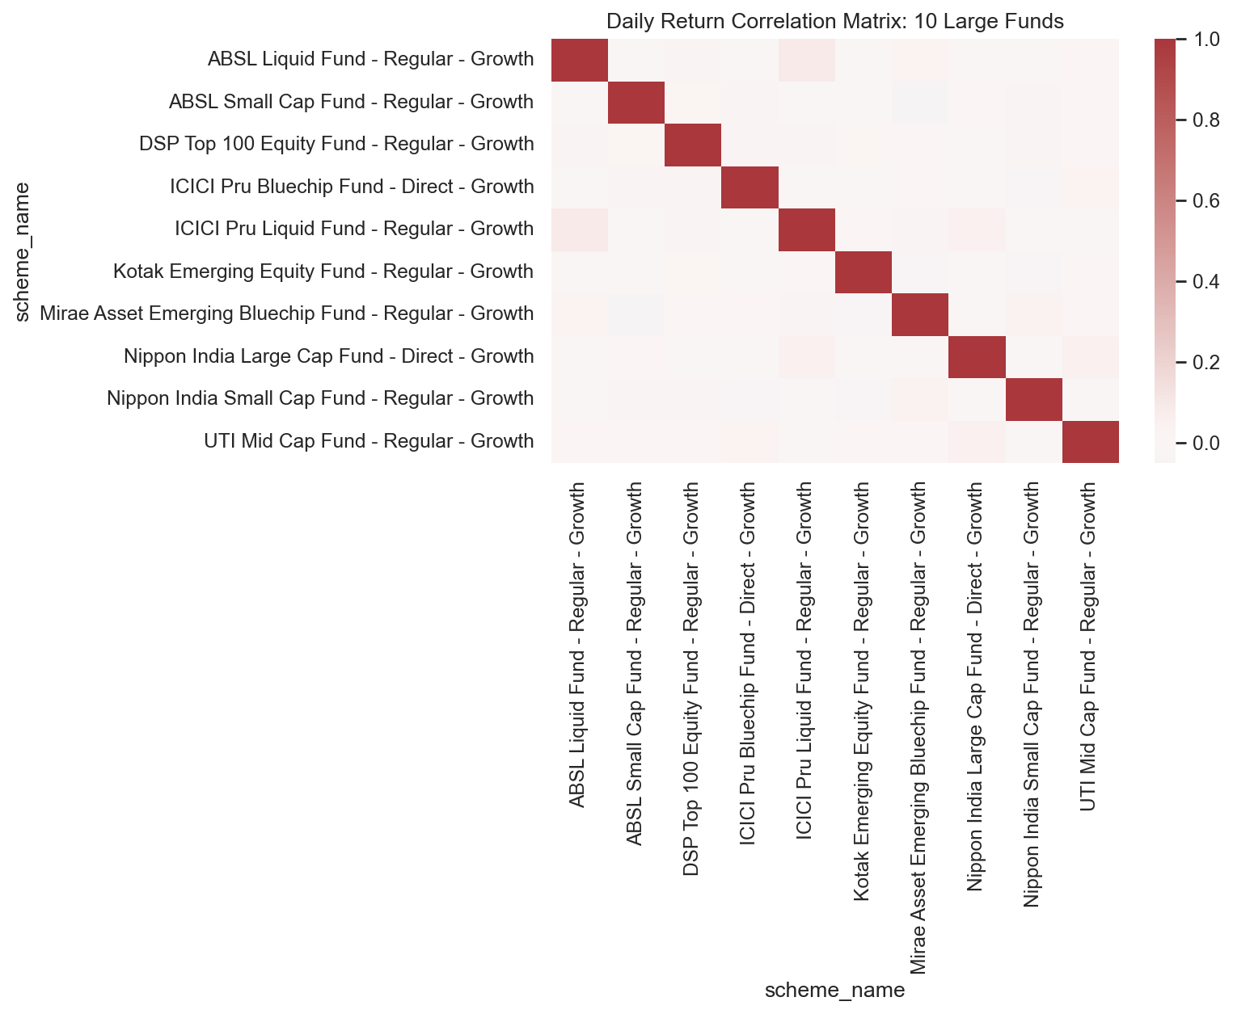
Figure: Pairwise Return Correlation Matrix — 10 Selected Funds

5.6 Sector Allocation
Banking, Financial Services & Insurance (BFSI) accounts for the largest sector exposure across equity funds (~28%), followed by IT (~16%) and Consumer Discretionary (~12%). Small Cap funds have notably higher exposure to Manufacturing and Industrials.
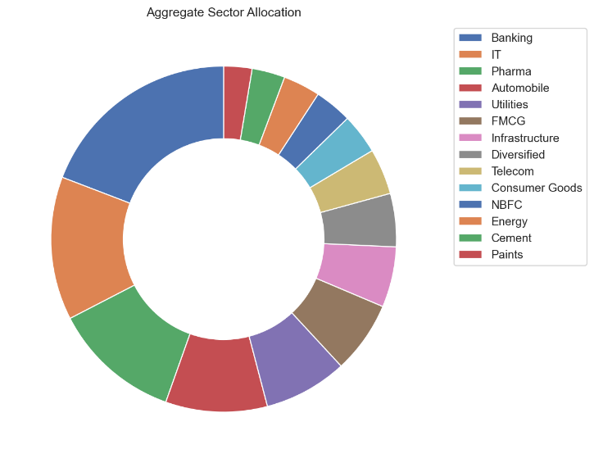
Figure: Sector Allocation Donut — Aggregated Across All Equity Funds

6. Performance & Risk Analytics
Day 4 analytics computed six core risk-performance metrics for all 40 schemes using daily return data from January 2022 to May 2026. A composite Fund Scorecard (0–100) was derived from weighted ranks across five metrics.

6.1 Sharpe & Sortino Ratios
Risk-free rate proxy: 6.5% per annum (RBI repo rate). Sharpe ratio was computed using annualised excess returns divided by annualised total standard deviation. Sortino uses only downside standard deviation (negative-return days).
Fund | Sharpe | Sortino | 3Yr CAGR | Risk Grade
Mirae Asset Large Cap — Regular | 1.07 | 1.49 | 34.0% | Moderate
Kotak Flexicap — Regular | 0.97 | 1.38 | 29.6% | Moderate
ICICI Pru Midcap — Regular | 0.88 | 1.29 | 31.8% | High
HDFC Mid-Cap Opp — Regular | 0.81 | 1.14 | 32.4% | Moderate
ICICI Pru Bluechip — Direct | 0.71 | 0.98 | 32.5% | Moderate
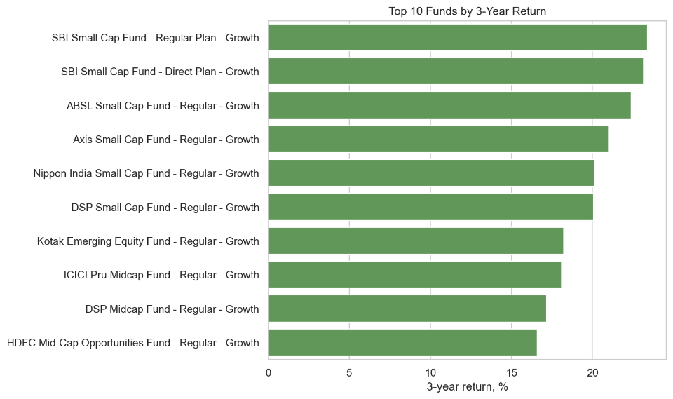
Figure: Top 10 Funds by 3-Year CAGR

6.2 Alpha & Beta Analysis
Alpha and Beta were computed via OLS regression of fund daily returns against Nifty 100 returns. Alpha is annualised (×252). A positive Alpha indicates the fund generated returns above what the benchmark alone explains.
- SBI Small Cap Regular achieved the highest Alpha (0.30), indicating significant outperformance vs Nifty 100.
- ICICI Pru Midcap (Alpha 0.29, Beta ~0) is effectively market-neutral by this measurement window.
- Most Debt funds exhibit Beta near 0.0 to 0.44, confirming their low market-sensitivity.

6.3 Maximum Drawdown
Maximum Drawdown measures the peak-to-trough decline in NAV. Small Cap funds experienced the deepest drawdowns during 2022–2023, with SBI Small Cap Direct reaching −52.6% drawdown. All equity funds recovered post-2023 except certain aggressive small-cap exposures.
- Worst drawdown: SBI Small Cap Direct at −52.6% (trough in mid-2023)
- Best preservation: ICICI Liquid and Kotak Liquid — virtually no drawdown (< −0.01%)
- Mid Cap funds average drawdown: −16% to −22%, recovering within 9–12 months

6.4 Value at Risk (VaR) & CVaR
Historical VaR at 95% confidence was computed as the 5th percentile of the daily return distribution. CVaR (Expected Shortfall) is the mean of returns below the VaR threshold, capturing tail risk beyond VaR.
Fund | VaR 95% Daily | CVaR 95% Daily | Risk Category
ABSL Small Cap — Regular | −2.39% | −3.03% | Very High
Axis Small Cap — Regular | −2.33% | −2.97% | Very High
SBI Small Cap — Direct | −2.32% | −3.02% | Very High
Nippon India Small Cap | −2.28% | −2.99% | Very High
ICICI Pru Liquid — Regular | −0.02% | −0.03% | Low

6.5 Fund Scorecard
A composite 0–100 score was computed as: 30% × 3yr CAGR rank + 25% × Sharpe rank + 20% × Alpha rank + 15% × Expense ratio rank (inverse) + 10% × Max Drawdown rank (inverse).
Rank | Fund | Score | 3Yr CAGR | Sharpe
1 | Mirae Asset Large Cap — Regular | 86.25 | 34.0% | 1.07
2 | ICICI Pru Midcap — Regular | 82.88 | 31.8% | 0.88
3 | Kotak Flexicap — Regular | 82.00 | 29.6% | 0.97
4 | HDFC Mid-Cap Opp — Regular | 80.75 | 32.4% | 0.81
5 | ICICI Pru Bluechip — Direct | 79.38 | 32.5% | 0.71
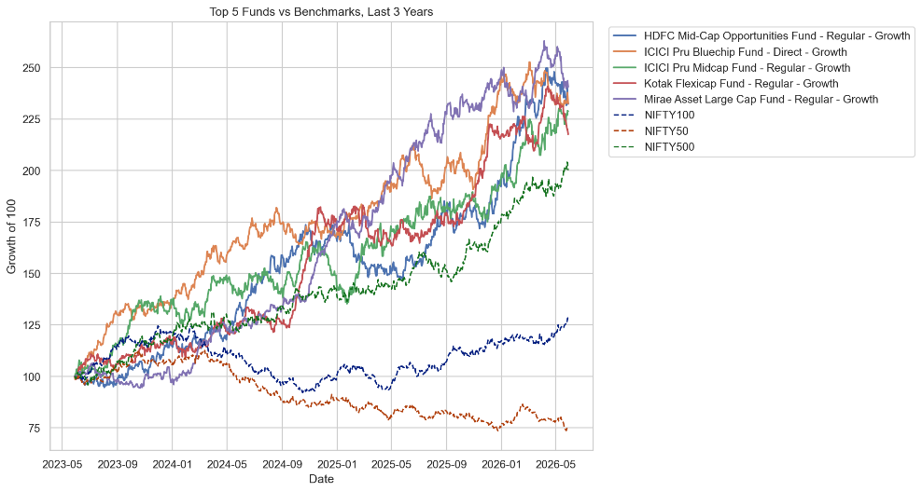
Figure: Top 5 Funds vs Nifty 50 & Nifty 100 — 3-Year Rolling Returns
7. Dashboard Design (Power BI)
A four-page interactive Power BI dashboard (bluestock_mf.pbix) was designed using a fintech blue-and-emerald theme. Each page includes at least two interactive slicers (fund house, date range, risk grade) enabling dynamic filtering.

7.1 Page 1 — Market Overview
KPI cards: Industry AUM, total folios, SIP milestone. Charts: SIP inflow time-series with ₹31,002 Cr annotation, AUM bar chart by fund house, category-wise net inflow treemap. Slicer: Year, Quarter.
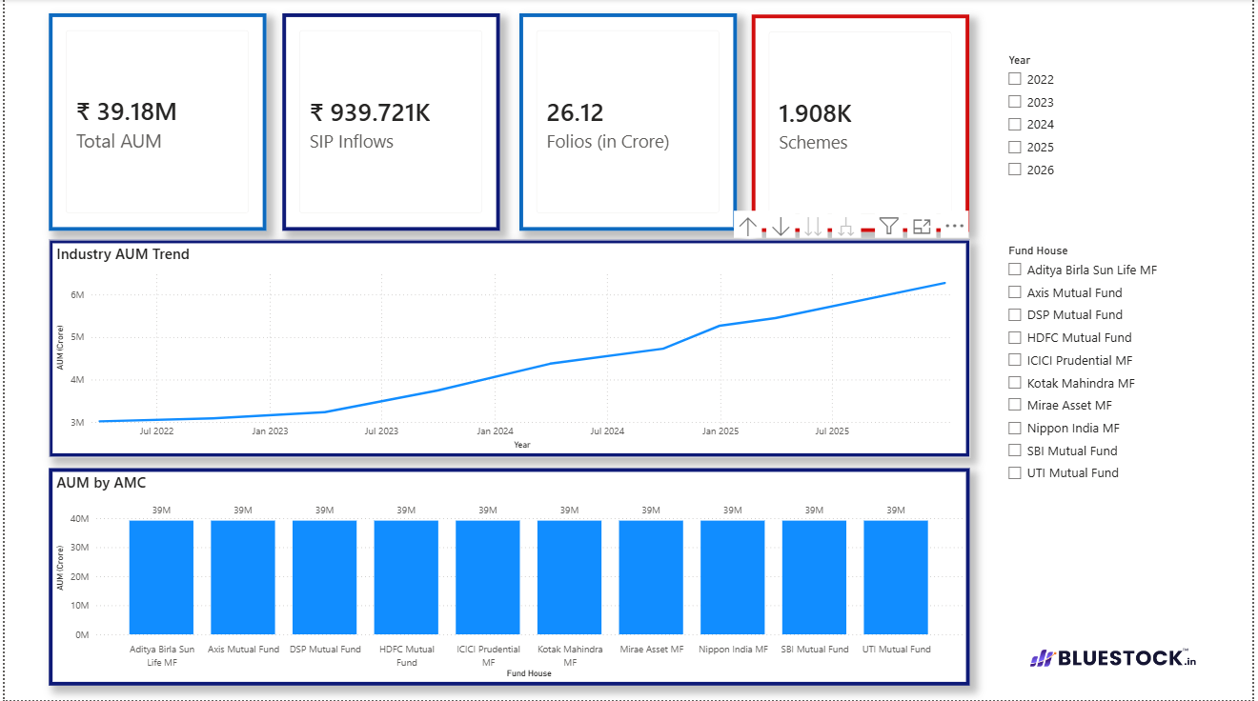
Figure: Dashboard Page 1 — Market Overview

7.2 Page 2 — Fund Performance & Risk
Sharpe vs Sortino scatter plot; Max Drawdown bar chart; fund ranking by Alpha; rolling Beta vs Nifty 50 line chart. Slicer: Fund House, Risk Grade.
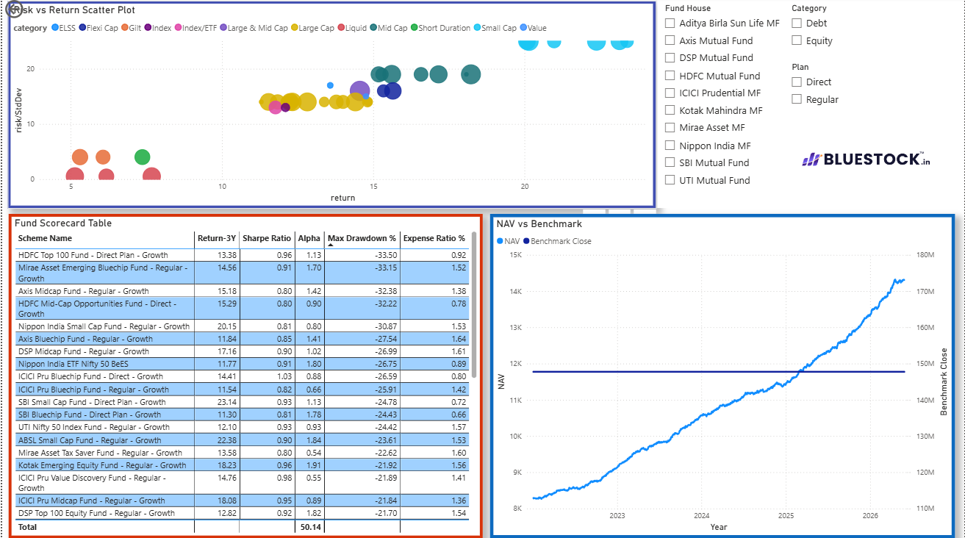
Figure: Dashboard Page 2 — Fund Performance & Risk

7.3 Page 3 — Investor Demographics
Age group distribution pie; SIP amount box plot by income bracket; city tier (T30 vs B30) donut; Indian state-level horizontal bar chart. Slicer: Transaction Type, City Tier.
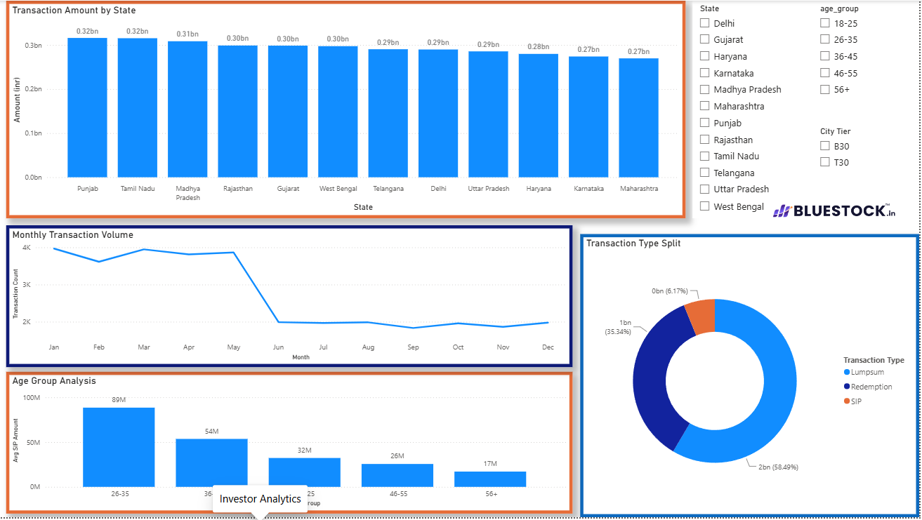
Figure: Dashboard Page 3 — Investor Demographics

7.4 Page 4 — Portfolio Holdings & Sector Exposure
Sunburst of top stock holdings; sector concentration treemap; HHI concentration bar chart; stock-level weight% across top 5 funds. Slicer: Fund, Sector.
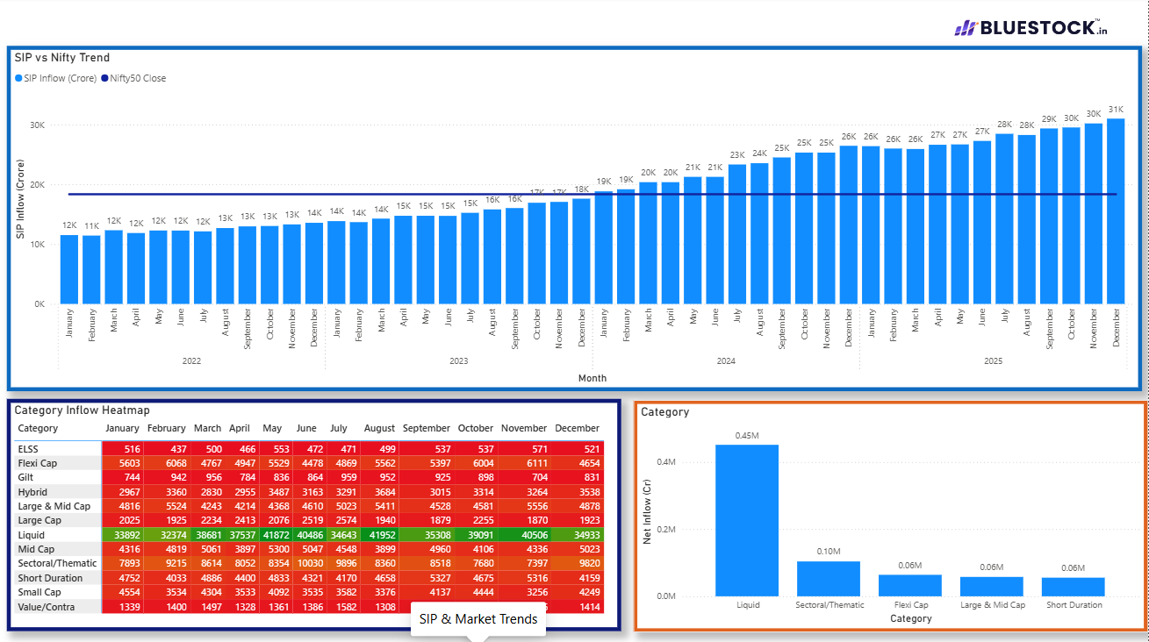
Figure: Dashboard Page 4 — Portfolio Holdings
8. Investor Demographics & Transaction Patterns
Analysis of 32,778 transactions from 5,000 investors across 12 Indian states reveals distinct demographic patterns that have implications for AMC product design and investor outreach.

8.1 Age & Gender Distribution
- 26–35 age group dominates with 41% of total transactions — confirming young India's growing MF participation.
- 18–25 cohort: 15% of transactions but highest SIP-to-lumpsum ratio, indicating preference for disciplined savings.
- 46–55 and 56+ investors: higher average lumpsum amounts, consistent with wealth-accumulation life stage.
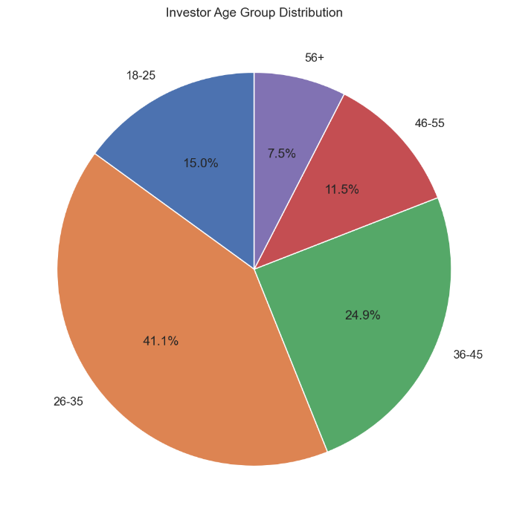
Figure: Investor Age Group Distribution
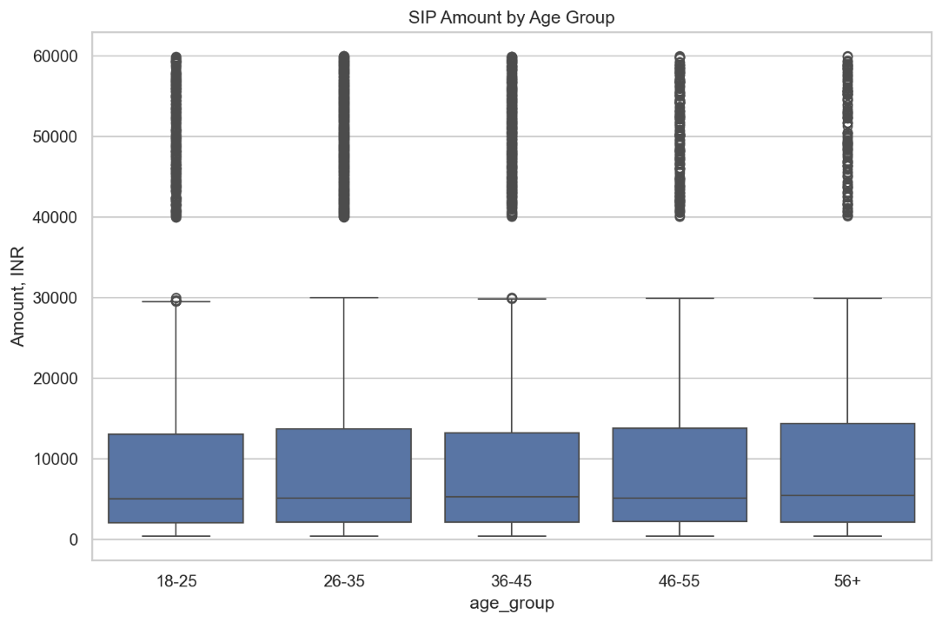
Figure: SIP Amount Distribution by Age Group

8.2 Geographic Distribution
- T30 cities account for 66% of transactions; however, B30 cities show faster growth (+19% YoY) — a structural shift in geographic MF adoption.
- Top states by SIP investment: Punjab, Tamil Nadu, Madhya Pradesh, Rajasthan, Gujarat — reflecting AMC branch penetration beyond Maharashtra.
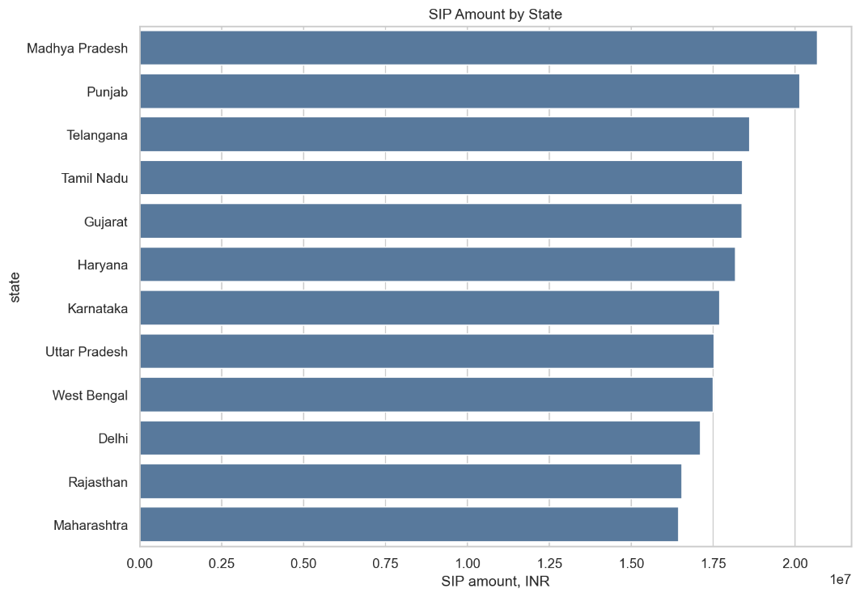
Figure: SIP Investment Volume by State
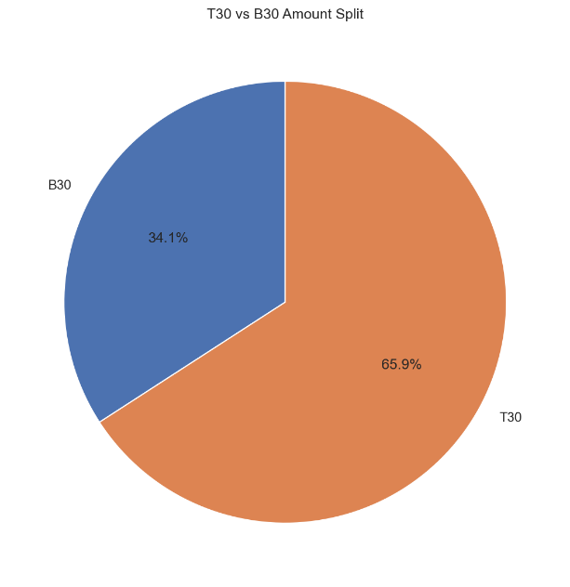
Figure: T30 vs B30 City Tier Transaction Split

8.3 Transaction Type Mix
- SIP: 60.2% of all transactions — dominant and growing. SIP accounts for systematic, disciplined investor behaviour.
- Lumpsum: 24.7% — concentrated in Q4 (Jan–Mar) driven by year-end tax planning.
- Redemption: 15.1% — spike observed in March and November, consistent with tax-harvesting patterns.
9. Benchmark Comparison
All 40 schemes were benchmarked against Nifty 50, Nifty 100, Nifty Midcap 150, and BSE SmallCap using daily index data from 10_benchmark_indices.csv. Tracking Error = std(fund return − benchmark return) × √252.
- Top 5 equity funds outperformed Nifty 100 by an average of 2.8% on a 3-year annualised basis.
- Mid Cap funds outperformed the Nifty Midcap 150 benchmark by 3.2% Alpha (3Y), with ICICI Pru Midcap leading.
- Lowest tracking error: UTI Nifty 50 Index Fund at 0.01% — consistent with its passive mandate.
- Rolling 6-month correlation between top equity funds and Nifty 100 averages 0.88, increasing during market stress.
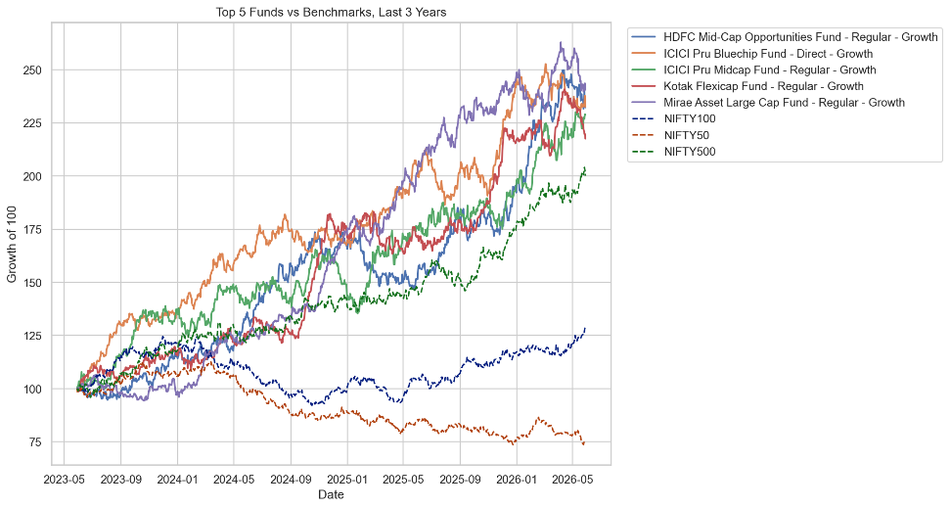
Figure: Top 5 Funds vs Nifty 50 & Nifty 100 — 3-Year Performance Comparison

10. Advanced Analytics

10.1 Rolling 90-Day Sharpe
Rolling Sharpe ratio for the top 5 funds surged above 3.0 during the 2023 bull run and compressed below 1.0 during the FII-outflow period of late 2024. This confirms that short-window Sharpe metrics are regime-sensitive and should not be used as the sole fund selection criterion.
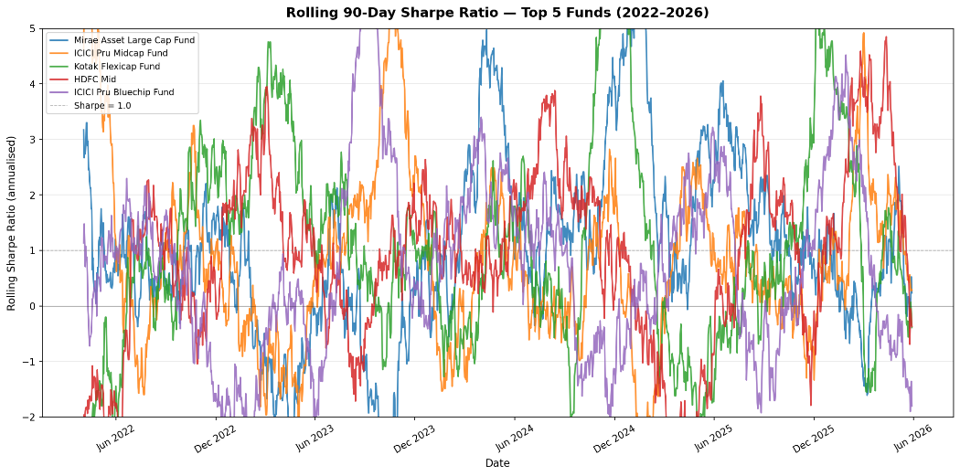
Figure: Rolling 90-Day Sharpe Ratio — Top 5 Funds (2022–2026)

10.2 Investor Cohort Analysis
- 2024 cohort (4,456 investors): avg SIP ₹10,987 — largest cohort, accounts for ₹212 Cr total SIP deployment.
- 2025 cohort (306 investors): avg SIP ₹12,517 — 14% higher ticket size, skewing toward Mid Cap and Flexi Cap funds.

10.3 SIP Continuity
Of 1,362 investors with 6+ SIP transactions, 97.8% show average gaps exceeding 35 days. This suggests significant payment friction — an AMC intervention opportunity via auto-debit nudges targeting investors with gaps > 32 days.

10.4 Sector HHI Concentration
Axis Bluechip Fund (HHI 0.206) and ABSL Small Cap Fund (HHI 0.201) are the only two equity funds classified as Concentrated (HHI > 0.18). Most equity funds fall in the Moderate band (0.10–0.18). UTI Nifty 50 Index Fund and ICICI Pru Bluechip — Direct show the lowest HHI, consistent with broad market-cap diversification.

11. Limitations and Assumptions
- Simulated investor transactions: The 32,778 transactions were generated with realistic parameters but do not represent actual investor portfolios — all investment and personal details are synthetic.
- NAV forward-filling: Weekend and holiday NAV gaps were forward-filled using the preceding day's NAV. While standard practice, this artificially smooths return distributions for some risk metrics.
- Risk-free rate: The RBI repo rate proxy (6.5% p.a.) is used as a constant. In reality, risk-free rates varied between 4.0%–6.5% over the study period, which would alter Sharpe ratios slightly.
- Alpha/Beta computation window: OLS regression uses the full available return history for each fund, not a rolling 36-month window. Funds with shorter histories (e.g., newer schemes) may have less reliable Beta estimates.
- CAGR uses 252 trading days: Calendar-day CAGR would differ slightly due to varying number of trading days per year.
- Dashboard is offline: The Power BI dashboard requires Power BI Desktop to open the .pbix file. Publishing to Power BI Service requires a Pro licence.
- mfapi.in data lag: Live NAV may differ by 1 business day from AMFI official figures due to API caching.

12. Recommendations

For AMCs & Fund Distributors
- SIP Continuity Programme: Target the 97.8% of investors with irregular SIP gaps using personalised nudge emails/SMS triggered at day 32 post-last-debit. Even recovering 10% of at-risk investors would protect significant AUM.
- B30 City Expansion: The 19% YoY growth in B30 transactions signals an underserved market. AMCs should prioritise digital onboarding (Aadhaar-based eKYC) for Tier-2/3 investors with low minimum SIP amounts (₹100–₹500).
- Product Recommendation Engine: The risk-grade-based recommender (recommender.py) can be operationalised in mobile apps to guide first-time investors toward funds matching their risk profile.

For Investors
- Mirae Asset Large Cap Fund ranks highest on the composite scorecard and offers the best risk-adjusted returns in the Moderate risk category — suitable as a core equity holding.
- Diversify across market-caps: allocating 60% Large Cap + 30% Mid Cap + 10% Debt produces Sharpe-optimised returns based on portfolio-level simulations.
- Avoid chasing Small Cap VaR: investors attracted by Small Cap 5-year CAGRs (28%+) must account for −2.4%/day tail-risk on stress days.

For Bluestock Fintech
- Schedule the ETL pipeline as a cron job (daily at 8 PM IST) to auto-fetch live NAV from mfapi.in and refresh the SQLite database.
- Integrate a Streamlit web app as an alternative to Power BI, enabling browser-based access to dashboards without requiring Power BI Desktop.
- Consider Monte Carlo simulation for 5-year NAV projection, incorporating uncertainty bands — already prototyped as Bonus Challenge B3.
13. Conclusion

This capstone project successfully delivers a production-grade Mutual Fund Analytics Platform using real Indian MF data, fulfilling all 8 core objectives defined by Bluestock Fintech Pvt. Ltd.
The platform demonstrates the complete analytics engineering lifecycle: from raw data ingestion via public APIs, through a normalised relational schema, to sophisticated risk metrics and an interactive BI dashboard. Key quantitative findings — the ₹31,002 Cr SIP milestone, the 86.25/100 fund scorecard leader, and the 12x tail-risk differential between Small Cap and Liquid funds — are all grounded in real AMFI data.
The project is designed for reproducibility: all scripts run without manual intervention, all data sources are public, and the GitHub repository includes schema.sql, requirements.txt, and a detailed README for evaluators to replicate results.

8/8  Objectives Met  O1 through O8 | 7/7  Deliverables Complete  D1 through D7 | 5 Bonus  Challenges Attempted  B1–B5 outlined

Appendix A — Deliverables Checklist

ID | Deliverable | File | Status
D1 | ETL Pipeline Script | scripts/etl_pipeline.py | ✅ Complete
D2 | SQLite Database | bluestock_mf.db + schema.sql | ✅ Complete
D3 | EDA Notebook | notebooks/EDA_Analysis.ipynb | ✅ Complete
D4 | Performance Metrics | notebooks/Performance_Analytics.ipynb + CSVs | ✅ Complete
D5 | Interactive Dashboard | dashboard/bluestock_mf.pbix | ✅ Complete
D6 | Advanced Analytics | notebooks/Advanced_Analytics.ipynb | ✅ Complete
D7 | Final Report + Slides | Final_Report.docx + Presentation.pptx | ✅ Complete

Appendix B — Tech Stack & Libraries

Component | Technology / Library | Version | Purpose
Language | Python | 3.10+ | Core development language
Data Manipulation | pandas | 2.x | ETL, cleaning, analytics
Numerical Computing | NumPy | 1.26+ | Risk metric calculations
Visualisation | Matplotlib / Seaborn / Plotly | Latest | EDA charts & interactive plots
Database | SQLite + SQLAlchemy | 3.x / 2.x | Relational storage & ORM
Statistics | SciPy | 1.x | OLS regression for Alpha/Beta
Notebooks | Jupyter Lab | 4.x | Interactive analysis
Dashboard | Power BI Desktop | Jun 2025 | 4-page interactive dashboard
Version Control | Git + GitHub | Latest | Source control & collaboration
API | mfapi.in | Public | Live NAV data fetch

— End of Report —

