Public Health Trend Analysis and Life Expectancy Prediction

1. Cover Page
Project Title: Public Health Trend Analysis and Life Expectancy Prediction Using Machine Learning
Course: Machine Learning

2. Abstract
This report presents a complete machine learning workflow for predicting life expectancy based on health and socioeconomic indicators. The project utilizes the WHO Life Expectancy dataset.

3. Introduction
Life expectancy is a critical metric for public health. This analysis explores various factors influencing life expectancy to aid in planning and policy making.

4. Problem Statement
A public-health organization wants to analyze historical observations and identify meaningful patterns useful for planning.

5. Objectives
- Perform Exploratory Data Analysis (EDA)
- Preprocess data and handle missing values
- Train and evaluate regression models
- Build an interactive Streamlit application

6. Dataset Description
The WHO dataset contains data from 2000-2015 for 193 countries, totaling 2938 records and 22 columns.

7. Exploratory Data Analysis
Trend Over Years:
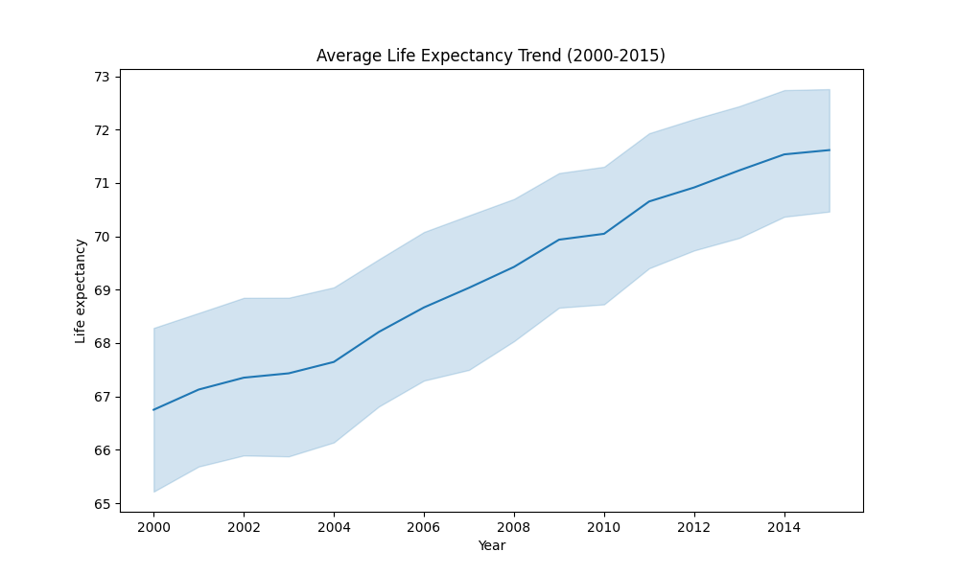
Observation: Life expectancy generally shows an increasing trend from 2000 to 2015.

8. Machine Learning Methodology
Linear Regression, Decision Tree Regressor, and Random Forest Regressor were trained on an 80/20 train-test split. Missing data was imputed (median for numeric, mode for categorical).

9. Results and Findings
Model Comparison Table:
Model | MAE | MSE | RMSE | R²
Linear Regression | 2.9273 | 15.6142 | 3.9515 | 0.8195
Decision Tree Regressor | 1.5783 | 7.2903 | 2.7000 | 0.9157
Random Forest Regressor | 1.0534 | 2.8209 | 1.6795 | 0.9674
Best Model: Random Forest Regressor
R² Score: 0.9674
RMSE: 1.6795

10. Conclusion
The Random Forest model effectively predicts life expectancy, demonstrating that socioeconomic factors heavily influence public health outcomes.

