**RAG(Knowledge Base)**

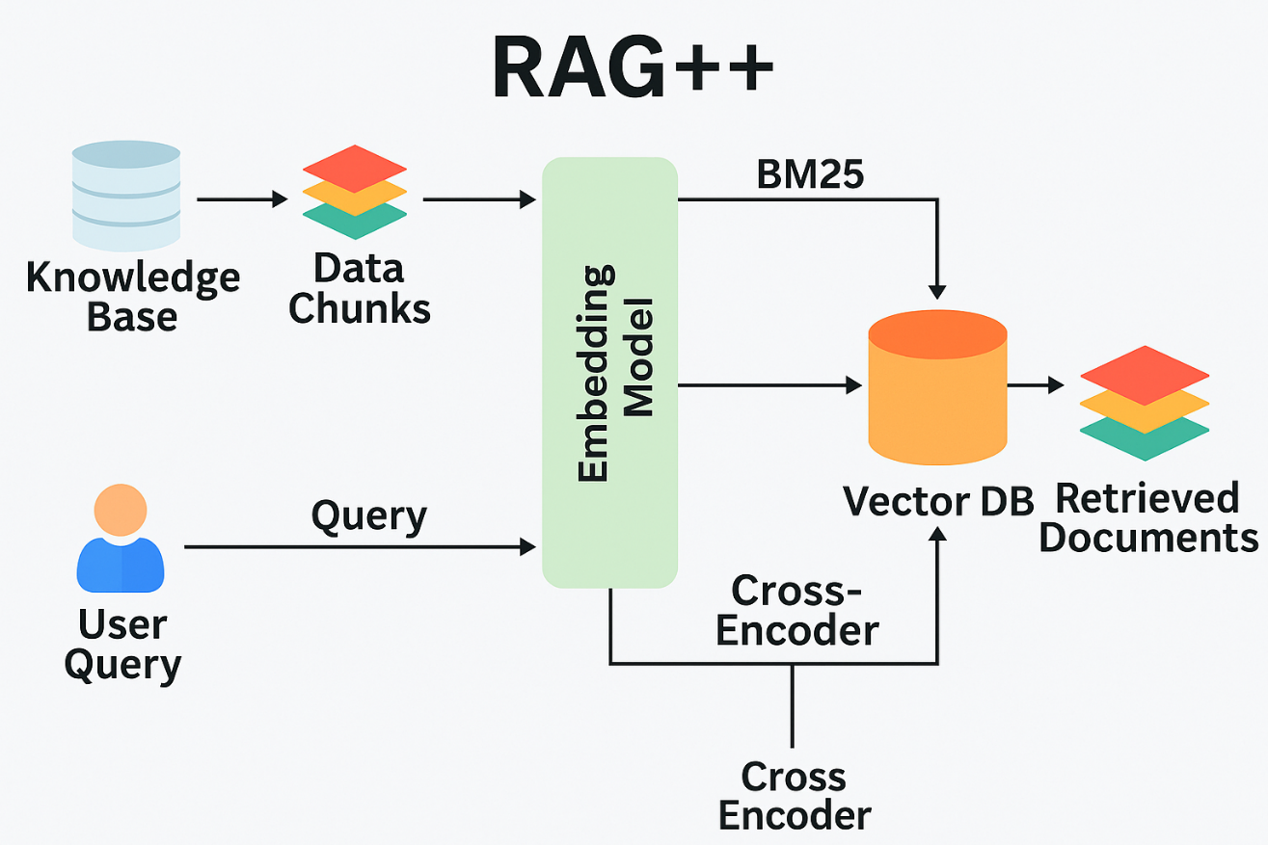

**Description:**

This project is a smart knowledge-based assistant that leverages a robust tech stack to provide fast, accurate, and context-aware answers. It uses ChromaDB or PostgreSQL to store and manage data, which is then transformed into embeddings for vector search—enabling efficient semantic retrieval. Retrieved relevant contexts are passed to a Large Language Model (LLM), which generates clear, human-like responses based on the input, making information access seamless and intelligent.

**Tech Stack:**

* CHROMADB/POSTGRE SQL: FOR STORING DATA AS KNOWDLEGE BASE
* VECTOR SEARCH: CONVERT THE DATA INTO VECTOR FOR FASTER ANS SEMANTIC SEARCH
* LLM INTEGRATION: THE RETRIVED CONTEXTS WILL BE SENT TO THE LLM AND GIVES CLEANER ANSWER
* Reinforcement Learning(Optional)

**TIME LINE:**

**Completely depends upon the dataset of the organization approx. < 1.5 month**

**AGENTIC FLOW(Workflow Automation)**

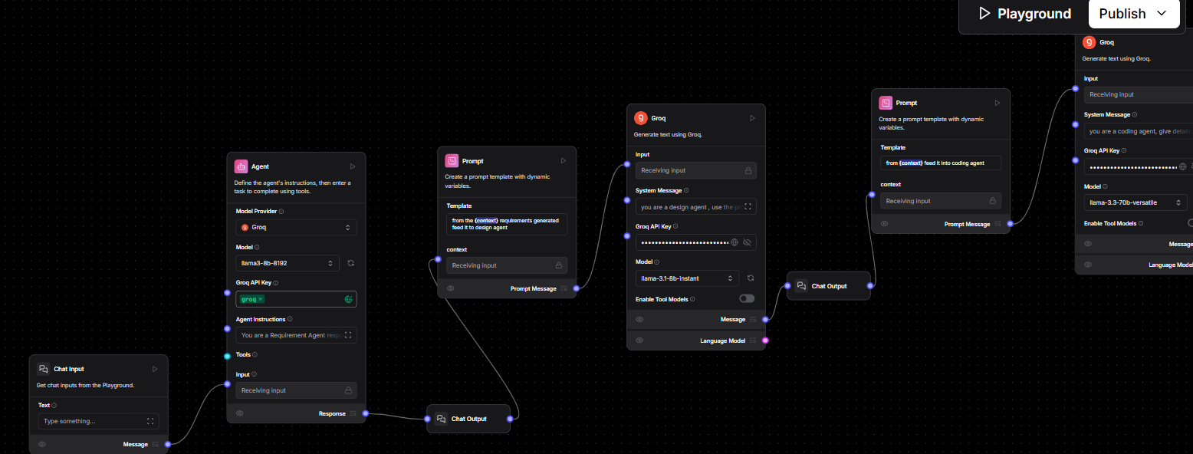 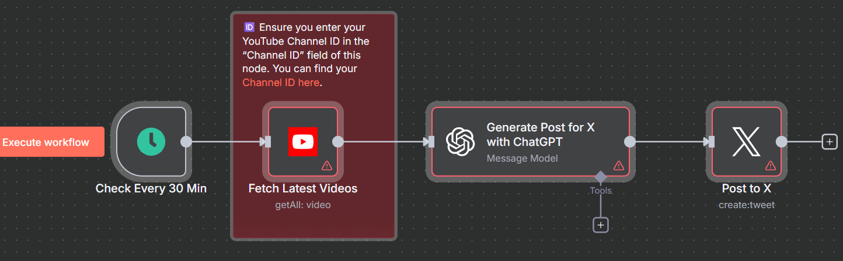

**Description:**

This project automates the core operational workflows of the organization—from conducting in-depth research on speakers to seamlessly publishing content across platforms like Instagram, X (formerly Twitter), and YouTube. It streamlines the entire process, ensuring consistent branding, faster execution, and a stronger digital presence with minimal manual intervention.

**Tech Stack:**

* Visual orchestration like n8n or Langflow
* Agent2Agent Communication
* Reasoning and One-shot model integration(Deepseek r1, GPT4-o)
* Model Providers – Groq

**TIME LINE:**

**Deployment time depends on workflow complexity and data readiness but typically takes less than one month for most organizations approx. < 1 month**

**HR AUTOMATION**

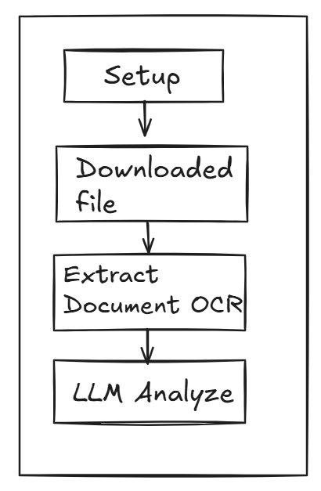

**Description:**

This project automates the initial resume screening process using **n8n**, **OpenAI**, and **Supabase**, streamlining candidate evaluation for recruiters and HR professionals. It intelligently analyzes a candidate’s resume against a job description and outputs structured insights to support faster, data-driven hiring decisions.

**Tech Stack:**

* n8n: Orchestration and automation
* OpenAI GPT-4o-mini: AI-driven CV analysis
* Supabase: CV hosting and structured result storage
* JSON Schema: Standardized output formatting

**TIME LINE:**

**This project may take up to approx. 15 days**