**AGENTIC FLOW (Workflow Automation)**

**FOR EACH MEMBER**

This document presents a consolidated roadmap of automation projects designed to optimize and streamline workflows across multiple functional areas within our organization. Each initiative is tailored to a specific use case, addressing recurring challenges with intelligent, AI-driven solutions that reduce manual effort, improve efficiency, and generate actionable insights.

The projects include:

* **HR Automation (Prathyusha):** AI-powered resume screening integrated with n8n, OpenAI, and Supabase to standardize candidate evaluation and accelerate hiring decisions.
* **Video Editing Automation (Aadiraj):** A knowledge assistant and workflow simplification toolkit that leverages RAG systems and automation tools to reduce manual content-editing work.
* **Guest Research Automation (Meneno):** A multi-agent research system with YouTube comment scraping and structured data pipelines to deliver faster and more comprehensive guest profiles.
* **Arsh Automation:** AI-driven content optimization to identify reel highlights, automate Opus Clip workflows, and recommend engaging thumbnail and title tools.
* **Neetu Automation:** Automated transcript-to-chart pipelines that transform raw meeting transcripts into structured data and visual dashboards for quick insights.
* **Overall RAG Knowledge Base:** A centralized, team-centric knowledge assistant integrating context retrieval and LLMs to provide fast, accurate, and human-like responses.

Each project is scoped with a clear timeline and deliverables, collectively showcasing how automation can transform everyday workflows into scalable, intelligent, and data-backed systems. Together, these initiatives highlight a unified vision: leveraging AI and automation to enhance decision-making, creativity, and organizational productivity.

**HR AUTOMATION(Prathyusha)**

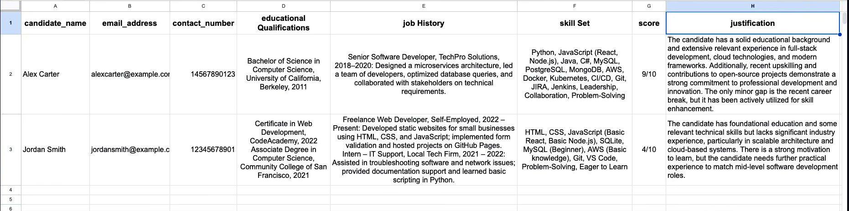 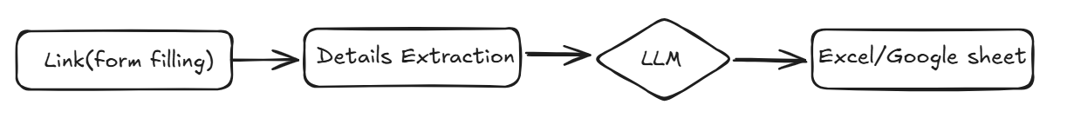

**Description:**

This project automates the initial resume screening process using **n8n**, **OpenAI**, and **Supabase**, streamlining candidate evaluation for recruiters and HR professionals. It intelligently analyzes a candidate’s resume against a job description and outputs structured insights to support faster, data-driven hiring decisions.

**Tech Stack:**

* n8n: Orchestration and automation
* OpenAI GPT-4o-mini: AI-driven CV analysis
* Supabase: CV hosting and structured result storage
* JSON Schema: Standardized output formatting

**Scope:**  
Automate the initial screening of resumes by analyzing candidate profiles against job descriptions and generating structured evaluation reports.

**Goals:**

* Reduce manual effort in resume shortlisting.
* Ensure consistent, unbiased, and data-driven evaluation.
* Provide recruiters with structured insights to make faster hiring decisions.

**TIME LINE: This project may take up to approx. 15 days**

**Video Editing Automation (Aadiraj)**

**Description:**

**Proposed Solutions**

1. **AI-Powered Knowledge Assistant (RAG System)**
   * Build a **Retrieval-Augmented Generation (RAG)** system trained on *Aadiraj contents*.
   * Newcomers can interact via a chatbot to get instant answers about processes, policies, and resources.
2. **Work Simplification Tools**
   * Identify and integrate **automation workflows** using existing tools in *Premier*.
   * Suggest additional productivity tools to reduce manual work and improve efficiency.

**Scope:**  
Simplify video-editing workflows and onboard newcomers faster using an AI-powered knowledge assistant and productivity automation.

**Goals:**

* Provide instant knowledge access via a chatbot trained on Aadiraj content.
* Reduce manual effort in video-editing workflows.
* Suggest additional productivity tools for efficiency.

**TIME LINE:**

**This project may take up to approx. 5 days**

**Guest Research Automation (Meneno)**

**Objective**

Automate the research process for guest profiling and engagement insights, reducing manual effort and enabling faster, structured data collection.

**Proposed Solutions**

1. **Multi-Agent Research System**
   * A network of agents working collaboratively.
   * Agents handle different aspects such as:
     + Guest timeline (career highlights, events)
     + Published works (books, articles)
     + Podcast appearances and media features
   * Agents communicate with each other (e.g., a **search agent** fetching raw data and passing it to a **summarization/analysis agent**).
2. **YouTube Comment Scraper (Free Tool)**
   * Lightweight application to scrape YouTube comments quickly and at no cost.
   * Extract audience feedback, sentiment, and engagement patterns.
   * Simplifies data collection compared to manual reviews.
3. **Additional Productivity Enhancements**
   * Recommend and integrate automation tools to reduce repetitive tasks.
   * Streamline research pipelines for better efficiency and consistency.

**TIME LINE:**

**This project may take up to approx. 20 days**

**Arsh Automation**

**Objective**

Automate the **content optimization workflow** by leveraging AI to identify impactful reel moments, streamline Opus Clip automation, and recommend tools for thumbnail and title generation — ultimately reducing manual effort and driving higher engagement through data-backed insights.

**Reels Timestamp Suggestion Model**

* AI model trained on past high-performing reels.
* Analyses how hooks and engagement moments were created.
* Suggests the **best timestamps/moments** from new transcripts to maximize reel impact.

**Opus Clip Automation**

* Enhance prompt engineering for improved **Opus Clip reel automation**.
* Automatically extract **audience feedback, sentiment, and engagement patterns**.
* Streamline content repurposing, reducing manual data collection and review.

**Smart Tool Suggestions for Thumbnails & Titles**

* Recommend AI-driven tools to generate **engaging thumbnails and optimized titles**.
* Improve click-through rates and viewer retention with data-backed suggestions.

**TIME LINE:**

**This project may take up to approx. 10 days**

**Neetu Automation**

**Automate the process of converting meeting transcripts into structured data and transforming that data into clear, actionable visual charts — reducing manual effort and enabling faster, data-driven insights.**

**📊 Transcript → Data → Charts**

* **Transcript to Data**: Extract key information, themes, and metrics from raw meeting transcripts.
* **Data to Charts**: Automatically generate visual charts and dashboards for improved clarity and decision-making.
* **Outcome**: Simplifies analysis, enhances understanding, and accelerates insight discovery.

**TIME LINE:**

**This project may take up to approx. 7 days**

**OVERALL RAG (Knowledge Base)**

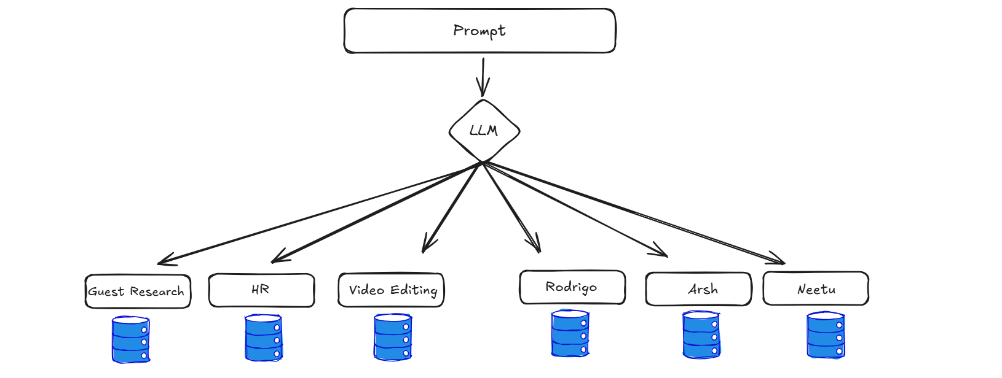

**Details:**

This project is a **smart knowledge-based assistant** designed to deliver **fast, accurate, and context-aware answers**. It leverages a **robust tech stack** and integrates with the team’s collective knowledge base for seamless information access.

**Key Features:**

* **Team-Centric Knowledge Base**: Each team member has a **dedicated database**, ensuring personalized and organized knowledge management.
* **Intelligent Retrieval**: Relevant contexts are retrieved efficiently and passed to the **Large Language Model (LLM)**.
* **Human-Like Responses**: The LLM generates clear, natural, and **human-like answers** tailored to user queries.
* **Seamless Access**: Makes information discovery **faster, smarter, and more intuitive** across the team.

**Scope:**  
Develop a centralized, team-centric knowledge assistant that provides fast, context-aware, and accurate answers across organizational datasets.

**Goals:**

* Create a dedicated database for each team member’s knowledge.
* Ensure intelligent retrieval of relevant context for queries.
* Generate human-like, clear, and natural responses.
* Make organizational knowledge easily discoverable and accessible.

**TIME LINE:**

**Completely depends upon the dataset of the organization approx. < 1.5 month**

**OVERALL COSTS**

* **N8N SUBCRIPTION: 28 EURO/per month**
* **OPEN AI API: 5$**
* **CURSOR PRO: 20$ Monthly**

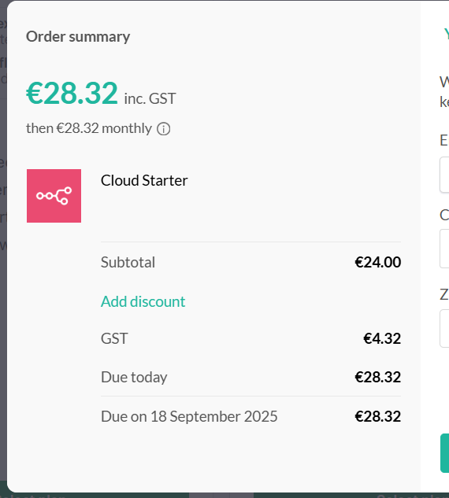 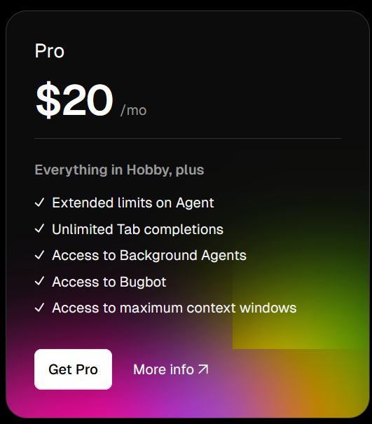

**Cheaper Alternative to N8N Cloud:**

**KVM Hosting from Hostinger(need to research on this)**