STUDENT INFORMATION MANAGEMENT SYSTEM

UML DIAGRAMS:
The following UML diagrams describe the process involved in the system
a. Use case diagram
b. Class diagram
c. Sequence diagram
d. Collaboration diagram
e. Activity diagram
f. Dataflow diagram

USE CASE DIAGRAM:

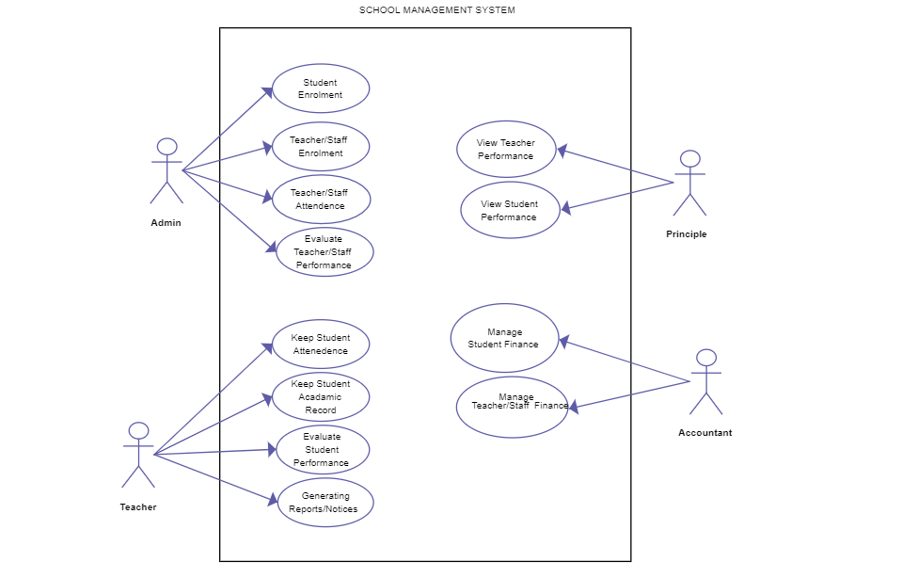

CLASS DIAGRAM:

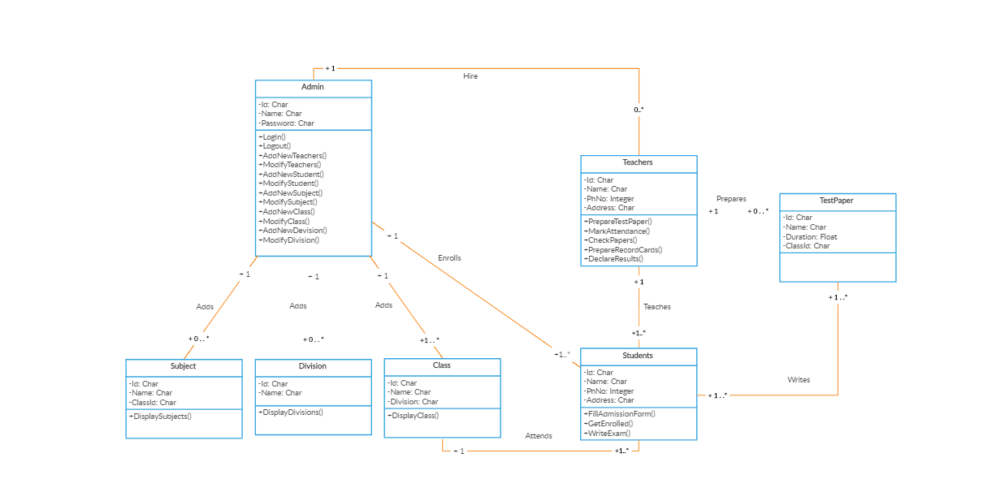

SEQUENCE DIAGRAM:

For Validity:
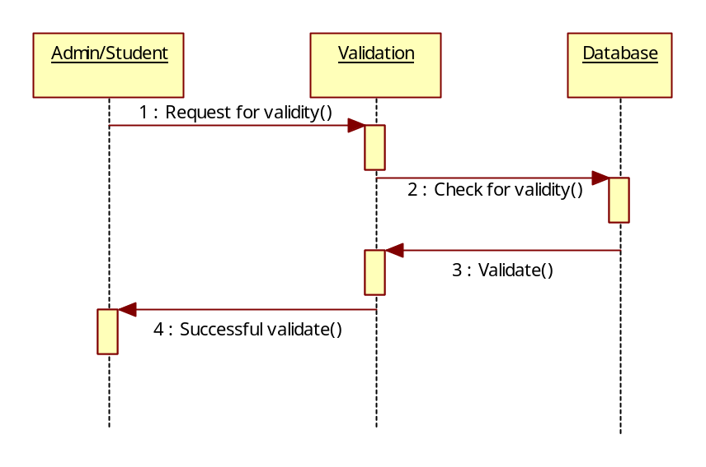

For Administrator:
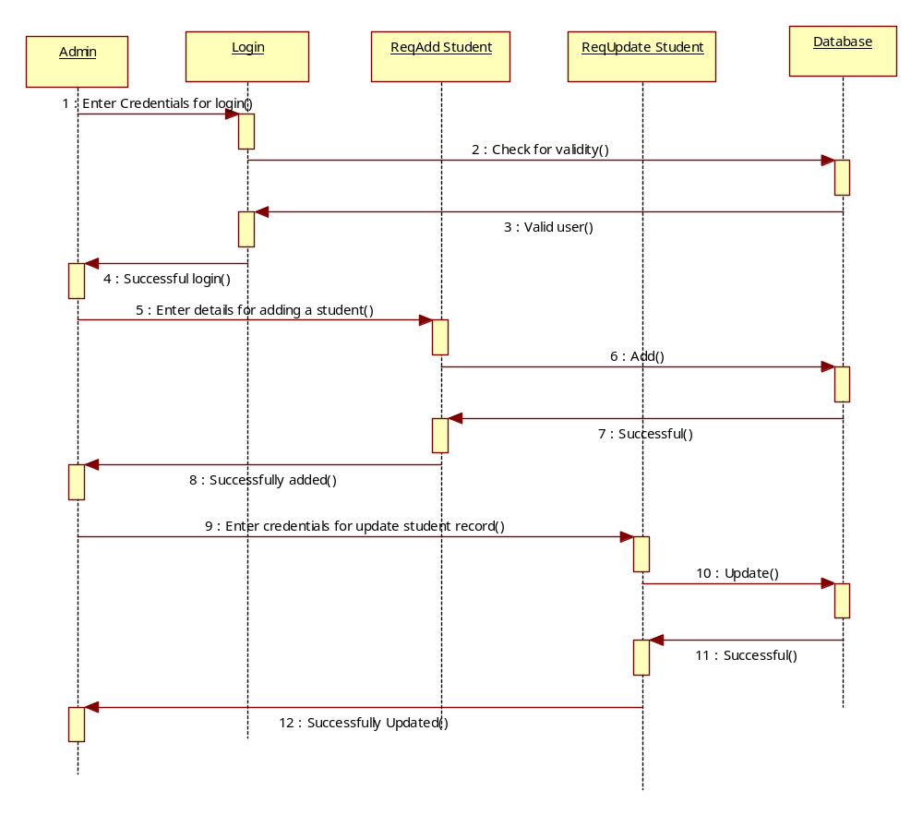

For Student:
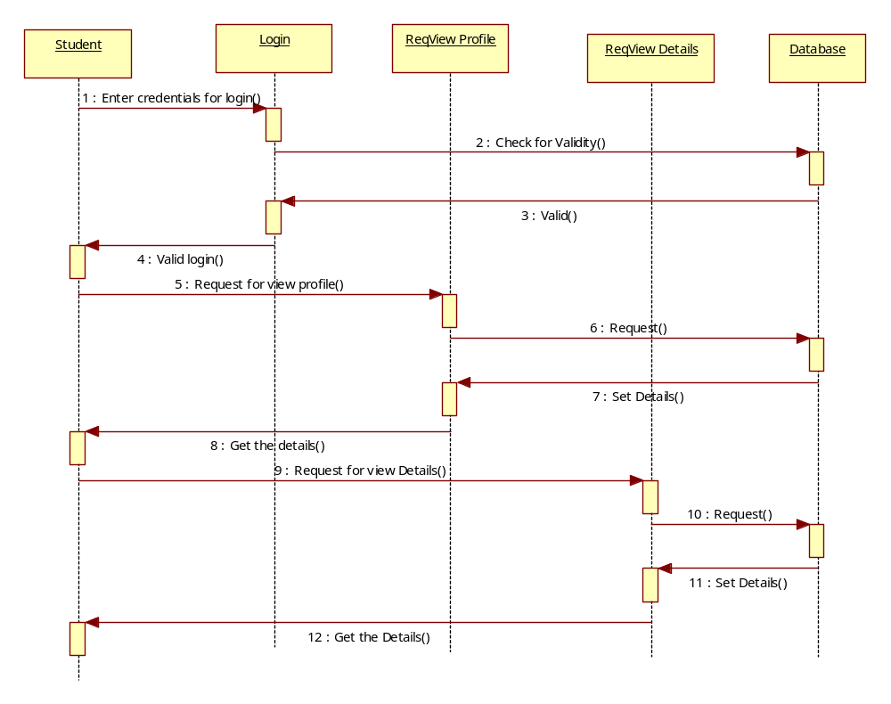

COLLABRATION DIAGRAM:

For Validity:
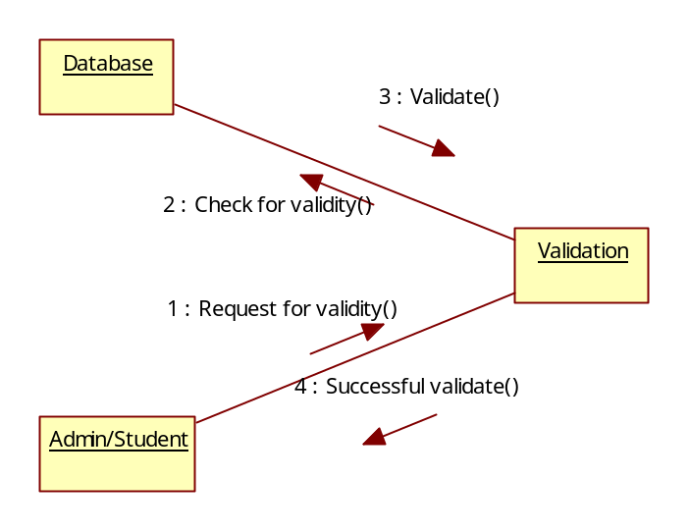

For Administrator:
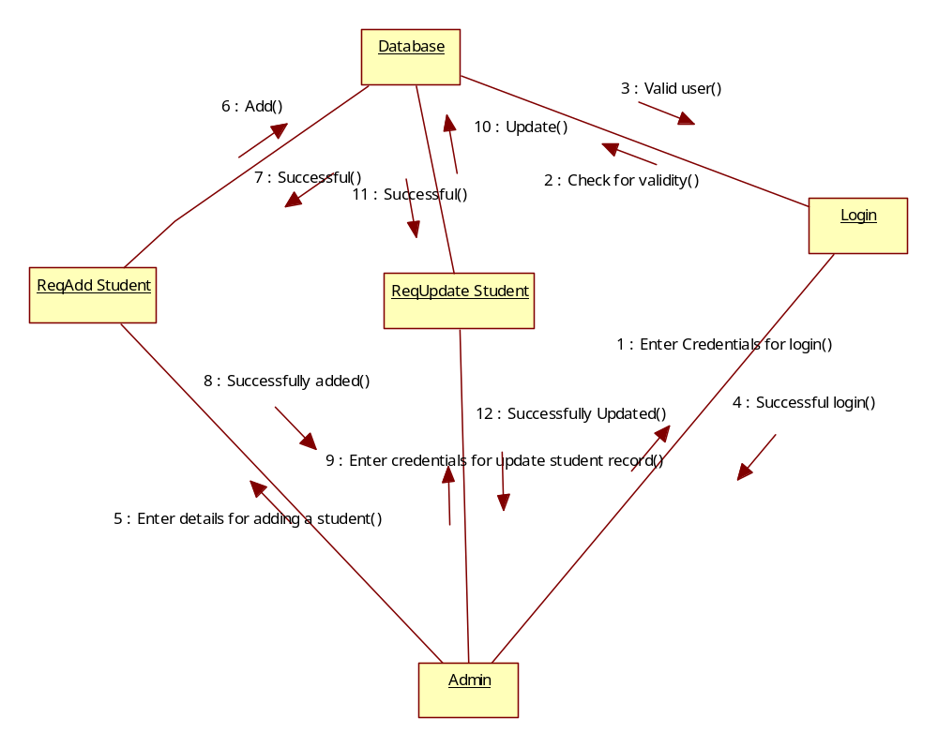

For Student:
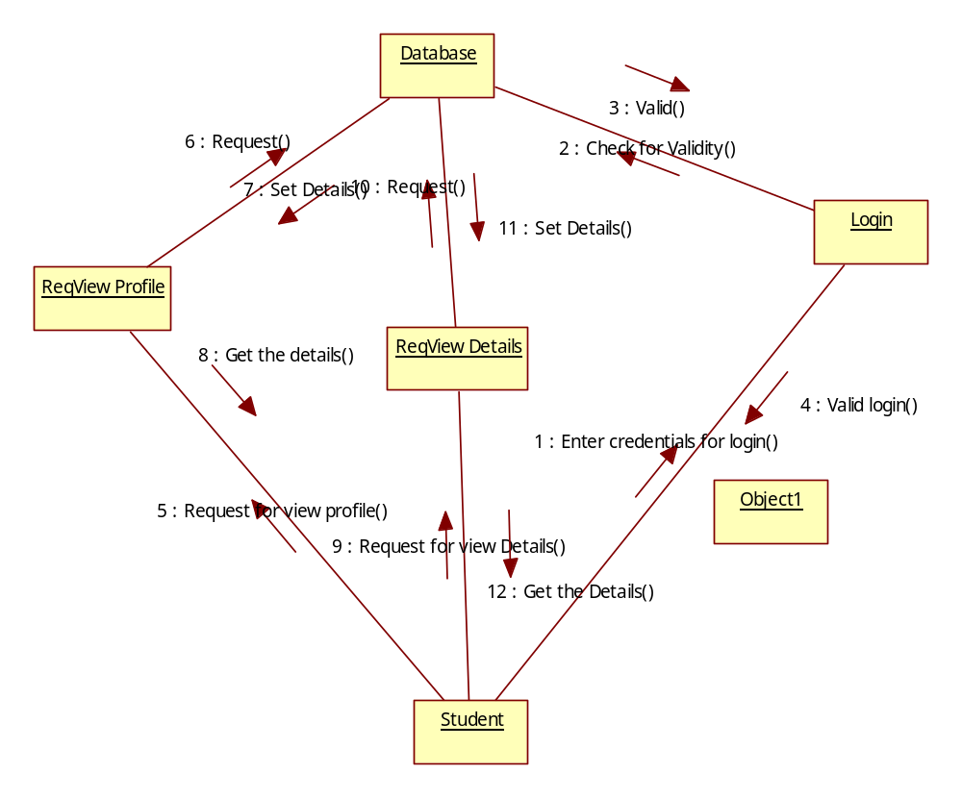

ACTIVITY DIAGRAM:
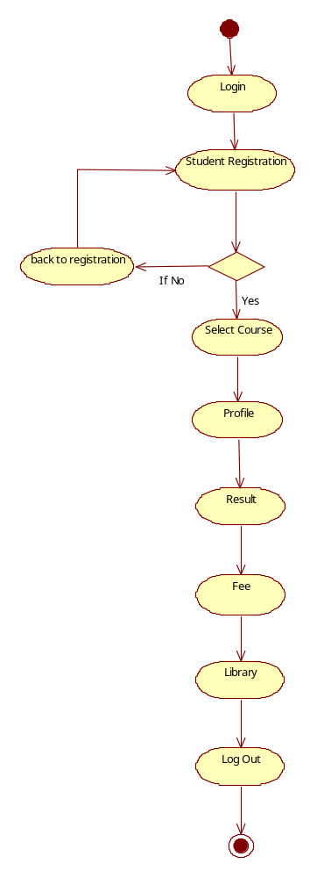

DATA FLOW DIAGRAM:

