# Chrome Browser Open Modes

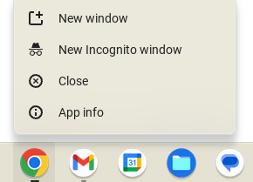

1. New Window - Opens a new window with browsing history

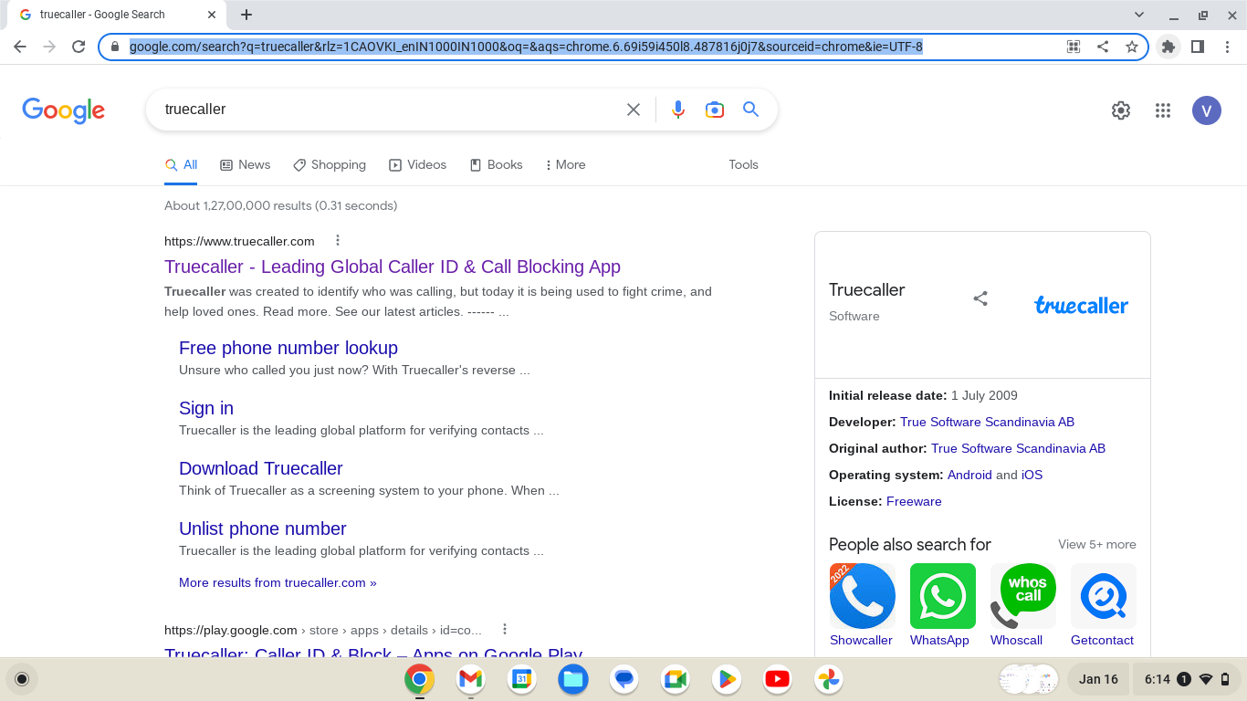

1. New Incognito Window (Private mode, cookies disabled) - New window with no browsing history.

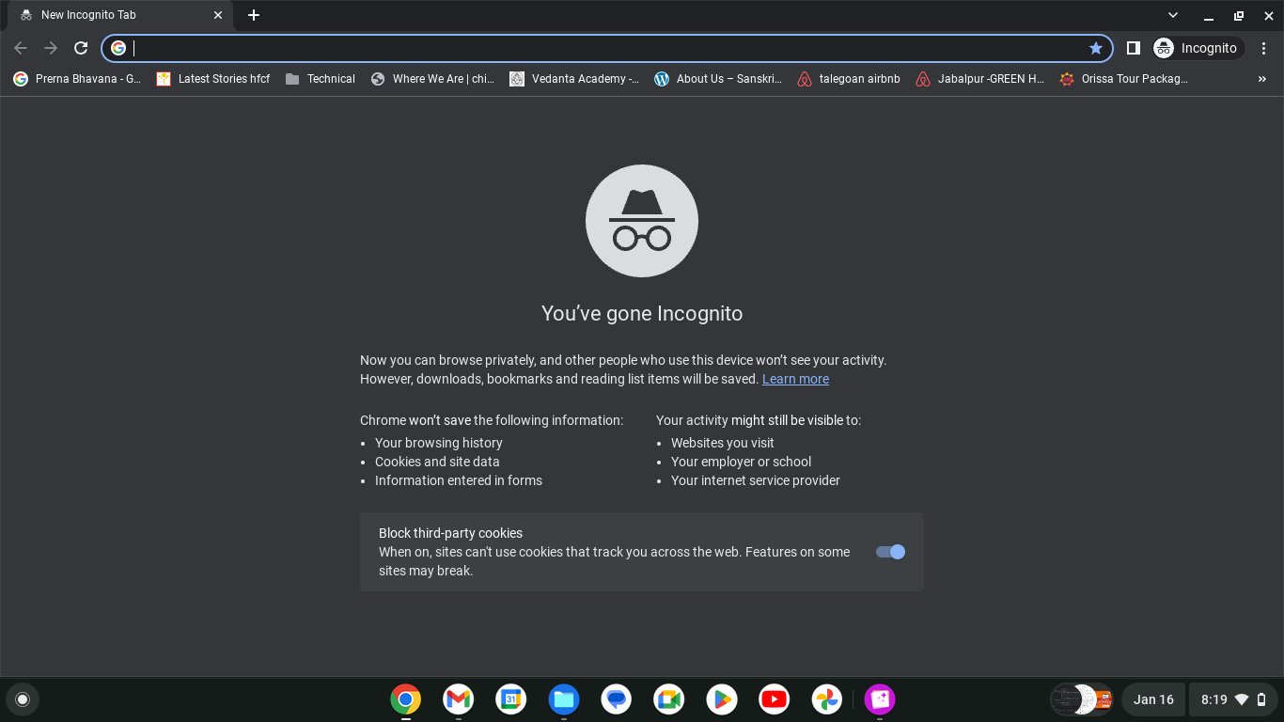

1. New Tab - A new tab with the same user browser session as the previously opened window. All the tabs in a browser window share the same user session i.e. if you have logged-in with a user, you remain logged-in all the other tabs.

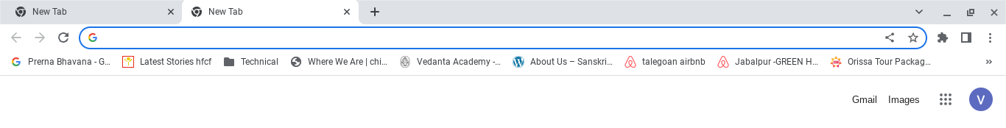

1. App Info - Information on Chrome OS controls 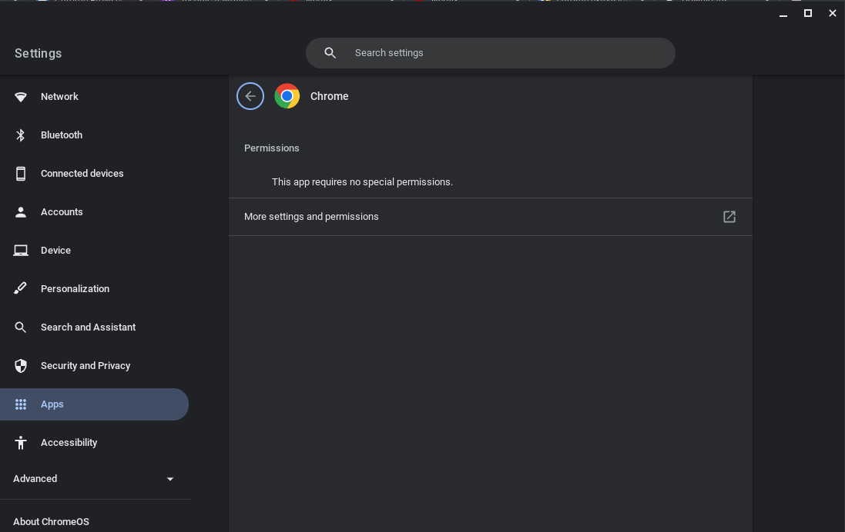

# 

# Top Toolbar Menu

1. Forward, Backward and Refresh for navigation on your browser history.
2. Status Bar highlighted in blue - the URL typed OR text entered will be selected in the default search engine 

3. Share this page

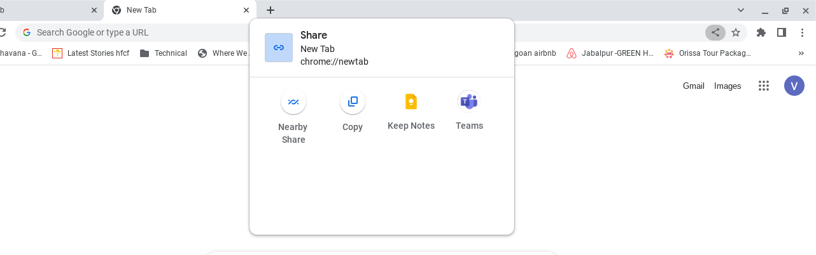

4. Bookmark - Add the link in bookmarks (a), then access it from the bookmarks menu

(a)

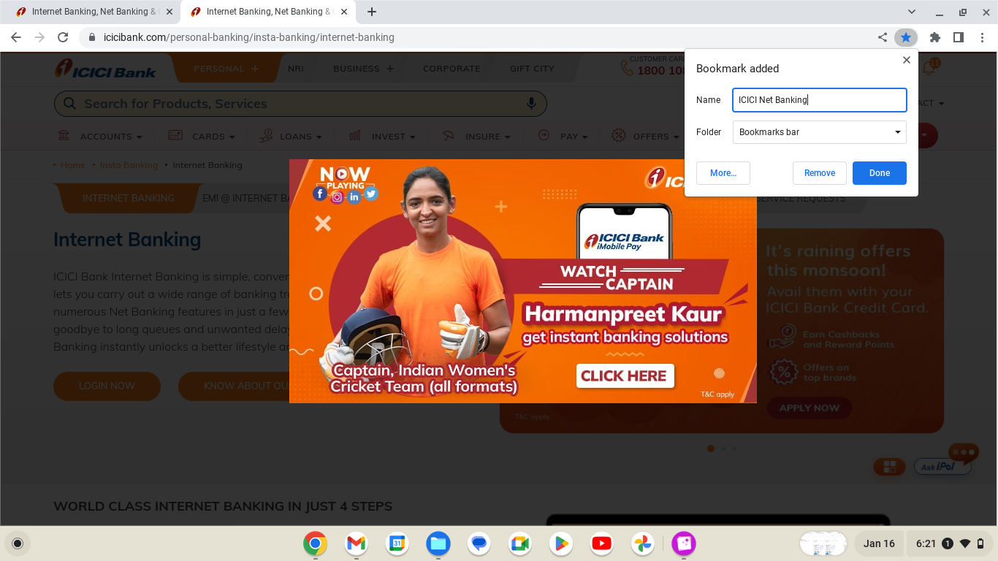

(b)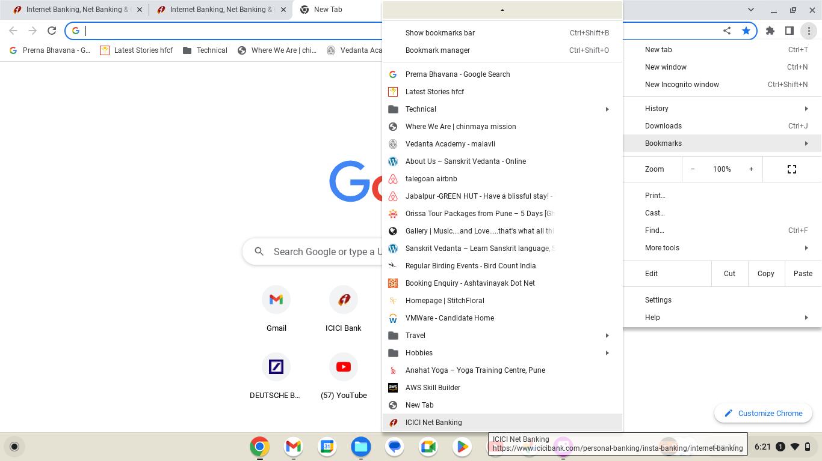

5. Extensions - Access all the chrome extensions installed

# 

# 

6. Side Panel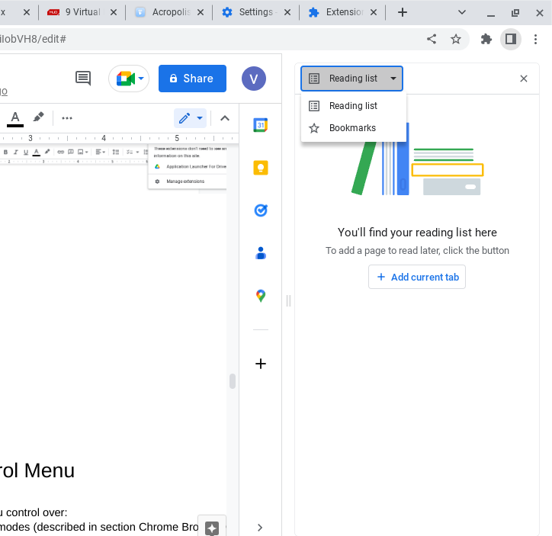

# Customize and Control Menu

This menu on the left gives you control over:

1. Open the Browser in different modes (described in section Chrome Browser Open Modes)
2. Access and configure Browsing History, Downloads, and Bookmarks
3. Zoom the browser window
4. Print the page, Cast the page on another device, Find text on the page
5. More Tools as shown in the below screenshot

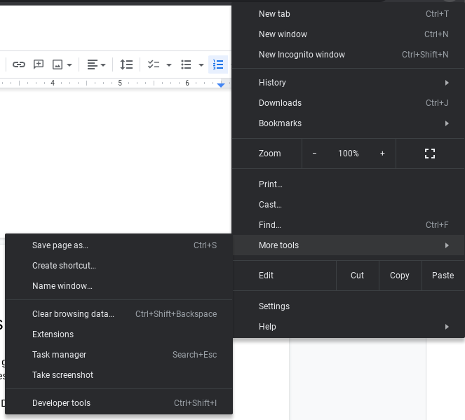

# Settings

Control the appearance, privacy and security, default search engine, extensions etc. with this menu

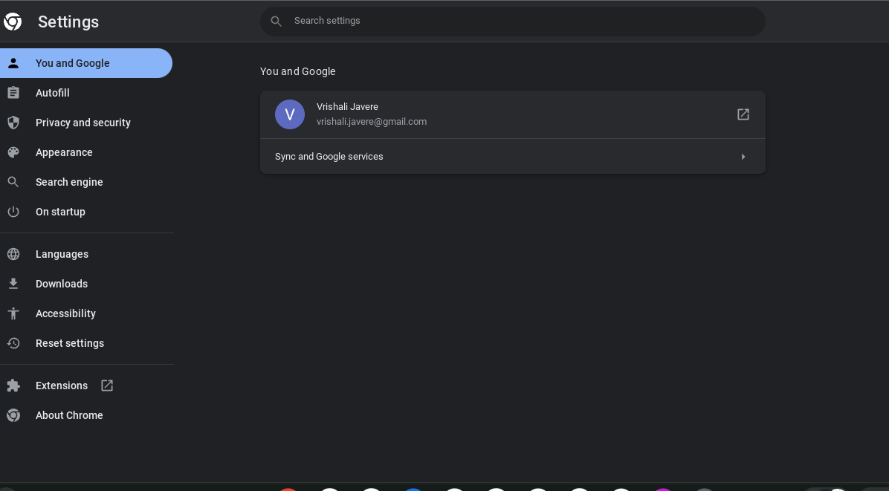

# 

# Help

Standard help topics menu , report an issue and check the chrome browser version in About Chrome Tab

