**1. In the below elements which of them are values or an expression? eg:- values can be integer or string and expressions will be mathematical operators.**

**\* , 'hello', -87.8, - , / , +, 6**

**Ans:** 4 Operators and 3 Expressions.

1. **Operators:**\*,-,/,+
2. **Expressions:**'hello', 87.8, 6

**2. What is the difference between string and variable?**

**Ans:**

1. String: A string in Python is a sequence of characters. It is a derived data type. Strings are immutable. Strings in python are surrounded by either single quotation marks, or double quotation marks.

Eg. 'hello' is the same as "hello".

1. Variable: Variables are symbols that you can use to store data in a program. Variable names may contain letters, digits (0-9) or the underscore character _ . Variable names must begin with a letter from A-Z or the underscore _ character. Either lowercase or uppercase letters are acceptable.

**3. Describe three different data types.**

**Ans:**

1. List: Lists are used to store multiple items in a single variable. Lists are created using square brackets. List items are ordered, changeable, and allow duplicate values. Lists are mutable.

Eg. ["apple", "banana", "cherry", "apple", "cherry"]

1. Tuple: A Tuple is a collection of Python objects separated by commas. Tuples are created using parentheses. In some ways a tuple is similar to a list in terms of indexing, nested objects and repetition but a tuple is immutable unlike lists which are mutable.

Eg. ("apple", "banana", "cherry", "apple", "cherry", 10)

1. Dictionaries: Dictionaries are used to store data values in key:value pairs. A dictionary is a collection which is ordered, changeable and do not allow duplicates.

Eg.{"brand":"Ford", "model":"Mustang", "year":1964}

**4. What is an expression made up of? What do all expressions do?**

**Ans:**

An expression is a combination of values, variables, operators, and calls to functions. Expressions need to be evaluated. If we ask Python to print an expression, the interpreter evaluates the expression and displays the result.

**5. This assignment statements, like spam = 10. What is the difference between an expression and a statement?**

**Ans:**

An expression is a combination of values, variables, and operators. When we type an expression at the prompt, the interpreter evaluates it, which means that it finds the value of the expression.

Eg.: x = 15 + 1.3

A statement is a unit of code that has an effect, like creating a variable or displaying a value. When we type a statement, the interpreter executes it, which means that it does whatever the statement says. In general, statements don’t have values.

Eg.: Variable declaration and assignment are statements because they do not return a value

**6. After running the following code, what does the variable bacon contain?**

**bacon = 22**

**bacon + 1**

**Ans:** For this example we can run it in three different ways.

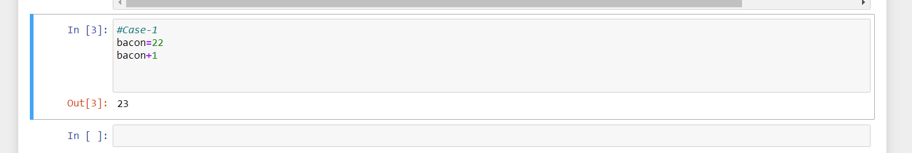

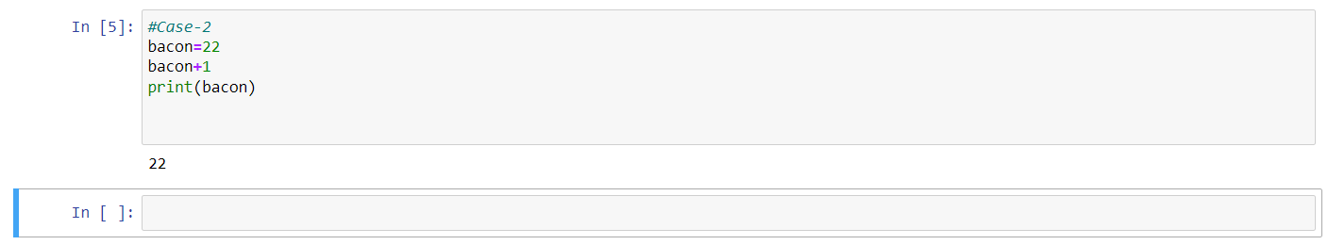

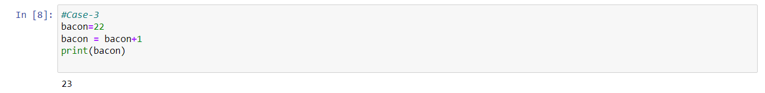

**7. What should the values of the following two terms be?**

**'spam' + 'spamspam'**

**'spam' * 3**

**Ans:**

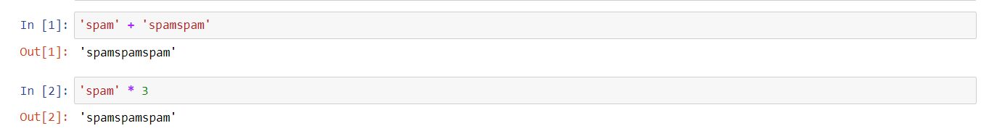

Both terms are giving same output.

**8. Why is eggs a valid variable name while 100 is invalid?**

**Ans:** A variable name cannot start with a number. A variable name must start with a letter or the underscore character

**9. What three functions can be used to get the integer, floating-point number, or string version of a value?**

**Ans:** int(), float(), str()

**10. Why does this expression cause an error? How can you fix it?**

**'I have eaten ' + 99 + ' burritos.'**

**Ans:** The expression causes an error because 99 is an integer, and only strings can be concatenated to other strings with the + operator. The correct way is ‘I have eaten ' + str(99) + ' burritos’ or 'I have eaten ' + '99' + ' burritos'