# Screenflow for Admin

A – Manage Company – Add A New Company

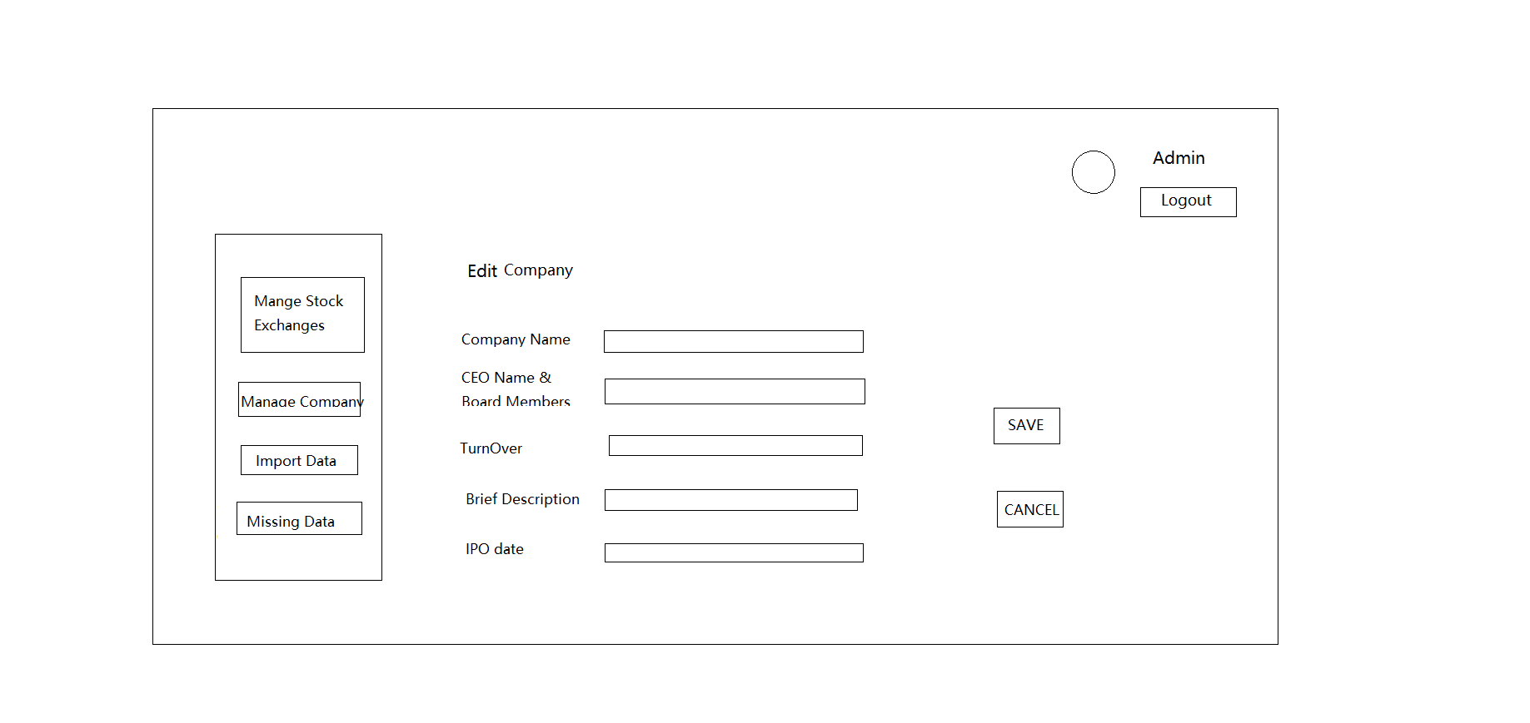A – Manage Company – Edit An Existing Company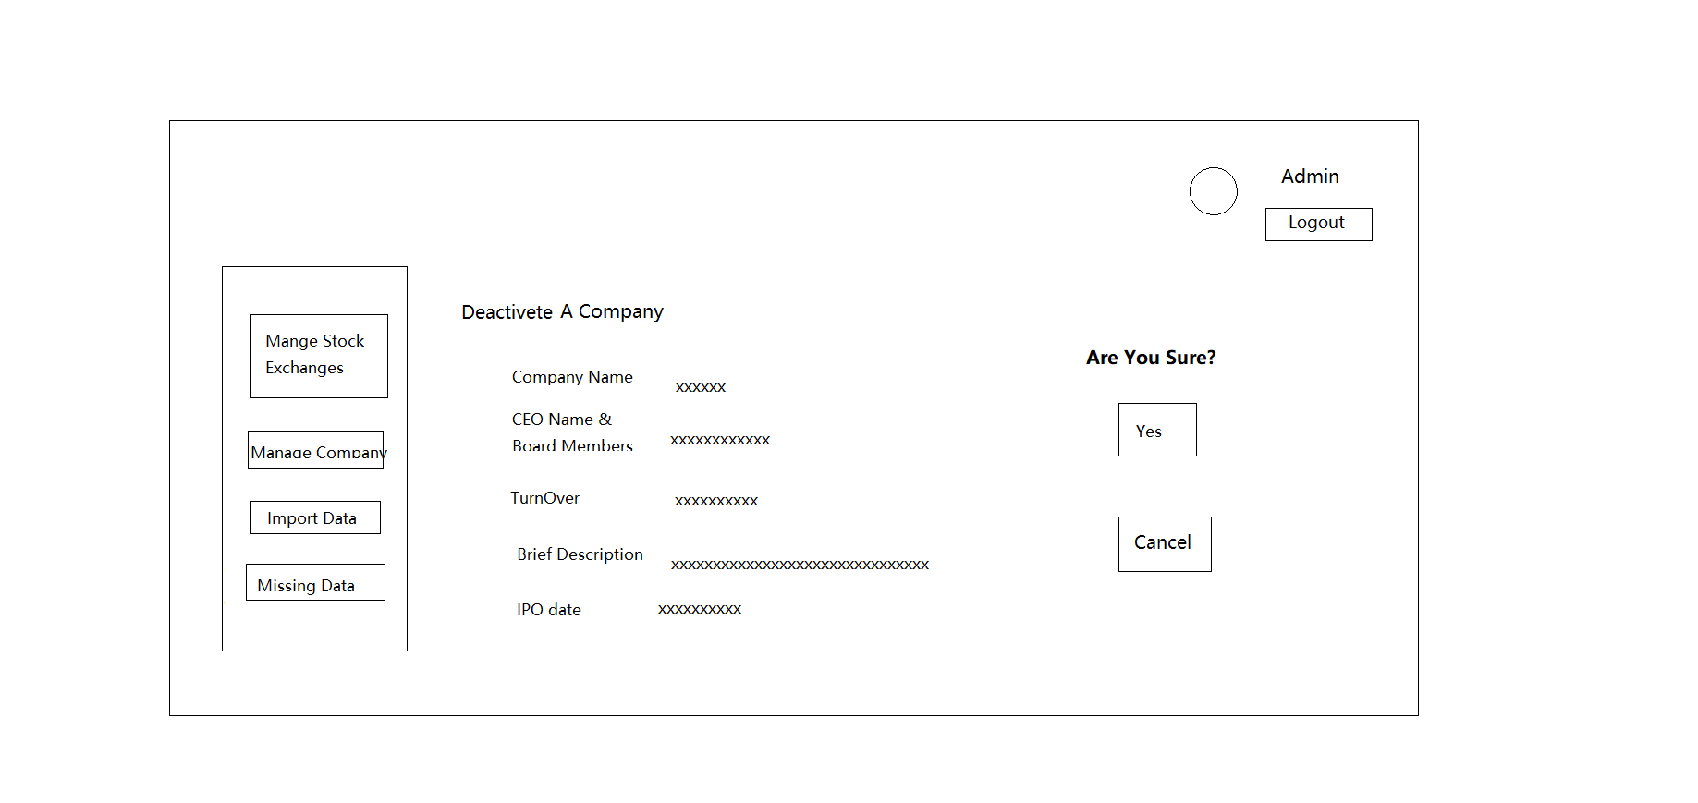A – Manage Company – Deactivate An Existing Company

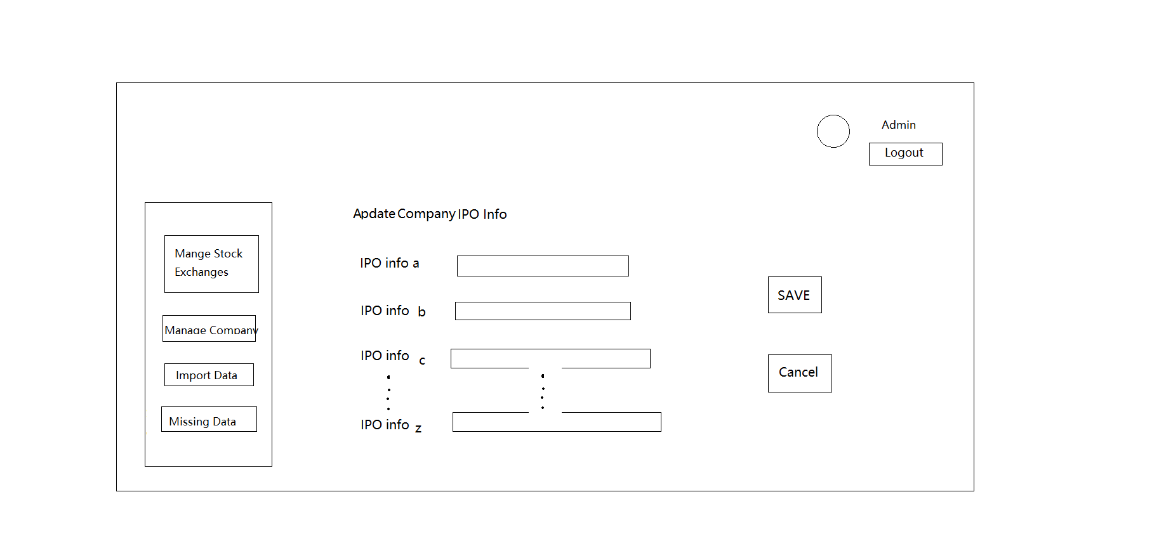A – Manage Company – Update IPO Related Data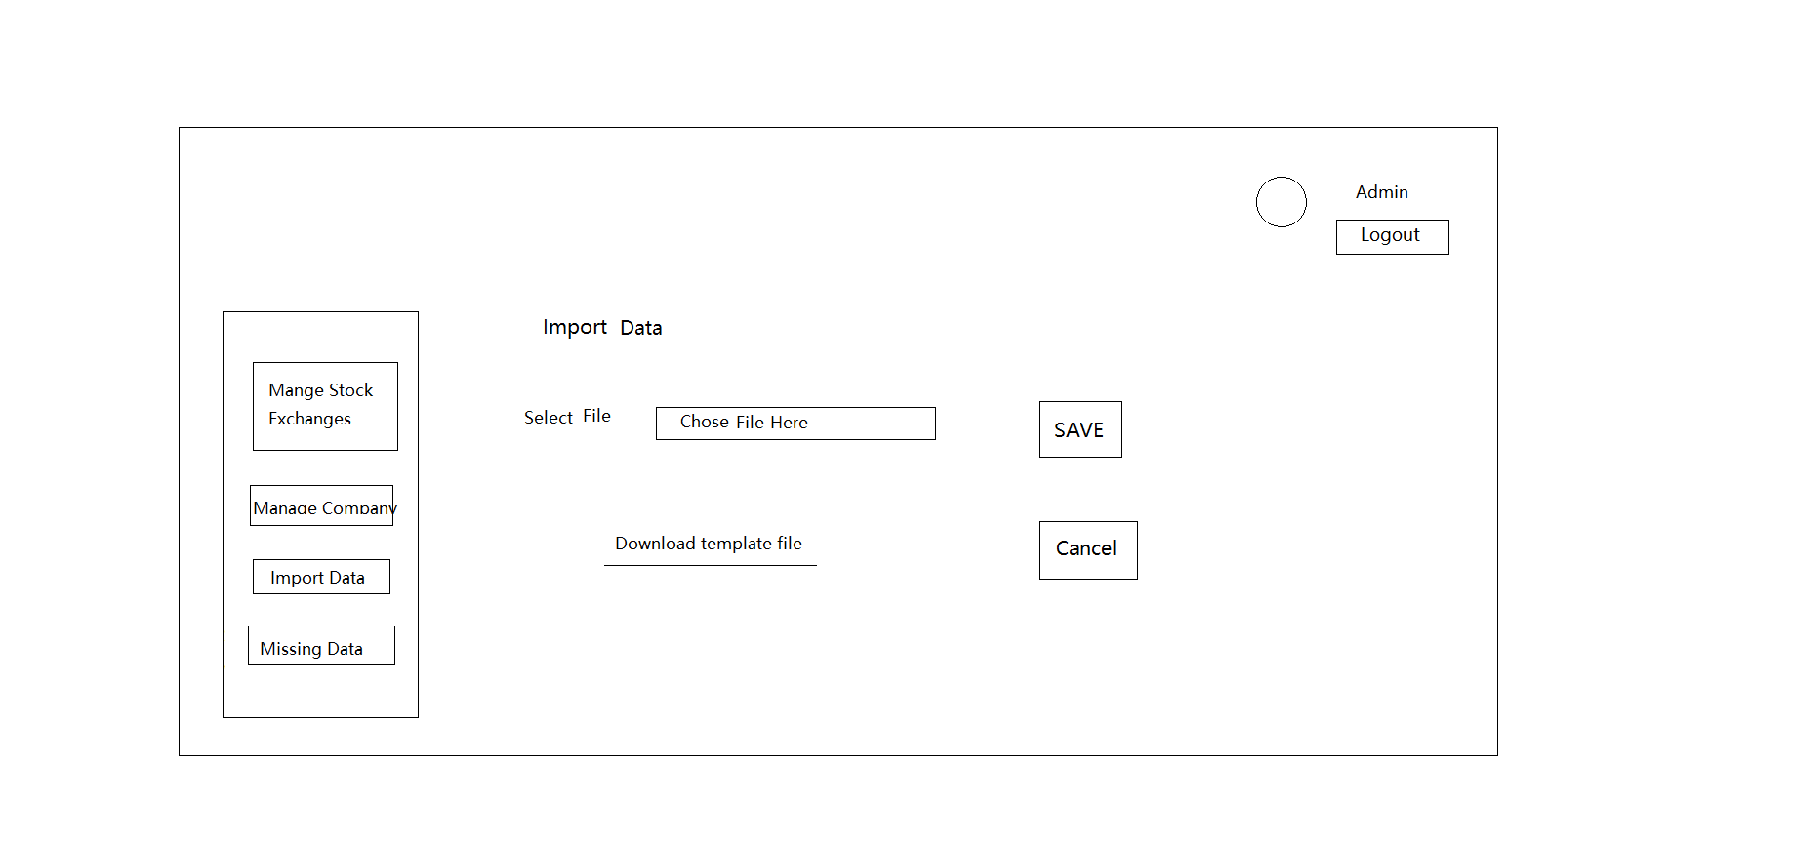A – Import Data – Upload Excel

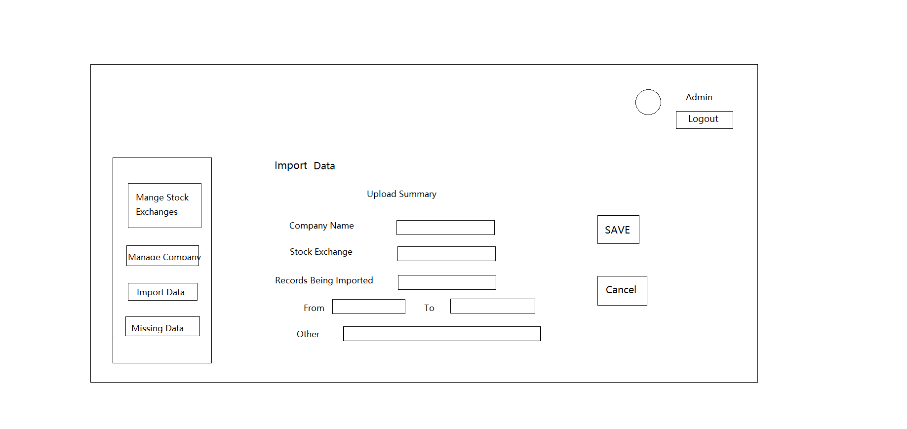A – Import Data – Import Summary

# Screenflow for User

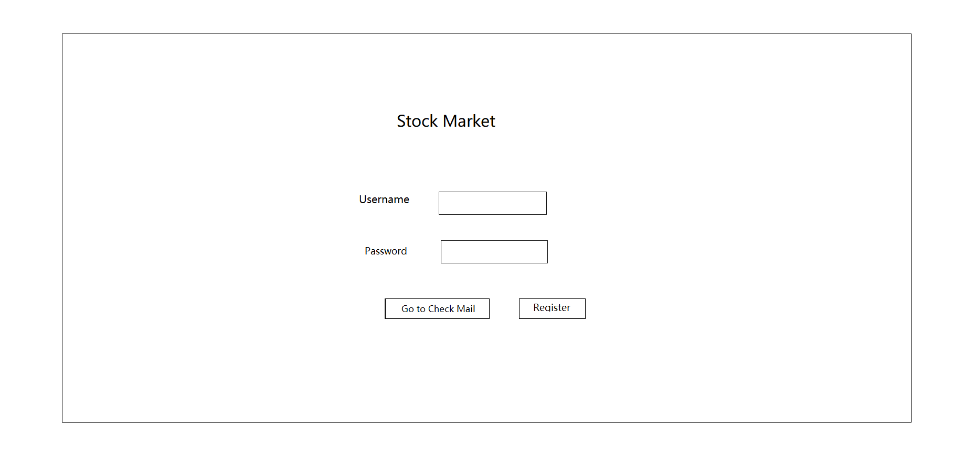U – Landing Page – Login&Register

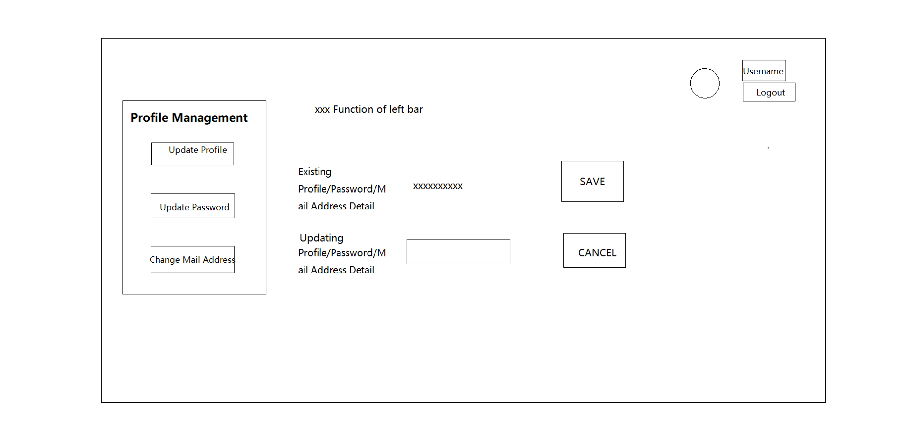U – Update Personal Info

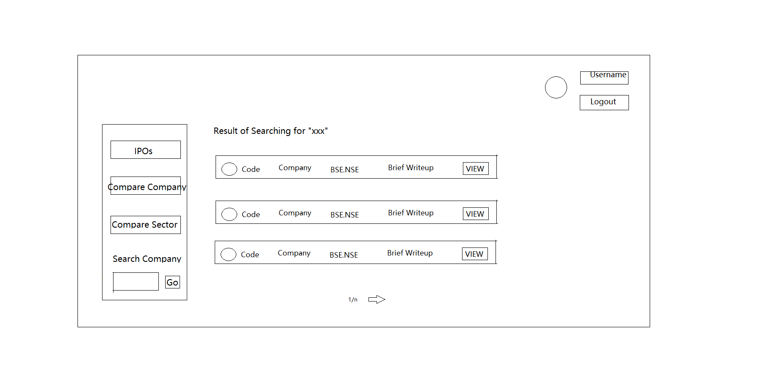 U – Search for A Company Basing on Company Name

U – Comparison Chart for Certain Period with interval Options(Week/Month,etc) for 2 Companies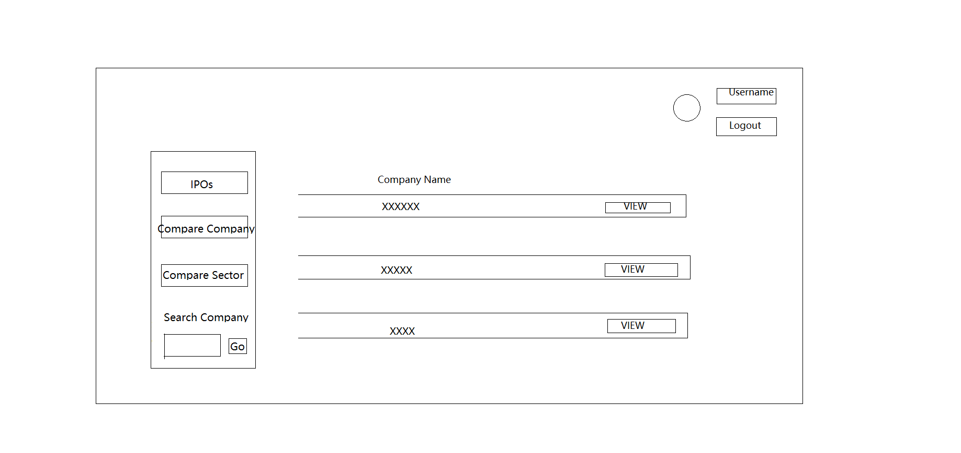

U – Display Matching Company Names

U – Display Different Colors For Multiple Entries Are Displayed in A Single Chart

U – Display Average, Min, Max For a Specific Period