

**OS LAB**

**(CSL-408)**

**Lab Assignment#2**

|  |  |
| --- | --- |
| **Submitted To:**  Ms. Sunita Sharma | **Submitted By:**  Vrishav Garg |

12111051

Branch: CSE

Semester: IV

Session: 2021-25

**Practical 1**

**Make use case diagram for course management system**

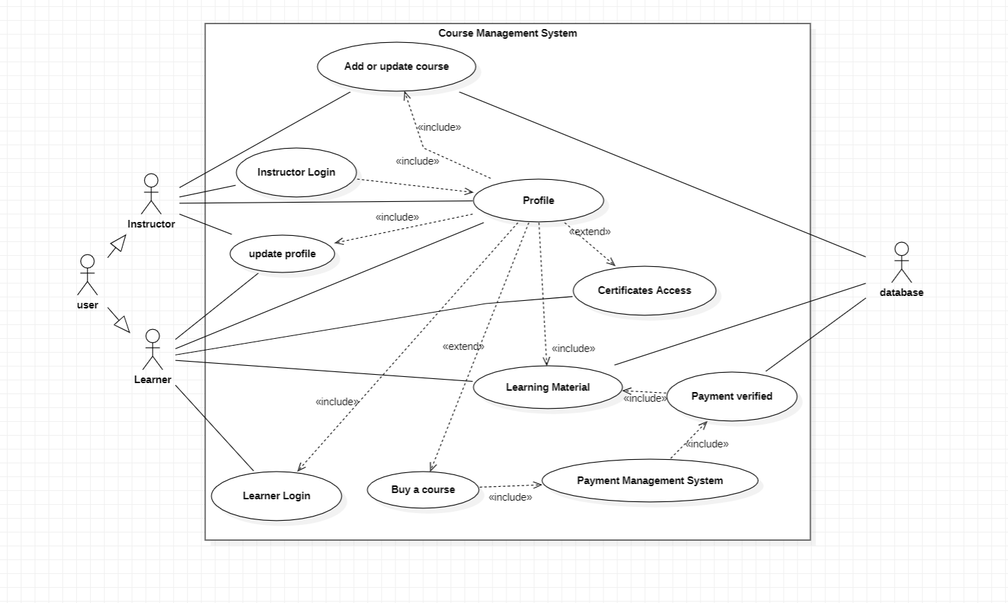

**Practical 2**

**Make use case diagram for E-bidding system**

