**WEB DEVELOPMENT**

**PRACTICAL 1**

**Name:** Vrishav Garg

**Roll No.:** 12111051

**Branch:** CSE

**CODE:**

<!DOCTYPE html>

<html lang="en">

<head>

<meta charset="UTF-8">

<meta http-equiv="X-UA-Compatible" content="IE=edge">

<meta name="viewport" content="width=device-width, initial-scale=1.0">

<title>Vrishav's 1st webpage</title>

</head>

<body>

<h1>I am Vrishav Garg</h1>

<hr>

<h2>Doing CSE in IIIT Sonepat</h2>

<hr>

<h3>Learning Web Development</h3>

<hr>

<h4>This webpage is made of HTML</h4>

<hr>

<h5>I like doing compititive programming</h5>

<hr>

<h6>I will become master in web development</h6>

</body>

</html>

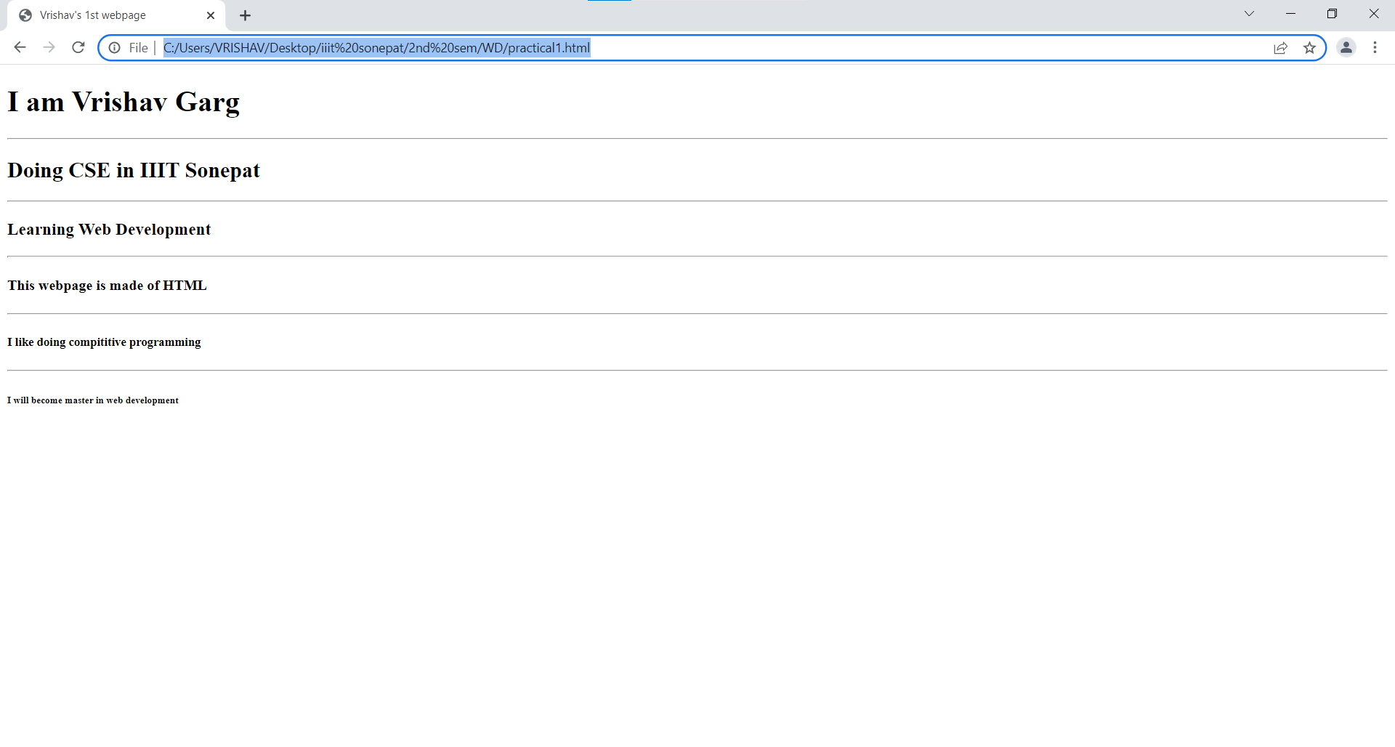**Output:**