Department of Electrical Engineering Autumn 2026-2027
EEO 101 : DATA STRUCTURES
Worksheet – No.
Name: Vrishin M
Enrollment: 25112116
Department: Chemical Engineering
Course name: Btech year 2 chemical engineering
Batch: Wednesday 4-6

Q1.
#include <stdio.h>
#include <stdlib.h>

void insertSorted(int arr[], int *n, int *ptr)
{
int i = *n - 1;
while (i >= 0 && arr[i] > *ptr)
{
arr[i + 1] = arr[i];
i--;
}
arr[i + 1] = *ptr;
(*n)++;
}

int main()
{
int arr1[10] = {10, 20, 30, 40, 50};
int n1 = 5;
int val1 = 35;

printf("--- Test Case 1 ---\n");
printf("Original array: 10 20 30 40 50\n");
printf("Value to insert: %d\n", val1);
insertSorted(arr1, &n1, &val1);
printf("Array after insertion: ");
for (int i = 0; i < n1; i++) printf("%d ", arr1[i]);
printf("\n\n");

int arr2[10] = {5, 15, 25};
int n2 = 3;
int val2 = 2;

printf("--- Test Case 2 ---\n");
printf("Original array: 5 15 25\n");
printf("Value to insert: %d\n", val2);
insertSorted(arr2, &n2, &val2);
printf("Array after insertion: ");
for (int i = 0; i < n2; i++) printf("%d ", arr2[i]);
printf("\n");

return 0;
}

OUTPUT:
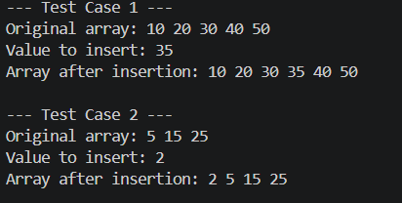

QUESTION 2:
#include <stdio.h>
#include <stdlib.h>

int main()
{
printf("Test 1: Allocating block for 10 integers using malloc...\n");
int *ptr2 = (int *)malloc(sizeof(int) * 10);
if (ptr2 != NULL) printf("Result 1: Malloc successful.\n\n");

printf("Test 2: Allocating block for 50 integers (5 blocks of 10) using calloc...\n");
int *ptr3 = (int *)calloc(5, sizeof(int) * 10);
if (ptr3 != NULL) printf("Result 2: Calloc successful.\n\n");

printf("Test 3: Modifying the malloc block size to hold 20 integers using realloc...\n");
ptr2 = (int *)realloc(ptr2, sizeof(int) * 20);
if (ptr2 != NULL) printf("Result 3: Realloc successful.\n\n");

free(ptr2);
free(ptr3);

printf("Memory freed.\n");

return 0;
}

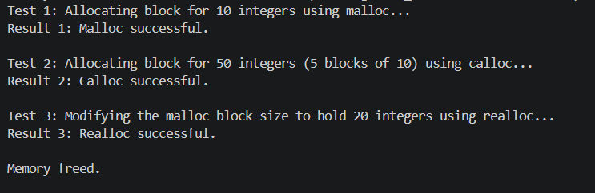

Question 3
#include <stdio.h>
#include <stdlib.h>
#include <string.h>

struct Address {
int house_no;
char street[50];
char city[50];
char state[50];
int pin_code;
};

struct Student {
char name[50];
char father_name[50];
char enrollment_no[20];
char specialization[50];
char majors[50];
char minors[50];
float gate_score;
char status_category[20];
char bhawan[50];
char room_no[10];
struct Address home_address;
char blood_group[5];
};

int main() {
int num_students = 15;

printf("--- M.Tech Student Database Allocation ---\n");
struct Student *students = (struct Student *)malloc(num_students * sizeof(struct Student));

strcpy(students[0].name, "udhay");
strcpy(students[0].enrollment_no, "wrgnrejngjekr");
students[0].gate_score = 850.0;

strcpy(students[1].name, "raju");
strcpy(students[1].enrollment_no, "wfnrjwgnrwjfgr");
students[1].gate_score = 720.0;

printf("Displaying populated student records:\n");
for (int i = 0; i < 2; i++) {
printf("Student %d -> Name: %s | Enrollment: %s | GATE Score: %.1f\n",
i+1, students[i].name, students[i].enrollment_no, students[i].gate_score);
}

free(students);
return 0;
}
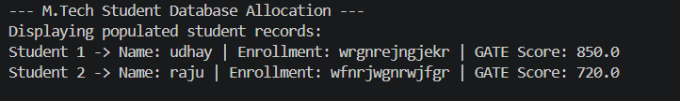

Question 4:
#include <stdio.h>
#include <stdlib.h>

int to_upper(char string[], int length){
char *ptr = malloc(sizeof(char));
int i;
for (i = 0; i < length; i++){
if (*(string + i) <= 'z' && *(string + i) >= 'a'){
string[i] -= 32;
}
}
printf("%s\n", string);
free(ptr);
return 0;
}

int main()
{
printf("--- Lowercase to Uppercase Conversion ---\n\n");

char str1[] = "udhay";
printf("Test 1 Original : udhay\n");
printf("Test 1 Result : ");
to_upper(str1, 5);

printf("\n");

char str2[] = "sanjay123";
printf("Test 2 Original : sanjay123\n");
printf("Test 2 Result : ");
to_upper(str2, 9);

return 0;
}

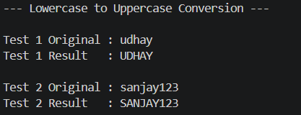

Question 5
#include <stdio.h>

void to_lower(char string[], int length) {
for (int i = 0; i < length; i++) {
if (string[i] >= 'A' && string[i] <= 'Z') {
string[i] += 32;
}
}
printf("%s\n", string);
}

int main() {
printf("--- Uppercase to Lowercase Conversion ---\n\n");

char str1[] = "HELLO";
printf("Test 1 Original : HELLO\n");
printf("Test 1 Result : ");
to_lower(str1, 5);

printf("\n");

char str2[] = "WoRLd";
printf("Test 2 Original : WoRLd\n");
printf("Test 2 Result : ");
to_lower(str2, 5);

return 0;
}
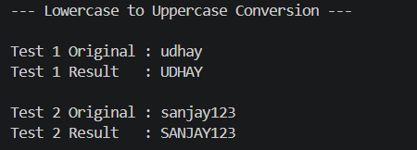

Question 6
#include <stdio.h>

void toggle_case(char string[], int length) {
for (int i = 0; i < length; i++) {
if (string[i] >= 'a' && string[i] <= 'z') {
string[i] -= 32;
} else if (string[i] >= 'A' && string[i] <= 'Z') {
string[i] += 32;
}
}
printf("%s\n", string);
}

int main() {
printf("--- Toggle Case Conversion ---\n\n");

char str1[] = "HeLlO";
printf("Test 1 Original : HeLlO\n");
printf("Test 1 Result : ");
toggle_case(str1, 5);

printf("\n");

char str2[] = "uDHAY";
printf("Test 2 Original : uDHAY\n");
printf("Test 2 Result : ");
toggle_case(str2, 5);

return 0;
}
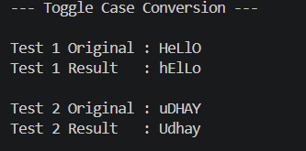

Question 7
#include <stdio.h>

int reverse_string(char string[], int length){
char temp;
int i;
for (i = 0; i < length / 2; i++){
temp = string[i];
string[i] = string[length - i - 1];
string[length - i - 1] = temp;
}
printf("%s\n", string);
return 0;
}

int main()
{
printf("--- String Reversal ---\n\n");

char str1[] = "sanjay";
printf("Test 1 Original : sanjay\n");
printf("Test 1 Reversed : ");
reverse_string(str1, 6);

printf("\n");

char str2[] = "udhay";
printf("Test 2 Original : udhay\n");
printf("Test 2 Reversed : ");
reverse_string(str2, 5);

return 0;
}
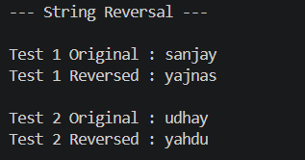

Question 8:
#include <stdio.h>

void check_palindrome(char string[], int length) {
int is_pal = 1;
for (int i = 0; i < length / 2; i++) {
if (string[i] != string[length - i - 1]) {
is_pal = 0;
break;
}
}
if (is_pal) {
printf("Result: '%s' IS a palindrome.\n", string);
} else {
printf("Result: '%s' IS NOT a palindrome.\n", string);
}
}

int main() {
printf("--- Palindrome Checker ---\n\n");

char str1[] = "racecar";
printf("Test 1: Checking string '%s'...\n", str1);
check_palindrome(str1, 7);

printf("\n");

char str2[] = "hello";
printf("Test 2: Checking string '%s'...\n", str2);
check_palindrome(str2, 5);

return 0;
}

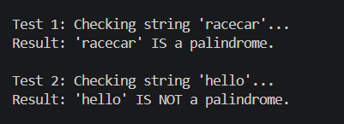

Question 9
#include <stdio.h>
#include <stdlib.h>

int rotate_array(int arr[], int length, int rotate_by){
int i;
int new_pos;
int *new_arr = malloc(length * sizeof(int));
for (i = 0; i < length; i++){
new_pos = i + rotate_by;
if (new_pos >= length){
new_pos -= length;
}
if (new_pos < 0){
new_pos += length;
}
new_arr[new_pos] = arr[i];
}
for (i = 0; i < length; i++){
printf("%d ", new_arr[i]);
}
printf("\n");
free(new_arr);
return 0;
}

int main()
{
printf("--- Array Rotation ---\n\n");

int arr1[] = {1, 2, 3, 4};
printf("Test 1 Original array: 1 2 3 4\n");
printf("Rotating by -1 positions (Left shift by 1)...\n");
printf("Resulting array: ");
rotate_array(arr1, 4, -1);

printf("\n");

int arr2[] = {10, 20, 30, 40, 50};
printf("Test 2 Original array: 10 20 30 40 50\n");
printf("Rotating by 2 positions (Right shift by 2)...\n");
printf("Resulting array: ");
rotate_array(arr2, 5, 2);

return 0;
}
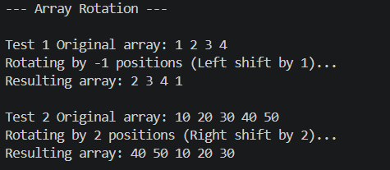

Queition 10
#include <stdio.h>

void reverse_pointers(char *arr[], int length) {
char *temp;
for (int i = 0; i < length / 2; i++) {
temp = arr[i];
arr[i] = arr[length - i - 1];
arr[length - i - 1] = temp;
}
}

int main() {
char *strings[] = {"apple", "banana", "cherry", "date"};
int len = 4;

printf("--- Reverse Array of Pointers to Strings ---\n\n");

printf("Original array of strings:\n");
for (int i = 0; i < len; i++) {
printf("[%d]: %s ", i, strings[i]);
}
printf("\n\n");

reverse_pointers(strings, len);

printf("Reversed array of strings:\n");
for (int i = 0; i < len; i++) {
printf("[%d]: %s ", i, strings[i]);
}
printf("\n");

return 0;
}
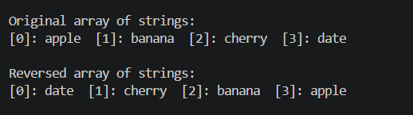

Question 11:
#include <stdio.h>

struct Complex {
float real;
float imag;
};

void Add_cmplx(struct Complex *c1, struct Complex *c2, struct Complex *res) {
res->real = c1->real + c2->real;
res->imag = c1->imag + c2->imag;
}

void Mult_cmplx(struct Complex *c1, struct Complex *c2, struct Complex *res) {
res->real = (c1->real * c2->real) - (c1->imag * c2->imag);
res->imag = (c1->real * c2->imag) + (c1->imag * c2->real);
}

void Div_cmplx(struct Complex *c1, struct Complex *c2, struct Complex *res) {
float denom = (c2->real * c2->real) + (c2->imag * c2->imag);
res->real = ((c1->real * c2->real) + (c1->imag * c2->imag)) / denom;
res->imag = ((c1->imag * c2->real) - (c1->real * c2->imag)) / denom;
}

void Negate(struct Complex *c, struct Complex *res) {
res->real = c->real;
res->imag = -c->imag;
}

int main() {
struct Complex num1 = {4.0, 3.0};
struct Complex num2 = {2.0, 1.0};
struct Complex res;

printf("--- Complex Number Operations ---\n\n");
printf("Operand 1: %.2f + %.2fi\n", num1.real, num1.imag);
printf("Operand 2: %.2f + %.2fi\n\n", num2.real, num2.imag);

Add_cmplx(&num1, &num2, &res);
printf("Addition Result : %.2f + %.2fi\n", res.real, res.imag);

Mult_cmplx(&num1, &num2, &res);
printf("Multiplication Result : %.2f + %.2fi\n", res.real, res.imag);

Div_cmplx(&num1, &num2, &res);
printf("Division Result : %.2f + %.2fi\n", res.real, res.imag);

Negate(&num1, &res);
printf("Conjugate of Op 1 : %.2f + %.2fi\n", res.real, res.imag);

return 0;
}
