St. Francis Xavier's College, Hamilton
2026 Year 11 – Enterprise Computing

Assessment Task 1
Enterprise Computing Portfolio

Student Name: | Vrix
Class: | 11ENC
Teacher: | [Mr Brooker]
Due Date: | Thursday 14th May 2026 – Week 4, Term 2
Weighting: | 30%

Section 1 Identifying and Defining
Define your audience?
For my website, the audience includes people of all ages, such as children, teenagers, young adults, and middle-aged adults who are interested in supporting and caring for the environment. Besides it’s very useful for everyone around the world, the website is more suitable for people living in the Hunter Region of Australia who want to learn more about recycling and waste management. The audience interacts with digital media by using phones, tablets, and computers to access information, viewing data, providing a map, and learning from other video sources to learn how recycling can help reduce waste and protect the environment.

Define the information you wish?
The information I want to communicate is that many people still do not recycle properly or support waste management, which can become a major disaster for the planet. Without recycling, landfills may overflow, pollution can increase, plastic waste can spread across oceans, and natural resources needed for human survival may become limited. To help address the issue, I decided to provide information such as explanations about recycling, data from a school that has experience with recycling programs, a map showing nearby recycling stations in the Hunter Region, video sources for learning, and information about our team and how we support recycling solutions.

Describe how your project will demonstrate safe and ethical use of online tools.
To ensure safe and ethical use of online tools, my project will include safe and educational videos that are suitable for all ages, especially young children, without any inappropriate or harmful content. The website will provide accurate information and statistics about recycling and waste management using trusted data, map, and sources. In addition, our team will help support and manage the website by ensuring the information remains safe, reliable, and appropriate for users.

Explain how your product will engage, capture, and hold the attention of the audience and collect user feedback.
My project will engage the audience by providing interactive videos that explain recycling, the problems caused by waste, and how individuals can take positive action to care for the planet. These videos will help capture and hold the audience’s attention by making the information more visual, clear and easy to understand.

User feedback will be collected through a 5-star rating system, allowing users to share their opinions on the website and the information provided. This feedback will help identify how useful and effective the content is, including the data, maps, and other resources included on the website.

Section 2 Researching and Planning
Outline your research into contemporary and innovative software.
Tool / Software | Purpose | Why Chosen
VS Code | It’s useful for website development, including HTML, CSS, and JavaScript. | This is one of the best and top-priority software tools for developers, engineers, programmers, and coders to create and manage code.
Using ‘HTML’ | For structuring and building web pages, coding in a powerful and professional way. | It’s very important for structuring my website in a more professional and successful way, including elements such as the “head”, “body”, and “headings”.
Using ‘CSS’ | For separating structure (html) since it’s providing styling, layout and formatting. | It’s very important for the ‘style’ section as it has access to changing size, colors, locations, and spacing.
Using ‘JS (Java Script)’ | For animations and extensions such as ‘Live Server’, ‘transitions’ and ‘scripts’. | It’s very useful for my “data” and “map” section, as I can include data graphs and map visuals created by other people as sources.
Identify your digital product and explain what platform or media you will use for your solution
My digital product is an educational website about recycling and waste management in the Hunter Region of Australia. The website I created using tools such as HTML, CSS, and JavaScript to structure, design and make the site interesting and interactive. This platform is suitable because it allows me to include videos such as images, videos, maps, and date graphs to help users to learn about recycling on electronic devices such as phones, tablets, and computers.

Check with your teacher the suitability of the platform or software you are researching and using for the project. Document the discussions.
Document any discussions you have had with your teacher about the suitability of your platform and software choices.
Date | Discussion Summary | Teacher Feedback
T1 Week 9 – T2Week 1 (April 20-27) | - Discussed using HTML, CSS, and JavaScript as the main tools for developing the website. Planned to include videos, data, and maps as information sources. Website features include banners, data sections, analysis pages, interactive maps, layout design, multiple pages, videos, and buttons within the code. | Check with Mr Brooker on 05/05/26.
Week 2 (April 27 - May 3) | - Discussed sourcing information from research and reliable resources. Adjusted visual elements such as size and color for design improvement. Added accurate data graphs and an interactive map using JavaScript. Implemented Map/Data.js within the code structure. | Check with Mr Brooker on  7/05/26.
Week 3 (May 4-10) | - Discussed final analysis of information and conclusions. Planned to include user feedback for audience review. Also included a section to acknowledge supporters and team members involved on the website/project. | Check with Mr Brooker on  11/05/26.

Investigate how digital marketing techniques influence consumer behavior.
Digital marketing techniques influence consumer behavior by using engaging visuals, clear information, and interactive features. In particular, the interactive map plays a key role in capturing the audience’s attention and encouraging them to explore the content further. In addition, providing maps and images helps users visually understand how recycling can be a problem and how others have worked to solve these issues.

The design of the website also influences user behavior. The use of banners and a simple color scheme help create a calm layout, which improves the user’s experience and prevents the website from being overwhelmed or chaotic. By adding interactivity and using real data, such as interactive maps, buttons, data graphs, and user reviews, the website encourages a better interest in learning about recycling. Overall, these techniques help users better understand the important of recycling and motivate them to take positive environmental action.

Section 3 Producing and Implementing
Examples (+ Time taken on producing)
(Term 1) Week 7-8 | “Home” page
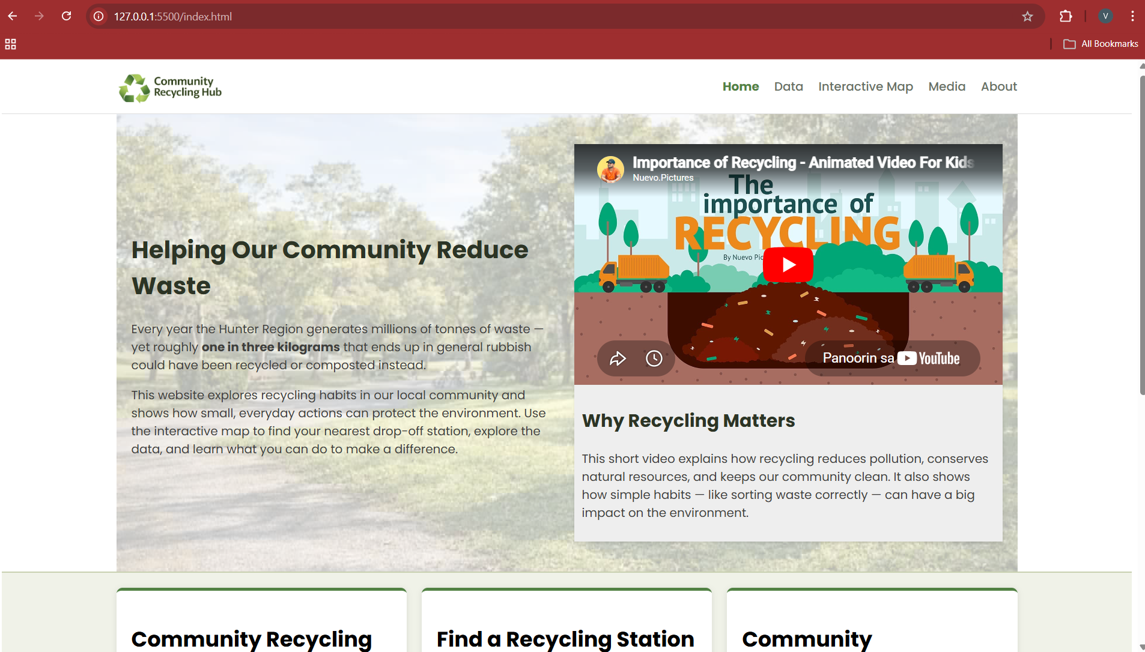

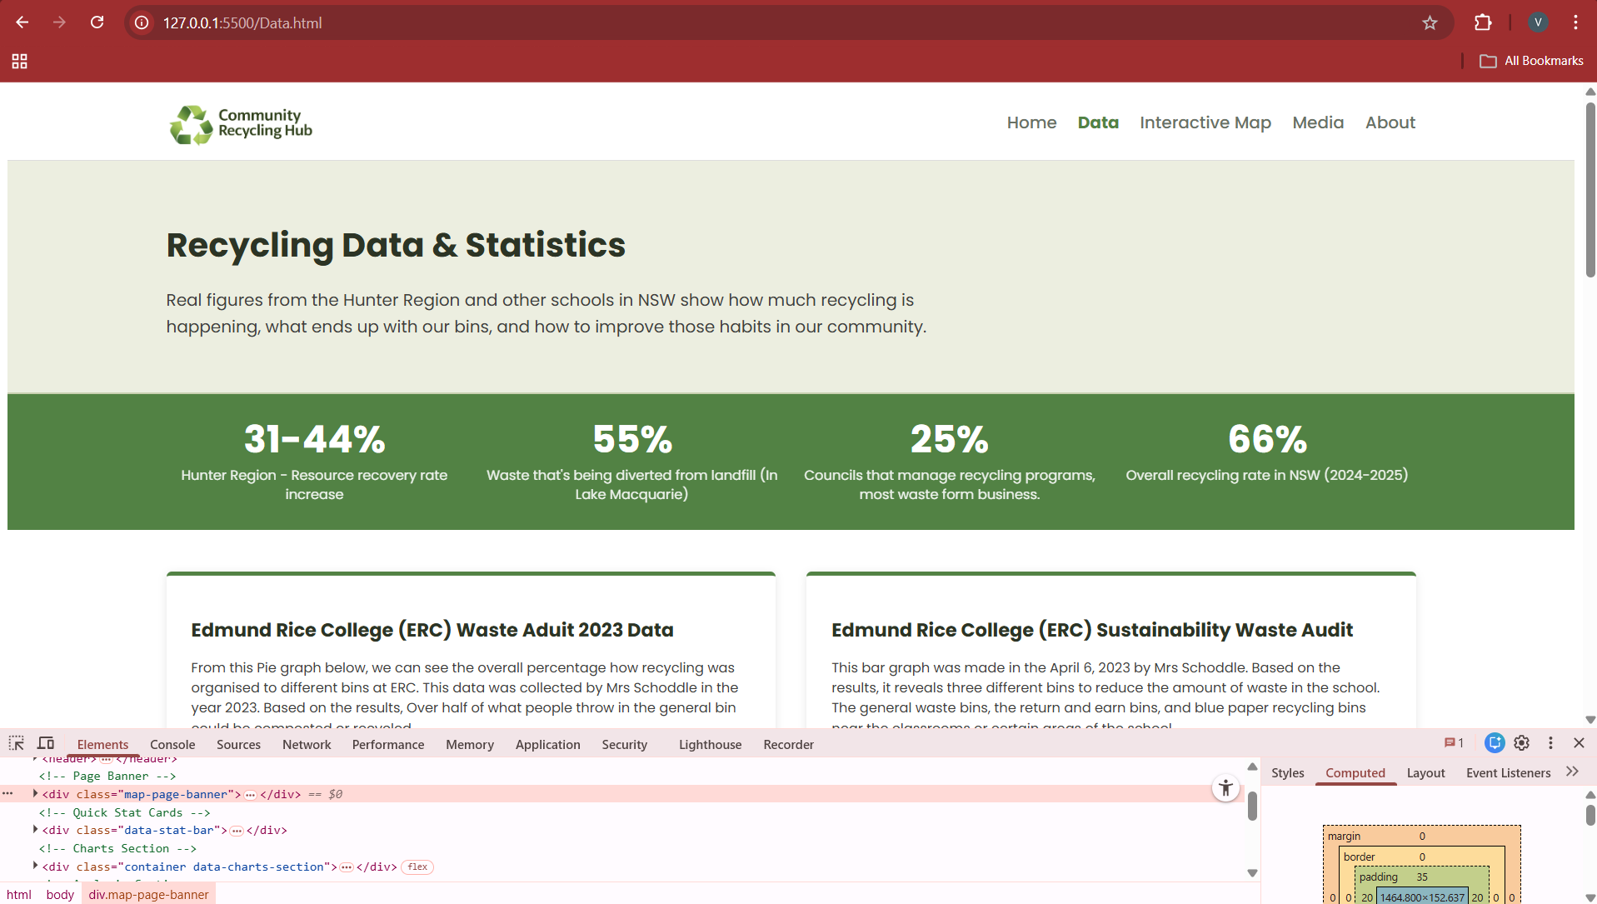
(Term 1) Week 9-10 | “Data” page

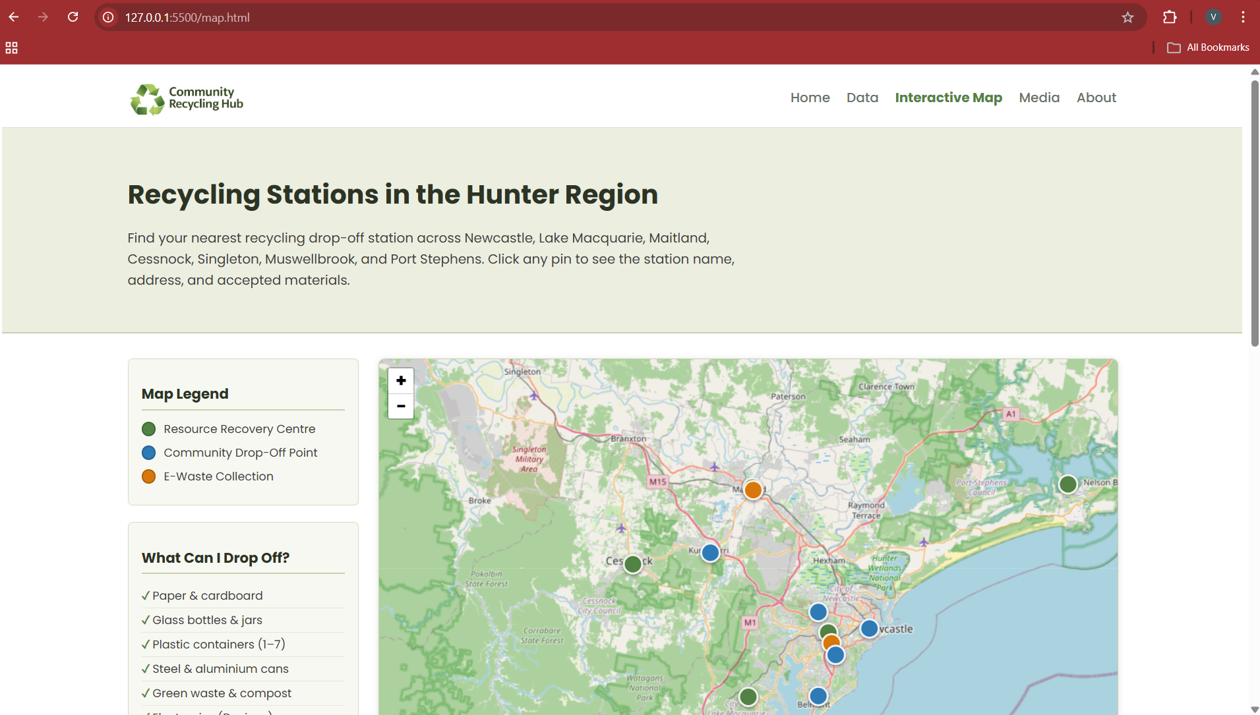
(Term 2) Week 1-3 | “Map”, “Media”, “About” page

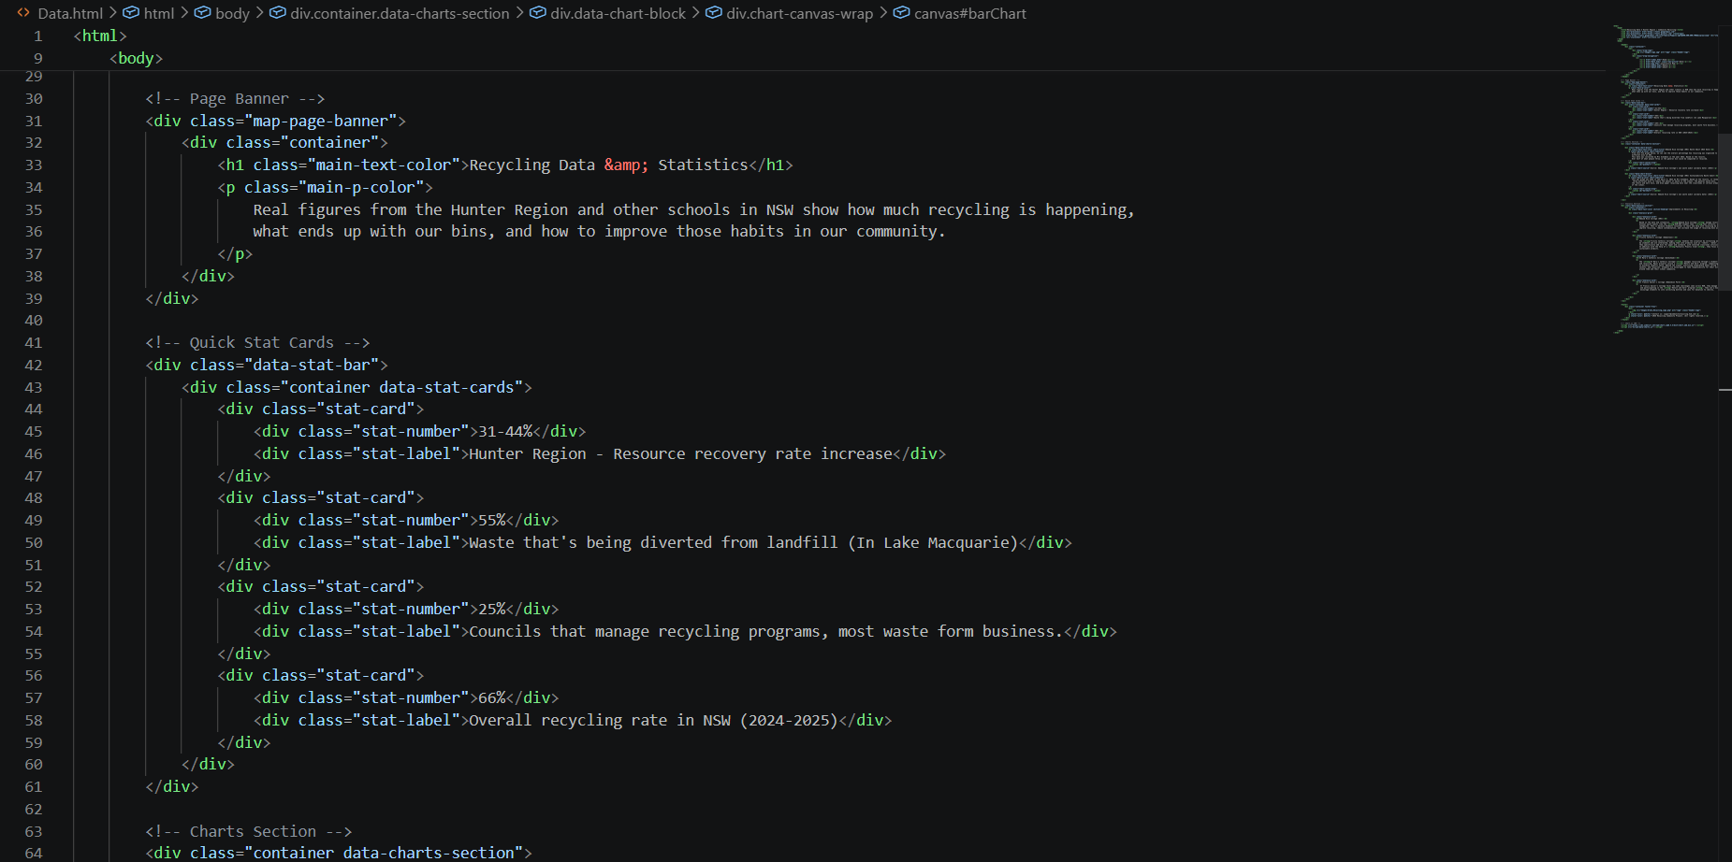
Vs Code example:

Section 4 Testing and Evaluating
Evaluate your performance requirements of hard drive for specific interactive media products.
The system needs to be evaluated to ensure that file storage, loading speed, and zipped website files are organized correctly and function according to the client’s requirements and expectations. Since the website includes interactive media such as images, videos, data graphs, and maps, sufficient capacity and the loading performance are important to ensure the website runs smoothly.
A variety of testing methods, such as ‘Live Server’ and ‘Inspect’, are used to check whether the website operates efficiently during both development and real-world use. These tests help identify errors and improve the overall system performance. If an error occurs, the system should respond safely to prevent major issues and maintain functionality.
Once the project is completed, the project team can evaluate whether the final project satisfies the clinet’s needs and requirements. In addition, data collected through surveys and user reviews can be used as feedback to make further improvements before the project in finalised.

Self and Peer assess the success of the product.
Peer Reviewer Name: Daniel, Kelly (Year 11)
Rating:
(9.5/10)
Strengths:
• the interactive map is highly interesting and function effectively.
• the information provided is way more relevant.
Areas of improvement:
• Changing the youtube banner language from Tagalog to English for better accessibility.
• The nav bar could have be improved to enhance usability and overall design.
Changes made based on peer feedback:
• The website design must be developed with additional detail and suitable language style, particularly English, to ensure that the target audience ca easily understand the content and remain engaged and interested about recycling and waste management.

Conclusion
- Overall, the website design may not appear too complicated, but I believe it was a huge success that achieved its purpose through careful organization and effective arrangement. The website includes JavaScript features such as data and maps, which serve as the focus and help engage the audience. In addition, boxes and space are used effectively to present information in a smoother, clearer, and more organized way for users to understand. Furthermore, adding a feedback section is highly important, as user feedback can provide ideas and suggestions to further improve the website and make it more visually appealing and eye-catching.

