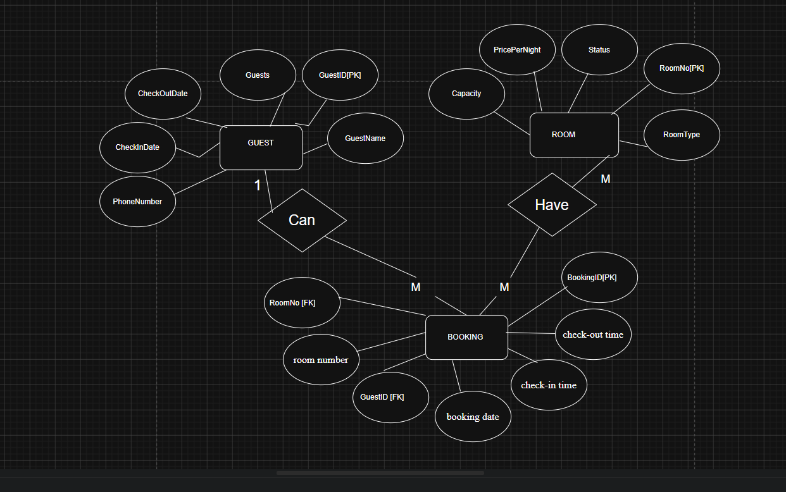

GUEST Table

Field Name | Key | Data Type | Data Format | Range | Function of Data
GuestID | PK | VARCHAR(10) | Gxxx (e.g., G001)
GuestName | - | VARCHAR(100)
PhoneNumber | - | VARCHAR(15)
CheckInDate | - | Date
CheckOutDate | - | Date
Guests | - | int

ROOM Table Data Dictionary
Field Name | Key | Data Type | Data Format | Range | Function of Data
RoomNo | PK
RoomType | -
Capacity | -
PricePerNight | -
Status | -

BOOKING Table Data Dictionary
Field Name | Key | Data Type | Data Format | Range | Function of Data
BookingID | PK
GuestID | FK
RoomNo | FK
BookingDate | -
CheckInDate | -
CheckOutDate | -
Guests | -

