FDE FAQ & Teaching Guide
Azure Bicep, Infrastructure as Code & Full-Stack Deployment
Based on Birlasoft Forge FDE Academy — Sprint 3, Days 43–44
Practical questions, clarifications, evidence to demand, and diagrams for FDE trainees
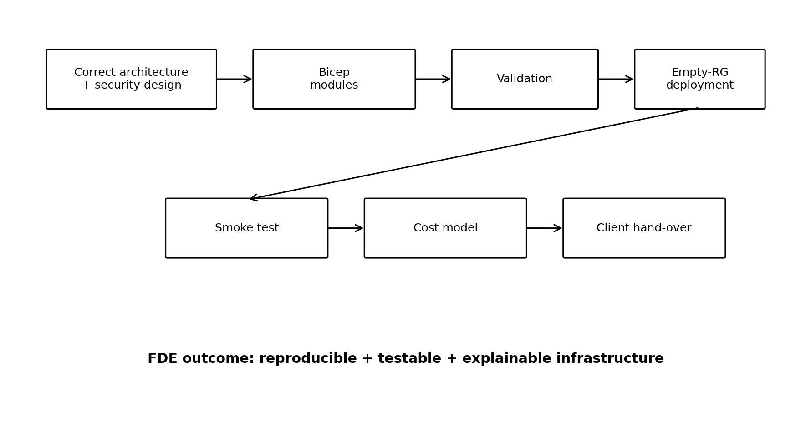

How to use this FAQ
This guide is designed to help an FDE understand the lesson as an engineering and client-delivery problem, not as a Bicep syntax exercise. Each question is phrased the way a reviewer, client, platform engineer, or FDE lead might ask it. The expected answer focuses on reasoning and evidence.
Source basis: the supplied Sprint 3 presentation covers the transition from secure infrastructure to repeatable Bicep, empty-resource-group rebuilds, validation, drift, module boundaries, pipeline controls, and cost modelling (pages 1–26).

1. The lesson in one page
Question | What an FDE should understand
Why Bicep? | Describe the intended Azure state so the system can be reproduced and reviewed.
What is the real goal? | A system another team can rebuild, test, operate and own.
What is drift? | The gap between the Bicep/template and what actually exists in Azure.
Why modules? | Separate resources by lifecycle so small changes do not unnecessarily touch critical systems.
Why an empty RG? | To prove the template is sufficient rather than relying on resources that already exist.
Does deployment success prove the app works? | No. A smoke test is required.
Does Infracost equal the AI system's total cost? | No. Usage-driven costs such as tokens, executions, egress, storage growth and logs can sit outside the template price.
What is the FDE value? | Judgement: boundaries, risks, drift controls, evidence, hand-over, and cost assumptions.

2. Visual model: from architecture to client hand-over
The deck's closing message is that the FDE should be able to prove the system can be rebuilt, explain drift controls, and present a cost shape with exclusions. See source pages 24–26.

3. FAQ — Foundations
Q1. What problem is Infrastructure as Code solving?
IaC turns infrastructure from a collection of portal clicks into a repeatable description. The practical goal is not simply 'having code'; it is being able to rebuild the environment consistently and hand it to somebody else.
FDE teaching point: Ask: If the original FDE disappears tomorrow, can the client's team rebuild the environment without calling that person?
Evidence to ask for: A successful rebuild from an empty resource group, the command used, elapsed time, and smoke-test evidence.
Q2. Why does the lesson put security before Bicep?
Because IaC repeats what you write. If you automate an insecure design, you make the insecure design repeatable across environments.
FDE teaching point: Ask trainees to identify the security decisions that must be settled before codifying the infrastructure.
Evidence to ask for: The deck explicitly connects Days 41–42's least privilege and secret hardening to Day 43's repeatability.
Q3. What does 'Bicep is not the cloud' mean?
Bicep represents intended state. Azure is the running state. They can diverge through manual changes, incremental deployment behaviour, limitations of what-if, and state that is outside Bicep.
FDE teaching point: Use this as the central mental model for the entire lesson.
Evidence to ask for: Show the repository and compare it with the actual Azure resource group.
Q4. What is drift in one sentence?
Drift is the gap between what the infrastructure template says should exist and what actually exists or behaves in Azure.
FDE teaching point: Do not accept 'drift means the deployment failed.' Drift can exist while deployments are green.
Evidence to ask for: A concrete diff between the template and live environment, or a documented drift-control process.
Q5. Is Bicep a script?
No. It is declarative. You describe the desired end state and Azure determines the deployment operations.
FDE teaching point: Ask the trainee to explain what should happen when the same Bicep is deployed twice.
Evidence to ask for: The expected concept is idempotent behaviour: repeated deployment should converge on the desired state.

4. FAQ — Bicep building blocks
Q6. What is a parameter?
An input that can vary by environment or deployment. Examples in the deck include environment, location, tier and replica count.
FDE teaching point: If a value is genuinely different between dev and prod, it may belong in a parameter file rather than hard-coded into the template.
Evidence to ask for: Ask: Which values change between environments, and why?
Q7. What is a variable?
A value calculated inside the Bicep file so it can be reused. It is not an external input.
FDE teaching point: Ask whether a trainee is creating parameters merely because they can. Too many parameters can indicate poor design.
Evidence to ask for: Review the parameter list and challenge each one: 'Why must the caller control this?'
Q8. What is a module?
A Bicep file called by another Bicep file. Modules provide architectural boundaries.
FDE teaching point: A module should represent a useful lifecycle or ownership boundary, not just a random collection of Azure services.
Evidence to ask for: The deck's three example stacks: inference, fraud, observability.
Q9. What is an output?
A value handed back to the caller or pipeline. Resource IDs, endpoint URLs, secret URIs and managed-identity principal IDs are examples of safe outputs.
FDE teaching point: Never treat deployment outputs as a secret channel.
Evidence to ask for: Inspect all outputs and verify that none contains credentials.
Q10. Why does API version matter?
The version after '@' is part of the resource type. It affects which properties exist and how the resource is described.
FDE teaching point: When something worked previously but now fails, ask whether the resource API version changed.
Evidence to ask for: The resource type and API version used in the Bicep.

5. FAQ — Secrets and identity
Q11. Why must secrets never be placed in Bicep outputs?
Deployment outputs are stored in deployment history. A credential published as an output can remain readable later, even after the credential has been rotated.
FDE teaching point: Teach trainees to distinguish an identifier from a credential. A Key Vault secret URI is an address; the secret value is the credential.
Evidence to ask for: A review of deployment outputs and deployment history.
Q12. Is @secure() enough to make a secret safe?
No. The deck says @secure() protects the parameter's handling, but a real secret committed inside a .bicepparam file is still a leak.
FDE teaching point: The best pattern, where possible, is to use a Key Vault reference so the deployment does not handle the secret at all.
Evidence to ask for: Search the repository and parameter files for actual secret values.
Q13. What are three common deployment secret leaks?
A plain string parameter instead of @secure(), a secret in an output, and a real secret stored in a .bicepparam file committed to Git.
FDE teaching point: Ask the trainee to identify which layer prevents each leak.
Evidence to ask for: Repository scan, Bicep review, outputs review, and Key Vault configuration.

6. Visual model: drift
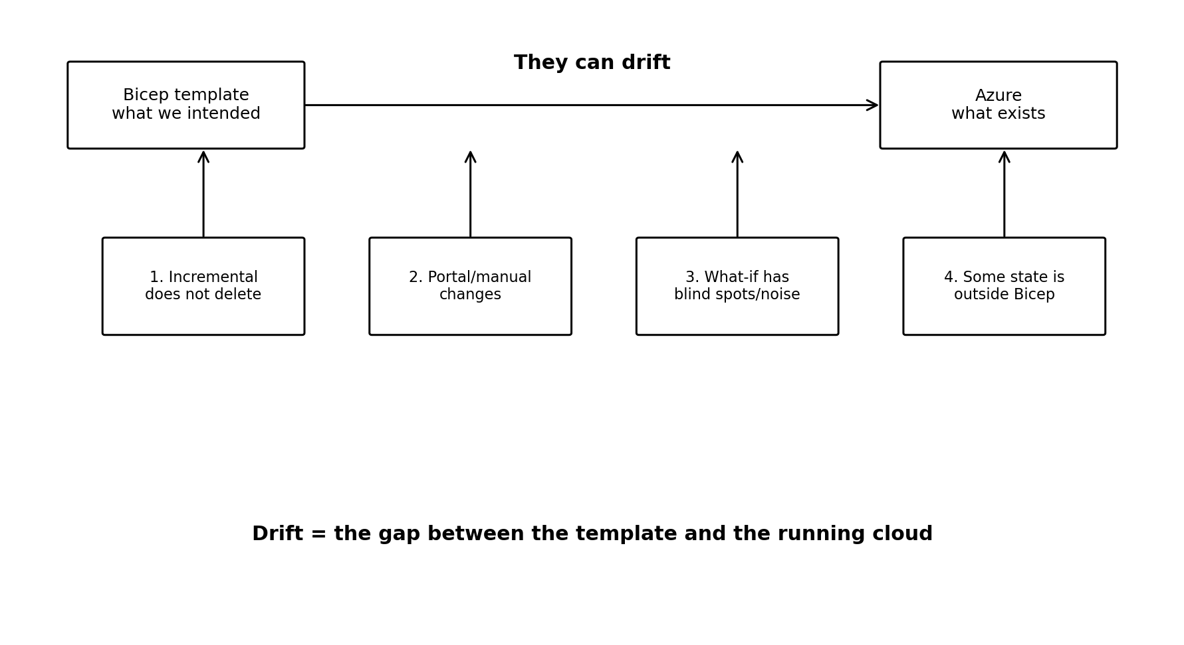

7. FAQ — Modules and architecture
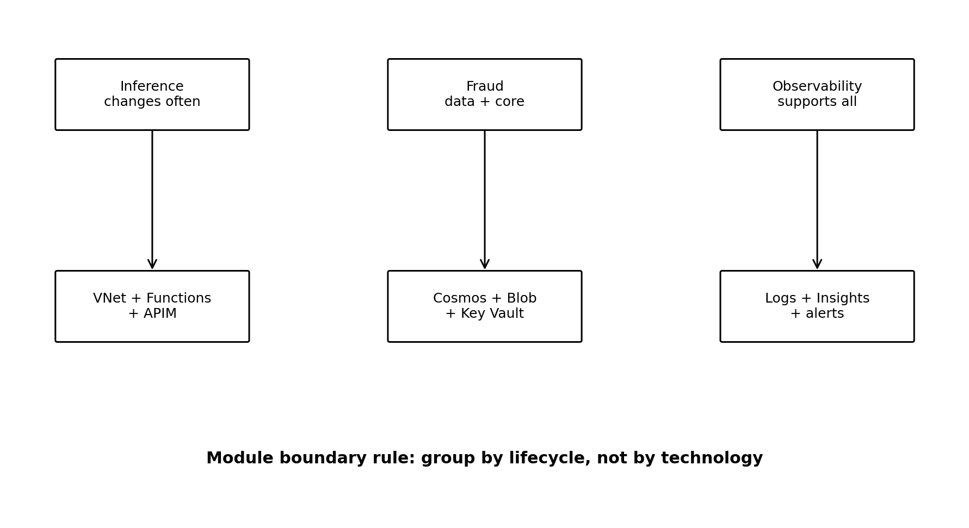
Q14. Why not put the entire system in one Bicep module?
A giant module means a small change can unnecessarily redeploy or touch unrelated components, including a database. Over time, that risk can make people afraid to deploy.
FDE teaching point: Use lifecycle as the main boundary: things that change together belong together.
Evidence to ask for: Ask: If this module fails halfway, what critical systems are affected?
Q15. What are the three example stacks?
Inference: VNet, six Functions, API Management and App Service plan. Fraud: Cosmos DB, model endpoint, Blob and Key Vault. Observability: Log Analytics, App Insights, workbooks and alerts.
FDE teaching point: The point is not to memorize the exact list; it is to understand why the boundaries exist.
Evidence to ask for: A diagram and a written justification for each module.
Q16. What is a good module-boundary test?
Ask: 'If this deployment fails halfway, what is broken?' If an unrelated critical system is included in the answer, reconsider the boundary.
FDE teaching point: Make trainees defend module boundaries in terms of blast radius and lifecycle.
Evidence to ask for: Failure-mode analysis for each module.

8. FAQ — Dev, staging and production
Q17. Should dev and prod use separate Bicep templates?
The deck recommends one template with separate parameter files. This keeps the shape consistent while making environment-specific differences visible.
FDE teaching point: Keep differences boring and explicit: size, count, tier, region, network exposure.
Evidence to ask for: main.bicep plus dev/staging/prod parameter files.
Q18. Why is a shape difference dangerous?
If dev uses a materially different service tier or deployment model, behaviour such as cold starts, concurrency or network integration can differ. A bug may then appear only in production.
FDE teaching point: Ask: Is dev actually a meaningful test of prod?
Evidence to ask for: A dev-vs-prod shape difference table, with an ADR explaining deliberate differences.
Q19. What should a good production parameter file tell a reviewer?
Within about a minute, the reviewer should be able to see what is different about production.
FDE teaching point: If the production differences are hidden inside complex conditionals, the design is harder to review and test.
Evidence to ask for: The production parameter file and a short comparison table.

9. FAQ — Validation and guardrails
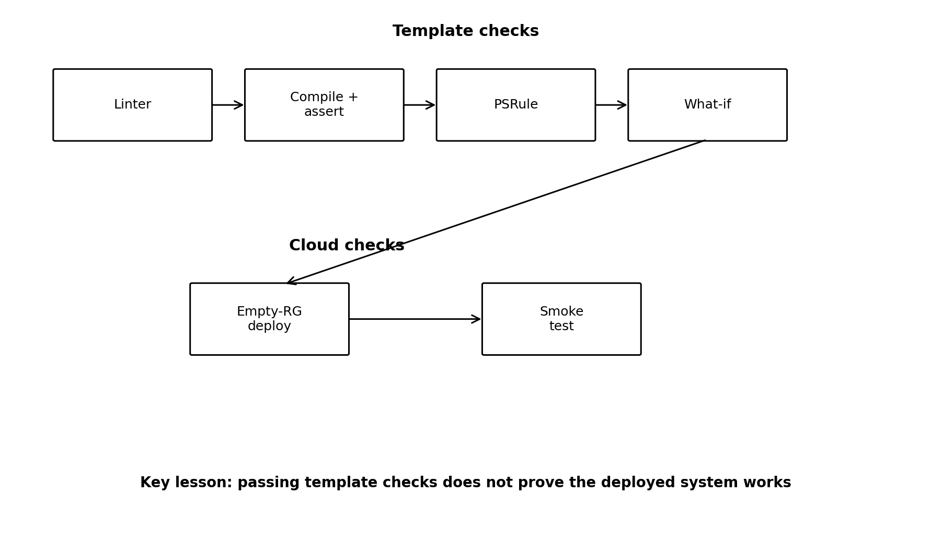
Q20. What does the Bicep linter do?
It checks template-level issues such as style, unused parameters and insecure defaults.
FDE teaching point: It is a template quality tool, not a complete cloud security review.
Evidence to ask for: The configured linter rules and the build output.
Q21. What does PSRule for Azure do?
It evaluates the compiled template against Azure-oriented rules. The deck lists examples such as public network exposure, missing diagnostics, weak TLS, key-based authentication and missing managed identity.
FDE teaching point: PSRule is useful in CI/CD, but it does not see the running environment.
Evidence to ask for: The agreed blocking baseline and a PR result.
Q22. What does Azure Policy add?
Azure Policy can act at deployment time in Azure to enforce compliance. The deck contrasts this with linter/PSRule checks that operate on the template.
FDE teaching point: Teach the distinction: blueprint checks versus live-cloud controls.
Evidence to ask for: The relevant policy assignments and enforcement mode.
Q23. What are deployment stacks doing in this lesson?
The deck presents deployment stacks as a way to manage resources as a unit and, with deny settings, help prevent people from editing deployed resources manually.
FDE teaching point: Ask whether the chosen governance mechanism closes the specific drift mechanisms the team cares about.
Evidence to ask for: The stack configuration and its deny/unmanage decisions.

10. FAQ — Testing: what exactly have you proved?
Q24. What does a Bicep 'unit test' actually prove?
In the lesson, it means compiling Bicep to ARM JSON and asserting properties of that generated JSON. It proves the template produced the intended structure; it does not prove Azure accepted it or that the deployed system works.
FDE teaching point: Always state the boundary of a test. Do not call template assertions proof of production behaviour.
Evidence to ask for: Compiled ARM JSON plus assertions.
Q25. What does what-if prove?
It predicts deployment changes. It is valuable as a preview, but the deck documents blind spots and noise around keys, references, secure values, deployment-time functions and other cases.
FDE teaching point: Treat what-if as a forecast, not as an infallible description of reality.
Evidence to ask for: A saved what-if result and the filtering rules used.
Q26. What actually tests the cloud?
An ephemeral or throwaway deployment tests the real Azure deployment. A smoke test then tests whether the deployed application actually works.
FDE teaching point: Use the phrase: 'The top checks test the file; the bottom checks test the cloud.'
Evidence to ask for: Empty-RG deployment result and an end-to-end smoke-test result.
Q27. Why must the deployment test start with an empty resource group?
Because deploying into an already populated environment can hide missing resources or configuration. A successful deployment there does not prove the template is complete.
FDE teaching point: The strongest evidence is a rebuild from empty.
Evidence to ask for: Resource-group creation timestamp, deployment command, duration, outputs and smoke test.

11. FAQ — What-if and the noise trap
Q28. Why can what-if show scary changes that are not real?
The deck explains that some values and references cannot be fully evaluated and that Azure may report changes where defaults or deployment-time behaviour make the preview noisy.
FDE teaching point: The FDE should know which categories are expected noise and avoid training humans to ignore all warnings.
Evidence to ask for: A representative what-if output with the team's interpretation.
Q29. How should what-if be operationalized?
The deck recommends machine-filtering the result and failing the pipeline on Delete or resource-replacing changes, while allowing ordinary noise to pass without requiring a human to read every line.
FDE teaching point: Automate the obvious high-risk cases so humans spend time on exceptions.
Evidence to ask for: The script/filter logic and a test showing a dangerous change causes a failed pipeline.
Q30. Why is alert fatigue an FDE lesson?
If a tool repeatedly produces noise, people learn to ignore it. That makes a later genuine destructive change easier to miss.
FDE teaching point: Ask: 'What behaviour will this alerting design train the operator to develop?'
Evidence to ask for: Evidence of thresholds, filters and escalation behaviour.

12. FAQ — Deployment order and Azure realities
Q31. Why does deployment order matter if Bicep handles dependencies?
Bicep can infer many dependencies, but the ones it cannot infer or external behaviours such as eventual consistency can still cause late failures.
FDE teaching point: Map dependencies before deployment and understand which resources are slow or eventually consistent.
Evidence to ask for: Dependency diagram and deployment timings.
Q32. Why can a Function get a 403 immediately after a role assignment?
Role assignments are eventually consistent. A role can exist while the authorization system has not yet propagated the permission to the running workload.
FDE teaching point: Include retry/wait logic in the smoke test rather than declaring the whole architecture broken after an immediate 403.
Evidence to ask for: Timestamped role assignment and subsequent successful smoke test.
Q33. What Azure-specific traps should I remember?
The deck highlights classic Consumption Functions lacking the required VNet integration, immutable/sensitive Cosmos choices such as partition key decisions, globally unique names, and Key Vault soft-delete name retention.
FDE teaching point: These are pre-flight questions, not surprises to discover at the end of a lab.
Evidence to ask for: Pre-flight checklist and ADR decisions.

13. FAQ — 'Provisioned by code' and deployment modes
Q34. Does incremental deployment guarantee that Azure exactly matches Bicep?
No. Incremental deployment adds and updates but does not delete resources simply because they disappeared from the template.
FDE teaching point: Teach the difference between 'everything in my template exists' and 'nothing exists outside my template.'
Evidence to ask for: A drift-check strategy or deployment-stack design.
Q35. Why is complete mode dangerous?
The deck says complete mode deletes resources in the resource group that are not in the template. One mistake can therefore be destructive.
FDE teaching point: Never recommend a destructive mode casually; the correct choice depends on the governance model.
Evidence to ask for: The ADR explaining why the chosen deployment mechanism is appropriate.
Q36. What is the modern governance option discussed?
Deployment stacks can manage a resource set as a unit and can provide deny settings to restrict manual edits.
FDE teaching point: Ask what specific drift mechanisms the chosen control closes.
Evidence to ask for: Deployment stack configuration and a test of manual-edit behaviour.

14. FAQ — Pipeline
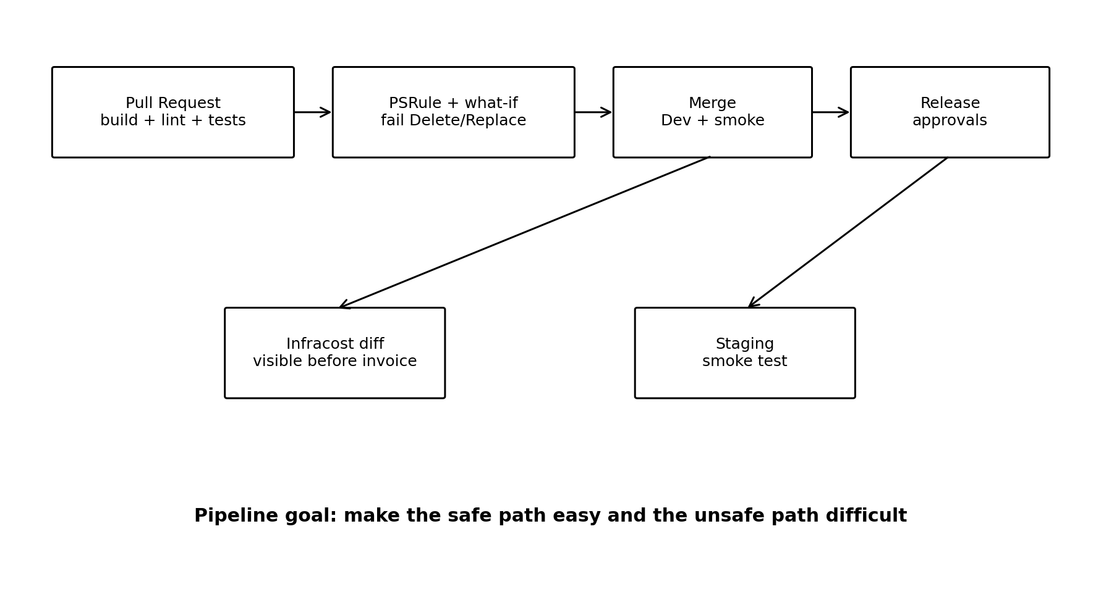
Q37. What should run on every pull request?
The deck lists Bicep build, linter, pytest on compiled ARM, PSRule against the agreed baseline, and what-if against production with machine filtering for Delete and Replace.
FDE teaching point: The purpose is fast feedback before Azure changes happen.
Evidence to ask for: A failed PR should clearly show which control stopped the change.
Q38. What should happen after merge to main?
Deploy to dev, run a smoke test, and post an Infracost diff so cost changes are visible before an invoice arrives.
FDE teaching point: Infrastructure cost should be part of engineering review, not an afterthought.
Evidence to ask for: CI run plus cost diff artifact.
Q39. What should happen at release?
The deck proposes manual approval, staging deployment and smoke test, another manual approval, then production deployment.
FDE teaching point: The FDE should be able to explain why each gate exists.
Evidence to ask for: Release pipeline definition and approval history.

15. FAQ — Cost: what does the number actually mean?
Q40. What does Infracost give me?
It prices resources represented in the infrastructure template, after Bicep is compiled. It is useful for fixed infrastructure costs and comparing template versions.
FDE teaching point: Never present it as the complete monthly cost of an AI workload without qualification.
Evidence to ask for: Compiled ARM input, Infracost output, and documented limitations.
Q41. What costs are outside the Bicep-only estimate?
The deck identifies usage-driven items such as model tokens, Function executions, egress, storage growth and logs, plus some autoscale/serverless behaviour.
FDE teaching point: Ask what assumptions connect business volume to technical usage.
Evidence to ask for: A usage model with volume assumptions.
Q42. What is the three-figure cost model?
Fixed floor, expected-volume estimate, and the same model at three times the stated volume, with exclusions clearly written.
FDE teaching point: The client needs a shape of cost, not a single confident number.
Evidence to ask for: Cost table with assumptions and exclusions.

16. FDE clarification checklist — questions to ask before accepting the work
Area | Ask this question | Evidence / acceptable answer
Architecture | What exactly are the three module boundaries and why? | Lifecycle/blast-radius justification.
Security | Which least-privilege and secret decisions from the previous days are encoded? | Role matrix, identity design, Key Vault pattern.
Parameters | What changes between environments? | Short parameter files and comparison table.
Secrets | Can I find any credential in outputs, parameters or Git? | No; secret scan + review.
Drift | How can Azure diverge from Bicep? | Four mechanisms identified; controls mapped.
Validation | Which checks test the template and which test Azure? | Clear separation of lint/compile/PSRule/what-if vs deploy/smoke.
What-if | What is expected noise? | Known categories plus automated Delete/Replace filtering.
Rebuild | Can you recreate it from empty? | Command + duration + dated successful run.
Dependencies | What must exist before what? | Dependency map and deployment order.
Runtime | How do you prove the application works? | End-to-end smoke test.
Cost | What is fixed, usage-driven, and excluded? | Three-figure model.
Handover | Can the client own it without the FDE? | Repository, parameters, ADR, pipeline and runbook.

17. FDE defence questions — use these in a review
1. Delete the resource group. Talk me through the next hour. What command do you run, how long does it take, and when did you last prove it?
2. Which of the four drift mechanisms have you actually closed? Which remain?
3. Show me a what-if output. Which lines are noise and which would stop the deployment?
4. What exists in Azure that is not represented in your Bicep? How did you check?
5. Why are these resources in the same module? What lifecycle do they share?
6. If this deployment fails halfway, what critical system is affected?
7. Why is dev a valid test of prod? Show me the shape differences.
8. Show me every output. Which one could contain a secret?
9. Where does the application get its secret at runtime?
10. What happens if the Function starts immediately after the role assignment?
11. Which Azure resource will take the longest to deploy, and how does that affect your plan?
12. What happens if the client uses three times the expected claim volume?
13. What part of your cost estimate comes from infrastructure configuration and what part depends on runtime usage?
14. What evidence would you leave behind so another engineer can reproduce the environment?

18. Common weak answers — and better follow-up questions
Weak answer | FDE follow-up
'We have Bicep, so we can recover.' | Show me a successful rebuild from an empty resource group.
'Everything is in code.' | How did you detect manual portal changes and resources outside the template?
'What-if is clean.' | What categories of what-if noise have you validated? Show me an example.
'The deployment succeeded.' | Show me the end-to-end smoke test.
'PSRule passed, so we're secure.' | What does PSRule not know about the live environment?
'Prod costs ₹X per month.' | What is the fixed floor, expected usage, 3× usage, and exclusions?
'The secret is secure because it uses @secure().' | Where is the actual secret stored? Is any real value committed to Git?
'Dev and prod are basically the same.' | Show me the exact shape-difference table.
'We used one module because it is simpler.' | What happens to the database when a Function changes?
'Nothing exists outside Bicep.' | What mechanism proves that claim?

19. Mini glossary for FDEs
Term | Simple meaning
ARM | Azure's deployment engine; Bicep compiles into ARM JSON.
Declarative | Describe the desired end state rather than writing a sequence of steps.
Module | A Bicep file called by another Bicep file.
API version | The version after @ in a resource type; it determines available properties.
Incremental mode | Default deployment mode that adds/updates but does not remove resources merely because they are absent from the template.
Complete mode | Deployment mode that can delete resources not represented in the template; potentially destructive.
Deployment stack | Resource-management mechanism discussed in the deck that can also provide deny settings.
What-if | A predicted change list for a deployment; useful but can contain noise.
Drift | The gap between template intent and live cloud state.
Idempotent | Repeated deployment converges on the same desired state.
Smoke test | A real functional check against the deployed system.
Blast radius | How much of the system is affected if a change or deployment fails.

20. Final FDE takeaway
The lesson is not 'learn Bicep syntax.'
The FDE lesson is to turn a secure architecture into something repeatable, testable, governable and hand-over ready. The strongest FDE answers are backed by evidence: an empty-environment rebuild, smoke-test output, drift controls, module-boundary reasoning, pipeline gates, and a cost model with assumptions and exclusions.
The key sentence to remember: The template is not the cloud.
Source: Sprint 3 Days 43–44, especially pages 2–4, 7–10, 12–18, 20–26 of the supplied presentation.

