Class and Object class is a template / blue print from which individual objects are created.
Instance of a class is called as an object
Class is the logical entity that contains logics. Object is physical entity contains memory
Class is the blueprint it decides object creation.
Based on class it is possible to create multiple objects.
To create class we use class keyword and to create object we use new keyword.
Class contains 5 diff elements like variables, methods, constructors, Instance blocks and Static Blocks.

What are the class types :
Execution class: Main method
Bean class: POJO Class : Used to set the data and transfer the data.
Functionality class. Functions those perform a task.
Java Types :
Class, Interfaces, Enumerations (Used to set up fixed set of values like number of days a week or number of months in year )
Annotations: used to provide instructions to compiler.

Data types

In Java, the data types are grouped into two categories:
Primitive types These are built in data type which stores the values.
Int,Char , Boolean, byte , double
Int x=0; x is primitive type

Reference types Reference types store a reference (memory address) pointing to an object — NOT the actual data.
String, classes, exceptions, errors, interfaces, enums, and arrays
abc x=new abc(); x—reference Type

Primitive | Reference
A locker that contains the item inside it. | A locker that contains only a paper that says "Go to locker #22". The actual item is in locker #22
Can not be null | Can be null
Stores value | Stores memory point to an object

Primitive types
There are 9 primitive types in Java.
Below table summarizes the categories of the primitive types:
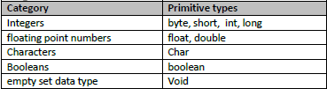

Wrapper class: Wrapper classes wraps the primitive data and provides the object capabilities.
Every class by default extends a object.
Object class is default class and also called super class.

Type casting is process to convert data type forcefully.
Byte value=(byte) 200; --but it is not a good practice.
Primitive data type are not supported by collections , wrapper classes are supported

Variables: Every variables contains its own type like primitive, class, array
Variables are 3 types
Local variable: Variables declared within method are called Local variables
Instance Variables: Variables declared inside the class and outside of the method
Instance variables are created when an object is created.
Stage 1: Public class Employee {
Public int id
Public double salaray; }
Above variable instance variable, unless we create the object no memory allocated to above variables
Stage 2: Employee e =new Employee () Now memory is allocated to above variables
e.id
e.salary
Instance variables are varies from object to object
Static Variables: Variables declared inside the class and outside of the method with modifier static
Static modifier used to refer the static variable and when class is created static variables created.
They are also known as class variables. Static variables cannot change from object to object.
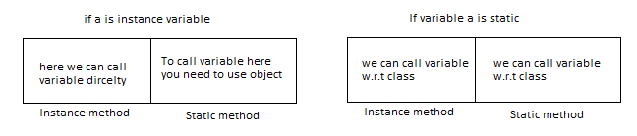
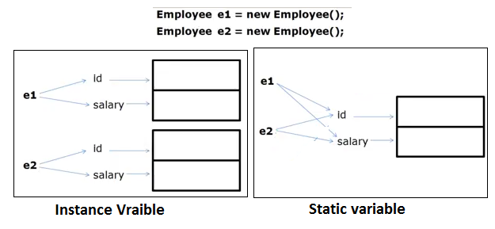
So if you want to call instance method in main method, you need to call through object.
Default values for byte, int, long is 0 and float is 0.0, for String single space and for Boolean is False.
For the classes default value is null
Instance Variable | Static variable
Instance variables are created when object is created | Static variables are created when class is created
No modifier is used to declare the variable | Static modifier used to declare the static variable
Instance variables value change from object to object | Static variables are same for all object

Methods
In classes you cannot write business logics, that’s why you need methods there you are going to write methods.
Types of methods
Static Method : Belongs to class , no need to create object to call static methods.
Instance (Non static) Methods : Belongs to Object , we must create object to call these methods

After processing the methods with parameters they return value using return type
Return type Is mandatory for methods
We cannot declare one method within other method, inner methods are not allowed. But inner classes are allowed, two same signature also not allowed
If application is having both instance and local variables are same name we will use THIS keyword to make differentiate.
This we used for instance variables. Inside the static method this key word is not allowed.
For methods return type is mandatory (either void or String or return type we need to mention), otherwise throws an error.
There are different return types in java like void, primitive type, class type and array type.
Inside the method return statement is last statement in method.

RAM+MOHAN in java it will be concatenating displays RAMMOHAN.10+20 is displays 30 ---here + symbol performs diff actions it is called operator overloading. But java is not supporting operator overloading except + operator. So + symbol is implicit operator in java.

Control Statements
These statements are used to control the flow of execution of program

Types
-----
- if statement / if .. else statement
- switch statement
- while loop
- do..while loop
- for loop
- break and continue

switch statement
----------------
- It is used to choose an option among the given set of options
- It is mainly used for menu driven applications

syntax
------
switch (expression)
{
case opt1: statements;break;
case opt2: statements;break;
case opt3: statements;break;
...
case optn: statements;break;
default: statements;
}

Ex:
String fruit = "apple";
switch (fruit)
{
case "apple": SOP("Apple");break;
case "mango": SOP("Mango");break;
}

Loops
-----
Loops are used to execute the set of statements repeatedly when the condition
is true

Types
-----
- while loop
- do..while loop
- for loop

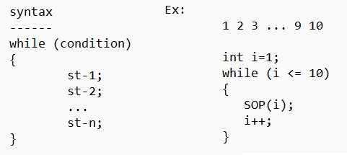

In case of while loop the condition is checked before the statements where as
in case of do..while loop the condition is checked after the statements

Ex:
1 2 3 ... 9 10

int i=1;
do
{
SOP(i);
i++;
}while (i<=10);
break and continue
------------------
- break is used to come out of loop
- continue is used to continue the loop

Ex:
while (condition)
{
...
break;
...
}

while (condition)
{
...
continue;
...
}

Constructors:
A constructor initializes an object when it is created.
Constructor is same name as that of class name. It looks like a method, but does not have return type
To call constructor in java there are diff ways
A a=new A()
Recursive call to constructor is allowed in java. If you don’t put any constructor in class,
JVM automatically put a default constructor at compile time. Constructor over loading is allowed in java but not overriding.
We can have any access specifier for constructor
If we give return type to a constructor, then it is considered as ordinary method.
Constructor is able to take parameters. If there is no any constructer then only default constructor will be generated

What is the basic usage of constructor:
Whenever you create object then constructor will get executed
Constructor are used to write business logics of the application, those logics are executed during object creation
Constructors are used to assign values to instantaneous variables
Types for Constructors :
Default constructor : Default Constructor is a special constructor that is automatically provided by the Java compiler.
parametrized constructor: A parameterized constructor in Java is a constructor that accepts parameters during object creation

Main Method
Public static void main (String[] args)
static public void main (String[] args)..it is also correct.
both are same ….

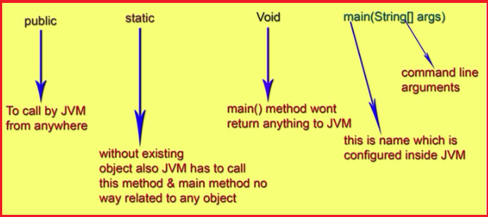

Modifiers in Java
In Java, a modifier is a keyword that changes the behavior, visibility, or properties of a class, method, variable, or constructor.
There are 13 modifiers in Java:
Private default modifier Protected Public
Final Static Abstract Interface
Synchronized Transient Native Strictfp volatile
The Java language has a wide variety of modifiers, including the following:
Java Access Modifiers
Non Access Modifiers
Access Control Modifiers:
Java provides a number of access modifiers to set access levels for classes, variables, methods and constructors. The four access levels are:
In Java, there are 4 accessibility modifiers: private, default or package modifier, protected, and public.
Note:
1) The scope of the private members is anywhere within the class.
2) The scope of the default members is anywhere within the package.
3) The scope of the protected members is anywhere within the same package and only subclass of the different package.
4) The scope of the public members is anywhere.
5) The default modifier is also know as package modifier.
6) The class modifier must be public to access from different package.
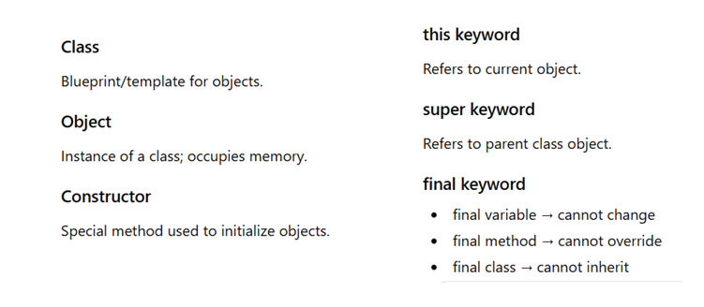
OOPS: OOPS are methodologies, which helps make code reusable, modular, secure, and easier to maintain.
Oops concept are Inheritance, Encapsulation, Polymorphism, Abstraction,
An object = data (fields) + behavior (methods).

Inheritance: Inheritance is used to build new classes from existing classes. Code Reusability is the basic usage of Inheritance.
Java Inheritance defines an IS-A relationship between a superclass and its subclasses. In Java, extends keyword is used to inherit a superclass.
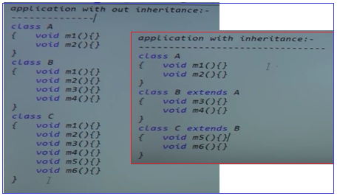

class A{}
class B{}
class C extends A,B {}//error - does not support multiple inheritance

Abstraction:
Hiding internal implementation and highlight set of services what it is offering is the concept of Abstraction.
Benefits are Security, Easy Enhancement
Abstraction can be achieved with either abstract classes or interfaces
The abstract keyword is a non-access modifier, used for classes and methods:
Abstract Class and Interfaces:

Abstract Class: A Method is declared but not define is called abstract method.
A class with abstract method is called abstract class.
An abstract class is a class that cannot be instantiated (cannot create object)
Remember abstract class may or may not have abstract method.

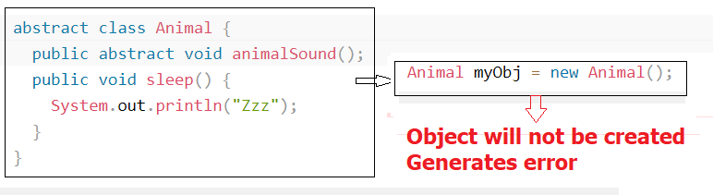
Why we can not create object in Abstract class : Answer is , Abstract means incomplete, so compiler will throw an error

If you want to create a object you need to extent this abstract class to another class there you can define that object is called as concrete method
Animal class is extended to other class PIG , Using that class we can define the object

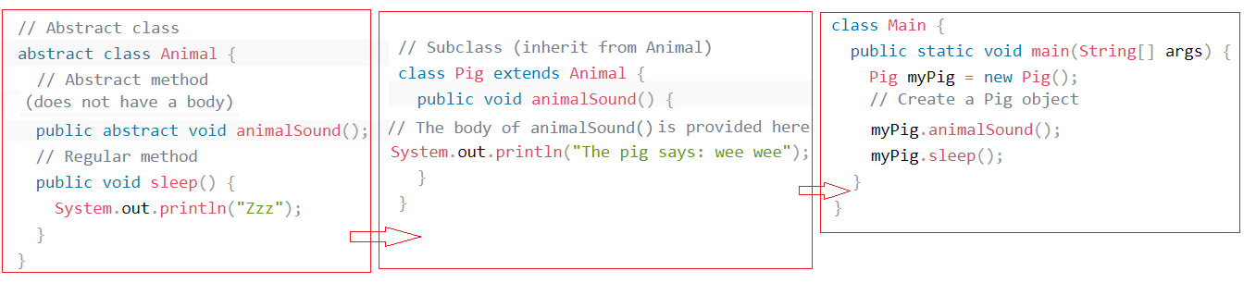

So finally use of abstract class is : To achieve security - hide certain details and only show the important details of an object.
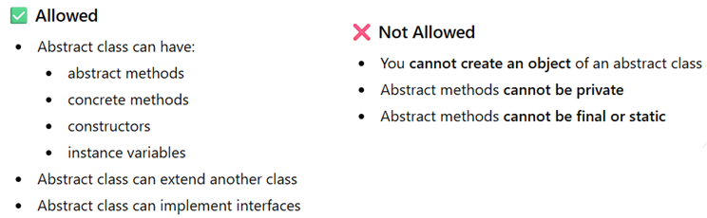

Normal Class | Abstract Class
All methods are concrete | At least one abstract method
We can create object | We can not create object

Interface:
Multiple inheritances cannot be achieved in java. To overcome this problem the Interface concept is introduced.
An interface is a template which has only method declarations and not the method implementation.
An Interface is complete Abstract class (100% abstract class.). Interfaces have only abstract methods
Again what is abstract method : A Method is declared but not define is called abstract method.
We can not create the objects using interface.
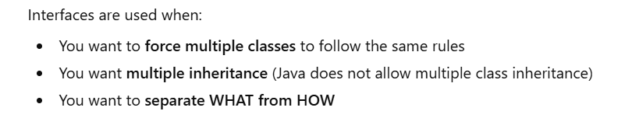
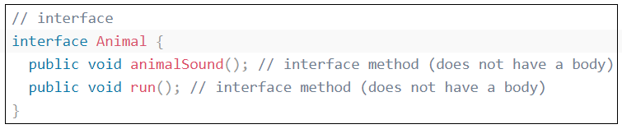
To access the interface methods, the interface must be "implemented by another class with the implements keyword (instead of extends). The body of the interface method is provided by the "implement" class:
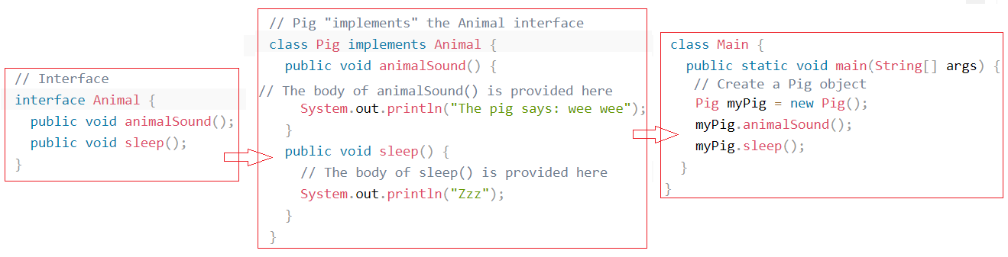

Why And When To Use Interfaces
1) To achieve security - hide certain details and only show the important details of an object (interface).
2) Java does not support "multiple inheritance" (a class can only inherit from one superclass).
However, it can be achieved with interfaces, because the class can implement multiple interfaces.

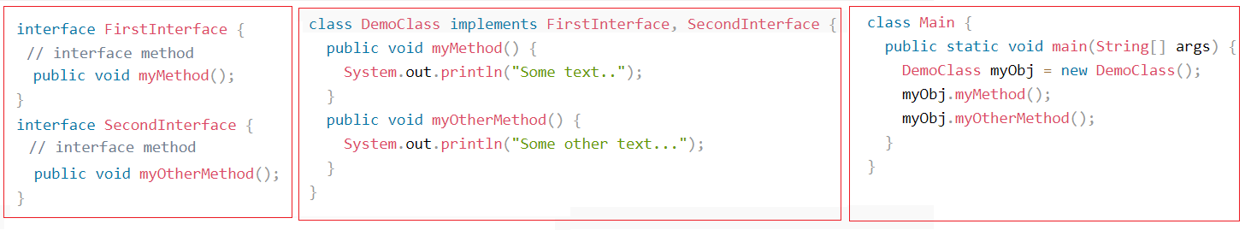
Methods in interfaces are public and abstract.
So public means, we can not use private and protected modifiers in interface.
Abstract means ,we can not use final, static modifiers in interface.

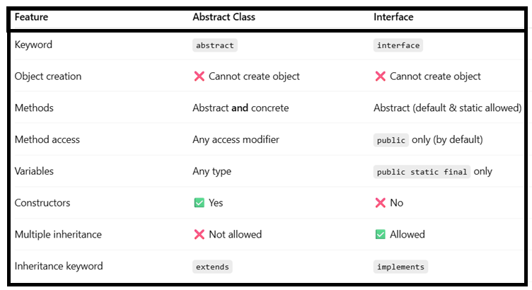
Static:
When the value is supposed to be shared across all objects
In Java, the static modifier means something is directly related to a class: if a field is static, then it belongs to the class; if a method is static, then it belongs to the class

Encapsulation: Encapsulation is the process of wrapping data (variables) and methods into a single unit (class) and restricting direct access to the data.
In simple words:
- Hide data
- Control access
- Protect object state

Basic usage of encapsulation is
Protects the code from others.
Code maintainability.
By declaring the variables as private means which are restricted to that class only , and these variables are access and update via public methods using setter and getters.

Class is best example for Encapsulation , Package is also one of example of encapsulation which is closely packed with interfaces and classes

User can not access the data directly , through the methods using setters and getters user can access the data.
It is the technique making fields in class are private and providing access via public methods.. If variables and methods are declared as private modifier means which are tightly encapsulated (because they restricted to that class only)
By providing setter and getter methods we can make class read only or write only
If we don’t provide setter method then read only (setter: set the data to the properties)
If we don’t provide getter method then write only (Getter: get the data from properties)
Encapsulation =Data Hiding +Abstraction
Benefits Security like hiding the implementation.
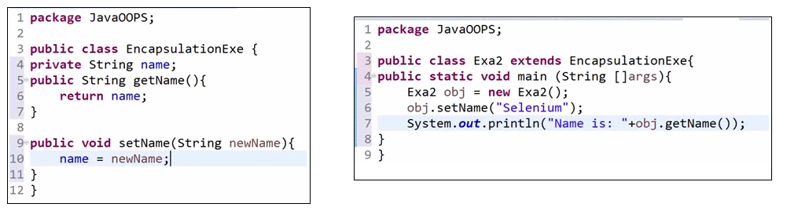
In above we can access the variable ‘name’ from one class (first diagram) to another class (second diagram)

getter and setter are two conventional methods that are used for retrieving and updating value of a variable which is declared as private in other class.
The wrapping(binding) upof data members and methods together into a container
called class and by providing security to data is called as encapsulation

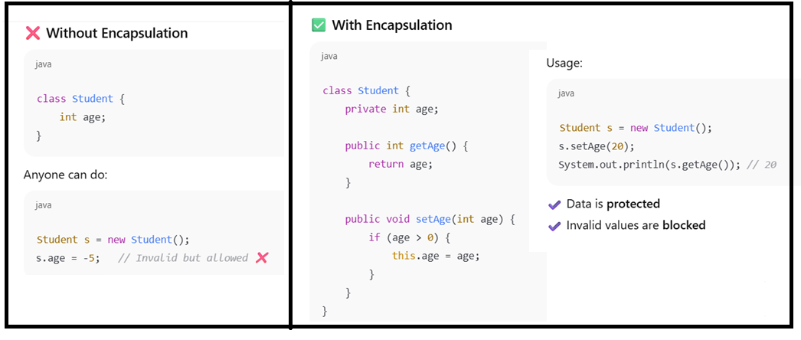
A class is fully encapsulated (secured) when all data members are private

Polymorphism
Polymorphism is the ability of an object to take many forms by allowing the same method name to perform different actions.
In simple words:
- One interface
- Many implementations

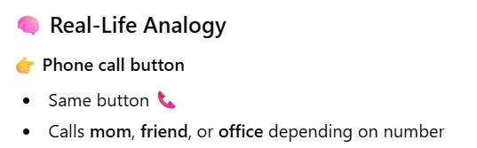

There are 2 types of polymorphisms
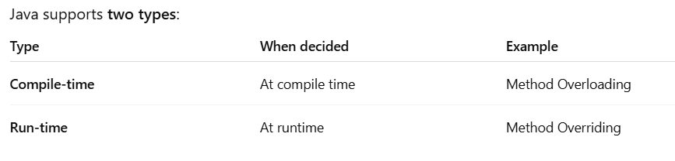
There different types in over loading (Method overloading, Constructor over loading)

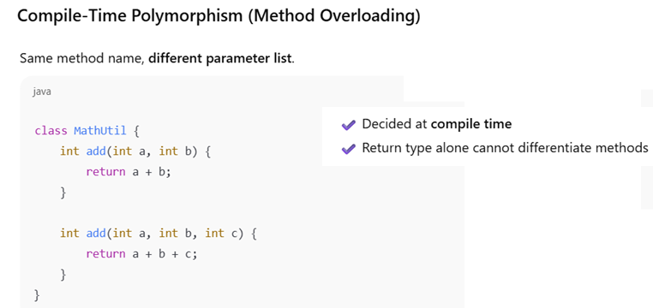
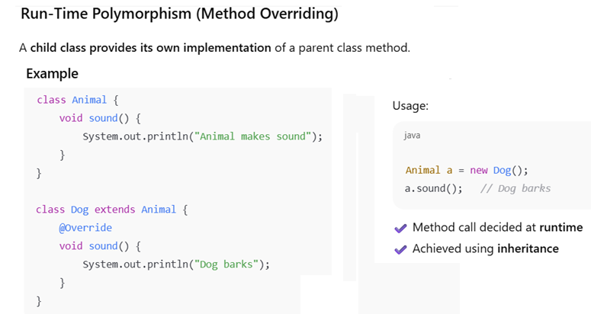
It calls the a.sound() from sub class not from super class, subclass method overrides the super class method called method overriding.

If there are two methods having same name in parent in child class, parent class method reference is used to call child class method is called overriding.

Method overriding rules:
a) The superclass and subclass methods must have same return type.
b) The superclass and subclass method signature must be same (i.e., method name, the number of parameters, parameter types, parameter order).

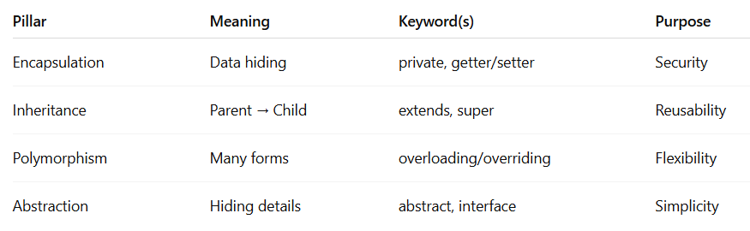

Exception Handling
Definition: An unexpected event that terminates the program abnormally is called as an exception.
For example: ArithmeticExcetion, ArrayIndexOutOfBoundsException, FileNotFoundException, etc.

There are two ways to handle the exception handling Try catch block and throws keyword
Types of exceptions are unchecked and checked exception. Error also one type of exception
The exceptions which are checked by compiler is called checked exceptions.
If the exceptions not checked by compiler and raised during run time are called unchecked exceptions.
If exception is checked or unchecked they will occur at run time only no exception occurs at compiler.
File not found exception is a checked exception and Arithmetic exception is an unchecked exception.

Checked exception must be handled, using try catch block or declaring Throws keyword
Unchecked exception may or may not be handled. The compiler will ignore unchecked exceptions

There are three keywords in exception handling try, catch and finally
Try: where the exception occurs
Catch:” error will caught in catch block
Finally: whether the program is having error or not the code in the finally block will get executed

Throw: Sometimes we can create an exception object explicitly we can handover to JVM manually for this we use THROW

Class test
P S V M (S[] a) {
Throw new ae(“divided by zerp”)
}
Throws : To delegate the exception handling responsibility to caller (caller is either other method or jvm)
Try catch is normal termination and Throws is abnormal termination .Throws issued only to convince compiler.in run time it get abnormal termination. We can not use throws keyword at class level only in class members like methods and constructors.

File not found exception --- Predefined checked exception – Try catch or throws
Incorrect password – application related user defined checked exception… Throw keyword
If user defined exception is checked exception. Your user exception class collects the exceptions
In predefined exceptions , JVM creates a exception and throws the object. OK in predefined its ok
In user defined who will create exception object and who will throw the exception.
As a programmer we have to create and we have to throw
Throw key word is used to throw the exception externally.

For checked exceptions we can handle try catch or throws class.

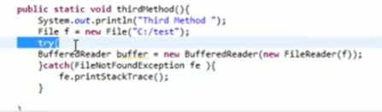

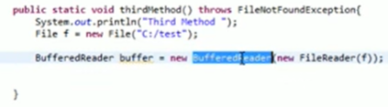
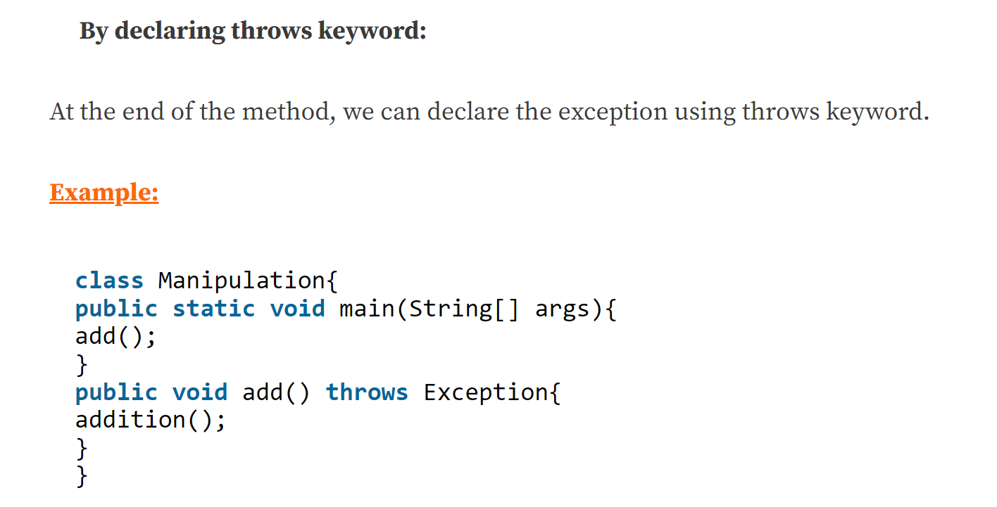

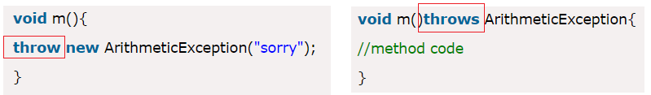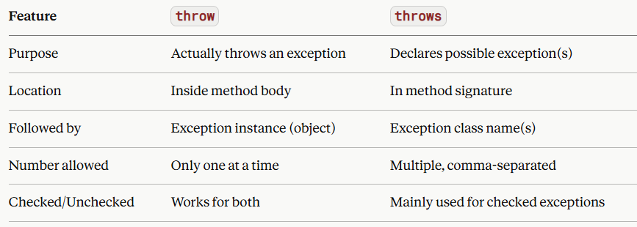

try catch and finally

try -- It contain businelogic ....which are going to raise the execption
If exception raises one object created for exception class
and reference of that exception object is thrown on to catch block
Ctach block hold that refecenre object ...

A try block can be followed by one or more catch blocks. Each catch block must contain a different exception handler.

Nested try catch also possible

with in try block we can use inner try catch final blocks
with in catch block we can use inner try catch final blocks
with in finally block we can use inner try catch final blocks

Garbage Collection: Garbage collection is a process of reclaiming the runtime unused objects. It is performed memory management. Finalize method is used in garbage collection
Arrays:
In Java, an array is a data structure that stores data of same type. Arrays in java are object.
Arrays are static, once we declare we can not change it.
Arrays : Accessing data is fast, where deletion and insertion is slow due to rearrange the items.
Array declare is
Int arr[] = {10,20,30,40}; --- while declaring no need to mention the size.
There is otherway to define.
Int arr[] = new int[5] ---- While instantiating we need to mention arry size… here in this case array is object (new key word).

public class DemoHashtable {

public static void main(String[] args) {

int arr[] = new int[5];
arr[0] = 10;
arr[1] = 20;
arr[4] = 30;

for (int i = 0; i < arr.length; i++) {
System.out.println(arr[i]);
}

// Enhanced for loop
int arry[] = new int[5];
arry[0]=10;
arry[1]=110;
arry[4]=220;

for(int element:arry) {
System.out.println(element);
}

}

}
In enhanced for loop, we can access one element at a time in forward direction, this is only disadvantage in enhanced loop.

Limitations with arrays:
1) Size of an array is fixed i.e., once an array is created, there is no way of increasing or decreasing its size.
2) Array can hold only homogeneous data elements.
Example:
String[] str = new String[5];
Str[0] = new String(“aspire”);
Str[1]=new Integer(10); //C.E
3) No predefined data structures to manage array data.

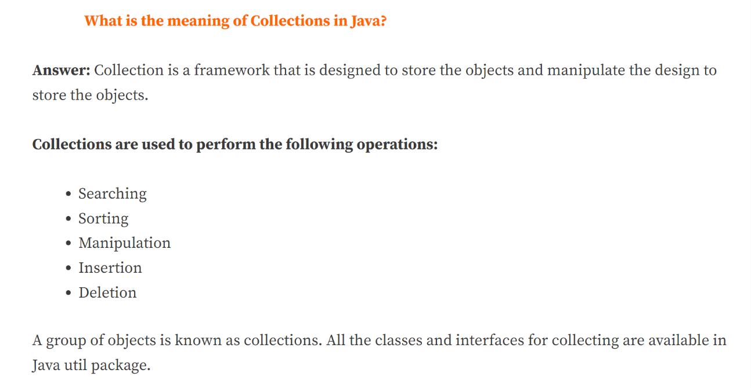

Collections

Collections : A group of individual objects as single entity is called collections.
Performance is good in arrays than collections

To overcome above limitations, Collection Framework was introduced:
1) The size of a collection is not fixed i.e., the size of a collection can be increased or decreased.
2) Collection can hold hetrogeneous (any type of) objects.
3) Predefined data structures such as Stack, Queue, DeQue, LinkedList,etc are defined to manage collection data.

Array | Collection
Size is fixed | Collection size can grow or shrink
Contains only homogeneous elements | Contains heterogeneous elements.
The elements type can be Primitive or Reference type. | Allows only Reference types but not Primitive type.
No predefined data structures to manage array data. | Predefined data structures are defined to manage collection data.

Collections :
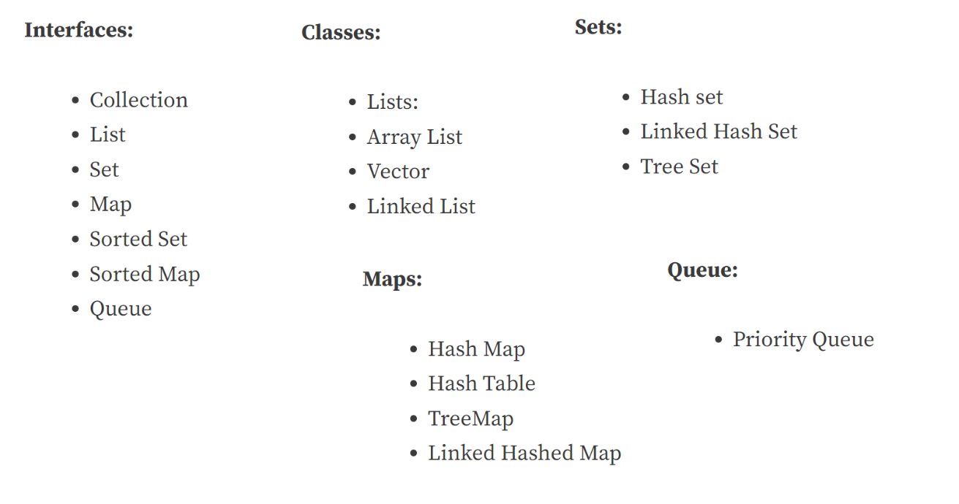
Collections and their objects are dynamic in nature.
In real time our application works with objects in dynamic in nature. Number of user accounts in FB is keeps on changing. Similarly passengers list in itinerary also keeps on change to handle these type of dynamic nature in objects we need to go for collections framework.
Collections grow in nature dynamically.
Collections interface in java.util package is key parent interface which is implemented by three interfaces like list set and Queue. All these data structures to hold the objects.
List : One of child interface in collections.
It is object entity, allowed duplicate values.
Insertion order is preserved.
Ex: ArrayList, LinkedList
Set : One of child interface in collections
It is object entity, not allowed duplicate values.
Insertion order is not preserved.
Queue is first in first out data structure.
Array list is fast in reading.
Not good for insertion and deletion , default size of arry list is 10.
In real time application when read is more compared to insert and delete, then we go for array list compared to linked list.

Add data to Array:
Add any type of data
ArrayList list = new ArrayList();
List.add(“Ram”)
List.add(“Sam”)
List.add(“90.5”)
List.add(“11”)
To add only particular data type: pass data type to array
ArrayList<Integer> list = new ArrayList<>();
list.add(11)
list.add(100)
list.add(211)
More methods in array list:
Using runtime polymorphism concept we can change above syntax as follows.
Add elements through for loop
List<Integer> list = new ArrayList<Integer>();
for(int i=10;i<100;i=i+10) {
list.add(i);
}
System.out.println("list"+ list);
}
List is a interface that is implemented by both array list and linked list.
We can add element at a particular index.
List<Integer> list = new ArrayList<Integer>();
for(int i=10;i<100;i=i+10) {
list.add(i);
}
System.out.println("list"+list);
list.add(1,100);
System.out.println("list"+list);
}
How to replace existing element.
list.set(1,200)

ArrayList and LinkedList both implements List interface and maintains insertion order.
ArrayList is better for storing and accessing data. LinkedList is better for manipulating data.

Set :
Set : One of child interface in collections
It is object entity, not allowed duplicate values.
Insertion order is not preserved.

Set collections 3 implementations like
Hash Set – Doesn’t follow insertion order
LinkedHashSet – maintains the same order what you entered
TreeSet--- It provides the sorting order or ascending or descending

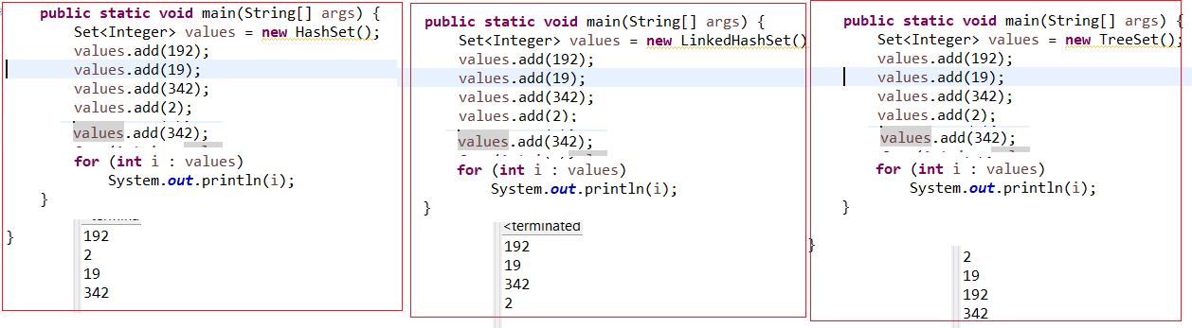

Methods of List interface
-------------------------
- boolean add(Object) => adds an element at last
- void add(int, Object) => adds an element at the given index
- void set(int, Object) => updates/modifies the element at given index
- boolean remove(Object) => deletes the given element
- Object remove(int) => deletes the element at the given index
- Object get(int) => returns the element at given index
- int size() => returns the number of elements

Additional methods in LinkedList
--------------------------------
- addFirst()
- addLast()
- removeFirst()
- removeLast()

Map
Hash Map :

https://www.youtube.com/watch?v=EFAbTZWbaAg
Hash map stores the items in key value pairs.
Hash map is class implements from map-interface.
It may have one null key and multiple null values.
It maintains no order.
Hashmap is non synchronized -- not thread safe
(multiple threads can access hashmap at same time, performance is good)

Concurrent modification exception : Fail fast condition
Any changes in the collection, such as adding, removing and updating collection during a thread are iterating collection then Fail fast throw concurrent modification exception.

import java.util.HashMap;
import java.util.Map.Entry;
public class DemoHashmap {
public static void main(String[] args) {
HashMap<Integer, String> hm = new HashMap<Integer, String>();
hm.put(1, "UFT");
hm.put(2, "Seleneuim");
hm.put(3, "Devops");
hm.put(4, "AWS");
System.out.println(hm.get(1));
System.out.println(hm.get(3));
// For loop
for (Entry m : hm.entrySet()) {
System.out.println(m.getKey() + " " + m.getValue());
}
// To remove the item
System.out.println(hm);
hm.remove(3);
System.out.println(hm);
}
}

How to use object in hashmap …We can java object also ..
Create a constructor in separate class.
public class Employee {
String name;
int age;
String dept;
Employee(String name, int age, String dept){
this.name=name;
this.age= age;
this.dept=dept;

}
}
import java.util.HashMap;
import java.util.Map.Entry;
public class DemoHashmap {
public static void main(String[] args) {
HashMap<Integer, String> hm = new HashMap<Integer, String>();
hm.put(1, "UFT");
hm.put(2, "Seleneuim");
hm.put(3, "Devops");
hm.put(4, "AWS");
System.out.println(hm.get(1));
System.out.println(hm.get(3));
// For loop
for (Entry m : hm.entrySet()) {
System.out.println(m.getKey() + " " + m.getValue());
}
// To remove the item
System.out.println(hm);
hm.remove(3);
System.out.println(hm);

HashMap<Integer, Employee> emp = new HashMap<Integer, Employee>();
// create a constructor

Employee e1 = new Employee("Ram", 1, "IT");
Employee e2 = new Employee("Raj ", 2, "HR");
Employee e3 = new Employee("Rao ", 3, "DEV");
emp.put(1, e1);
emp.put(2, e2);
emp.put(3, e3);
for (Entry<Integer, Employee> m : emp.entrySet()) {
int key = m.getKey();
Employee e =m.getValue();
System.out.println(key+ " Info");
System.out.println(e.name+" "+e.age+" "+e.dept);
}
}
}

Classes under Map interface
---------------------------
- HashMap => unordered based on keys and no duplicate keys
- LinkedHashMap => ordered based on keys and no duplicate keys
- TreeMap => sorted based on keys and no duplicate keys.

Hash Map | Hash Table
HashMap is non synchronized. It is not-thread safe | Hash table is synchronized. It is thread-safe
HashMap allows one null key and multiple null values | Hash table doesn’t allow any null key or value.
Multi threaded, Performance is good | Single threaded, so Performance is poor compared to HashMap

Hash Table :
HashTable is similar to hash-map and hash table is synchronized.
Stores the values in key value pair.
In hash table every key is in the form of object ,each object has one hash code, on that hash code value is stored.
When you create a object , JVM gives a 32 bit number to that object that number is hash code .
Here synchronized means.. In case of multi threading , it access one by one thread ,..not parallely. that’s why it is thread safe.

import java.util.Enumeration;
import java.util.Hashtable;
import java.util.Set;

public class DemoHashtable {

public static void main(String[] args) {

Hashtable ht = new Hashtable();
ht.put(1, "Ram");
ht.put(2, "Raj");
ht.put(3, "Rao");
ht.put(4, "Rao");
// Clone or shallow copy of hash table
Hashtable hc = new Hashtable();
hc = (Hashtable) ht.clone();
System.out.println("From ht " + ht);
System.out.println("From hc " + hc);

// Contains
if (ht.contains("Ram")) {
System.out.println("Exist");
}
System.out.println("------ Enumeration");
// Print all values using enumeration.
Enumeration e = ht.elements();
while (e.hasMoreElements()){
System.out.println(e.nextElement());
}
System.out.println("------ Entry set");
// Get the values from hash table using entry set()
Set s =ht.entrySet();
System.out.println(s);

// How to get the hash code of object
System.out.println("Hash code " +ht.hashCode());

}

}

Hash-map we use entry set to get the values where as in hash-table we use enumeration or entry set to get the values.

Packages : A package can be defined as a group of similar types of classes, interface. Using package it becomes easier to locate the related classes.
Built-in Package:-Existing Java package for example java.lang, java.util,Java.io etc.
User-defined-package:- Java package created by user to categorized classes and interface
Java.lang:
Language is referred to as lang. The Java language package is made up of Java classes and interfaces, which together make up the JVM and the Java language
Java.io:
Input and output are referred to as “io.” It offers a selection of I/O streams for reading and writing data to files.
Java util:
Utility is denoted by util. It includes a number of practical utility classes and associated interfaces for implementing data structures including LinkedList, Dictionary, HashTable, stack, vector, calendar, and data utility.

import keyword is used to import built-in and user-defined packages into your java source file

Maven : It is a build management tool works on POM (project Object Model) model
It is used for projects build, dependency and documentation. It simplifies the build process
groupId: This is an Id of project's group. This is generally unique amongst an organization or a project
artifactId: This is an Id of the project. This is generally name of the project
Maven life cycle :

Maven lifecycle is a predefined order of build phases that Maven executes to manage a project from source code to deployment.
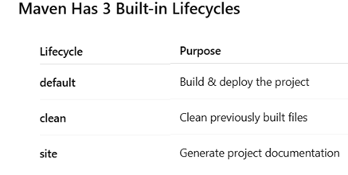
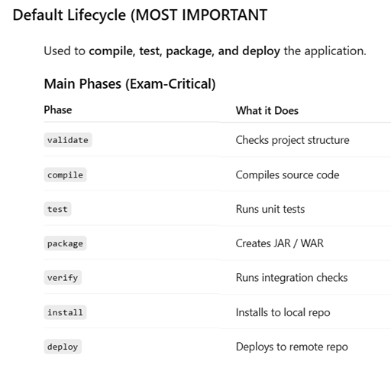
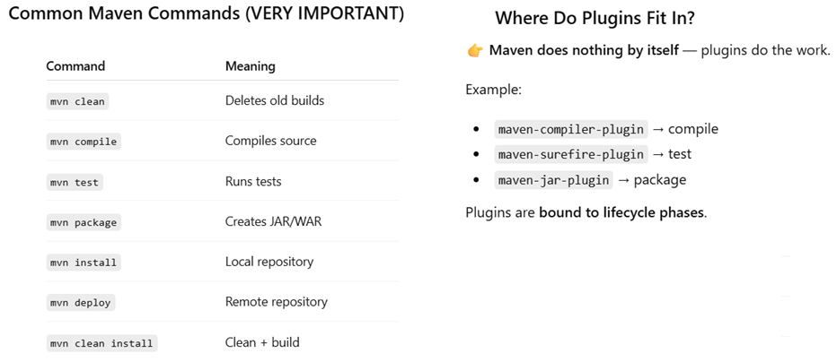

There adifferent phases in maven life cycle
- Process resources. : At this stage it make sure that all project resources and copying the resources.
- Compile : At this stage it will compile the source code
After compilation it process all test resources and execute the tests
- Package : after compilation and test , package the project in to jar file or war file depends on type of project
- Install : finally it install the project
So if you run the mvn install prior to install it will perform all above preconditions like 1,2,3 ect.
Maven Goals :
There are multiple goals bound to a each phase of maven
- Process resources --resources: resource (first resource is plugin and second one goal)
- Compile ---------------- compile : compile (first compile is plugin and second one goal)
- Test : test the junit test cases or automation test cases
- Package ------------------ jar : jar (first jar is plugin and second one goal)
- Install ------------------- install: install

Maven execute all the phases before the phase what you execute.
If execute maven install .. it executes all phases 1,2,3,4 ,then it executes install
If you execute maven test --- it executes all before phases 1,2 then it executes test

Even we can execute install using goal also … mvn install:install --- as usually before install it will go through all stages

.m2 is the hidden repository in local machine where all the jar files will be added here.

3. Maven Phase
A Maven phase represents a stage in the Maven build lifecycle. Each phase is responsible for a specific task.
Here are some of the most important phases in the default build lifecycle:
compile: compile the source code
test-compile: compile the test source code
test: run unit tests
package: package compiled source code into the distributable format (jar, war, …)
install: install the package to a local repository
deploy: copy the package to the remote repository

4. Maven Goal
Each phase is a sequence of goals, and each goal is responsible for a specific task.
When we run a phase – all goals bound to this phase are executed in order.
Here are some of the phases and default goals bound to them:

compiler:compile – the compile goal from the compiler plugin is bound to the compile phase
compiler:testCompile is bound to the test-compile phase
surefire:test is bound to test phase
install:install is bound to install phase

Maven Plugins : A Maven plugin is a group of goals
Are the one through which tasks like compiling the code ,testing them with junit and creating the file like JAR/WAR
Maven Compile – Maven compiler plugin
Maven Test – Maven surefire plugin
Maven resources .JAR –Maven resources plugin
Clean plugin – to delete the target directory.
Compile plugin – to compile the code
Surefire – to run test cases
Jar /war ---- create jar/war files
Javadoc –generate javadocs of the project.

Compiling a Java program means taking the programmer-readable text in your program file (also called source code) and converting it to bytecodes

Goals represents specific tasks :
Maven commands :
Mvn deploy -- deploy the entire project
Mvn clean install --- It will create the build (means it create the jar file)…
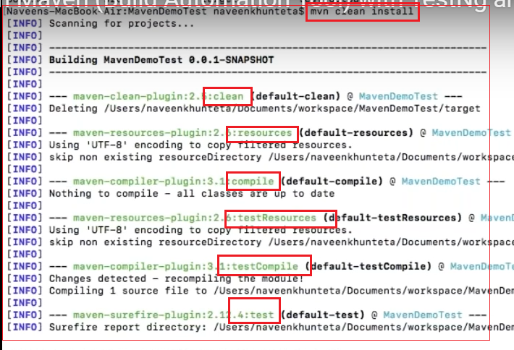

Mvn install
Mvn clean install
To run specific task
Mvn compiler:compile ---- compiler is plugin and compile is goal

There are three diff build life cycles in maven
Default build cycle: In deafault cycle we have 23 phases , some of key cycles are as follows

process-resources: Processing the resources by putting it in the right folder.
compile: Compilation of project source.
test-compile: Compilation of test source code.
test: Run the generated test cases using a unit test framework like JUnit.
package: Perform the packaging in a distributed format like jar, war or ear.
install: Install the package into the local repository.
deploy: Copying the final build to a remote repository.

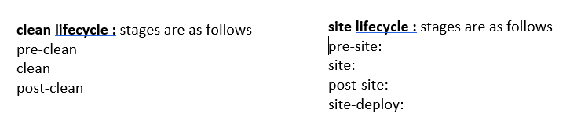
Generics : Basic purpose is to type safety and to resolve the type casting problems.
Following are the 3 advantages of generics
Type-safety: We can hold only a single type of objects in generics. It doesn’t allow to store other objects.
Type casting is not required: There is no need to typecast the object.
Compile-Time Checking: It is checked at compile time so problem will not occur at runtime.

Interfaces in Java-6 and Java-8

Java 8 introduces the possibility for an interface to have default methods. Default methods start with a default keyword and contain a body like class methods do.

Try with resource :
In exception handling ,finally block and explicitly close a resource.
From java 7 onwards
there is try-with-resource feature. If a resource implements java.lang.AutoCloseable, which includes all objects implementing java.io.Closeable, will be auto closed if they are created within try statement.

Base64:
Base64 class has methods for encoding and decoding, including basic encoding, url encoding and mime encoding.

Parallel Arrays
Java 8 release adds a lot of new methods to allow parallel arrays processing. The purpose is to speed up bulk processing of an Array on a multi-core hardware. The methods are: Arrays.parallelPrefix, Arrays.parallelSetAll and Arrays.parallelSort. All three methods have additional different variants, related to array type, with supplied Comparator for sorting etc.

Static and Non static methods :
When do you go for static:
a. If you are writing utility classes and they are not supposed to be changed.
B .If the method is not using any instance variable.
c. If any operation is not dependent on instance creation.
d. If a piece of code shared by all the instance methods.

Static | Non Static
Belongs to class | Belongs to instance
Access only static variables | Can access both static and non static variables
Uses early binding (compile binding) | Uses runtime binding
We can not override static methods, because static methods are early binding | We can override non static methods, because override needs dynamic bindig(runtime bingind)
Can not use this and super keywords in static methods | Can use this and super keyword

Method Over loading and method over riding :

Method overloading | Method over riding
Method overloading is performed within class. | Method overriding occurs in two classes that have IS-A (inheritance) relationship
In case of method overloading, parameter must be different. | In case of method overriding, parameter must be same.
Method overloading is the example of compile time polymorphism. | Method overriding is the example of run time polymorphism.

Overloading concept comes in polymorphism concept.
In Java there are 3 types of overloading

- Constructor overloading
- Method overloading
- Operator overloading

Senario1: If application is having both instance and local variables are same name we will use THIS keyword to make differentiate. This we used for instance variables. Inside the static method this key word is not allowed.
Scenario2: In constructor over loading if we want to call one constructor from other constructor we wil use this method

The super keyword refers to superclass (parent) objects. It is used to call superclass methods, and to access the superclass constructor from child class. The most common use of the super keyword is to eliminate the confusion between superclasses and subclasses that have methods with the same name

Singleton Class :
A Singleton class is a class that allows only ONE object (instance) to be created in the entire program.
A Singleton class ensures that only one instance of the class exists and provides a global access point to it.
In a normal class, we use a java constructor to instantiate the object of the class
In Singleton class to instantiate a singleton class, we use the getInstance() method

Real-Life Analogy
- Database connection
- Logger
👉 You don’t want multiple objects for these — one shared instance is enough.

Why Do We Use Singleton?
- To save memory
- To control shared resources
- To ensure consistent state across the application

To create a singleton class, we need to do following steps:
- Make the constructor private
- Create a private static instance of the class
- Provide a public static method to return the instance
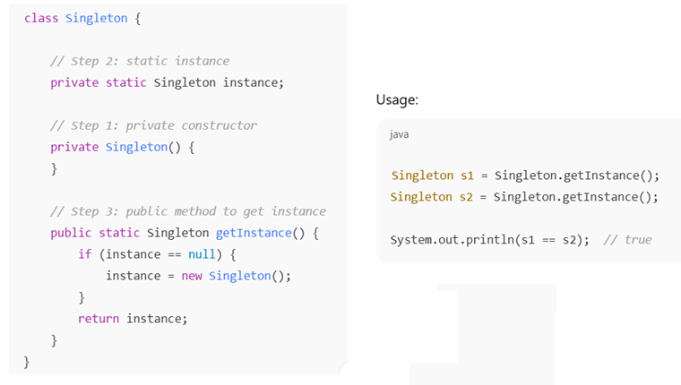

FAQ

- How many methods are there in Object Class
Hash code, Notify, Notify All, Getclass, Finalize
- Use of Finalize : Grabage collection
- Method overloading and overriding
Even same method name and same number parameters and data types are different, even that is called as Method overloading
Overriding concepts comes in Inheritance concepts (Methods and variables defined in parent classes can be accessed in child class).If there are two methods having same name in parent in child class, parent class method reference is used to call child class method is called overriding.

- Return type of constructor is null
- What is diff between If Else and Switch
In If else, every if condition executed even first condition is true
Where as in Switch, it will directly jump in to condition
- Diff between for loop and While loop
In for loop there is condition, intilization and increment at one go
In while you can check only condition, Initlization and increment you need to put manually.
- How to run infinite loop :
Ans : Don’t write anything in semicolon or write a true condition like 1=1

- Final : Value is fixed , it can’t change
If method is final we can’t override it
- Array list vs Set
Array list duplicate allowed, in set No duplicate
Array list is ordered, in set it is disordered
- What is static and Advantages of static
Static is something which is common for all the objects. We can use this static in utility objects which are common for all objects
- Is Null is keyword : Yes null is keyword

- What is class level variable : Whatever we declare outside the method which are class level or global variables which are common for all methods
Local variables are declared with in function which specifically meant for that method only not for all methods in that class
- Default value for Boolean is False
Default value for Integer is Zero
Default value for Object is Null

- What is difference between string and String buffer class?
String objects are immutable (not able to change) where as string buffer is mutable (possible to change)
String s =new String(“Ram”) | StringBuffer sb=StringBuffer(“Ram”)
s.concat(“Mohan” | sb.Append(“Mohan”)
SOP(s) –dsiplay Ram only because String is not changeable | Sop(s) –RamMohan --string buffer is mutable
String creates new object every time, whereas string buffer creates uses same object

- Diff between throw and throws
Throw deliberately throws an exception.
Throws tells that particular function has capable of throwing exception.

- Diff between Final and Finally
"Final" denotes that something cannot be changed. You usually want to use this on static variables that will hold the
Same value throughout the life of your program.
Finally: We required one place to maintain cleanup code which should be executed always irrespective of whether
Exception is raised or not and exception is handle or not. Such type of block is called as finally block.
Hence the main objective of finally block is to maintain cleanup code.
- Diff between Unchecked and Checked
Exception which are checked at compile time are checked exception.
Exception which are checked at run time are called unchecked exceptions.

If an exception (or error) is directly or indirectly inherited from Runtime Exception (or Error) is called as unchecked
Exception i.e., in the exception hierarchy, if Runtime Exception (or Error) presents then it is a Unchecked exception,
Otherwise, it is a checked exception.
Checked exception must be handled, otherwise the program will not be compiled.
Unchecked exception may or may not be handled. The compiler will ignore unchecked exceptions

Types of Exceptions
ArithmeticException | Arithmetic error, such as divide-by-zero.
ArrayIndexOutOfBoundsException | Array index is out-of-bounds.
IndexOutOfBoundsException | Some type of index is out-of-bounds.
NullPointerException | Invalid use of a null reference.

- Difference between equals() and ==
Main difference between == and equals in Java is that "==" is used to compare primitives while equals () method is
Recommended to check equality of objects.
== operator is meant for reference object comparison where as equals method is meant for content comparison
- Difference between array and String Array
In java, a string array is a collection of string class objects while a char array is a collection of char (primitive data type)
Values.

- Diff between error and Exception
Error is something which you can not handle while exception is what you can handle via try catch.

- What is Constructor?
It is special type of method which is used to initialize the object.Retrun type of constructor is None.
We should have good knowledge in constructor, this is used in POM.

- Diff between b++ and b=b+1
b++ is correct and b=b+1 will give the compile error (possible loss of precision)

- System.Out.Println here System is class ,Out is a Static variable println is method
- Web Server vs Application server
Webserver supports web applications
Application supports Enterprise applications. Every application server contains inbuild web server
- JDK,JRE,JVM
Jdk –java development kit –Used to develop and run the program
JRE – Java run time environment = only to run the program we use JRE
JVM –Java virtual machine is interpreter, in JRE, JVM is responsible to run the program line by line

- What is Final,Finally,Fianlize

Final is modifier applicable for methods and classes and variables, If variable declared as final, that value become final we cannot change that value, If method is declared final we can’t over ride it.If class is final we can’t extend that class
Finally: It is block always associated with try catch block, we are going to maintain clean up code in this block
Finalize: It is method invoked by garbage collector just before destroying an object to perform clean up activities.
- What is bytecode
While compiling java it compiles and creates .class file, that. Class file is called bytecode. This .class file we can run on
any platform

- What is Selenium
It is set of API and Jars which automate web browsers.

- Can selenium Windows applications
No Selenium will not automate Windows
Then how do you automate if you want to insert a file in desktop? ..You can say the: We can use tools like AutoIT to identify windows.

- What is Appium?
Appium is used to automate mobile.

31 . Examples of Error, Checked Exception and unchecked exception
Error : java.lang.StackOverflowError, java.lang.OutOfMemoryError
Unchecked: ArrayIndexOutOfBoundsException, NullPointerException ,NumberFormatException
Checked Exception: IOException ,FileNotFoundException ,ClassNotFoundException

32 : String Functions :
equalsIgnoreCase() determines the equality of two Strings, ignoring thier case (upper or lower )
String str = "java";
System.out.println(str.equalsIgnoreCase("JAVA"));
Output : true
length() function returns the number of characters in a String.
String str = "Count me";
System.out.println(str.length());
Output : 8
replace() method replaces occurances of character with a specified new character.
String str = "Change me";
System.out.println(str.replace('m','M'));
Output : Change Me

substring() method returns a part of the string. substring() method has two forms,
String str = "0123456789";
System.out.println(str.substring(4));
Output : 456789
System.out.println(str.substring(4,7));
Output : 456
toLowerCase() method returns string with all uppercase characters converted to lowercase.
String str = "ABCDEF";
System.out.println(str.toLowerCase());
Output : abcdef

toUpperCase(): This method returns string with all lowercase character changed to uppercase.
String str = "abcdef";
System.out.println(str.toUpperCase());
Output : ABCDEF
trim() : This method returns a string from which any leading and trailing whitespaces has been removed.
String str = " hello ";
System.out.println(str.trim());
Output : hello

33: This and Super method:

Senario1: If application is having both instance and local variables are same name we will use THIS keyword to make differentiate. This we used for instance variables. Inside the static method this key word is not allowed.
Scenario2: In constructor over loading if we want to call one constructor from other constructor we wil use this method

The super keyword refers to superclass (parent) objects. It is used to call superclass methods, and to access the superclass constructor from child class. The most common use of the super keyword is to eliminate the confusion between superclasses and subclasses that have methods with the same name

34 : JDBC Connection
Step1: Register the driver class :
The forName() method of Class class is used to register the driver class.
Class. ForName("oracle.jdbc.driver.OracleDriver");
Step 2: Create the connection object :
The getConnection () method of DriverManager class is used to establish connection with the database.
Connection con=DriverManager.getConnection("jdbc:oracle:thin:@localhost:1521:xe","system","password");
Step 3: Create the Statement object :
The createStatement () method of Connection interface is used to create statement.
Statement stmt=con.createStatement();
Step 4: Execute the query
The executeQuery() method of Statement interface is used to execute queries to the database.
ResultSet rs=stmt.executeQuery("select * from emp");
while(rs.next()){
System.out.println(rs.getInt(1)+" "+rs.getString(2)); }
Step 5: Close the connection object
By closing connection object statement and ResultSet will be closed automatically.
con.close();

35. When you use string string buffer and string builder
Once we created string object , we can not change in existing object , String is immutable
Where as an string buffer is mutable, we can perform changes on string buffer object
String buffer is mutable…whenever thread safety matters then we go for string buffer
Thread safety means no two threads calls a method simultaneously
String builder : String builder also mutable and if thread safety doesn’t matter and multiple threads allowed to operate then we go for string builder
If multiple threads works on method and value changes every time .. then it is not thread safety
StringBuffer is a class used to create modifiable String objects

36. POI API Excel read and Write data
To read or write an Excel,Apache provides a very famous library POI
o read XLS files, an HSSF implementation is provided by POI library.
To read XLSX, XSSF implementation of POI library will be the choice
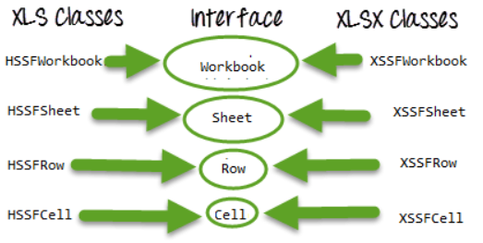
File file = new File(filePath+"\\"+fileName); ---//Create an object of File class to open xlsx file
FileInputStream inputStream = new FileInputStream(file); //object of FileInputStream class to read excel file
ramworkbook = new XSSFWorkbook(inputStream);-- //If it is xlsx file then create object of XSSFWorkbook class
Sheet ramSheet = ramworkbook.getSheet(sheetName);-- //Read sheet inside the workbook by its name
int rowCount = ramSheet.getLastRowNum()-ramSheet.getFirstRowNum();
Row row = ramSheet.getRow(i);
String value=row.getCell(j).getStringCellValue() // to read data
ramWorkbook.write(outputStream); --//write data in the excel file

TypeCasting :
Type casting is when you assign a value of one primitive data type to another type.
Integer.toString() --- Integer to String
Integer. valueOf() --- String to Integer
Character.getNumericValue(c) -- Char to Numeric
double myDouble = myInt;
int myInt = (int) myDouble;

Enums
An enum is a special "class" that represents a group of constants
To create an enum, use the enum keyword (instead of class or interface), and separate the constants with a comma. Note that they should be in uppercase letters:

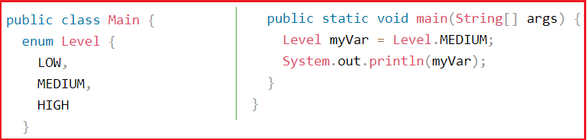

An enum can, just like a class, have attributes and methods. The only difference is that enum constants are public, static and final (unchangeable - cannot be overridden).
An enum cannot be used to create objects, and it cannot extend other classes (but it can implement interfaces).

Use enums when you have values that you know aren't going to change, like month days, days, colors, deck of cards, etc.

Array | Array List
Size is fixed | Size is dynamic
Homogeneous data | Heterogeneous data

What is a Thread?
- A thread is a light weight process under execution within a process
- Multithreading is used to increase the performance of application
Answer: In Java, the flow of execution is called Thread. Every java program has at least one thread called the main thread, the main thread is created by JVM. The user can define their own threads by extending the Thread class (or) by implementing the Runnable interface. Threads are executed concurrently.

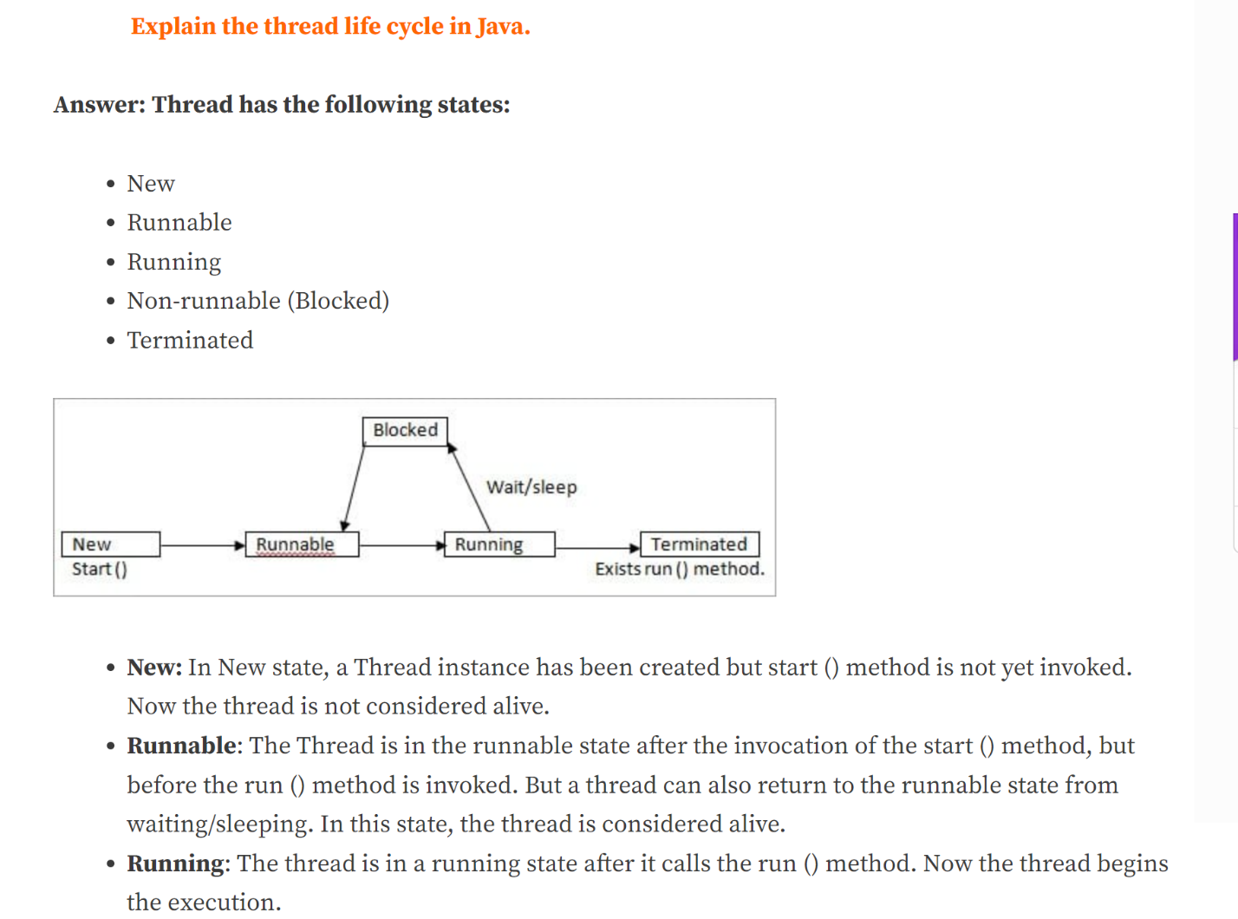
Creating Threads
----------------
- By creating a class which extends Thread class
or
- By creating a class which implements Runnable interface
Creating Threads using Runnable interface
-----------------------------------------
- If a class extends another class and to make this class as thread, the class
should implement Runnable interface as Java does not support multiple inheritance
- Ensures that run() is overridden

Ex:
class A
{}
class B extends A, Thread {} //error - does not support multiple inheritance

class B extends A implements Runnable
{
public void run(){..}
}

What is Synchronization?
Answer: Synchronization makes only one thread to access a block of code at a time. If multiple threads accesses the block of code, then there is a chance for inaccurate results at the end. To avoid this issue, we can provide synchronization for the sensitive block of codes.

- When two are more threads access the same resource then there is a change of
getting concurreny problems
- Synchronization is used to avoid concurreny problems
- synchronized keyword is used for synchronization
- synchronized keyword can be used for a method or block of statements only
Ex:
synchronized void xxx()
{
...
...
}

void yyy()
{
...
...
synchronized (object) //synchronized block
{
...
...
}
...
...
}

- In a synchronized context (method/block) only one thread will be running
which degrades the performance of application
Autoboxing - added in Java 5 version
-----------
Converting respective primitive type into reference type or vice-versa
automatically. This feature is known as autoboxing

Ex:
void xxx()
{
int n = 10;//primitive type
yyy(n);//error - prior Java 5, not an error from Java 5
yyy(new Integer(n));//priort Java 5
}

void yyy(Integer n) //reference type
{}

Java 8 Version Features
-----------------------
- Define methods in Interfaces using default keyword
- Define static methods in Interfaces
- Collection Factory method - of() => added in Java 9 version
Ex:
List<Integer> list1 = new ArrayList<Integer>();
list1.add(10);
list1.add(20);
list1.add(30);
list1.add(40);
list1.add(50);

//Using Collection Factory method - of()
List<Integer> list1 = List.of(10,20,30,40,50);
- Lambda Expressions
- Functional Interfaces
- Stream API

Lambda Expressions
------------------
- The expression through which we can represent an anonymous method
- Anonymous method which does not have any name

syntax
------
Parameter Expression Body
() -> SOP("Lambda");

Functional Interface
--------------------
- The interface which contains only one abstract method but can have multiple
default and static methods is called as Functional Interface
- @FunctionalInterface annotation is used to mark the interface as Functional Interface

Ex:
- Runnable => run()
- Comparable => compareTo()
- Comparator => compare()

Refer program LambdaDemo.java

Java Stream API
---------------
- Java Stream API is used to operate on the source data structure (collection and array)
and produce pipelined data that we can use and perform specific operations
such as we can create a stream from the list and filter is based on a condition
- Stream API is used to increase the performance of applications
- Java Stream API is present in java.util.stream package

Refer program StreamDemo1.java

Ways of traversing a collection
-------------------------------
- traditional for loop
- Enhanced for loop - added in Java 5 version
- forEach() - added in Java 8 version
- method reference (System.out::println) => added in Java 8 version

Filtering using Stream API
--------------------------
- filter() is an intermediate operation that reads the data from a stream
and returning a new stream after transforming the data based on the given condition

Upcasting and downcasting : Upcasting and downcasting are about converting an object reference between a parent type and a child type in an inheritance hierarchy.

ClassCastException is a runtime exception. Java throws it when your code tries to cast an object to a type that the object isn’t actually an instance of.
It extends RuntimeException, which makes it an unchecked exception. The compiler doesn’t force you to catch it or declare it with throws.

Arrays vs MAP when they used : Real-life analogy: an array is like seats in a row (seat 1, seat 2, seat 3). A map is like a phone contact list, where you search by the person’s name, not by their position in the list.

Which is faster, HashMap or Hashtable? Why? : HashMap is faster because it’s not synchronized. Hashtable locks every method, which adds overhead. Hashtable is a legacy class; for thread safety today we use ConcurrentHashMap.

StackOverflowError is thrown when a thread’s call stack runs out of space, StackOverflowError is an Error, not an Exception. It extends VirtualMachineError. It happens when the call stack fills up, usually due to infinite or very deep recursion, because each method call adds a frame to the stack.

Garbage collector works only on the heap. Stack memory is freed automatically when a method returns. Garbage collector removes heap objects that are no longer reachable from any reference.”

Private constructor : We use a private constructor for utility classes, singletons like ConfigReader or DriverManager, and factories. Since you can’t create the object with new, you call static methods using the class name, or get the instance through a static method like getInstance().”

Name a frequently used Java class whose object you can't create : The Math class. Its constructor is private and all its methods are static, so we call them as Math.max() or Math.sqrt() without creating an object. System, Collections, and Arrays work the same way.”

Java is strictly pass-by-value. For objects, the reference is copied, so the method can modify the same object but can’t make the caller’s variable point to a new one. In POM, we pass the WebDriver reference to each page’s constructor, so all pages share one browser session.”

How do you create your own custom exception?
I create a class that extends RuntimeException (or Exception if I want it checked), add constructors that call super(message) and super(message, cause), and throw it with throw new MyException(...). In my framework, I use something like FrameworkException for invalid config, missing test data, or unsupported browsers.”

Can you write a try block without a catch block? Can you write try with only finally?
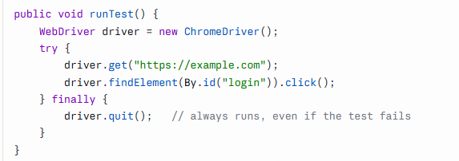

Have you heard of the Single Responsibility Principle (SRP)?
SRP means a class should have only one reason to change, so one job per class. In my POM framework, page classes only hold locators and actions, test classes only hold test logic and assertions, and utilities like ConfigReader, DriverFactory, and WaitUtils each handle one concern. If a locator changes, I only update the page class.

Singleton advnatages : One shared instances , save memory and time,
Disadvantage : bad fit for webdriver parallel execution.

What does System.out.println(0.1 + 0.2) == 0.30000000000000004
To get 0.3 --- System.out.printf("%.2f%n", 0.1 + 0.2); // 0.30

Write a simple Java class with a constructor.
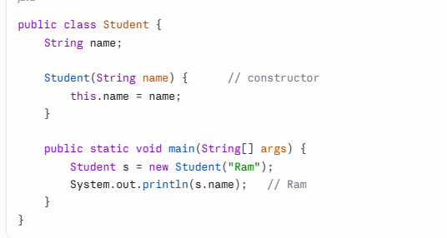

What is a constructor, and why do we use it?
A constructor is a special method with the same name as the class and no return type. It runs automatically when an object is created and is used to initialize the object’s values.

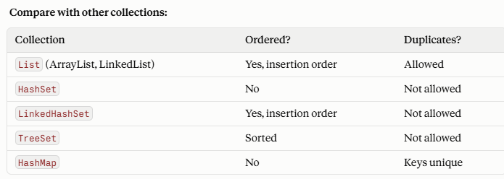
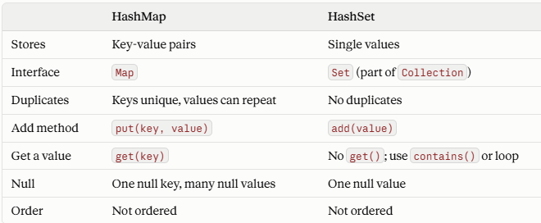

Synchronized means only one thread can access the collection at a time, which makes it thread-safe but slower. Vector and Hashtable are synchronized. ArrayList and HashMap aren’t. Today we prefer ConcurrentHashMap for thread safety.

Where are objects stored? : Objects are stored in heap memory. Whenever you create an object with new, the JVM allocates it on the heap.
The reference variable that points to the object is stored separately: on the stack if it’s a local variable inside a method.

The garbage collector (GC) is a part of the JVM that automatically frees heap memory by removing objects that are no longer used.

Can you run a class without a main method? As a standalone program, no. The JVM needs a main method as the entry point. Without it, you get:

Can we overload the main method? Yes, main can be overloaded, but the JVM always starts with public static void main(String[] args). Other overloaded versions run only if we call them explicitly.

