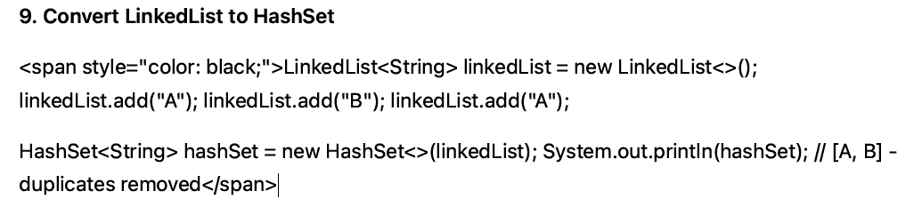

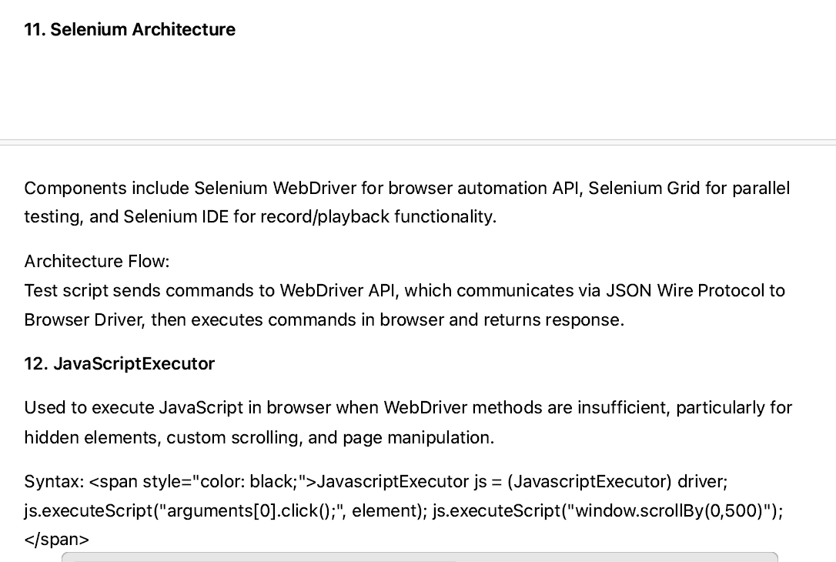

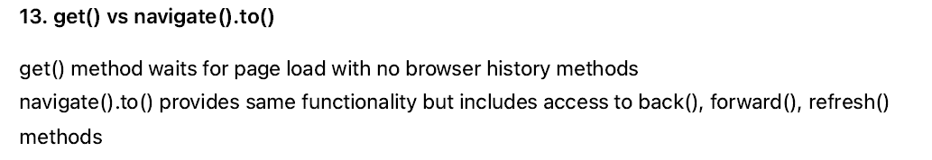
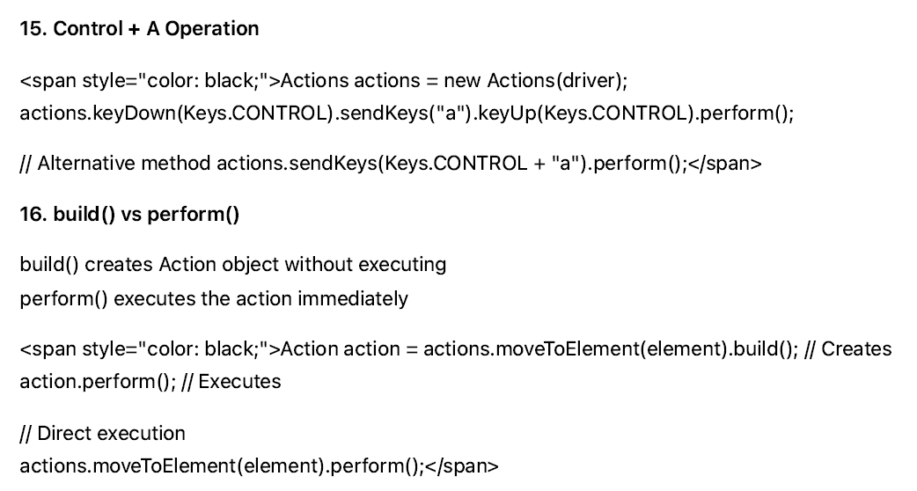
Control +A operation
Actions actions = new Actions (driver);
Actions.keyDown(keys.CONTROL).sendKeys(“a”).keyup(keys.CONTROL).perfomr()

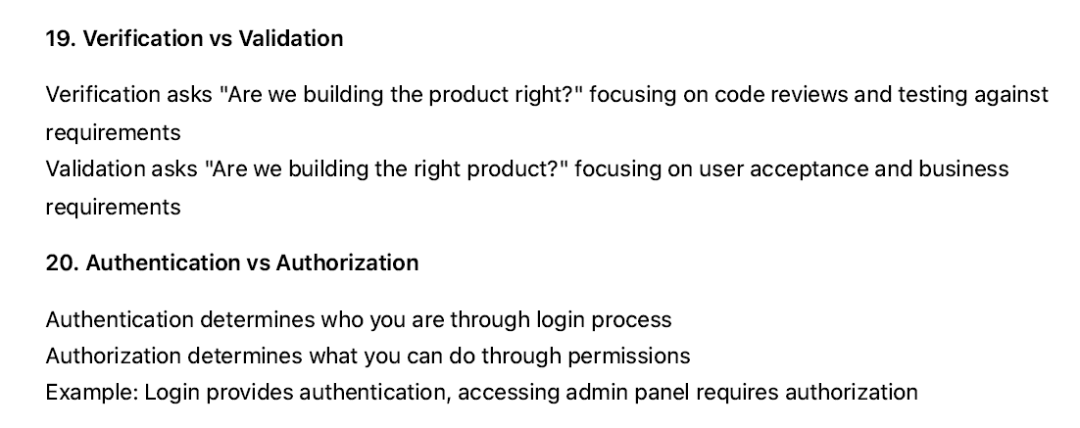

. How would you add new fields to the object repository?

8. Can you explain Jenkins and its role in automation testing?
10. How do you handle file upload buttons (browse buttons) in Selenium?
11. What is polymorphism, and how is it applied in Selenium?
12. What is method overloading, and in what scenarios do you use method overloading in Selenium?
3. What is the Page Object Model (POM), and why is the object repository used in POM?
4. Can you explain the purpose of the Robot class in Selenium?
5. Why is Page Factory used in object repositories?
6. How do you launch Internet Explorer in Selenium WebDriver?
7. How do you use the Select class in Selenium for handling dropdowns?
8. How do you work with frames in Selenium? How many ways can you pass values to frames?
9. Can you explain the use of XPath and sibling elements in XPath?

. How do you handle dynamic elements in Selenium? Give an example.
5. How would you handle multiple browser windows or tabs in Selenium?

8. What is a StaleElementReferenceException and how can you avoid it?
9. Explain how you would handle alerts and pop-ups in Selenium WebDriver.
. How do you run your Selenium tests in different browsers?
14. How can you verify if an element is present on a web page?
16. What is TestNG / JUnit? Why do we use it with Selenium?
18. How do you handle synchronization issues in Selenium?
20. How do you upload a file in Selenium WebDriver?
21. What is the use of DesiredCapabilities?
22. What are some common exceptions you have faced while using Selenium?
24. How do you implement logging in your Selenium framework?
25. How do you integrate Selenium tests into CI/CD pipelines (e.g., Jenkins)?
6. What is your strategy to reduce flaky tests and ensure stable automation runs?
8. Have you automated API testing? How do you structure your API tests and what validations do you perform?
10. What reporting tools have you used, and how do you customize or enhance reports to be meaningful for stakeholders?
13. Share an example when your automation scripts started failing due to UI changes. How did you handle it?
14. What strategies do you use for cross-browser and parallel execution in your automation projects?
15. How do you handle file uploads and downloads in your automation scripts?
16. Have you worked with version control systems like Git? How do you manage your automation codebase?
17. Write a Java function to check if two strings are anagrams of each other.
18. How do you reuse common code or utilities across your test scripts to avoid duplication?
19. What are some best practices you follow to keep your automation framework clean and maintainable?
22. Describe a challenging bug or issue you found through automation and how it was fixed.
23. What tools or methods do you use for test data generation when real data is not available?
. Given an SQL table, find the second-largest salary of an employee.
4. Explain the concept of joins and list the different types of joins available.
5. What is LinkedHashMap? Explain its use.
7. What is the difference between an exception and an error?
10. Write Selenium code to automate a calendar WebElement.
11. How would you fetch the text from a text box in Selenium?
12. How do you enter text in an alert using Selenium?
17. Explain the challenges you faced in your project.
2. In your framework, if you have 100 pages, do you create 100 Page Objects?
3. What is an “Element click intercepted” exception, and how do you fix it?
4. How do you take screenshots for failed test cases only in TestNG?
. What is the get fetch command?
8. Why do you prefer using Cucumber BDD in your project?
9. Explain dynamic binding and static binding.
11. What is the difference between Comparable and Comparator?
12. How would you conclude that a login page is user-friendly?
13. What are 5 points you consider when writing a good test case?
14. Suppose a developer is not fixing a bug; how would you approach the situation?
17. In what cases would you require fluent waits?
18. In Selenium, how would you open a new tab?
19. In Jenkins, what is the purpose of a CRON expression?
3. For the array `[1, 2, 3, 4, 5]`, if you rotate it to the right by 3 positions, what will the new array look like?
4. Could you explain your approach to executing test cases across multiple browsers?
5. How would you manage to execute 20 test cases in each browser if you have a total of 100 test cases?
6. When using the TestNG framework, how do you run failed test cases in the same test execution?
9. What are the different types of black-box testing?

15. What is the difference between verify() and assert() in test automation?
Does Selenium support API testing? If so, how can it be integrated?
21. When and why would you use the linkText() locator?
22. When should the partialLinkText() locator be used in Selenium?

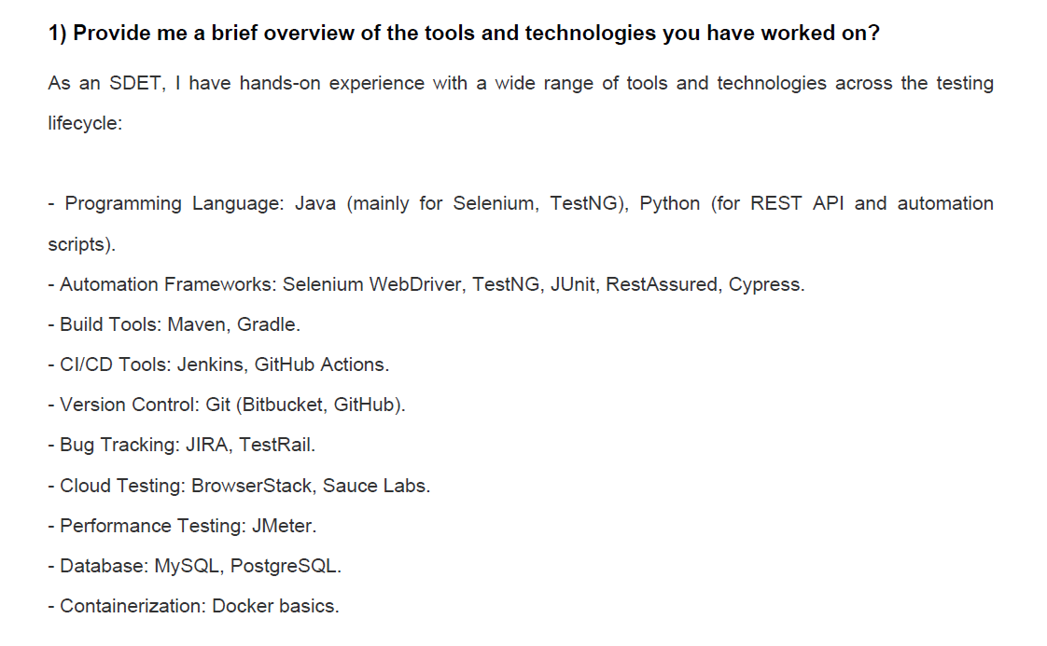
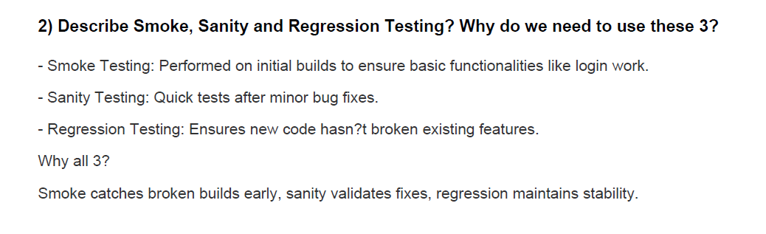
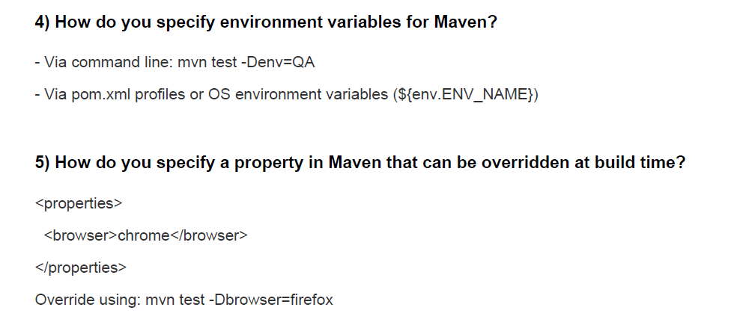
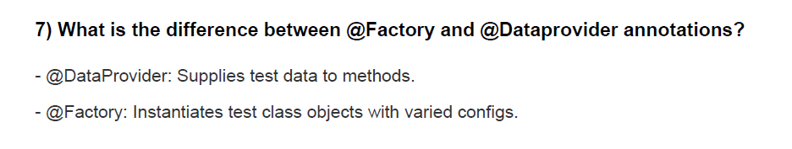

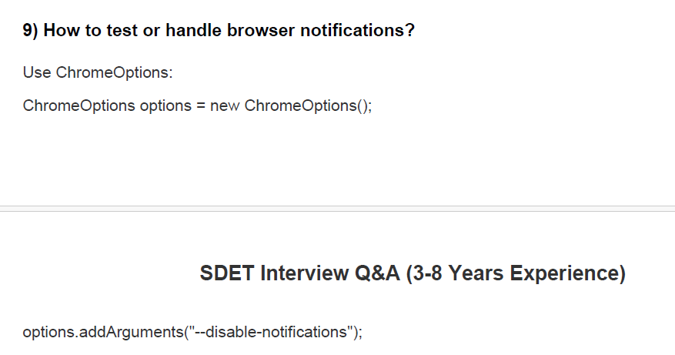
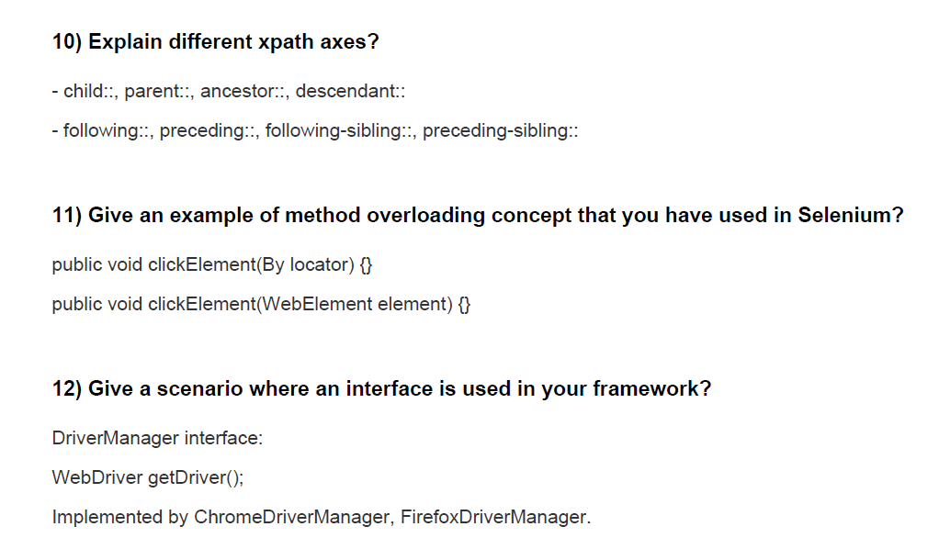
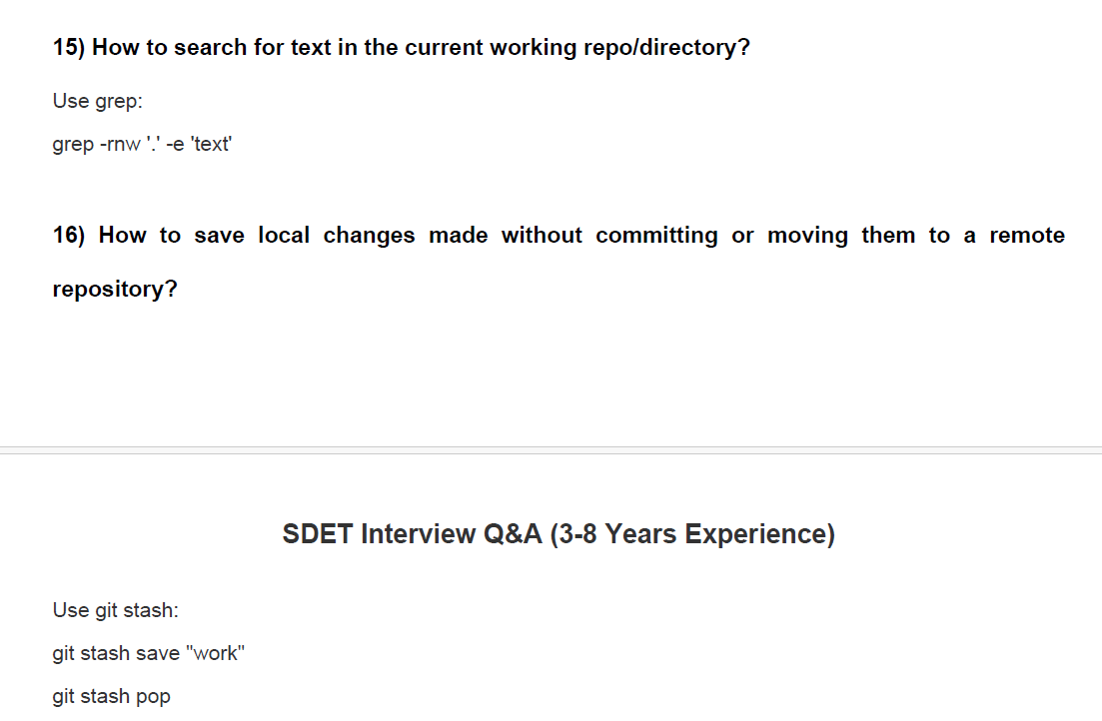
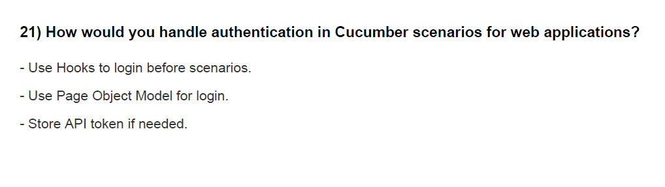
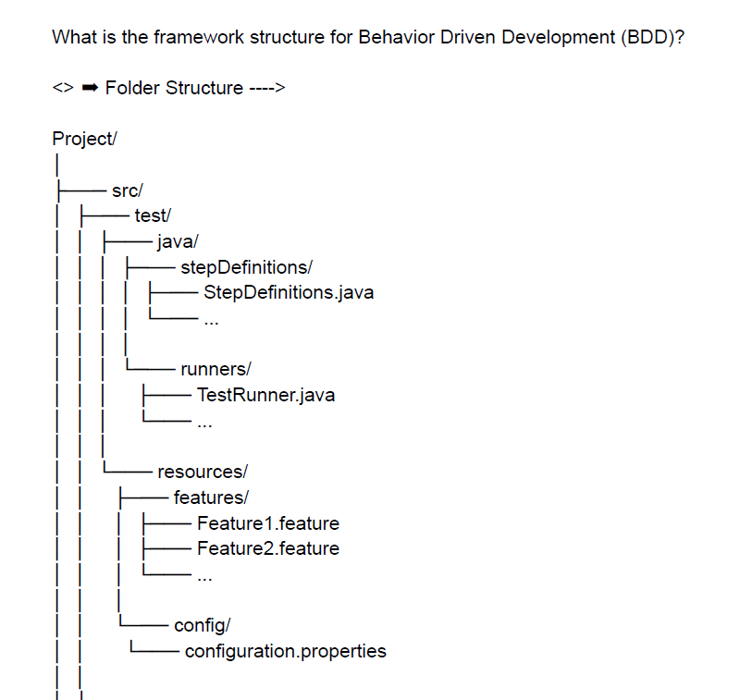
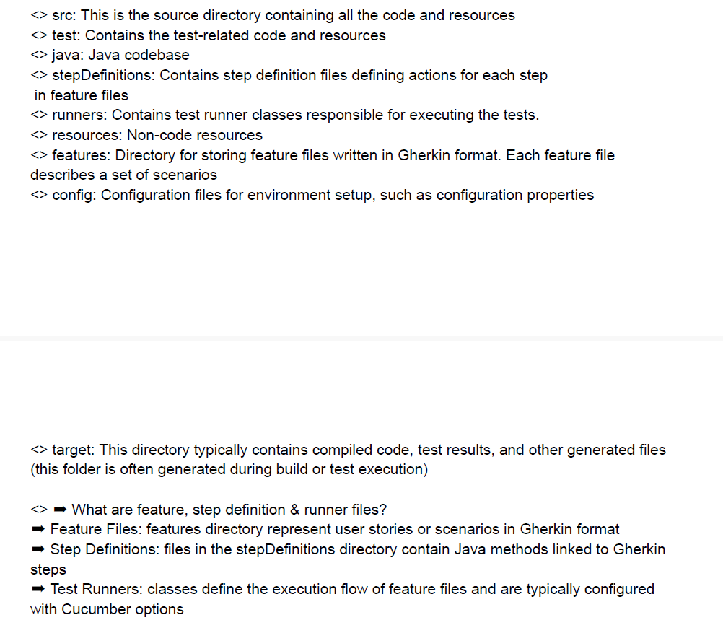
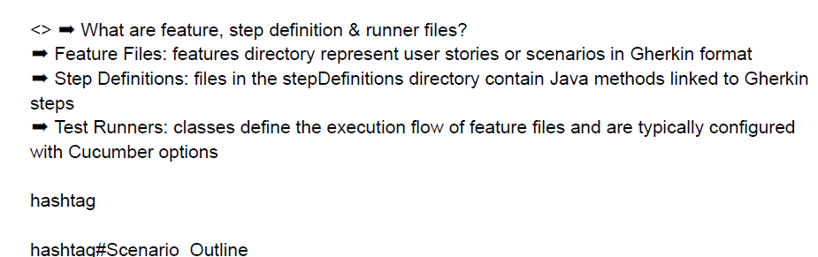

Check if a number is Armstrong Number or not
Missing number in series of numbers 1,2,4,5
1) Reverse a given Array 1
2) Find the Largest element in an array 4
Given an array, we have to find the largest element in the array. 4
3) Find Second Smallest and Second Largest Element in an array 5
4) Remove Duplicates in-place from Sorted Array 8
5) Left Rotate the Array by One 11
6) Move all Zeros to the end of the array 15
7) Union of Two Sorted Arrays 19
8) Given a non-empty array of integers, every element appears twice except for one. Find that single one. This is a very common problem, often referred to as "Single Number". 22
"Frequency Counting using HashMap" 22
Reverse words in a string

