- How to verify alert :

We are going to write a method which returns a Boolean based on that we can confirm whether alert is displayed or not
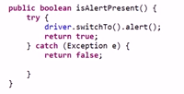
- There are 2 ways either you can dismiss or accept the alert
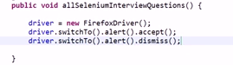
- How to get the text of alert
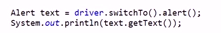
- How to select the frame
You can switch to frame based on index, object or element
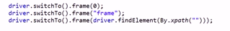
- What are the different ways to handle the window frames

Webdriver provides two methods getWindowhandle and getWindow handles().
Through window handle we can uniquely idenfiy the browser window on desktop.
getWindowHandle() method return a string value (Session-id) and it returns the Window handle of current focused browser window. getWindowHandles() method returns a set of all Window handles of all the browsers that were opened in the session
Set<String> allWindows = driver.getWindowHandles();
Default focus is always on parent window.
In order to shift focus from Parent Window to any child window we have to use the following command on WebDriver – WebDriver.SwitchTo().window(String windowHandle).
Once the Switch happens all the driver commands will go to the newly focused window
Set<String> allWindows = driver.getWindowHandles();
It=allWidnows.iterator()
It.next() – 0 index
It.next()-1 index window
It.next() -2 indexwindw..suppose here you want focus on 2nd index window means third window
String thirdwindow=it.next()
driver.SwitchTo().Window(thirdwindow)

Return type of getwindowhandles is Set .Someone says list it is not correct because list will
give the duplicate values where as set gives the unique window id
If you are in child window if you want to come back parent window,then following should be used.
driver.SwitchTo().defaultContent();

- What are the wait conditions in selenium
Implicit wait and Explicit wait
Implicit wait tells wait a certain amount of time before throwing an exception
Explicit wait tells wait certain condition before throwing exception.
If you write the implicit wait at top of the class , it will applicable for the page.
This driver will wait for 30 seconds to load all DOM objects , if not driver gives timeout exception
Explict Wait : We have one class in selenium, webdirverwait, we are going to create object webdirver and supply the wait,
Assume that there is a page popups a alert in 30 seconds, in that case we will go for explicit.
Implict wait is for page not for object
There is another wait option in selenium
FluentWait : In this wait we can setup a maximum amount of time , at polling itntervals we check the condition , Using Fluent wait interface we can implement this.

- Mouse over in selenium
Actions used to simulate the mouse.Using Action class ,we have to make the object of action class, and supply the
driver. Using the move element

- How to select the data in drop down :
There three diff ways to select the items in list box like index, or by element or visible text
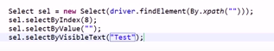
How to get the items in list box
- How to do the drag and drop
- How to scroll down
Using javascript interface we can handle scroll down
JavascriptExecutor js = (JavascriptExecutor) driver;
Using above js object either we can move by coordinate or element visibility

js.executeScript("arguments[0].scrollIntoView();", Element); ==== Element Visibility.
js.executeScript("window.scrollBy(0,1000)"); === Scroll vertically down by 1000 pixels.

- What are the methods available in web driver wait
elementToBeClickable()
elementToBeSelected()
presenceOfAllElementsLocatedBy()
presenceOfElementLocated()
visibilityOf()
visibilityOfAllElements()
- How to take the screen shot
You cannot take the screen shot directly you have to cast your driver with take a screen shot class.
Cast the driver with takescreenshot class and get the image using Getscreenshot as method and copy the image.

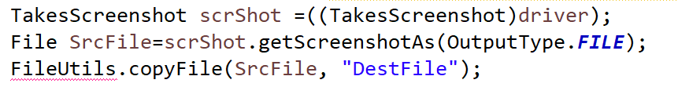

- How to get the coordinates of window.
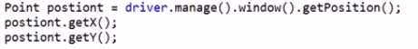
- How to do forward and backward in selenium
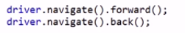
- How to get URL of the particular page and title of the page
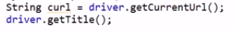
- How to find total similar elements present in a page
- How to know following sibling and preceding sibling.
- If there are similar elements in a page, how to know the fifth element
- How to check whether check box is selected or not and displayed or not and is enabled or not
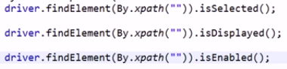

- How to execute java script in selenium
Here we have to cast the driver with javascript executor and we need to pass arguments like href etc.
- How to maximize the window
driver.manage().window().maximize();
driver.getCurrentUrl();
driver.getTitle();
driver.quit();
driver.close();
driver.manage().deleteAllCookies();
driver.navigate().back();
driver.navigate().forward();

- How to get the attribute of an element in web page
- What is the alternate way to click a web button instead of click.

- Head less mode implementation :
Whenever there is not environment like no ui like in unix environment then we will go for HTMLDriver.
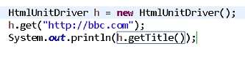
takes http request and response mechanism

- Diff between IsDisplayed and Iselementpresent
IsDisplayed function tells us whether element is visible to human eye or not.
IsElementpresent says whether element s present in web page or not and
moreover it is belongs to Selenium RC not webdriver.
- How to run eclipse script from cmd prompt :
You need to have the build.xml with targets of compiling and training and you need to place the jars in one
location and you need to execute with ANT
- How to handle the multiple windows.
If there are multiple windows, each window is having unique ID using that we can handle multiple browsers.
- Diff between Find element and Find elements
Find element: Finds the first element present in page based on given criteria (return type is Webelement)
Find elements: Pull all the elements and put them in the list

Find element | Find Elements
Return single element | Return list of elements
If multiple elements with same locator,returns first element | Return all elements ,even is same locator
If no element found returns no such element exception | Returns empty list

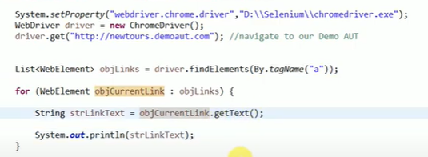

- Default time out of selenium is close to zero
- In Ajax based applications you need to use explicit time more.
- How to handle the dynamic objects in Selenium
Suppose if you take Login button in face book is dynamic object On every new browser x path is Solution 1 for dynamic objects:
keep on changing in that case you need to create your own x path
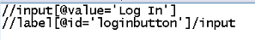
Solution 2for dynamic objects:
If you take the ID of login button id=’U_O_X..ONLY the last part x is changing U and O are remains same
In this case you can modify your x path accordingly
If the last part is dynamically changing then we will follow
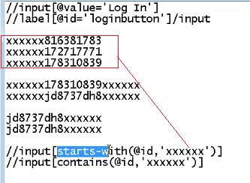

- Parameter reads the data to test cases

- In Selenium run from step concepts is not there like QTP.Every time you need to run from line number1
- Selenium alone will not Mobile application.Appium will automate the mobile applications.

- IDE works on only Mozilla and it will generate reports.
In webdriver there are drivers for every browser

- How to know whether check box is checked or not
- Captcha will not handle by Selenium (Letters or images in login page in some of web sites)

- Common difficulties in the project
Object Identification, ajax components, variable x paths, changing requirements.

- Explain what assertion in Selenium is and what are the types of assertion?
Assertion is used as a verification point. It verifies that the state of the application conforms to what is expected. The types of assertion are “assert” , “verify” and “waifFor”.
AssertEquals, AssertTrue, and AssertFalse methods are the most commonly used assertions in Selenium.

Assert.assertEquals(ActualTitle, ExpectedTitle); --if it fails test execution stops
Assert.assertTrue(checkButtonPresence);
- Mention what is the use of X-path?
X-Path is used to find the Web Element in web pages. It is also useful in identifying the dynamic elements.
- What is the difference between type keys and type commands?
TypeKeys () will trigger JavaScript event in most of the cases whereas .type () won’t. Type key populates the value attribute using JavaScript whereas .typekeys () emulates like actual user typing

- What the difference is between verify and assert commands?

Assert: Assert allows to check whether an element is on the page or not. The test will stop on the step failed, if the asserted element is not available. In other words, the test will terminated at the point where check fails.

Verify: Verify command will check whether the element is on the page, if it is not then the test will carry on executing. In verification, all the commands are going to run guaranteed even if any of test fails.
Test NG doent support verify (don’t tell unless they ask)
- What is JUnit Annotations and what are different types of annotations which are useful?
JUnit is a unit testing open-source framework for the Java programming language.
JUnit is preferred for automation as it can also be used along with the Selenium WebDriver to automate tests for web applications. It provides a unique way to write structured, short, and better test cases.
We are going to use junit annotations to control the automation test execution
In JAVA a special form of syntactic meta-data can be added to Java source code, this is know as Annotations. Variables, parameters, packages, methods and classes are annotated some of the JUnit annotations which can be useful are
Test, Before. After. Ignore, BeforeClass, AfterClass, RunWith
@Before:This annotation is used if you want to execute some statement such as preconditions before each test case.
@BeforeClass:This annotation is used if you want to execute some statements before all the test cases for
@After:This annotation can be used if you want to execute some statements after each Test Case for e.g resetting variables
@AfterClass: This annotation can be used if you want to execute some statements after all test cases.
@Ignores: This annotation can be used if you want to ignore some statements during test execution.
- TestNG in selenium
TestNG is an automation testing framework in which NG stands for “Next Generation”
Using TestNG, you can generate a proper report, and you can easily come to know how many test cases are passed, failed, and skipped. You can execute the failed test cases separately.
Default Selenium tests do not generate a proper format for the test results. Using TestNG in Selenium, we can generate test results.
The TestNG framework can be easily integrated with tools like TestNG Maven, Jenkins, etc.
Annotations used in the testing are very easy to understand ex: @BeforeMethod, @AfterMethod, @BeforeTest, @AfterTest
WebDriver has no native mechanism for generating reports. TestNG can generate the report in a readable format like the one shown below.
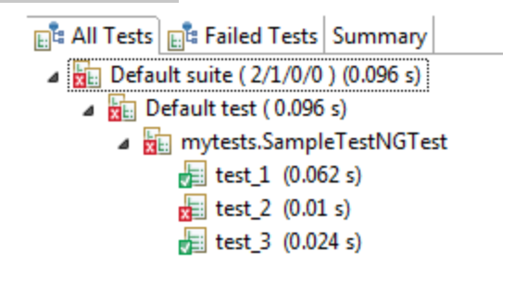
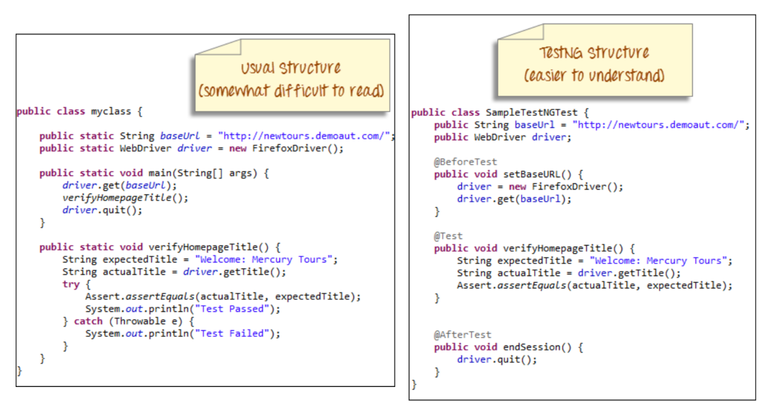
There are three major advantages of TestNG over JUnit:
Annotations are easier to understand
Test cases can be grouped more easily
Parallel testing is possible

Parallel test execution in TestNG triggers with the help of keyword "parallel". In this variable.
Parallel = ‘methods’ or parallel =’Tests’
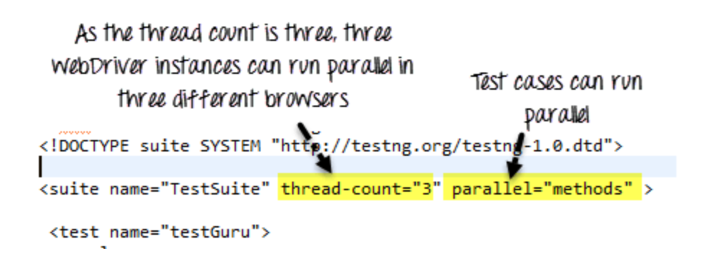

How to Write Test Cases in TestNG?
Step 1) Write your business logic and insert the TestNG annotations in your code.
Step 2) Add more information like class name, groups name, package name, etc
Step 3) Run the TestNG.
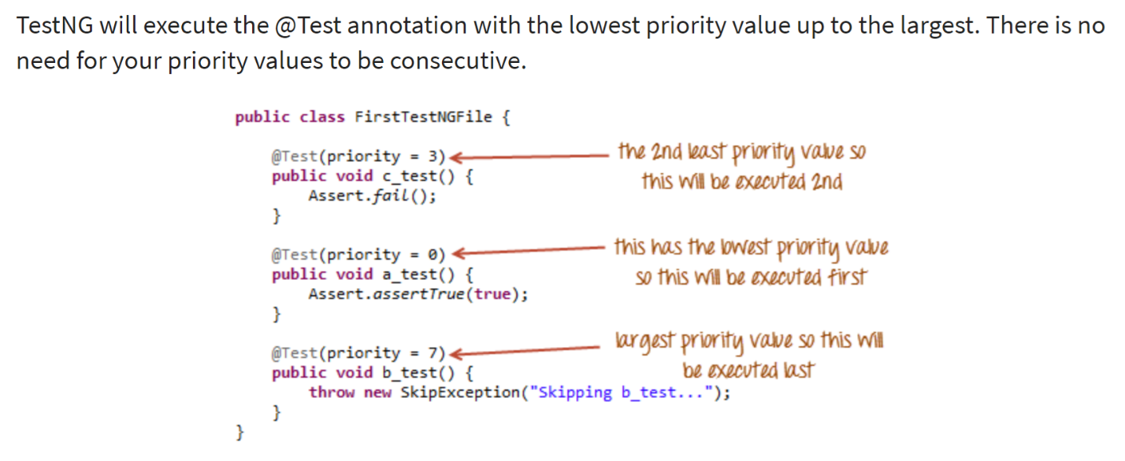
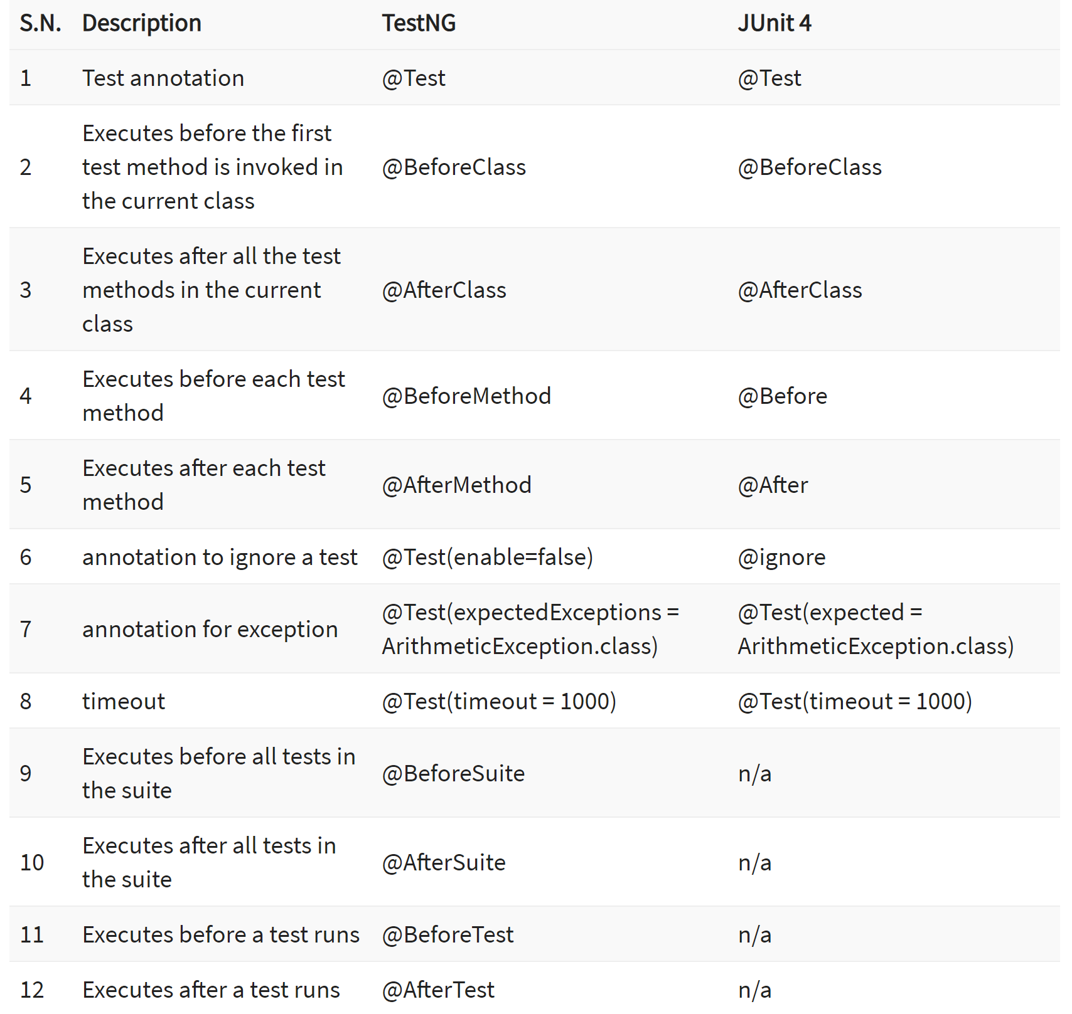

Runner file Syntax using TestNG

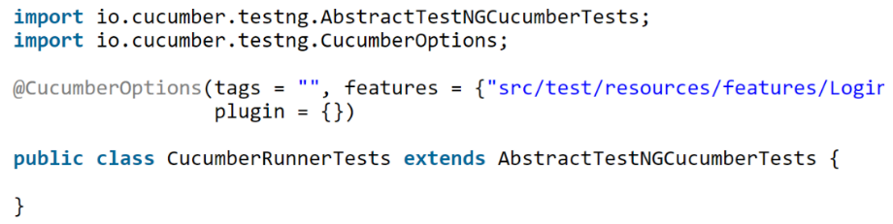

Runner File in Junit
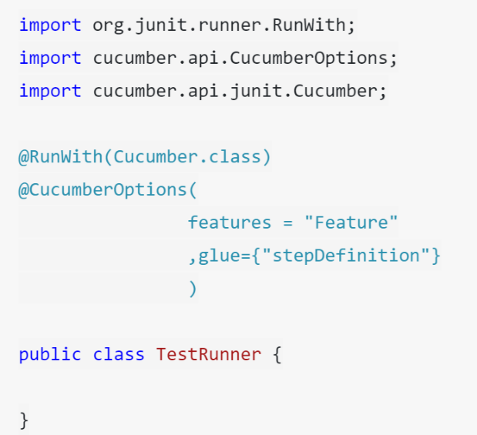

- Diff between TestNG and JUNIT
TestNG is a Java-based framework, while JUnit is an open-source Unit Testing Framework for JAVA.
Comparing TestNG Vs JUnit, TestNG annotations are easier to use and understand than JUnit.
TestNG allows us to create parallel tests, whereas JUnit does not support running parallel tests.
In TestNG, Test cases can be grouped together, while in JUnit, Grouping tests together is not possible.

- While using click command can you use screen coordinate?
To click on specific part of element, you would need to use clickAT command. ClickAt command accepts element locator and x, y co-ordinates as arguments- clickAt (locator, cordString)
- What are the four parameter you have to pass in Selenium?
Four parameters that you have to pass in Selenium are
Host
Port Number
Browser
URL
- How you can use “submit” a form using Selenium ?
You can use “submit” method on element to submit form-
element.submit () ;

- Explain what is Datadriven framework and Keyword driven?
Datadriven framework: In this framework, the test data is separated and kept outside the Test Scripts, while test case logic resides in Test Scripts. Test data is read from the external files ( Excel Files) and are loaded into the variables inside the Test Script. Variables are used for both for input values and for verification values.
Keyword driven framework: The keyword driven frameworks requires the development of data tables and keywords, independent of the test automation. In a keyword driven test, the functionality of the application under test is documented in a table as well as step by step instructions for each test.
- Mention what are the capabilities of Selenium WebDriver or Selenium 2.0 ?
WebDriver should be used when requiring improvement support for
Handling multiple frames, pop ups , multiple browser windows and alerts
Page navigation and drag & drop
Ajax based UI elements
Multi browser testing including improved functionality for browser not well supported by Selenium 1.0
- Explain how you can find broken images in a page using Selenium Web driver ?
To find the broken images in a page using Selenium web driver is
Get Xpath and get all the links in the page using tag name
In the page click on each and every link
Look for 404/500 in the target page title
- Explain how you can handle colors in web driver?
To handle colors in web driver you can use
Use getCssValue(arg0) function to get the colors by sending ‘color’ string as an argument .
- Mention 5 different exceptions you had in Selenium web driver?
The 5 different exceptions you had in Selenium web drivers are
WebDriverException
NoAlertPresentException
NoSuchWindowException
NoSuchElementException
ElementNotselectableException
ElementNotvisibleException
TimeoutException
- Explain using Webdriver how you can perform double click ?
You can perform double click by using
Syntax- Actions act = new Actions (driver);
act.doubleClick(webelement);
- How will you use Selenium to upload a file ?
You can use “type”command to type in a file input box of upload file. Then, you have to use “Robot” class in JAVA to make file upload work.
- X path and CSS syntaxes?

css=input[name=lastName]
XPath=//*[@name='username']
XPath=//*[contains(@id,'Name')]
XPath=//*[text()='Username or email']

Following sibling : The following-sibling selects all sibling nodes after the current node at the same level //li[@class='sreading']/following-sibling::li[4]

The preceeding-sibling selects all sibling nodes before the current node at the same level
//input[@id = 'u_0_2']//preceding-sibling::input[1]

Ancestor : The ancestor axis selects all ancestor elements (parent, grandparent, great-grandparents, etc.) of the current node. //input[@id = 'u_0_a']//ancestor::td

- Explain how you can switch back from a frame?
To switch back from a frame use method defaultContent()
Syntax-driver.switchTo().defaultContent();
- List out different types of locators?
Different types of locators are
By.id()
By.name()
By.tagName()
By.className()
By.linkText() : Used to click on links
By.partialLinkText() : used to click on links
By.xpath
By.cssSelector()
- To generate pdf reports mention what Java API is required?
To generate pdf reports, you need Java API IText.

- Mention what is Listeners in Selenium WebDriver?
In Selenium WebDriver, Listeners "listen" to the event defined in the selenium script and behave accordingly. It allows customizing TestNG reports or logs. There are two main listeners i.e. WebDriver Listeners and TestNG Listeners.

- What is WebDriver?
WebDriver is a web automation framework that allows you to execute your tests against different browsers, not just Firefox (unlike Selenium IDE).
WebDriver also enables you to use a programming language in creating your test scripts (not possible in Selenium IDE).
You can now use conditional operations like if-then-else or switch-case
You can also perform looping like do-while.
- When you will go for xpath
In Selenium automation, if the elements are not found by the general locators like id, class, name, etc. then XPath is used to find an element on the web page.

- Before using send keys and better use the clear method and clear the text (existing data cleared)

- What are the few scenarios what we cannot automate
Bitmap comparison is not possible
Captcha is not possible to automate using selenium
We cannot read bar code using selenium web driver
- Which operating systems support selenium web driver
Windows, iOs, Linux
- Language supported by Selenium
Java,C#,Ruby,Python,Perl,PHP
- What are web drivers supported by Selenium
Gheco driver (Firefox), IE, Chromed driver, Safari, Opera, Android, iPhone,HTML unit Driver
- Which web driver implementation is faster
HTML unit Driver implementation is fastest, HTML unit Driver does not execute tests on browser but plain http request which is far quick than launching a browser and executing test.
- What are the difference between Browsers Close and Browser. Quit
Browser. Close will close only currently active browser
Browser. Quit will closes all opened browser that the program has opened.
- What is the diff between Getattribute and Gettext
Get attribute used to read the element id, name, class and type etc.
Get Text used to read the text from element or alert.
- How to pause a test execution for 10 seconds
Thread.Sleep (10000)
- How to store the page source using selenium webdriver
GetPagesource ()
- Lint text and PartialTLinkText all only for Links not for any other elements

- Difference between get and navigate method
Get(“google.com”) --- get wait till loading all dom objects
Navigate (“google.com”)---it hits url , immediately looks for next step , wont wait to load the page
That’s why most of us using get.
Navigate uses for forward, backward, refresh activities
- How to handle https certificates in selenium
We need to provide accept.ssl certificate desired capability to the browser.
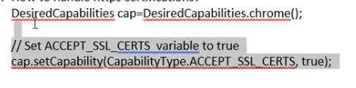
- Write xpath and css of id and tag are given.
Xpath syntax is =//tagname[@id=’value’]
Css tagname[id=’value’] -- in css no slash and no @
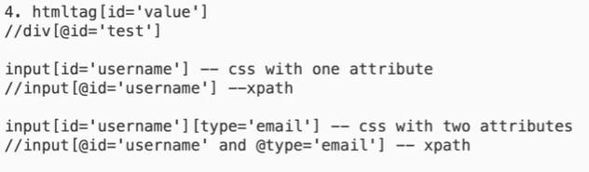
- How to use contains regular expression in xpath
If id changes dynamically and in systematic format like id = u044 uo 65 u0922 .. here u0 is common, in that case we go for contains
//tagname[contains(@id,’u0’]
How to use regular expression in CSS …… tagname[id*=’u0’]
- How to check object is hidden or not
isDisplayed check element is hidden or not
- How to get the count of similar elements in a page
Class name=”abc”
Driver.findelements(By.classname(“abc”).size())
- Importance of desired capabilities
It is a class which describes a browser and os properties.
We can set the browser properties and methods using desired capabilities, suppose there is ceriticate error there we set accept_ssl_cert …this is one of desired capability
- Count number of links in a page
driver.findElement(By.tagname(“a”).size())

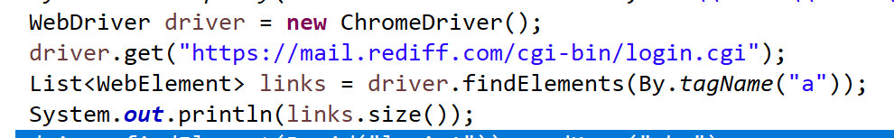

- How to validate whether you switch the child window successfully or not
Get the title of child window and validate it.
- How do you debug your scripts
Validate x paths, check logs, check infrastructure ,highlight the issue in standup meeting
- How to enter text in cpas lock
Driver.findelement().sendKeys (keys.SHIFT,”abc”)

- How to handle java alert
Selenuim is strict to browser , to handle the java alert we need to switch from browser to alert
Driver.switch.alert()
- How to handle ajax calls in selenium
We can handle by using dynamic waits
- titleIs
- elementTobClickable
- JavascriptError :
Some times webelements will not respond on seleneuim commands, in that cases we are going to use javscriptexecutor interface.
- How to handle file uploading and downloading files.
We can use robot class, AUOTIT or Sikoli class to handle uploading and downloading files
- Can we test API or webservices using selenium web driver
No , selenium is browser automation tool, where as webservices are headless so we can not automate

What is selenese.
Selesense is the set of selenium commands which are used to test your web application.Tester can test the broken links existence of some object on the UI ,ajax functionalites,alerts,window,list of options and lot more using slenese.

- staleelement exception : when the Selenium test code refers to an element that is no longer available (not attached or removed) in the DOM (document object model)
- StaleElementReferenceException can be avoided by using some workarounds like refreshing the webpage before accessing the web element, using the try-catch block, using explicit wait(wait for the expected condition or wait for the refresh of DOM), or using POM

LOCATROS :
To identify web elements in web page we have diff locators
Locatros : id,name,linktestpartial linktext,classname,tag name
Customized locators: xpath and CSS selector

Id – driver.findElement(By.id(“search”)).sendKeys(“iphone”);
Name driver.findElement(By.name(“search”)).sendKeys(“iphone”);
linkText driver.findElement(By.linkText(“search”)).Click;
linkText driver.findElement(By.partialLinkText(“search”)).Click;

Types of Xpaths :
Absolute xpath |  | Partial x path
/html/body/div[1]/div[3]/img |  | //*[@id=’divLogo’]/img
Starts from root node |  | Directly jump to element on DOM
Starts with / |  | Starts with //
We can use only tags and nodes | We use attributes

Contains – driver.findElement(By.xpath(“//input[contains(@id,’search’)]”)).sendKeys(“phone”)
With text -- driver.findElement(By.xpath(“//a[text()=’search’)]”)).sendKeys(“phone”)
Xpath with 2 attributes
//input[@id=’search’ and @name=’searchinput’]

Following and preceding works only when there is common parent class
When there is object identify for one child and there is no object identification for other child, in that case we will go for following and preceding sibling

//a[contains(text(),’Features’)]/parent::*/following-sibling::li[1]/a
//a[contains(text(),’Clients’)]/parent::*/preceding-sibling::li[2]/a

- What is singleton class where do you use in Selenium?

A Singleton class allows only one object to be created. We make it with a private constructor, a private static instance variable and a public static getInstance() method. In Selenium, I've used it for WebDriver management so only one browser instance is shared across tests, and for reading the config file once. For parallel execution we use ThreadLocal, because a plain Singleton driver isn't thread-safe."
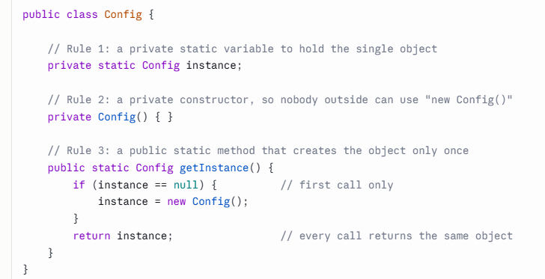
- How does Singleton pattern help in Selenium Webdriver?
In Selenium, the WebDriver object is typically a Singleton, as there should be only one instance of the browser for the entire test run.
- Keep track of same driver instance throughout execution.
- DBMS connectivity.
- Loading external files like properties, excel etc once rather than loading again and again.
- Logger.
- In Selenuim , Where JAVA Oops concepts used ?
Inheritance
Inheritance in Selenium = writing common code once (parent) and using it in all test classes (child)
In Selenium (Java), you often write automation like:
- Open browser , Launch URL ,Setup driver , Close browser
These steps are same for every test
Instead of repeating them in every file → we use inheritance
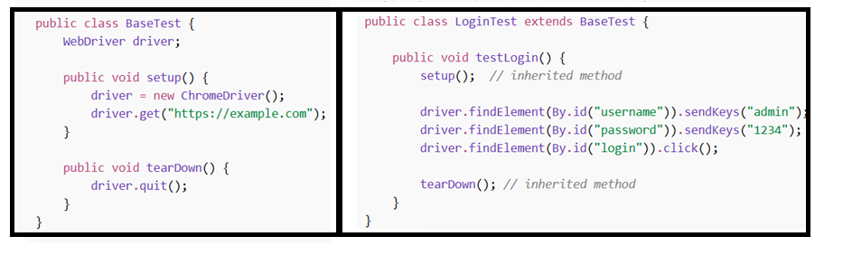
Encapsulation

In Selenium, we use encapsulation in the Page Object Model. We declare locators as private variables in the page class and access them only through public methods like login(). This hides the locators from test classes, protects them from being changed, and means a locator change is fixed in one place only. 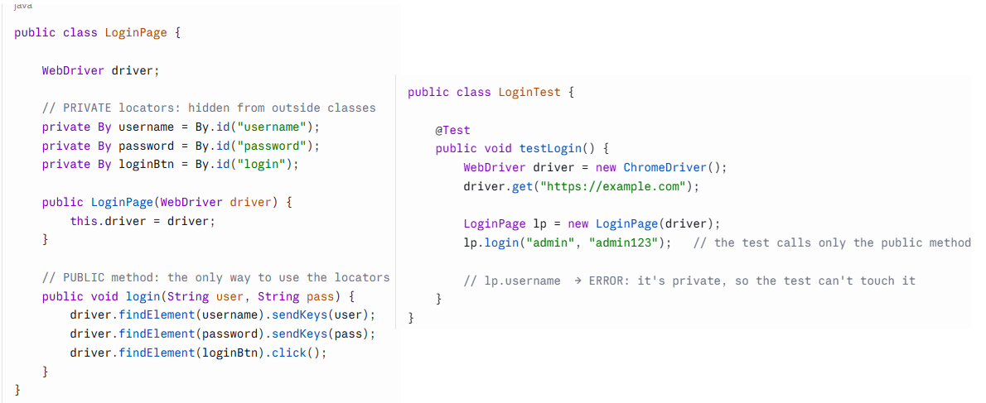

Polymorphism
“In Selenium, polymorphism allows the same WebDriver or WebElement methods to behave differently for different browsers or elements.”
Polymorphism means one name with many forms. In Selenium, method overloading is seen in switchTo().frame(), which accepts an index, a name or a WebElement. Method overriding is seen in WebDriver driver = new ChromeDriver(). Methods like get() and click() are implemented differently by ChromeDriver and FirefoxDriver, and which one runs is decided at runtime."
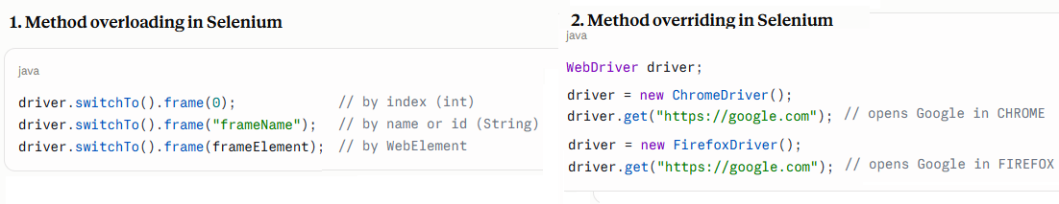

ABSTRACTION
Abstraction in Selenium means hiding complex browser operations and exposing only simple actions like click(), sendKeys(), and get().

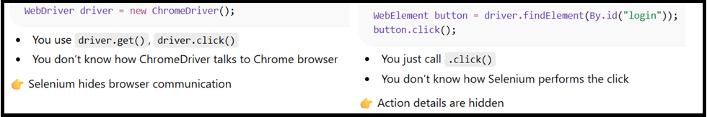

INTERFACE
WebDriver → interface → controls browser
WebElement → interface → controls elements

Interface = what actions are possible
Class = how those actions actually happen

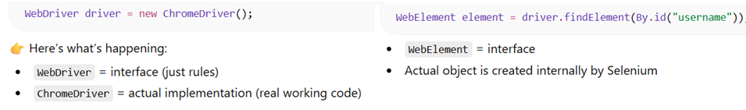

- What is BDD? Cucumber frame work
A cucumber is a tool based on Behavior Driven Development (BDD) framework which is used to write acceptance tests for the web application. It allows automation of functional validation in easily readable and understandable format (like plain English) to Business Analysts, Developers, Testers, etc.
It is helpful to involve business stakeholders who can’t easily read the code
Cucumber Testing enhances the end-user experience
Style of writing tests allow for easier reuse of code in the tests
Allows quick and easy setup and execution
Behavior Driven Development is an extension of Test Driven Development and it is used to test the system rather than testing the particular piece of code
Major three components are there Feature files, stepdefinations, runner class and HTML reports
WE developed feature files using gherkin kewords using Given,when,and then, background
Given – Pre condition, When --- action and ---- to combine same scenarios, Then –expected result
Background – used to repeat the same steps like login page etc.
We pass the tags per each scenario , based on tags we run the maven command and run the scripts
Step definaitions : Each feature we developed the methods using java called step definitions
Junit runner : to execute the the script we have a runner class its run based on feature name or tags.
import cucumber.api.junit.Cucumber;</pre>
import org.junit.runner.RunWith;
@RunWith(Cucumber.class)
@Cucumber.Options(format={"SimpleHtmlReport:report/smokeTest.html"},tags={"@smokeTest"})
Public class JUnitRunner {

}
At the end Cucumber generates its own HTML format
In the TestRunner class, @RunWith(Cucumber.class) tells JUnit to run the tests using Cucumber's runner. @CucumberOptions configures the execution. features gives the path to the feature files, glue gives the step definitions package, tags filters which scenarios to run, plugin generates reports, monochrome makes the console output readable, and dryRun checks for missing step definitions without running the tests.

Feature : High level description of a software feature
Scenario : title of the scenario
Hooks : code blocks run with annotations
Test harness : Framework of tests, test data test results and test report.

- What is tag in Cucumber testing?

In Cucumber, tags are used to associate a test like smoke, regression etc. with a particular scenario.
By default, Cucumber executes all the scenarios inside the feature file, but if we need to execute or skip any specific scenario under a specific test, so we can declare scenarios within a tag.

set of multiple tags in cucumber testing : We use OR & AND operators for multiple tags
The OR operator can be used in the case, when we need to test an application like this, if the application has failed in the first test, then the next test should be checked. If the next test is also failed, then another next test should be checked and so on.
The AND operator can be used in the case, when we need to test an application like this, if the application has passed in the first test, then jump to check the next test, but if it gets failed, then testing should be terminated.
In the case, when we need to skip a test, then we can use Special symbol "~" within the tag.
tags={"@SmokeTest", "~@RegressionTest"}

- POM:
Page Object Model (POM) is a design pattern where each web page gets its own class. That class holds the page's locators (where elements are) and actions (what you can do on the page). Test classes just call those methods, so they never deal with locators directly.
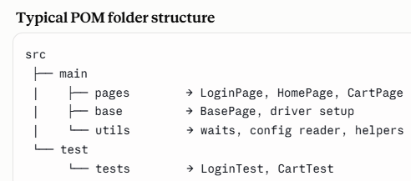
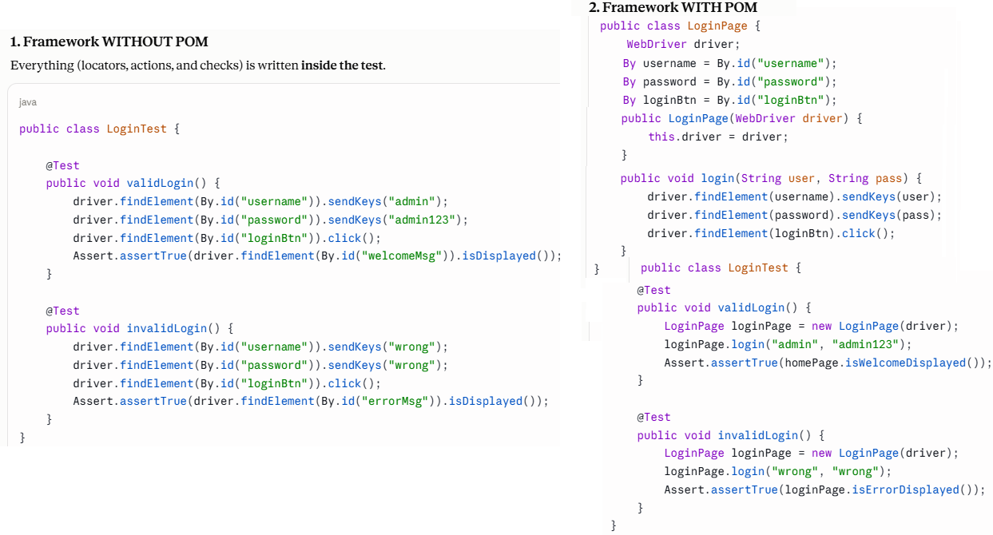
Without POM, locators and actions are written directly in test scripts, which causes duplication and heavy maintenance when the UI changes. With POM, each page has its own class containing its locators and actions, and tests just call those methods. So a UI change is fixed in one place, code is reusable, and tests are more readable and maintainable.
In POM, each page has its own class with private locators and public action methods, assertions stay in the test layer, and page methods return the next page object to represent navigation. This makes the framework readable, reusable, and easy to maintain when the UI changes.

POM is a design pattern where every page has its own class with its locators and actions, and tests call those methods. When designing it, I keep locators private with public action methods, keep assertions only in the test layer, and make page methods return the next page object to represent navigation. This gives readable, reusable, and low-maintenance tests.
"I keep assertions in test classes. Page classes should only perform actions and return values. Putting assertions in page methods makes them non-reusable, for example a login method couldn't be used for negative tests. It also mixes responsibilities and makes failures harder to debug.

Page factory Approach :
Page Factory is Selenium's built-in way to implement POM. We declare elements with @FindBy and initialize them with PageFactory.initElements(), which reduces code, keeps page classes clean, and finds elements only when they're used.

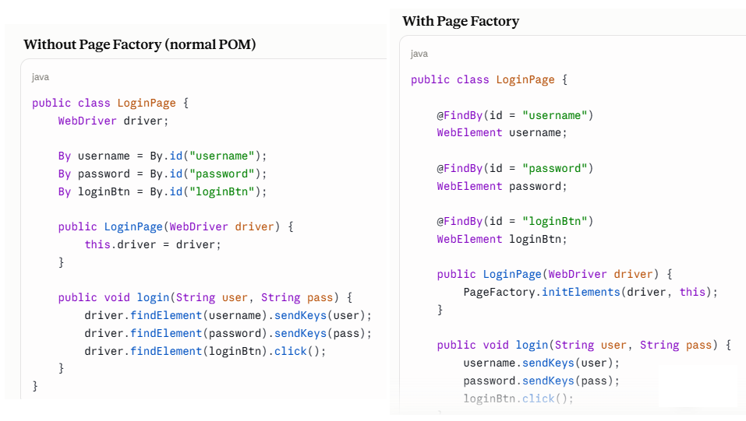
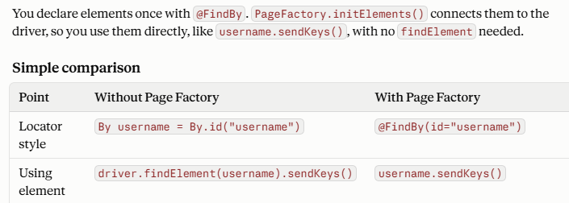
Interviewers sometimes ask about the downside too: Page Factory can throw StaleElementReferenceException on dynamic pages, so many teams prefer plain By locators for very dynamic apps.

- What are the challenges in selenium and how to solve them
As I am using selenium is automation tool in my current project , there should be more challenges compared to other vendor tools like UFT
As selenium is open source tool , there pro and corns in the open source tool
As selenium is browser automation tool, it is not non -web based applications like windows applications
To work on selenium we should have good coding background ,.
Selenuim can not do image validation , captche ,tool tips etc.
In selenium ,to upload the or download the files we need to use third party tools like Autoit , sikoli etc.
Screen shots are only in .PNG format
Selenuim doesn’t have any default reporting structure, we need to rely on third party plugins like extent reports,testNG
There is no dedicated people or organization or vendor to support the issues in selenium , we need to go through forums, blogs or we need to do R&D ,there is no direct support like HP for UFT tool.
Handling dynamic objects also one of the challenge , we need create xpaths or css locators accordingly as per element changes using regular expression concepts

- TDD and BDD:
TDD stands for Test Driven Development. In this software development technique,
we create the test cases first and then write the code underlying those test cases. Although TDD is a development technique,
it can also be used for automation testing development.
1) Write a test case:
2) Run all the test cases:
3) Develop the code for that test cases:
4) Run test cases again:
5) Refactor your code:
6) Repeat the steps 1- 5 for new test cases:
BDD :
BDD stands for Behavior Driven Development. BDD is an extension to TDD where instead of writing the test cases, we start by writing a behavior.
The scenario defined in the BDD approach makes it easy for the developers, testers and business users to collaborate.
1) Write the behavior of the application:
2) Write the automated scripts:
3) Implement the functional code:
4) Check if the behavior is successful:
5) Refactor or organize code:
6) Repeat the steps 1-5 for new behavior:
TDD | BDD
The process starts by writing a test case. | The process starts by writing a scenario as per the expected behavior
Test cases are written in a programming language. | Scenarios are more readable when compared to TDD as they are written in simple English format.
Collaboration is required only between the developers. | Collaboration is required between all the stakeholders.

- Selenium Grid for Parallel Testing :

Selenium Grid is used to run tests in parallel across multiple machines and browsers to reduce execution time.

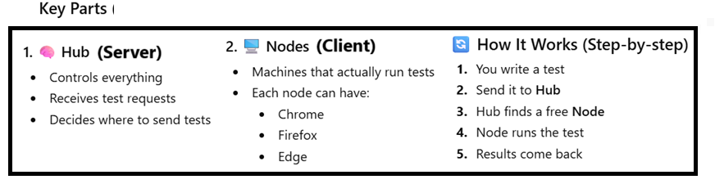

Step1: Download selenium server
selenium-server-4.x.x.jar
Step2 : Start Hub
java -jar selenium-server-4.x.x.jar hub
Step3: Now open browser:
http://localhost:4444
We can see Grid UI

Step4 : Start Node (Open NEW terminal window)
java -jar selenium-server-4.x.x.jar node
This registers your machine as a Node

So basic set up is ready
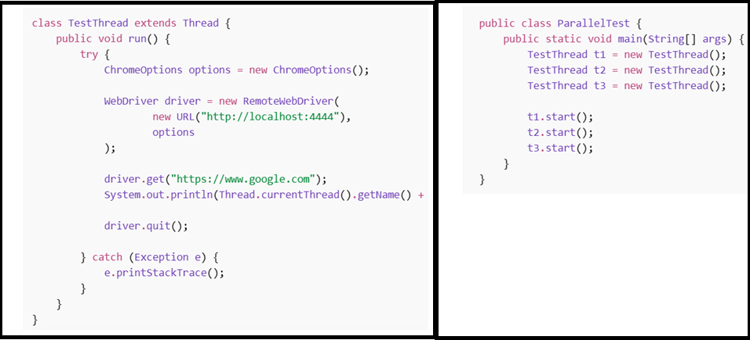

Finally answer for grid parallel testing is
We configure a Selenium Grid with a Hub and multiple Nodes, then use RemoteWebDriver to send test execution requests to the Hub, which distributes them across nodes for parallel execution.

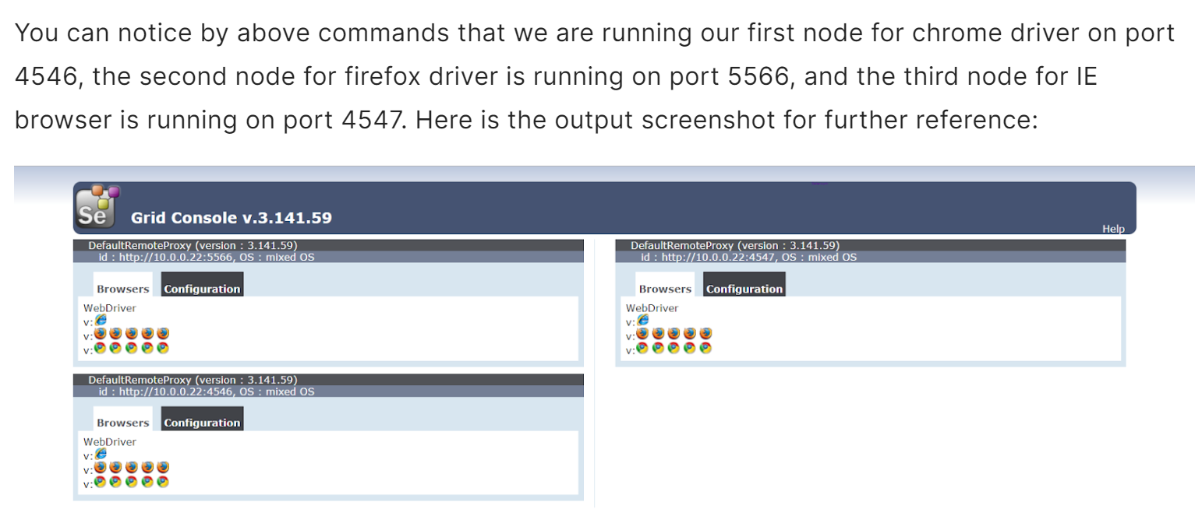

- Extent Reports in Selenium

Extent Reports is a reporting tool that generates detailed and visually rich HTML reports for Selenium test execution.
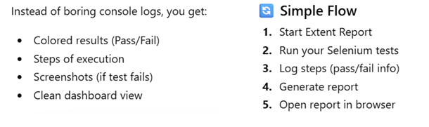

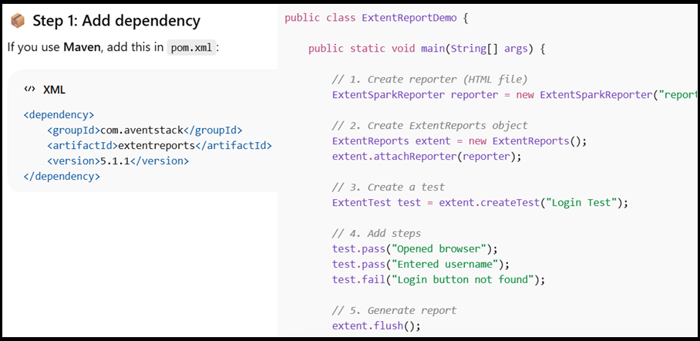

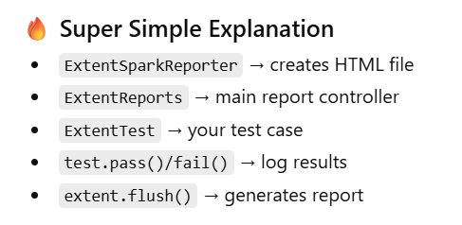
- What is your approach on frequently failed automation test cases.
Verify the execution log
Verify the error log
Verify the pattern of failure timings and days of failure.
Verify the failure scenario input data.
Server performance during failure
Execute the failed test cases manually and find the pattern.
- How to autoamte …Shadow and Nested Shadadow Elements
Using selectorHub we can get the element address..By.xpath not works like normal webelemnt , we need to identify the host path of shadadow elements.
Shadow DOM is a functionality that allows the web browser to render DOM elements without putting them into the main document DOM tree.
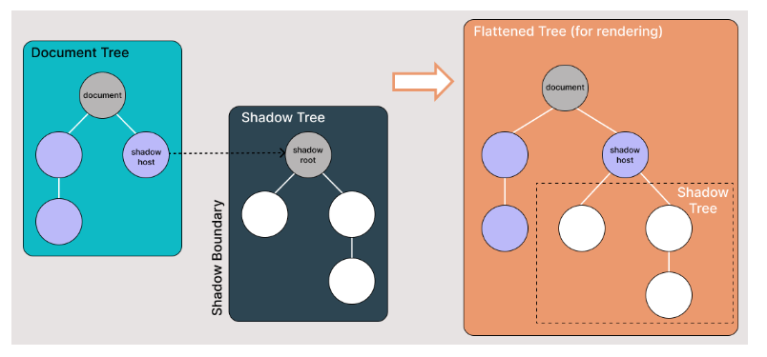
For above shadow elements we can not get the webelement in normal way ..throw No such element exceptions
We would use the following strategy to access the Shadow DOM locators:
Using JavaScriptExecutor.
Using Selenium WebDriver’s getShadowDom() method.
Using selectorHub we can find the x paths
- If window application is attached in web how to automate it clicks
Approach 1: Sikoli : can automate not only web-based applications but also desktop applications. It uses image recognition to interact with elements on the screen based on their visual appearance, allowing testers to automate actions like clicking buttons, filling forms, or verifying content in desktop applications.
Approach 2: If you are trying to automate desktop applications, there we can integrate powershell using selenuim..so powershell used to perfrom click actions various screens on desktop applications.
- Notes in Test NG
Skip the test case : @Test(enabled = false)
Using priority attribute we can control the test execution priorities
@Test (priority=1) –runs first
@Test (priority=2) –runs Second
If priority is same for to test cases , then it goes on alphabetical order.
If you don't specify a priority value for a test method, TestNG assigns it a default priority value of 0.
- Webdriver driver = new ChromeDriver () Explain the step
is a common way to initialize an instance of the ChromeDriver class
Webdrive is Interface ..ChromeDriver is class..new
new ChromeDriver() creates a new instance of the ChromeDriver class
he WebDriver driver part declares a variable named driver of type WebDriver. This variable will hold the reference to the ChromeDriver instance.

- 114: How to refresh the page using selenium
driver.navigate().refresh();
sendKeys(Keys.F5)
sendKeys(Keys.CONTROL + "r");
((JavascriptExecutor) driver).executeScript("location.reload()");

- How to run the test cases parallel in TestNG
Configure TestNG XML File: Create a TestNG XML file where you define your test suite configuration, including the parallel execution mode.

Parallel Execution Modes: TestNG supports different parallel execution modes:
parallel="tests": Runs individual test methods in parallel across multiple threads.
- In TestNG what is the difference between Fatcory method and Data provider
In TestNG, the Factory method and DataProvider are used together to provide a way to create and execute multiple instances of a test class with different sets of test data
The factory method is responsible for creating and returning instances of the test class with different sets of parameters.
TestNG will invoke the DataProvider method to get the test data, and then pass this data as arguments to the test methods.
- Different Test scenarios in ecommerce
User registration
User login
Product search
Shopping cart
Payment gateway
Checkout process
User Account Information

- How will import your test cases from excel or css file to JIRA :
Using utility Zephyr (pronounce it is Jafar)..from zephyr utility u can see the import test case option ..and we will map the excel columna names and make sure is same in jira too…start importing from row 2 in excel
- What is null pointer exception in selenium
Nullpointer exception : when we get nullpointer and how will overcome it ?
If any reference object is null we will get the null pointer value… we need to use try catch block to debug the issue.

- Log4j
Import Log4j classes in your test code and use them to log messages at different log levels (e.g., INFO, WARN, ERROR, DEBUG).
Run your Selenium tests, and Log4j will log messages according to the configuration specified in the log4j2.xml file. You can view the log output in the console or in the log files generated by Log4j appenders.
We add log4j dependency in POM.xml
- How do you define which framework is suitable for the application
That will decided by various factors like target users who uses framework and type of application etc.
If application need to run various types of data , then we go for Data driven
If more functions need to validate and already few methods (keywors) developed in that we go for keyword driven framework.
Some times we go for Hybrid framework.
- What is the data provider in TestNG
In TestNG, a DataProvider is a method annotated with @DataProvider that supplies test data to the test methods. It allows you to separate your test data from your test logic, making your tests more modular and reusable. DataProviders are particularly useful when you need to run the same test method with different sets of input data.
@DataProvider(name = "testData")
public Object[][] testData() {
return new Object[][] {
{"username1", "password1"},
{"username2", "password2"},
{"username3", "password3"}
};
- How to create and run TestNG XML file
Create a TestNG XML file in project directory
Define the test suite structure:
Run the TestNG XML file: using command line or from IDE’s like IntelliJ and Eclipse

- Cucumber Hooks
Cucumber supports hooks, which are blocks of code that run before or after each scenario. You can define them anywhere in your project or step definition layers, using the methods @Before and @After. Cucumber Hooks allows us to better manage the code workflow and helps us to reduce the code redundancy.
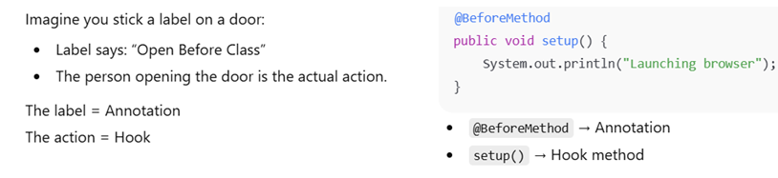

- What is AJAX application.
An Ajax (Asynchronous JavaScript and XML) application is a web application that uses asynchronous communication between the client-side and server-side components. Traditional web applications typically require a full page reload whenever data needs to be updated or retrieved from the server. Ajax applications, however, can update parts of a web page dynamically without needing to reload the entire page.

- What are Listeners in Selenium

A listener in Selenium (TestNG) listens to test events like pass/fail and performs actions such as logging or taking screenshots.

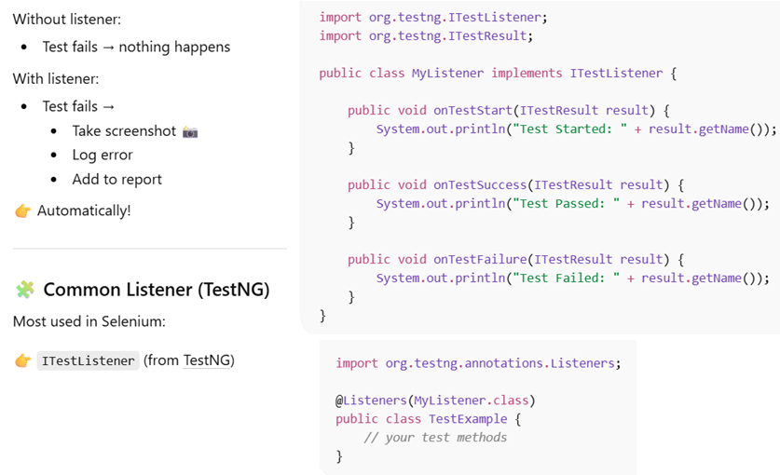

Selenium Architecture

Selenium WebDriver follows a client–server architecture
Test script (client) sends commands as HTTP requests to a browser driver (server), and the driver controls the real browser.
Selenium WebDriver has a client-server architecture with four parts: client libraries, the WebDriver protocol, browser drivers, and browsers. When I write a command like click(), the language binding converts it into a JSON request and sends it over HTTP to the browser driver, such as ChromeDriver. The driver acts as a server, executes the command in the real browser using native support, and returns the response. Every action is a request-response cycle tied to a session ID. For distributed or parallel runs, we use RemoteWebDriver with Selenium Grid, where the Hub routes requests to Nodes.

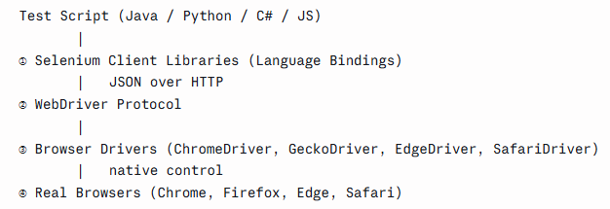

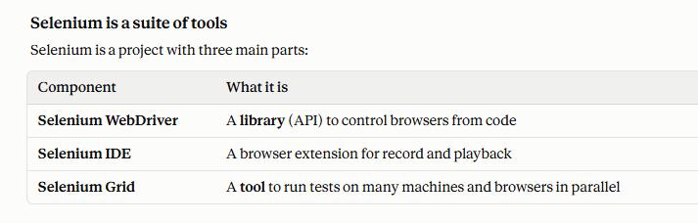
Selenuim 3 vs Selenuim 4

Selenium 4 is the upgraded version of Selenium 3. The biggest change is how the script talks to the driver

Selenium 3 used the JSON Wire Protocol. Browsers follow the W3C standard, so requests had to be translated in between
Selenium 4 uses the W3C WebDriver protocol directly. Script and driver speak the same language

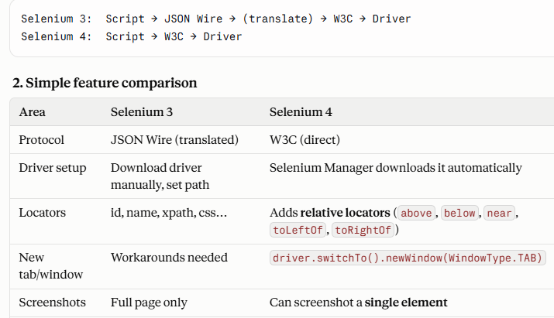

How many window IDs does the set from getWindowHandles() store?
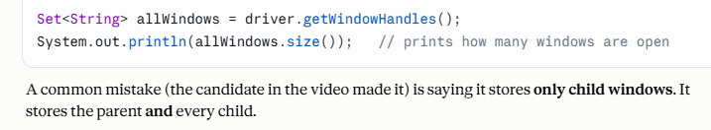

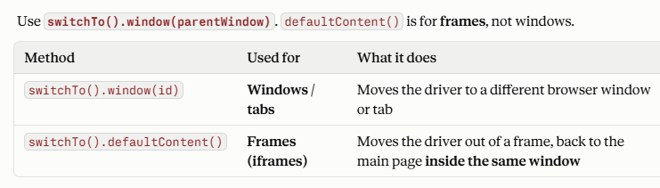

After closing the second window, where is the driver pointing?
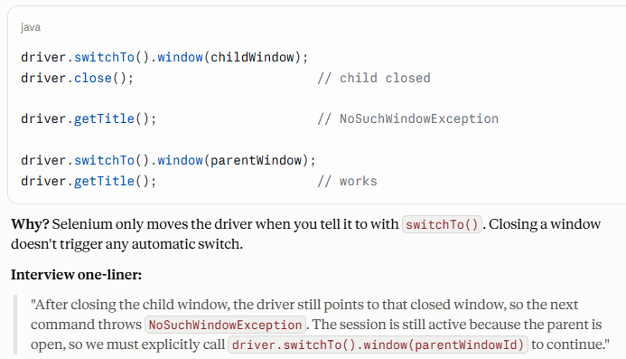

Name at least five important methods in the Actions class.
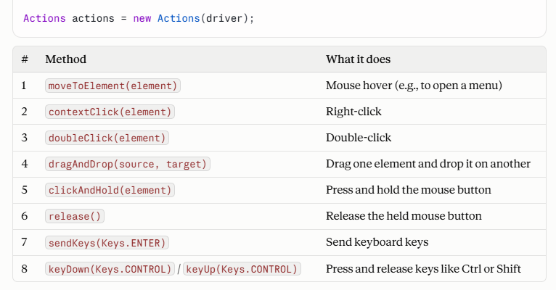

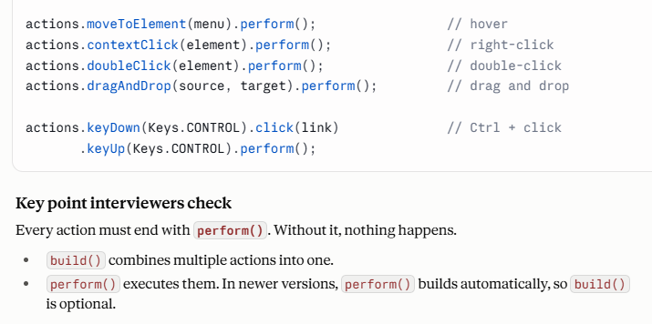

What happens on the server side when you write WebDriver driver = new ChromeDriver()?

When you write new ChromeDriver(), Selenium starts the driver server and creates a new session. That session gets a unique session ID, which is the most important part of the answer.
- driver.quit() closes all windows and ends the session, so the session ID becomes null. You must create a new driver to continue.
- driver.close() closes only the current window. If it was the last window, the session also ends. Otherwise the session stays alive, and you switch to another window.

What is sent along with every request (session ID)?

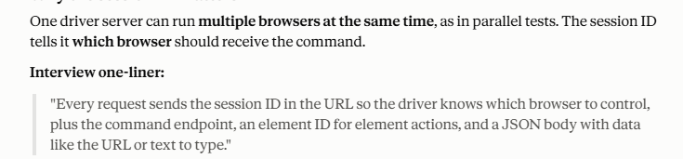

What is Cucumber?
Cucumber is a BDD tool that lets us write test scenarios in plain English using Gherkin’s Given-When-Then format. Feature files hold the scenarios, step definitions map each step to Java code, usually using Selenium page objects or REST Assured, and a runner class configures features, glue, tags, and reports. I use Scenario Outlines for data-driven tests, hooks for setup and screenshots, and tags like @smoke and @regression to control execution in Jenkins. Its biggest benefit is that business and technical teams share the same understanding of the requirements.

Which language is used to write feature files?
Feature files are written in Gherkin, a plain-English language using keywords like Feature, Scenario, Given, When, and Then, so both business and technical people can read them.

What hooks are available in Cucumber?
Cucumber provides @Before and @After hooks that run before and after each scenario, @BeforeStep and @AfterStep for each step, and in Cucumber 7, @BeforeAll and @AfterAll that run once for the whole suite. I use @Before to launch the browser and @After to take a screenshot on failure using scenario.isFailed(), attach it to the report, and quit the driver. Hooks can also be tagged, like @Before("@db"), and ordered with the order attribute.

What's the difference between Background and Hooks in Cucumber?
Background is written in the feature file in Gherkin and runs before each scenario in that file only, so it’s for business preconditions like logging in, and it’s visible to stakeholders. Hooks are written in Java with @Before and @After, apply to all scenarios or tagged ones, and handle technical setup like launching the browser, screenshots, and teardown. The order is: @Before hook, then Background, then the scenario steps, then the @After hook.

Can you write hooks inside a feature file? – No
What's the difference between a Data Table and Examples?

Examples is used with Scenario Outline and runs the entire scenario once per row, so it’s for data-driven testing, like logging in with multiple users. A Data Table is attached to a single step and passes multiple values to it, while the scenario runs only once, like filling in a registration form. In the step definition, I read a Data Table with methods like asMap() or asMaps().”

Where do you use List and HashMap in Selenium?
I use List mainly with findElements(): counting links, verifying menu items, reading dropdown options and table rows, switching windows by index, and comparing expected vs. actual lists. I also use findElements().isEmpty() to check element presence without an exception. I use HashMap for test data from Excel, config values, mapping table data by a key column, setting Chrome preferences like the download folder, and counting duplicates.”

You run tests on Sauce Labs. Do you use RemoteWebDriver?
Yes, Sauce Labs is a cloud Selenium Grid, so we use RemoteWebDriver with the Sauce hub URL. I set the browser, version, and platform in ChromeOptions, and Sauce-specific settings like username, access key, test name, and build in sauce:options. Credentials come from Jenkins environment variables. The framework is config-driven, so the same tests run locally or on Sauce. After each test, I update the job status with sauce:job-result so the dashboard shows pass/fail, and we use Sauce Connect for internal environments.

Without RemoteWebDriver, how would you run tests on Sauce Labs? Where do you pass the hub URL?
“For Selenium, we can’t run on Sauce Labs without RemoteWebDriver, because ChromeDriver and FirefoxDriver only launch local browsers and can’t take a hub URL. Even when we don’t create it directly, like with the Selenium 4 builder, Sauce Bindings, frameworks like Serenity, or Appium drivers that extend RemoteWebDriver, it’s still RemoteWebDriver underneath. The hub URL is passed either in the RemoteWebDriver constructor, the builder’s address() method, or a config file or Jenkins parameter that the framework reads.

Why do you get a StaleElementReferenceException?
StaleElementReferenceException happens when a previously located element is no longer attached to the DOM, usually because the page refreshed, navigated, or part of it was re-rendered by AJAX or a framework like React. The reference still points to the old element. I fix it by re-locating the element right before using it, waiting with ExpectedConditions.refreshed() or stalenessOf(), adding retry logic for dynamic sections, and storing locators instead of WebElements. With PageFactory, I avoid @CacheLookup on dynamic elements.

How do you handle an untrusted SSL certificate in Selenium?
In Selenium 4, I use setAcceptInsecureCerts(true) on ChromeOptions, FirefoxOptions, or EdgeOptions, which makes the browser accept self-signed or invalid certificates and skip the warning page. For Chrome, --ignore-certificate-errors also works, and in Selenium 3 we set the ACCEPT_INSECURE_CERTS capability. It works with RemoteWebDriver and Sauce Labs too. I set it in the DriverFactory, controlled by config, and use it only in test environments.

The locator is correct, but you still can't click a button or link. What could be the reason?

“Even with a correct locator, a click can fail because the element isn’t clickable yet, another element like a spinner or modal is covering it, it’s out of view, it’s inside an iframe, shadow DOM, or another window, the locator matches a hidden duplicate, the button is disabled, the element went stale, or the window size changed the layout in headless mode. I check the exception message first. ElementClickInterceptedException even names the blocking element. Then I fix it with explicit waits, scrolling, switching frames or windows, or Actions. I use a JavaScript click only as a last resort, since it can hide real UI issues.”

