Moffat1D

2024-03-21

library(ggplot2)  
library(plotly)

##   
## Attaching package: 'plotly'

## The following object is masked from 'package:ggplot2':  
##   
## last_plot

## The following object is masked from 'package:stats':  
##   
## filter

## The following object is masked from 'package:graphics':  
##   
## layout

library(readr)  
library(ggpointdensity)  
library(viridis)

## Loading required package: viridisLite

library(tidyr)  
library(fitdistrplus)

## Loading required package: MASS

##   
## Attaching package: 'MASS'

## The following object is masked from 'package:plotly':  
##   
## select

## Loading required package: survival

Importing the data and narrowing it down to a “1D” slice of a Celestial Source Viewing some of those slices

library(here)

## here() starts at C:/Users/Blake/Dropbox/My PC (LAPTOP-R53ILDBG)/Documents/GitHub/Terzan-5

i_am("MoffatPDF.Rmd")

## here() starts at C:/Users/Blake/Dropbox/My PC (LAPTOP-R53ILDBG)/Documents/GitHub/Terzan-5

Tz5 <- readr::read_csv(here("Data", "Terzan 5 X-ray events.csv"), col_types = list(.default = readr::col_guess()), )  
head(Tz5)

## # A tibble: 6 × 19  
## time expno ccd_id node_id chipx chipy tdetx tdety detx dety x y  
## <dbl> <dbl> <dbl> <dbl> <dbl> <dbl> <dbl> <dbl> <dbl> <dbl> <dbl> <dbl>  
## 1 174000000 110 7 1 299 499 4216 2201 4187. 4113. 4107. 4113.  
## 2 174000000 110 7 1 298 523 4215 2225 4187. 4088. 4131. 4111.  
## 3 174000000 112 7 0 236 509 4153 2211 4125. 4103. 4115. 4052.  
## 4 174000000 113 7 1 373 562 4290 2264 4262. 4050. 4174. 4187.  
## 5 174000000 115 7 0 241 511 4158 2213 4130. 4101. 4118. 4059.  
## 6 174000000 115 7 0 245 516 4162 2218 4134. 4095. 4124. 4062.  
## # ℹ 7 more variables: pha <dbl>, pha_ro <dbl>, energy <dbl>, pi <dbl>,  
## # fltgrade <dbl>, grade <dbl>, status <chr>

T5 <- data.frame(Tz5$x, Tz5$y)  
colnames(T5) <- c('x','y')  
POI1 <- T5 %>%  
 filter(x>4160 & x<4180 & y>4180 & y<4200)  
POI2 <- T5 %>%  
 filter(x>4105 & x< 4125 & y>4040 & y<4060)  
#data to fit to  
line2 <- POI2 %>%  
 filter(y>4050.5 & y< 4051.5)  
plotdist(line2$x)

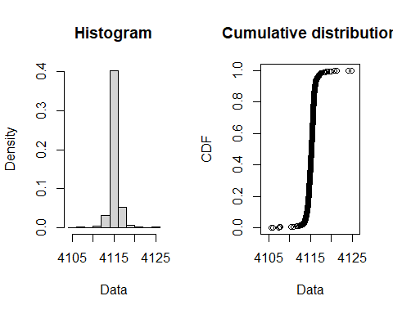

plot(line2)

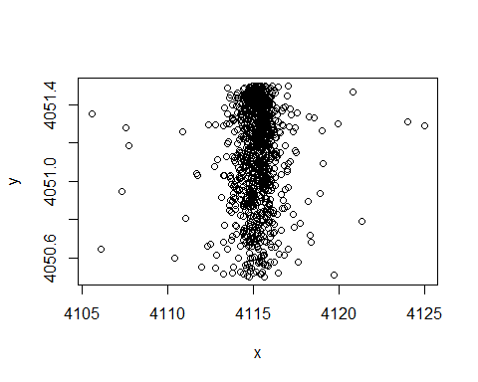

line2.5 <- line2 %>%  
 filter(y>4050.5 & y< 4051)  
plot(line2.5)

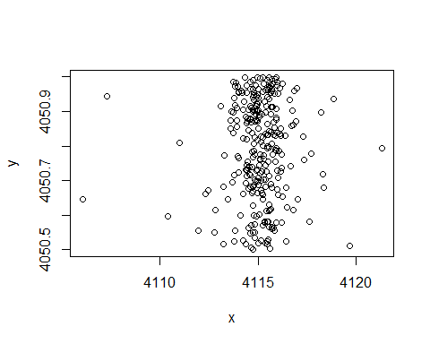

xl2 <- line2$x  
xl2.5 <- line2.5$x  
xVall2 <- seq(min(xl2), max(xl2), length = 963)  
xVall2.5 <- seq(min(xl2.5), max(xl2.5), length = 291)

This Rmarkdown document is to create a function of the 1D Moffat distribution function where the amplitude is given in respect to the parameters that describe the core width and power index.

The equation is as follows:

In order for the amplitude to remain positive, alpha must be greater than 0 and beta must be greater than or equal to 1.5.

MOFFATPDF <- function(parameters, x){  
 mu <- parameters[[1]]  
 alpha <- parameters[[2]]  
 beta <- parameters[[3]]  
   
 alpha <- pmax(alpha, 1e-6)  
 beta <- pmax(beta, 0.5+1e-6)  
   
 predictedDensity <- (gamma(beta)/(alpha*sqrt(pi)*gamma(beta-0.5)))*(1+((x-mu)/alpha)^2)^-beta  
   
}

To use the optim function likes to minimize functions. For that I need a Negative Log Likelihood

NLL <- function(parameters, x){  
 predictedDensity <- MOFFATPDF(parameters, x)  
 return(-sum(log(predictedDensity)))  
}

Now I need the partial derivatives of the negative log likelihood with respect to each parameter

To obtain the partial derivative with respect to beta I will be using the Rcode of digamma

derivMOFFATPDS <- function(parameters, x){  
 mu <- parameters[[1]]  
 alpha <- parameters[[2]]  
 beta <- parameters[[3]]  
   
   
 dMu <- -sum((2*beta*(x-mu))/(alpha^2 + (x-mu)^2))  
 dAlpha <- -sum(-1/alpha + (2*beta*(x-mu)^2)/(alpha^3+alpha*(x-mu)^2))  
 dBeta <- -sum(digamma(beta)-digamma(beta-0.5)-log(1+(x-mu)^2/alpha^2))  
   
 return(c(dMu, dAlpha, dBeta))  
}

Trying with optim

initialGUESS <- c(mu = 4115, alpha = 1, beta = 4)  
lowerBOUNDS <- c(0, 1e-6, 1.5)  
  
RESULT <- optim(par = initialGUESS, fn = NLL, gr = derivMOFFATPDS, x = xl2.5, method = "L-BFGS-B", lower = lowerBOUNDS)  
optimPAR2.5 <- RESULT$par  
optimPAR2.5

## mu alpha beta   
## 4115.125763 1.082681 1.771935

optimDENS2.5 <- MOFFATPDF(optimPAR2.5, xVall2.5)  
plot(xVall2.5, optimDENS2.5, type = "l", main = "Optimised Density Function", xlab = "x", ylab = "Density")

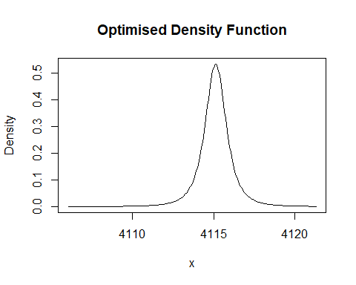

RESULT <- optim(par = initialGUESS, fn = NLL, gr = derivMOFFATPDS, x = xl2, method = "L-BFGS-B", lower = lowerBOUNDS)  
optimPAR2 <- RESULT$par  
optimPAR2

## mu alpha beta   
## 4115.2307593 0.9860251 1.8368043

optimDENS2 <- MOFFATPDF(optimPAR2, xVall2)  
plot(xVall2, optimDENS2, type = "l", main = "Optimised Density Function", xlab = "x", ylab = "Density")

