Presentation

2024-02-24

library(MASS)  
library(ggplot2)

## Warning: replacing previous import 'lifecycle::last_warnings' by  
## 'rlang::last_warnings' when loading 'tibble'

## Warning: replacing previous import 'lifecycle::last_warnings' by  
## 'rlang::last_warnings' when loading 'pillar'

library(plotly)

## Warning: package 'plotly' was built under R version 4.0.5

##   
## Attaching package: 'plotly'

## The following object is masked from 'package:ggplot2':  
##   
## last_plot

## The following object is masked from 'package:MASS':  
##   
## select

## The following object is masked from 'package:stats':  
##   
## filter

## The following object is masked from 'package:graphics':  
##   
## layout

library(readr)  
library(ggpointdensity)

## Warning: package 'ggpointdensity' was built under R version 4.0.5

library(viridis)

## Loading required package: viridisLite

## Warning: package 'viridisLite' was built under R version 4.0.5

library(tidyr)

Terzan5 <- read.csv("C:\\Users\\Blake\\Desktop\\Uni\\Honours\\Project\\Terzan 5 X-ray events.csv")  
T5 <- data.frame(Terzan5$x, Terzan5$y)  
colnames(T5) <- c('x','y')  
POI1 <- T5 %>%  
 filter(x>4160 & x<4180 & y>4180 & y<4200)  
POI2 <- T5 %>%  
 filter(x>4105 & x< 4125 & y>4040 & y<4060)  
Central <- T5 %>%  
 filter(x>4085 & x< 4150 & y>4060 & y<4125)  
POI3 <- T5 %>%  
 filter(x>4120 & x< 4140 & y>4100 & y<4120)  
  
dMoffat1D <- function(x, amplitude, mu, gamma, alpha){amplitude*(1+((x-mu)/gamma)^2)^-alpha}  
  
Moffat1D_Deriv <- function(x, amplitude, mu, gamma, alpha){  
 chain = (1 + (x - mu)^2 / gamma^2)  
 d_A = chain^(-alpha)  
 d_mu = 2*amplitude*alpha*(x - mu)*d_A/(chain*gamma^2)  
 d_gamma = 2*amplitude*alpha*((x - mu)^2)*d_A/(chain*gamma^3)  
 d_alpha = -amplitude*d_A*log(chain)  
   
 return(list(c(d_A, d_mu, d_gamma, d_alpha)))  
}

ggplot(T5, aes(x,y))+ geom_point(shape = ".") +coord_fixed()

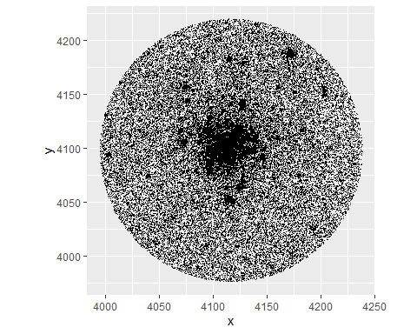

ggplot(T5,aes(x,y)) + geom_pointdensity(adjust = 0.05, size = 0.1, shape = "1") + scale_color_viridis(direction = -1, option = "B", trans = "log", breaks = c(10, 100, 1000, 10000)) + coord_fixed()

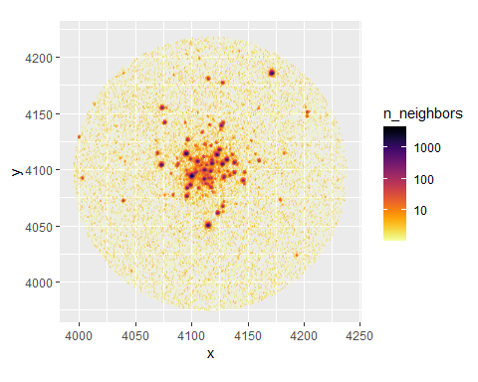

ggplot(POI1, aes(x,y))+ geom_pointdensity(adjust = 0.05, size = 0.1, shape = "1") + scale_color_viridis(direction = -1, option = "B", trans = "log", breaks = c(10, 100, 1000)) + coord_fixed()

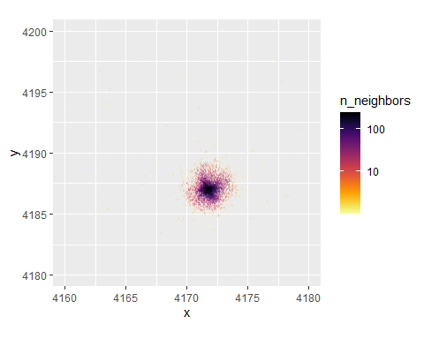

ggplot(POI2, aes(x,y))+geom_pointdensity(adjust = 0.05, size = 0.1, shape = "1") + scale_color_viridis(direction = -1, option = "B", trans = "log", breaks = c(10, 100, 1000)) + coord_fixed()

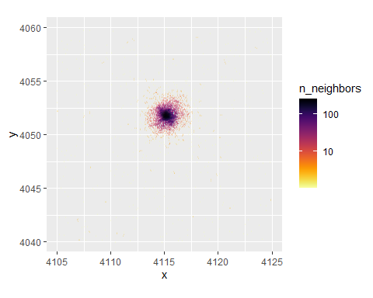

ggplot(Central, aes(x,y))+ geom_pointdensity(adjust = 0.05, size = 0.1, shape = "1") + scale_color_viridis(direction = -1, option = "B", trans = "log", breaks = c(10, 100, 1000, 10000)) + coord_fixed()

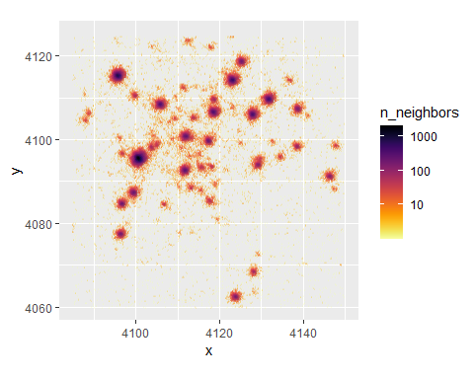

ggplot(POI3, aes(x,y))+ geom_pointdensity(adjust = 0.05, size = 0.1, shape = "1") + scale_color_viridis(direction = -1, option = "B", trans = "log", breaks = c(10, 100, 1000, 10000)) + coord_fixed()

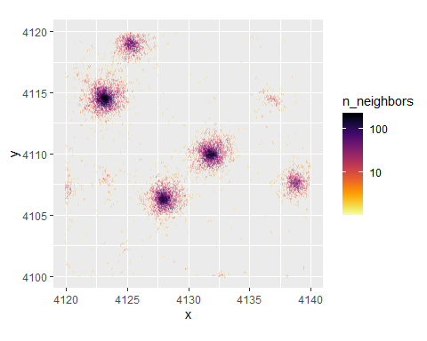

ggplot(POI1, aes(x,y))+ geom_point(shape = ".", size = 0.5) + coord_fixed() + geom_hline(yintercept = 4190, col = "red") + geom_hline(yintercept = 4189, col = "red")+ geom_hline(yintercept = 4188, col = "red")+ geom_hline(yintercept = 4187, col = "red")+ geom_hline(yintercept = 4186, col = "red")+ geom_hline(yintercept = 4185, col = "red")

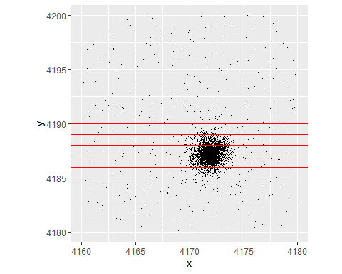

range2 <- seq(-3, 4, by = 0.1)  
my.at <- c(-3:3)  
#f(x) = A(1+(x-mu)^2/gamma^2)^-alpha  
  
plot(dMoffat1D(range2, 1, 0, 1, 1), main = "Changing mu", type = "l", xlab = "x", ylab = "f(x)", ylim = c(-0.5, 1.2), axes = FALSE)  
axis(1, at = 0:60, labels = seq(-3,3, by = 0.1))  
axis(2)  
lines(dMoffat1D(range2, 1, 0.5, 1, 1), type = "l", col = "red")  
lines(dMoffat1D(range2, 1, 1, 1, 1), type = "l", col = "blue")  
lines(dMoffat1D(range2, 1, -1, 1, 1), type = "l", col = "green")  
legend("topright", legend = c("mu = 0", "mu = 0.5", "mu = 1", "mu = -1"), col = c("black", "red", "blue", "green"), lty=1:2, cex=0.8)

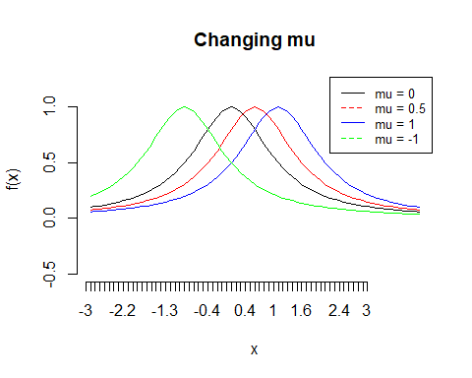

plot(dMoffat1D(range2, 1, 0, 1, 1), main = "Changing alpha", type = "l", xlab = "x", ylab = "f(x)", ylim = c(-0.5, 1.2), axes = FALSE)  
axis(1, at = 0:60, labels = seq(-3,3, by = 0.1))  
axis(2)  
lines(dMoffat1D(range2, 1, 0, 1, 2), type = "l", col = "red")  
lines(dMoffat1D(range2, 1, 0, 1, 4), type = "l", col = "blue")  
lines(dMoffat1D(range2, 1, 0, 1, 0.5), type = "l", col = "green")  
legend("topright", legend = c("alpha = 1", "alpha = 2", "alpha = 4", "alpha = 0.5"), col = c("black", "red", "blue", "green"), lty=1:2, cex=0.8)

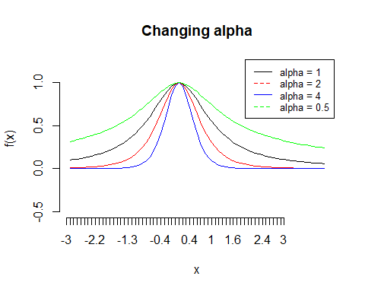

plot(dMoffat1D(range2, 1, 0, 1, 1), main = "Changing gamma", type = "l", xlab = "x", ylab = "f(x)", ylim = c(-0.5, 2), axes = FALSE)  
axis(1, at = 0:60, labels = seq(-3,3, by = 0.1))  
axis(2)  
lines(dMoffat1D(range2, 1, 0, 2, 1), type = "l", col = "red")  
lines(dMoffat1D(range2, 1, 0, 4, 1), type = "l", col = "blue")  
lines(dMoffat1D(range2, 1, 0, 0.5, 1), type = "l", col = "green")  
legend("topright", legend = c("gamma = 1", "gamma = 2", "gamma = 4", "gamma = 0.5"), col = c("black", "red", "blue", "green"), lty=1:2, cex=0.8)

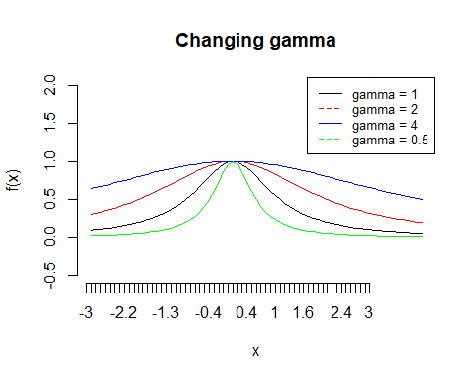

plot(dMoffat1D(range2, 1, 0, 1, 1), main = "Changing A", , type = "l", xlab = "x", ylab = "f(x)", ylim = c(-0.5, 5), axes = FALSE)  
axis(1, at = 0:60, labels = seq(-3,3, by = 0.1))  
axis(2)  
lines(dMoffat1D(range2, 2, 0, 1, 1), type = "l", col = "red")  
lines(dMoffat1D(range2, 4, 0, 1, 1), type = "l", col = "blue")  
lines(dMoffat1D(range2, 0.5, 0, 1, 1), type = "l", col = "green")  
legend("topright", legend = c("A = 1", "A = 2", "A = 3", "A = 0.5"), col = c("black", "red", "blue", "green"), lty=1:2, cex=0.8)

