POI1

2023-10-12

library(ggplot2)

## Warning: replacing previous import 'lifecycle::last_warnings' by  
## 'rlang::last_warnings' when loading 'tibble'

## Warning: replacing previous import 'lifecycle::last_warnings' by  
## 'rlang::last_warnings' when loading 'pillar'

library(plotly)

## Warning: package 'plotly' was built under R version 4.0.5

##   
## Attaching package: 'plotly'

## The following object is masked from 'package:ggplot2':  
##   
## last_plot

## The following object is masked from 'package:stats':  
##   
## filter

## The following object is masked from 'package:graphics':  
##   
## layout

library(readr)  
library(ggpointdensity)

## Warning: package 'ggpointdensity' was built under R version 4.0.5

library(viridis)

## Loading required package: viridisLite

## Warning: package 'viridisLite' was built under R version 4.0.5

library(tidyr)  
library(fitdistrplus)

## Warning: package 'fitdistrplus' was built under R version 4.0.5

## Loading required package: MASS

##   
## Attaching package: 'MASS'

## The following object is masked from 'package:plotly':  
##   
## select

## Loading required package: survival

## Warning: package 'survival' was built under R version 4.0.5

library(rlang)

## Warning: package 'rlang' was built under R version 4.0.5

Terzan5 <- read.csv("C:\\Users\\Blake\\Desktop\\Uni\\Honours\\Project\\Terzan 5 X-ray events.csv")  
T5 <- data.frame(Terzan5$x, Terzan5$y)  
colnames(T5) <- c('x','y')  
POI1 <- T5 %>%  
 filter(x>4160 & x<4180 & y>4180 & y<4200)  
POI2 <- T5 %>%  
 filter(x>4105 & x< 4125 & y>4040 & y<4060)

head(POI1)

## x y  
## 1 4173.789 4187.020  
## 2 4172.088 4187.384  
## 3 4166.581 4191.414  
## 4 4171.884 4186.286  
## 5 4171.953 4186.385  
## 6 4171.344 4188.172

head(POI2)

## x y  
## 1 4114.870 4051.548  
## 2 4118.489 4058.659  
## 3 4115.268 4052.355  
## 4 4115.318 4052.077  
## 5 4118.257 4051.339  
## 6 4117.281 4050.829

ggplot(POI1, aes(x,y))+ geom_point(shape = ".") + geom_density2d() + coord_fixed()

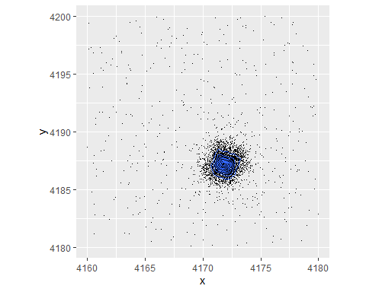

ggplot(POI2, aes(x,y))+ geom_point(shape = ".") + geom_density2d() + coord_fixed()

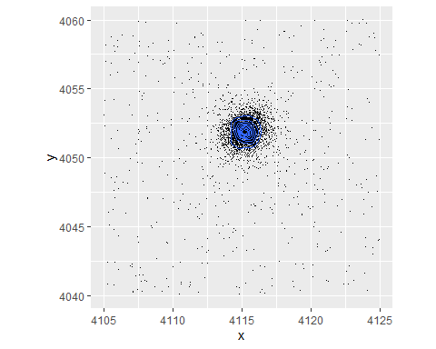

#setting up lines  
  
line0 <- POI2 %>%  
 filter(y>4048.5 & y< 4049.5)  
line1 <- POI2 %>%  
 filter(y>4049.5 & y< 4050.5)  
line2 <- POI2 %>%  
 filter(y>4050.5 & y< 4051.5)  
line3 <- POI2 %>%  
 filter(y>4051.5 & y< 4052.5)  
line4 <- POI2 %>%  
 filter(y>4052.5 & y< 4053.5)  
line5 <- POI2 %>%  
 filter(y>4053.5 & y< 4054.5)  
line6 <- POI2 %>%  
 filter(y>4054.5 & y< 4055.5)  
lineback <- POI2 %>%  
 filter(y>4055 & y< 4060)  
  
#histograms with superimposed densities  
plotdist(line0$x, histo = TRUE, demp = TRUE)

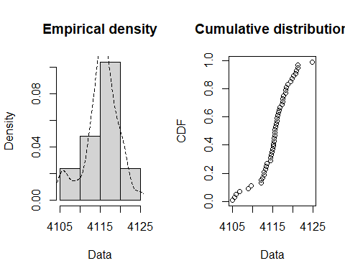

plotdist(line1$x, histo = TRUE, demp = TRUE)

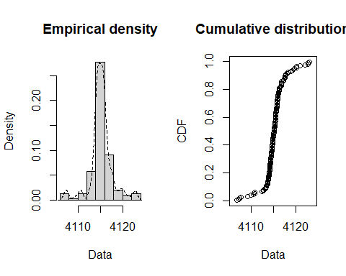

plotdist(line2$x, histo = TRUE, demp = TRUE)

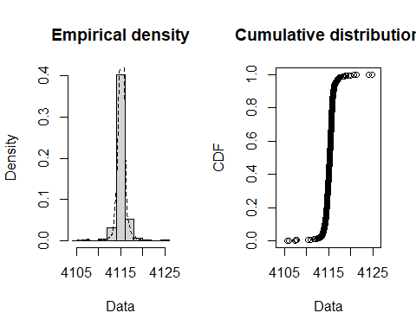

plotdist(line3$x, histo = TRUE, demp = TRUE)

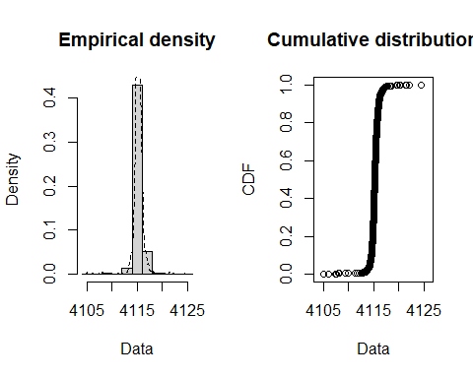

plotdist(line4$x, histo = TRUE, demp = TRUE)

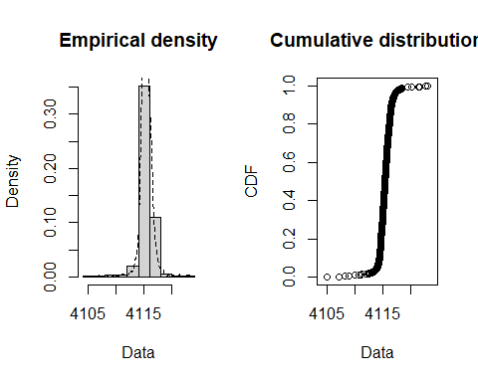

plotdist(line5$x, histo = TRUE, demp = TRUE)

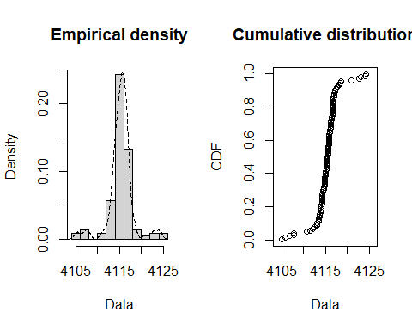

plotdist(line6$x, histo = TRUE, demp = TRUE)

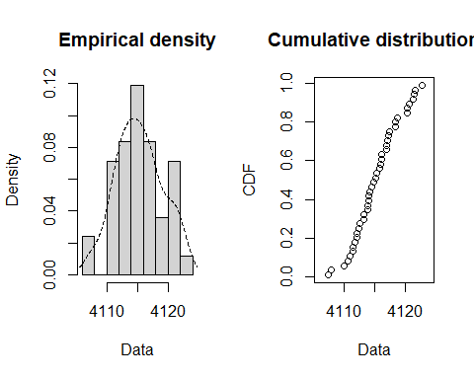

plotdist(lineback$x, histo = TRUE, demp = TRUE)

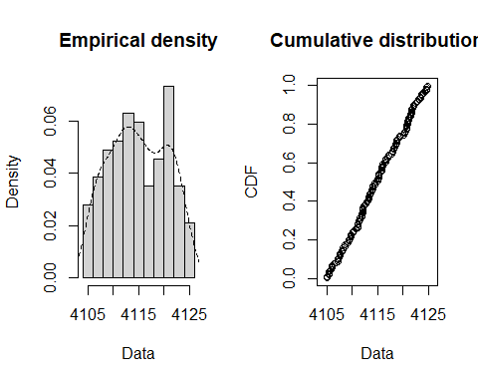

#Q-Q and P-P plots  
l0 <- fitdist(line0$x, "norm")  
par(mfrow = c(2,2))  
cdfcomp(l0)  
denscomp(l0)  
qqcomp(l0)  
ppcomp(l0)

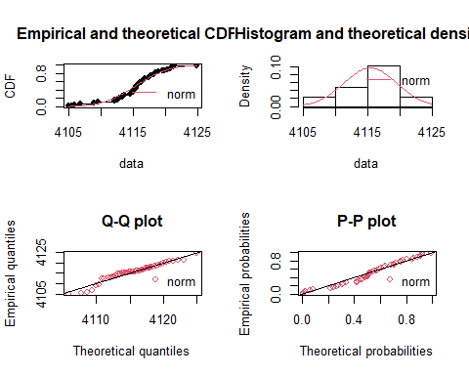

l1 <- fitdist(line1$x, "norm")  
par(mfrow = c(2,2))  
cdfcomp(l1)  
denscomp(l1)  
qqcomp(l1)  
ppcomp(l1)

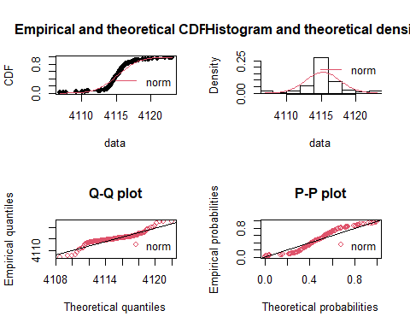

l2 <- fitdist(line2$x, "norm")  
par(mfrow = c(2,2))  
cdfcomp(l2)  
denscomp(l2)  
qqcomp(l2)  
ppcomp(l2)

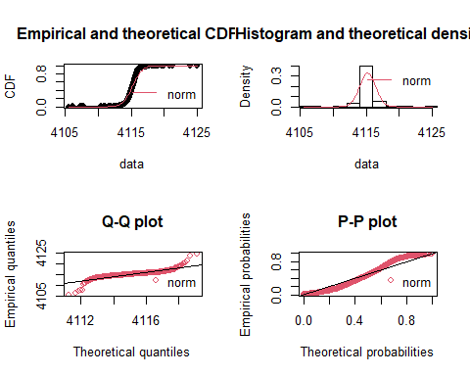

l3 <- fitdist(line3$x, "norm")  
par(mfrow = c(2,2))  
cdfcomp(l3)  
denscomp(l3)  
qqcomp(l3)  
ppcomp(l3)

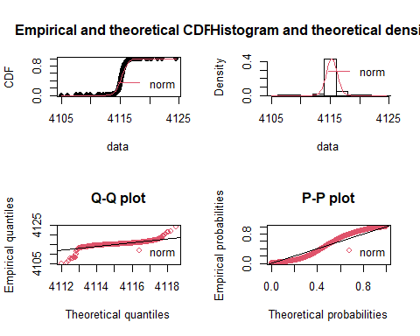

l4 <- fitdist(line4$x, "norm")  
par(mfrow = c(2,2))  
cdfcomp(l4)  
denscomp(l4)  
qqcomp(l4)  
ppcomp(l4)

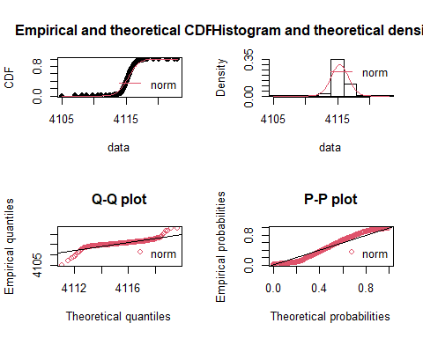

l5 <- fitdist(line5$x, "norm")  
par(mfrow = c(2,2))  
cdfcomp(l5)  
denscomp(l5)  
qqcomp(l5)  
ppcomp(l5)

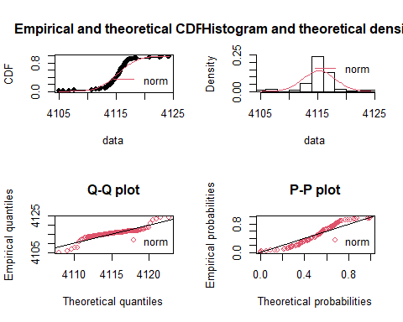

l6 <- fitdist(line6$x, "norm")  
par(mfrow = c(2,2))  
cdfcomp(l6)  
denscomp(l6)  
qqcomp(l6)  
ppcomp(l6)

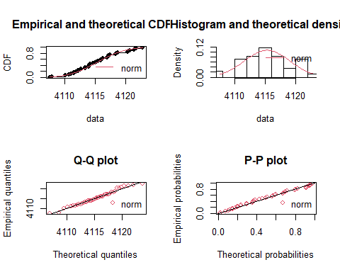

lb <- fitdist(lineback$x, "unif")  
par(mfrow = c(2,2))  
cdfcomp(lb)  
denscomp(lb)  
qqcomp(lb)  
ppcomp(lb)

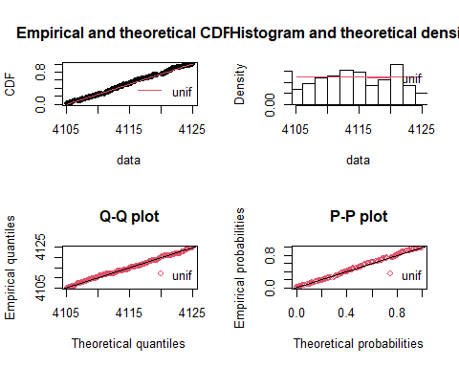

band <- POI2 %>%  
 filter(y>4048.5 & y< 4055.5)  
ggplot() + geom_point(mapping = aes(x,y), data = line0, shape =".") + geom_point(mapping = aes(x,y), data = line1, colour = "red", shape =".") + geom_point(mapping = aes(x,y), data = line2, colour = "blue", shape =".") + geom_point(mapping = aes(x,y), data = line3, shape =".") + geom_point(mapping = aes(x,y), data = line4, colour = "blue", shape =".") + geom_point(mapping = aes(x,y), data = line5, colour = "red", shape =".") + geom_point(mapping = aes(x,y), data = line6, shape =".") + coord_fixed()

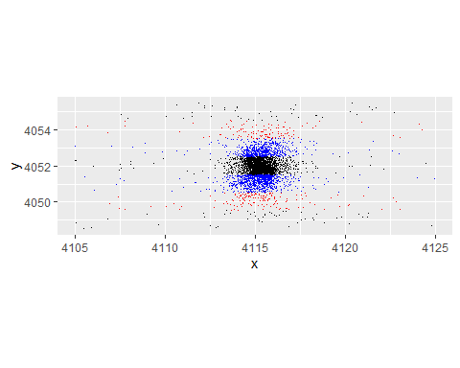

line3.1 <- line3 %>%  
 filter(y>4051.5 & y< 4051.7)  
line3.2 <- line3 %>%  
 filter(y>4051.7 & y< 4051.9)  
line3.3 <- line3 %>%  
 filter(y>4051.9 & y< 4052.1)  
line3.4 <- line3 %>%  
 filter(y>4052.1 & y< 4052.3)  
line3.5 <- line3 %>%  
 filter(y>4052.3 & y< 4052.5)

plotdist(line3.3$x, histo = TRUE, demp = TRUE)

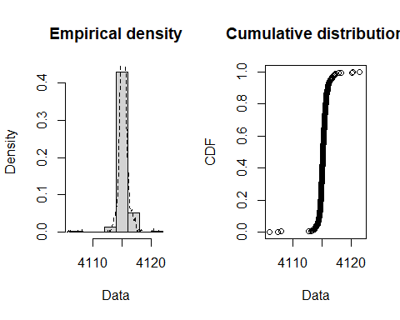

mean(line1$x)

## [1] 4115.258

mean(line2$x)

## [1] 4115.195

mean(line3$x)

## [1] 4115.252

mean(line4$x)

## [1] 4115.349

mean(line5$x)

## [1] 4115.327

mean(POI2$x)

## [1] 4115.227

line3.1$x

## [1] 4114.870 4115.030 4114.349 4114.506 4115.291 4115.888 4114.896 4115.295  
## [9] 4115.104 4114.251 4115.053 4114.730 4115.031 4115.542 4115.685 4115.427  
## [17] 4115.490 4115.120 4115.865 4115.318 4116.197 4114.077 4114.805 4115.274  
## [25] 4115.699 4115.927 4116.542 4115.663 4114.872 4115.521 4115.780 4115.281  
## [33] 4115.472 4114.768 4115.043 4115.066 4114.707 4115.583 4115.065 4115.176  
## [41] 4115.251 4114.665 4115.559 4116.230 4114.965 4115.161 4114.894 4114.797  
## [49] 4114.257 4115.406 4114.754 4117.377 4115.373 4114.792 4116.179 4114.842  
## [57] 4115.069 4116.002 4115.425 4115.247 4115.468 4114.357 4115.130 4115.886  
## [65] 4115.690 4114.743 4115.325 4115.252 4116.584 4115.838 4115.113 4115.438  
## [73] 4115.378 4114.866 4115.655 4115.609 4113.425 4115.344 4116.362 4115.091  
## [81] 4115.730 4115.053 4116.187 4115.397 4115.892 4115.770 4115.065 4115.373  
## [89] 4115.346 4115.198 4115.631 4115.197 4114.908 4115.366 4115.773 4114.949  
## [97] 4115.636 4113.525 4114.254 4114.722 4114.922 4117.887 4116.760 4115.221  
## [105] 4114.595 4114.793 4117.217 4116.429 4116.446 4115.546 4115.878 4115.930  
## [113] 4114.964 4115.475 4116.460 4116.424 4114.886 4114.382 4115.533 4115.444  
## [121] 4115.240 4115.254 4115.678 4118.198 4114.732 4115.072 4115.114 4115.372  
## [129] 4114.149 4115.289 4113.456 4115.567 4115.626 4115.531 4114.291 4115.689  
## [137] 4114.300 4115.101 4115.309 4114.845 4115.652 4115.975 4115.307 4115.775  
## [145] 4116.037 4114.668 4114.887 4113.675 4115.197 4114.540 4116.131 4115.585  
## [153] 4116.129 4115.646 4115.223 4117.552 4115.245 4114.773 4115.069 4115.544  
## [161] 4115.406 4115.699 4115.544 4114.667 4116.111 4115.172 4115.094 4117.224  
## [169] 4115.556 4115.138 4114.961 4115.234 4115.188 4114.892 4114.972 4115.304  
## [177] 4115.355 4115.087 4115.416 4115.728 4115.085 4115.181 4115.791 4114.836  
## [185] 4116.508 4115.078 4115.361 4116.350 4115.494 4116.150 4114.971 4115.330  
## [193] 4115.197 4116.042 4115.212 4115.059 4115.066 4115.211 4114.960 4115.255  
## [201] 4114.990 4115.037 4114.824 4115.922 4116.001 4115.194 4115.560 4114.950  
## [209] 4115.838 4115.844 4115.688 4115.948 4115.420 4115.302 4115.558 4115.002  
## [217] 4115.551 4114.862 4115.570 4115.458 4115.236 4115.054 4115.775 4115.509  
## [225] 4115.402 4115.186 4115.190 4115.410 4114.845 4115.482 4115.664 4115.494  
## [233] 4115.614 4115.543 4115.480 4114.685 4115.060 4115.259 4115.725 4115.209  
## [241] 4114.571 4114.746 4115.500 4115.202 4116.330 4116.036 4115.950 4114.998  
## [249] 4115.310 4115.553 4115.474 4116.143 4114.277 4115.781 4115.069 4113.583  
## [257] 4115.917 4114.356 4115.688 4115.528 4113.709 4115.618 4115.047 4115.678  
## [265] 4115.165 4115.502 4116.337 4115.686 4114.818 4115.648 4114.859 4115.587  
## [273] 4115.419 4115.486 4115.253 4113.278 4115.252 4115.464 4115.490 4115.241  
## [281] 4116.076 4115.098 4113.817 4115.213 4115.731 4114.922 4113.730 4114.469  
## [289] 4115.512 4113.543 4114.787 4115.788 4115.300 4115.945 4114.991 4115.356  
## [297] 4115.458 4115.664 4115.238 4115.037 4115.463 4114.917 4115.815 4115.838  
## [305] 4116.360 4114.127 4114.776 4115.716 4114.433 4115.170 4115.223 4115.930  
## [313] 4115.020 4114.842 4115.667 4115.819 4114.038 4114.409 4114.598 4115.202  
## [321] 4115.028 4114.883 4115.894 4115.876 4115.042 4116.815 4119.513 4114.856  
## [329] 4115.026 4115.343 4114.852 4115.086 4115.102 4115.565 4115.833 4115.067  
## [337] 4115.527 4115.581 4115.077 4114.776 4114.955 4113.758 4115.186 4114.880  
## [345] 4115.633 4114.765 4115.292 4115.292 4115.787 4114.857 4115.333 4115.140  
## [353] 4114.976 4115.077 4115.148 4115.371 4115.417 4115.337 4116.990 4115.628  
## [361] 4116.160 4115.886 4113.939 4114.439 4115.343 4115.409 4116.018 4114.990  
## [369] 4115.212 4115.088 4115.087 4115.526 4114.409 4114.681 4114.868 4115.110  
## [377] 4116.105 4115.184 4116.078 4116.141 4115.246 4115.488 4115.326 4114.207  
## [385] 4115.811 4114.986 4114.564 4111.637 4115.502 4115.810 4115.873 4115.960  
## [393] 4114.944 4116.470 4115.596 4114.645 4114.997 4114.998 4115.318 4115.078  
## [401] 4114.963 4114.867 4111.232 4115.414 4115.976 4114.005 4114.447 4116.572  
## [409] 4114.308 4115.274 4115.054 4113.337 4115.010 4115.205 4115.286 4114.967  
## [417] 4114.232 4114.987 4116.047 4115.409 4116.804 4115.281 4114.917 4115.307  
## [425] 4114.905 4114.107 4116.049 4116.911 4115.012 4115.235 4115.676 4114.990  
## [433] 4114.830 4115.915 4115.116 4116.199 4116.281 4114.955 4115.938 4116.182  
## [441] 4115.588 4115.089 4115.359 4115.551 4115.716 4115.913 4115.423 4115.251  
## [449] 4115.475 4115.047 4115.195 4114.950 4114.685 4115.833 4114.605 4115.457  
## [457] 4114.990 4115.917 4116.151 4115.492 4114.887 4115.046 4115.104 4115.352  
## [465] 4115.206 4114.623 4114.923 4114.845 4114.874 4115.151 4115.725 4115.180  
## [473] 4114.468 4115.036 4115.976 4115.332 4114.901

mean(line3.1$x)

## [1] 4115.297

trial <- order(line3.1$x)  
#plot(dMoffat1D(line3.1$x, 1, mean(line3.1$x), 1, 1))