Terzan5

2023-09-28

## Libraries

library(here)

## here() starts at C:/Users/Blake/Dropbox/My PC (LAPTOP-R53ILDBG)/Documents/GitHub/Terzan-5

library(ggplot2)  
library(plotly)

##   
## Attaching package: 'plotly'

## The following object is masked from 'package:ggplot2':  
##   
## last_plot

## The following object is masked from 'package:stats':  
##   
## filter

## The following object is masked from 'package:graphics':  
##   
## layout

library(readr)  
library(ggpointdensity)  
library(viridis)

## Loading required package: viridisLite

library(tidyr)

## Import Data

i_am("Terzan5.Rmd")

## here() starts at C:/Users/Blake/Dropbox/My PC (LAPTOP-R53ILDBG)/Documents/GitHub/Terzan-5

# import data from csv file  
Terzan5 <- readr::read_csv(here("Data", "Terzan 5 X-ray events.csv"), col_types = list(.default = readr::col_guess()), )  
# head(Terzan5)  
  
# import data from ODS file  
# library(readODS)  
# Terzan5 <- read_ods(here("Raw Data.ods"), col_types = list(.default = readr::col_guess()), )  
#removing extraneous columns  
T5 <- data.frame(Terzan5$x, Terzan5$y)  
colnames(T5) <- c('x','y')

View Data

head(Terzan5)

## # A tibble: 6 × 19  
## time expno ccd_id node_id chipx chipy tdetx tdety detx dety x y  
## <dbl> <dbl> <dbl> <dbl> <dbl> <dbl> <dbl> <dbl> <dbl> <dbl> <dbl> <dbl>  
## 1 174000000 110 7 1 299 499 4216 2201 4187. 4113. 4107. 4113.  
## 2 174000000 110 7 1 298 523 4215 2225 4187. 4088. 4131. 4111.  
## 3 174000000 112 7 0 236 509 4153 2211 4125. 4103. 4115. 4052.  
## 4 174000000 113 7 1 373 562 4290 2264 4262. 4050. 4174. 4187.  
## 5 174000000 115 7 0 241 511 4158 2213 4130. 4101. 4118. 4059.  
## 6 174000000 115 7 0 245 516 4162 2218 4134. 4095. 4124. 4062.  
## # ℹ 7 more variables: pha <dbl>, pha_ro <dbl>, energy <dbl>, pi <dbl>,  
## # fltgrade <dbl>, grade <dbl>, status <chr>

Transform Data, remove unneccessary columns

T5 <- data.frame(Terzan5$x, Terzan5$y)  
colnames(T5) <- c('x','y')  
head(T5)

## x y  
## 1 4106.614 4112.823  
## 2 4131.315 4111.262  
## 3 4114.870 4051.548  
## 4 4173.789 4187.020  
## 5 4118.489 4058.659  
## 6 4123.895 4062.175

# Visualisation

Figure 1.2.1

ggplot(T5, aes(x,y))+ geom_point(shape = ".") + coord_fixed()

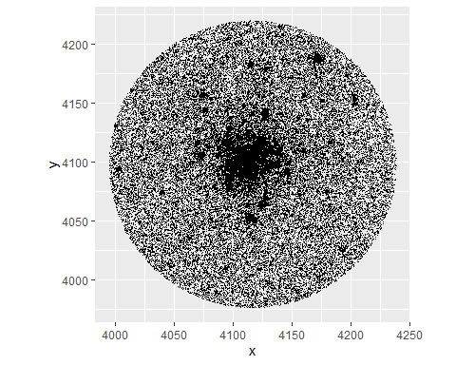

Viewing the dataset via a density heatmap. Figure 1.2.2

modelTerzan5 <- ggplot(T5,aes(x,y)) +   
 geom_pointdensity(adjust = 0.05, size = 0.1, shape = "1") +   
 scale_color_viridis(direction = -1, option = "B", trans = "log", breaks = c(10, 100, 1000, 10000)) +   
 coord_fixed()  
  
modelTerzan5

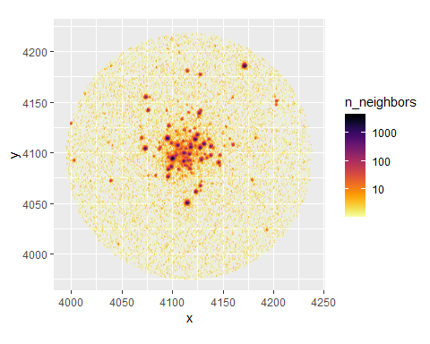

Darker areas indicate areas containing a high number of observations. These indicates the existance of a celestial source. The first aim is to try to fit a Moffat Model to each individual celestial source to predict. By then removing all of the celestial sources and their associated observations, if there is a higher level remaining this is an indication of interstellar gas remaining within the cluster.

Before getting to that stage, I want to focus on two individual celestial sources that are isolated (unlikely to contain observations that may come from another nearby source).

Choosing two Points of Interest (POI)

POI1 <- T5 %>%  
 filter(x>4160 & x<4180 & y>4180 & y<4200)  
POI2 <- T5 %>%  
 filter(x>4105 & x< 4125 & y>4040 & y<4060)  
Central <- T5 %>%  
 filter(x>4060 & x< 4160 & y>4040 & y<4140)

Viewing one of those Points of Interest

modelPOI1 <- ggplot(POI1, aes(x,y)) +  
 geom_pointdensity(adjust = 0.05, size = 0.1, shape = "1") +   
 scale_color_viridis(direction = -1, option = "B", trans = "log", breaks = c(10, 100, 1000)) +   
 coord_fixed()  
  
modelPOI1

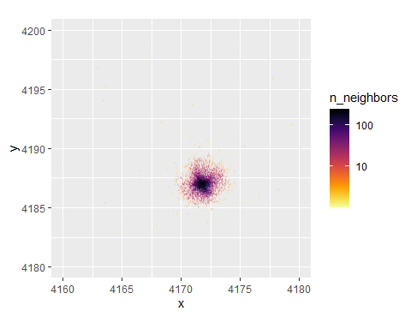

Figure 1.2.3

modelPOI2 <- ggplot(POI2, aes(x,y)) +  
 geom_pointdensity(adjust = 0.05, size = 0.1, shape = "1") +   
 scale_color_viridis(direction = -1, option = "B", trans = "log", breaks = c(10, 100, 1000)) +   
 coord_fixed()  
  
modelPOI2

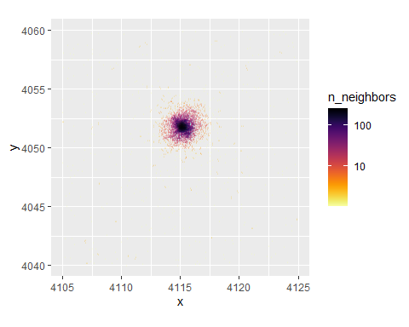

It’s important to note that while a lot of the surrounding area appears to be empty, it is full of background observations. It appears blank as observations are darker in colour and more prominent when there is a higher number of other observations close by.

RAWPOI1 <- ggplot(POI1, aes(x,y)) +  
 geom_point(size = 0.5) +  
 coord_fixed()  
  
RAWPOI2<- ggplot(POI2, aes(x,y)) +  
 geom_point(size = 0.5) +  
 coord_fixed()  
  
RAWPOI1

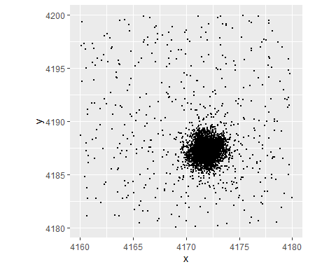

RAWPOI2

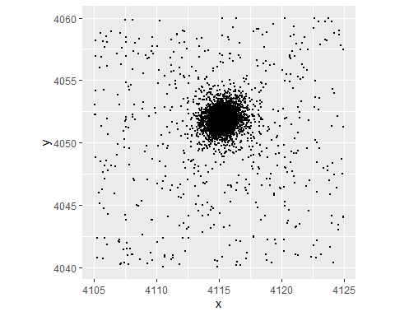

Before fitting a 2D Moffat Model, I want to simplify and fit a 1D model to see if it is the most appropriate fit to the data. To do that, I’m going to slice my celestial sources (POI’s) into lines, with fewer observations and treat them as being one-dimensional.

modelCentral <- ggplot(Central, aes(x,y)) +  
 geom_pointdensity(adjust = 0.05, size = 0.1, shape = "1") +   
 scale_color_viridis(direction = -1, option = "B", trans = "log", breaks = c(10, 100, 1000)) +   
 coord_fixed()  
  
modelCentral

