OSSP (Operating Systems And Systems Programming) - 25CS2104E
(SKILL Content Delivery Concepts)

SKILL 10A :
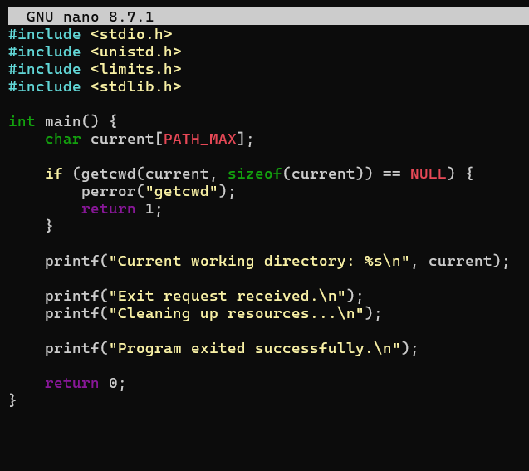
OUTPUT :
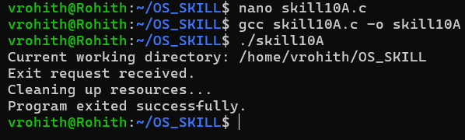

Skill 10B :
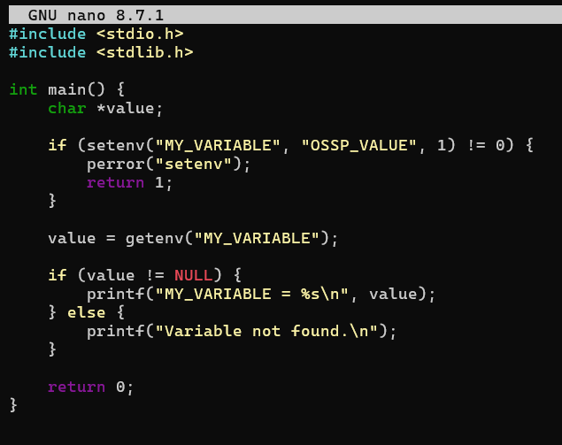
Output :
