OSSP (Operating Systems And Systems Programming) - 25CS2104E
(SKILL Content Delivery Concepts)
Skill 11A :
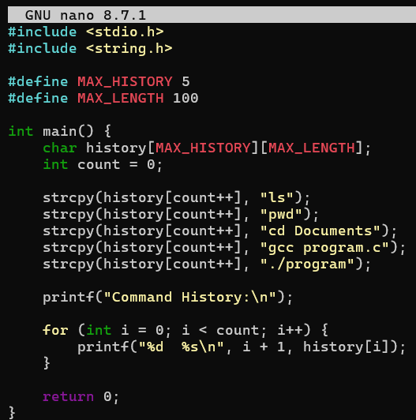
OUTPUT :
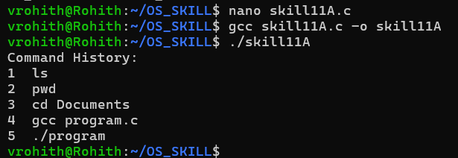

Skill 11B :
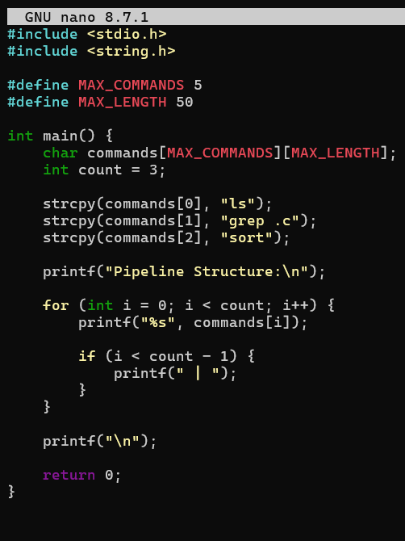

OUTPUT :
