OSSP (Operating Systems And Systems Programming) - 25CS2104E
(SKILL Content Delivery Concepts)
SKILL 9A :
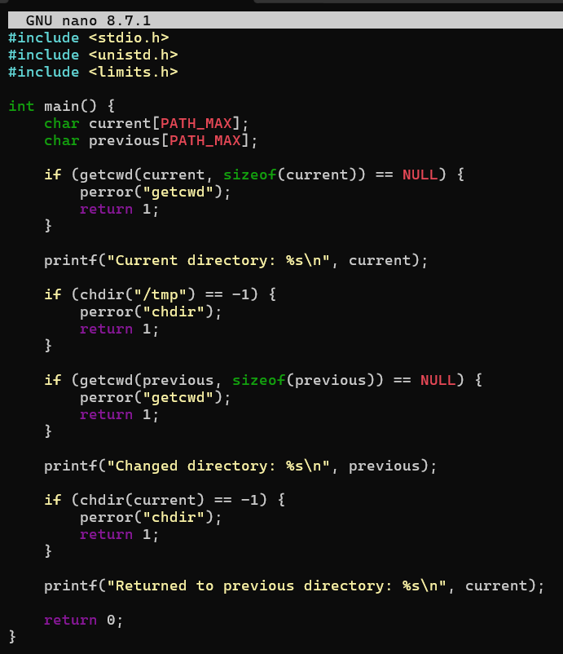

OUTPUT :
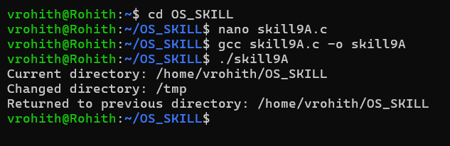

SKILL 9B :
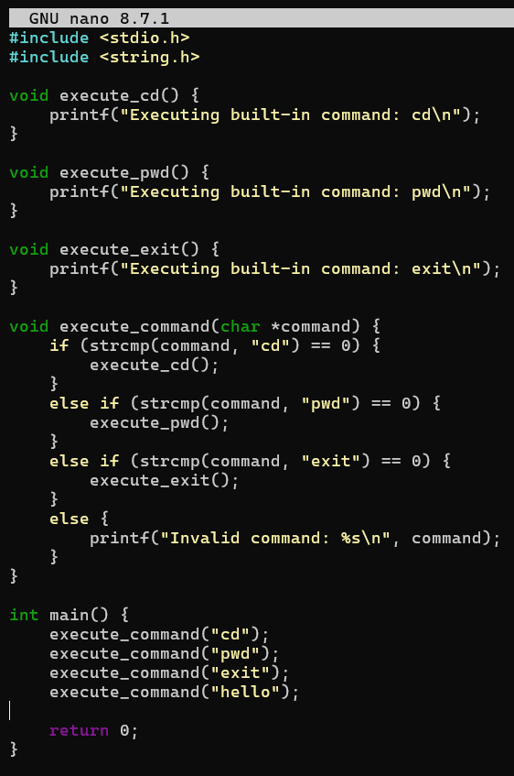
OUTPUT :
