OSSP (Operating Systems And Systems Programming) - 25CS2104E

Practical 9A :
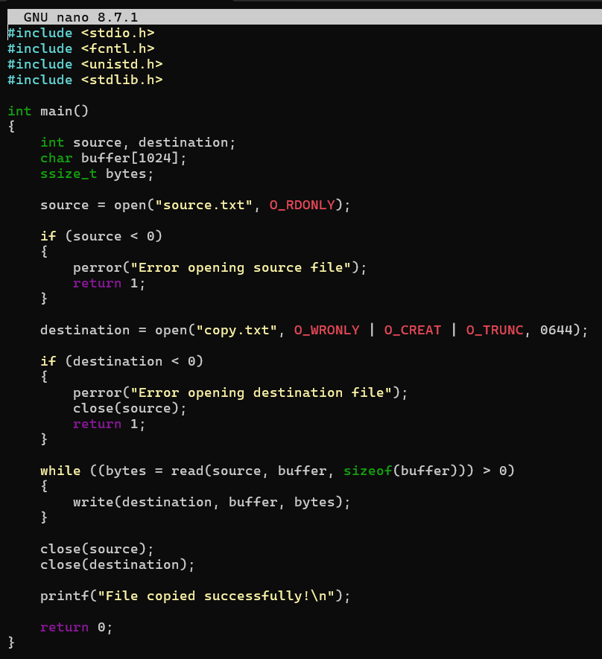
OUTPUT :
