OSSP (Operating Systems And Systems Programming) - 25CS2104E

Practical 9B :
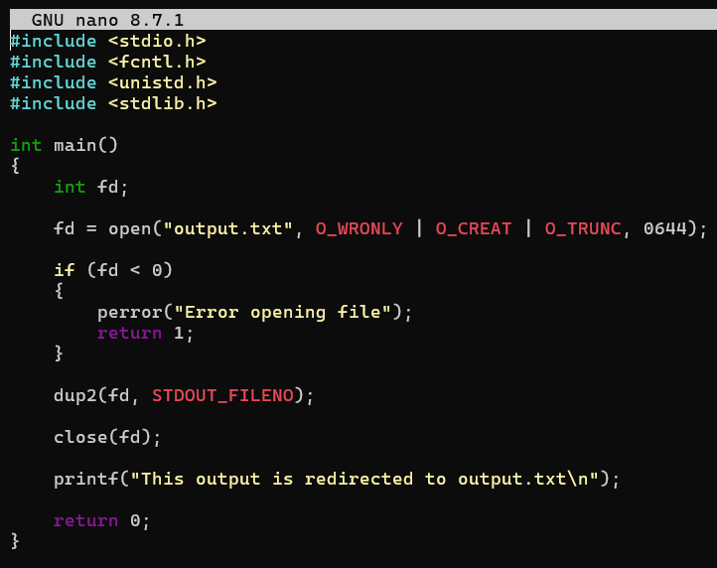

Output :
