OSSP (Operating Systems And Systems Programming) - 25CS2104E

PRACTICAL 8B :
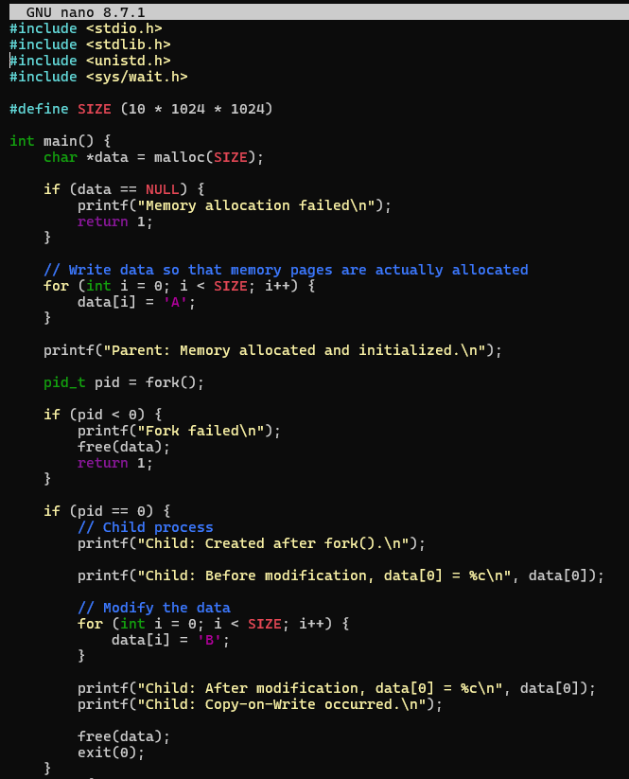

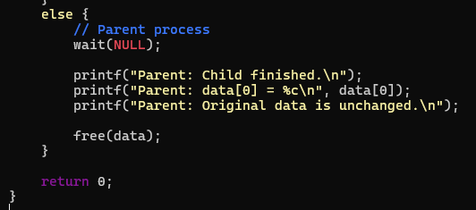

OUTPUT :
