OSSP (Operating Systems And Systems Programming) - 25CS2104E

Practical 11A :
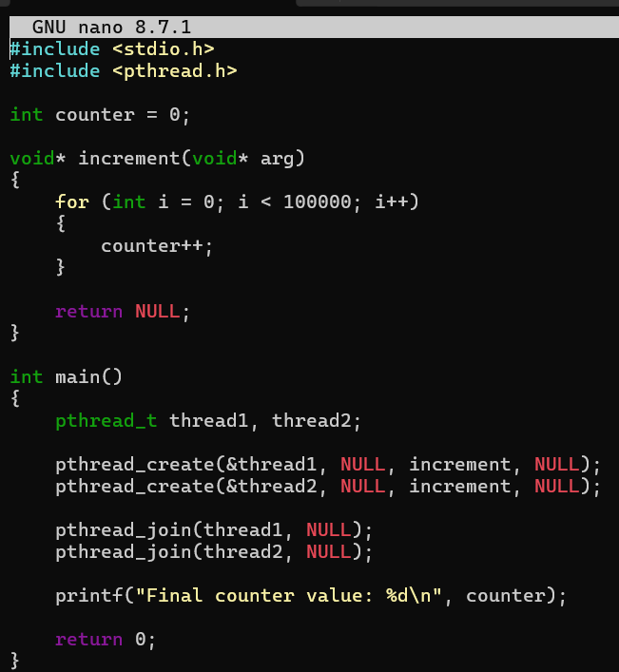

OUTPUT :
