OSSP (Operating Systems And Systems Programming) - 25CS2104E

Practical 12C:
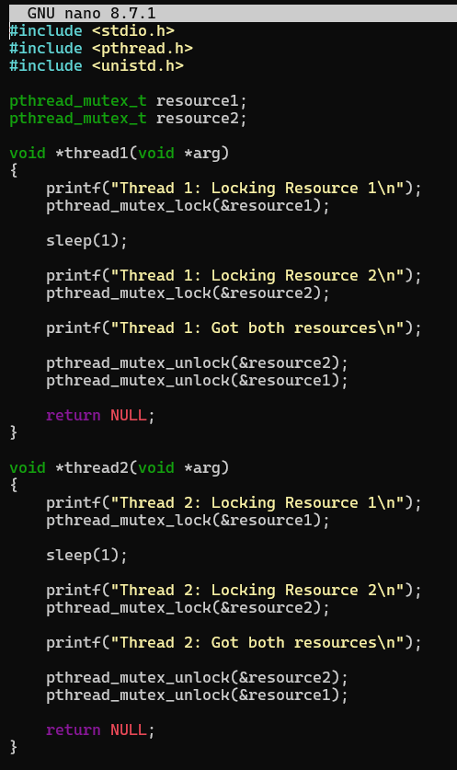

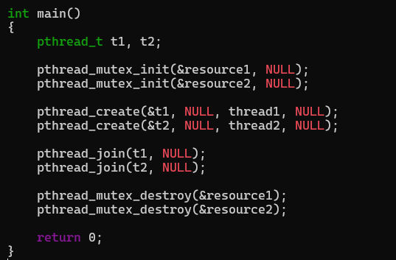

OUTPUT :
