OSSP (Operating Systems And Systems Programming) - 25CS2104E

(SKILL Content Delivery Concepts)

SKILL 5A :
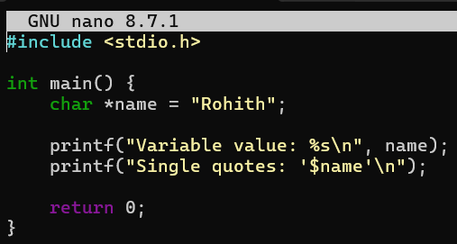
OUTPUT :
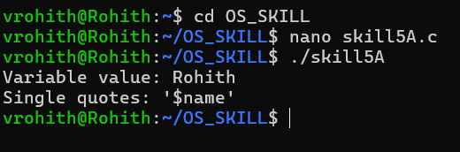
SKILL 5B :
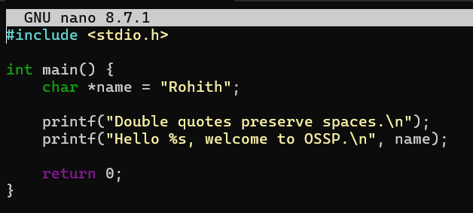
OUTPUT :
