OSSP (Operating Systems And Systems Programming) - 25CS2104E

(SKILL Content Delivery Concepts)
SKILL 6A :
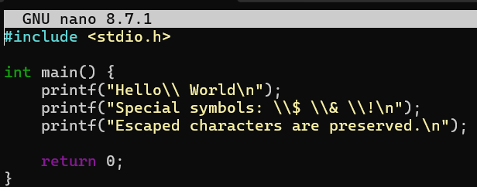
OUTPUT :
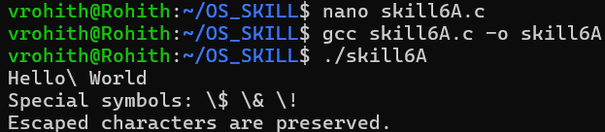
SKILL 6B :
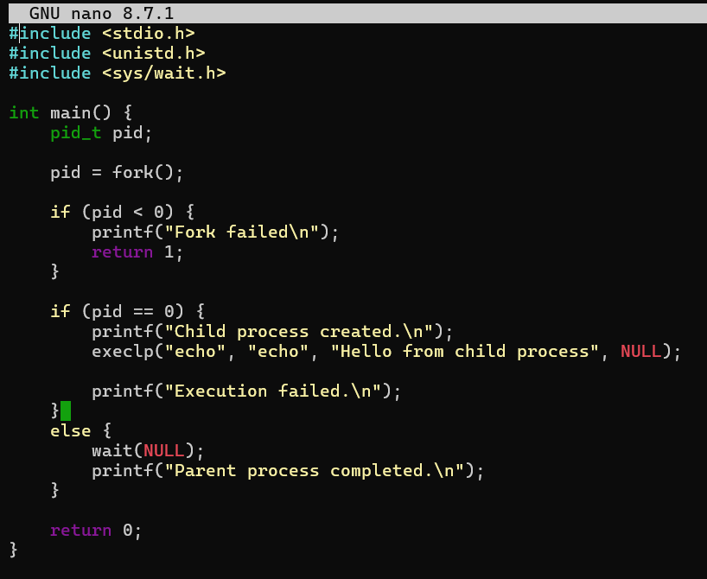
OUTPUT :
