OSSP (Operating Systems And Systems Programming) - 25CS2104E
(SKILL Content Delivery Concepts)

Skill 7A :
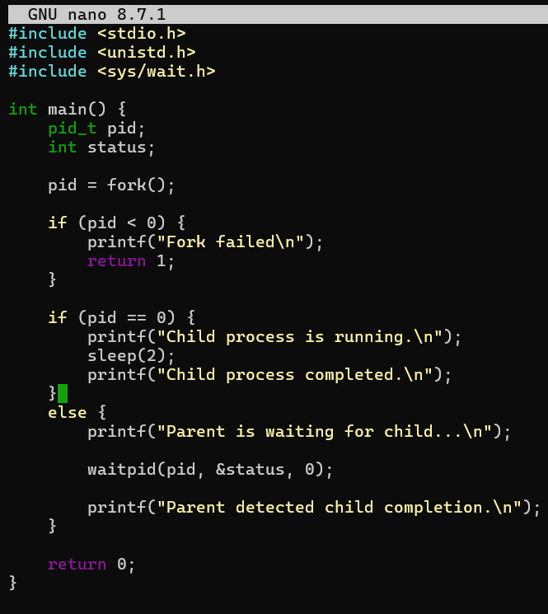
OUTPUT :
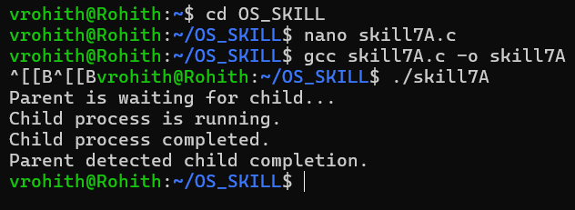
SKILL 7B :
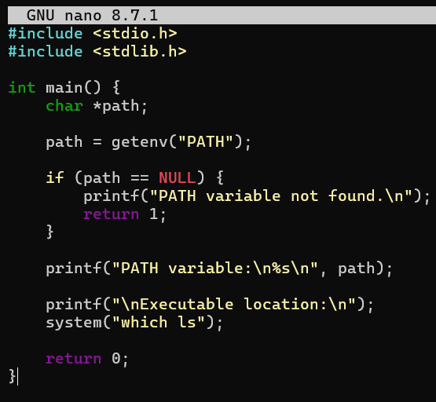
OUTPUT :
