OSSP (Operating Systems And Systems Programming) - 25CS2104E
(SKILL Content Delivery Concepts)
SKILL 8A :
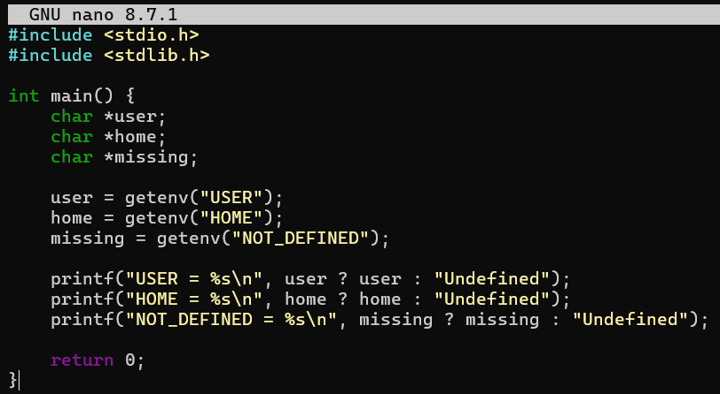
OUTPUT :
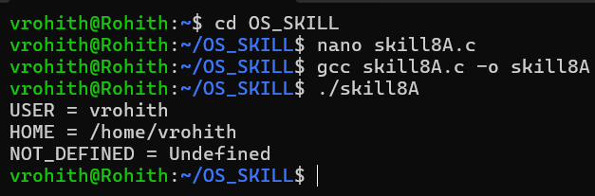

SKILL 8B :
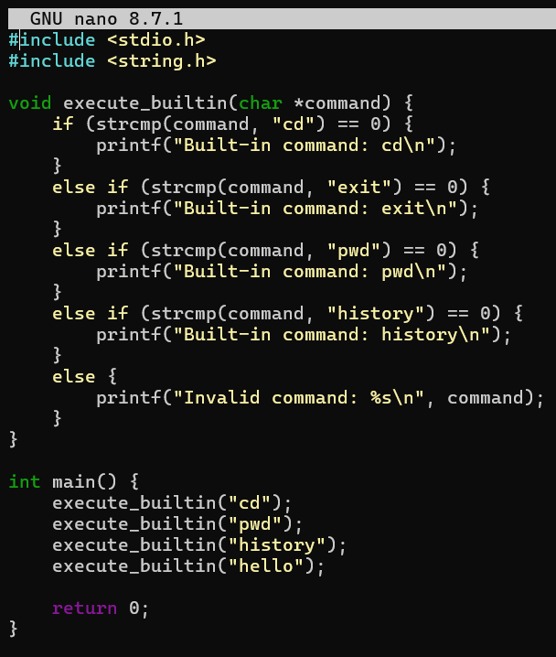
OUTPUT :
