PRACTICAL 2 :
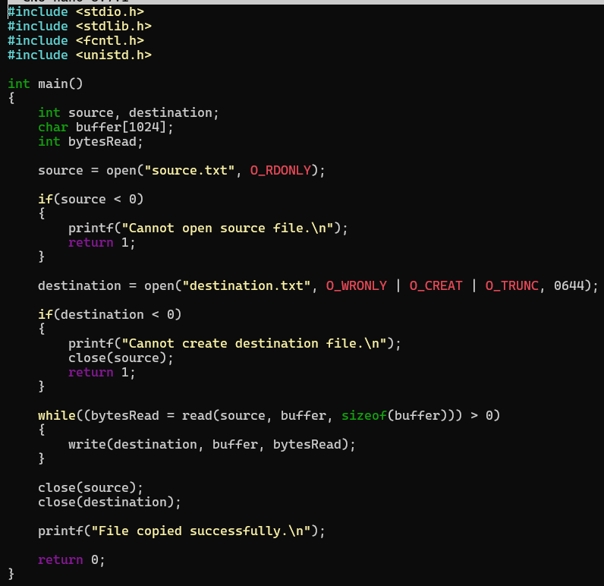

OUTPUT:
