OSSP (Operating Systems And Systems Programming) - 25CS2104E
(SKILL Content Delivery Concepts)
Skill 12A :
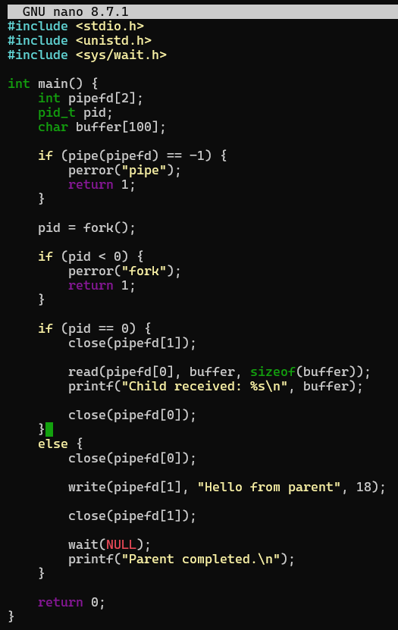
OUTPUT :
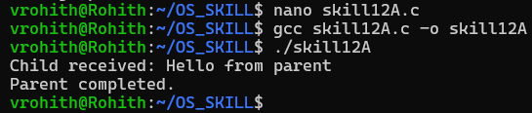

Skill 12B :
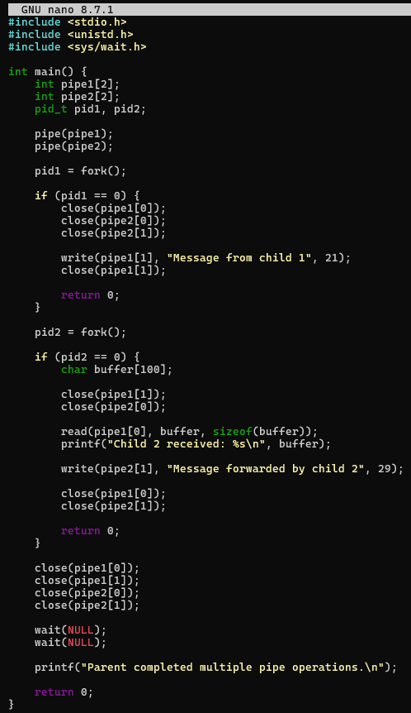
OUTPUT :
