OSSP (Operating Systems And Systems Programming) - 25CS2104E

PRACTICAL 5A :
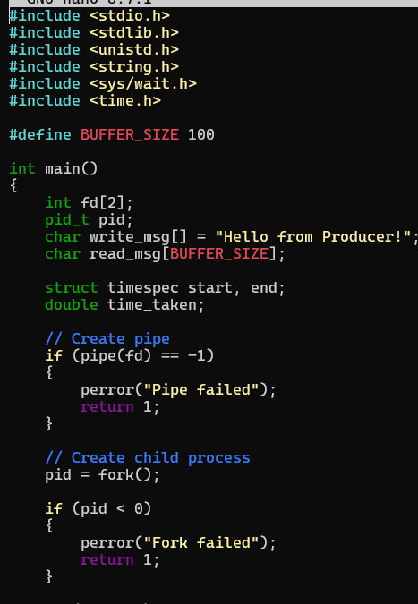
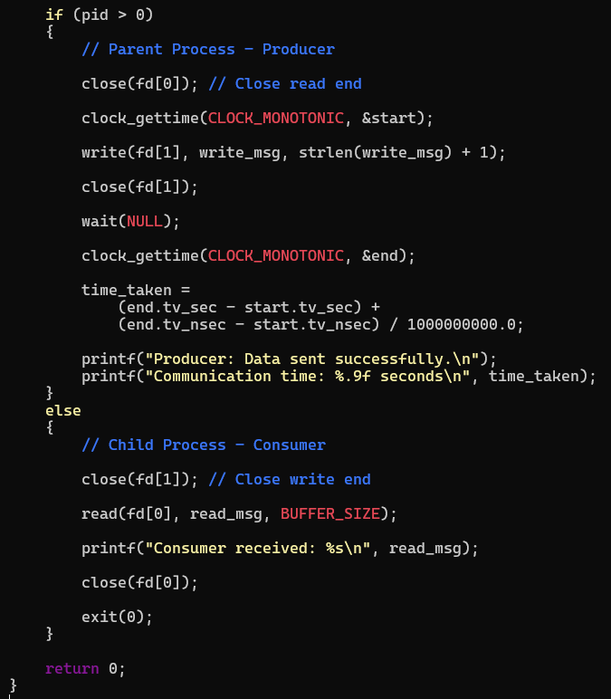
OUTPUT:
