OSSP (Operating Systems And Systems Programming) - 25CS2104E
Create a file called permission.c :
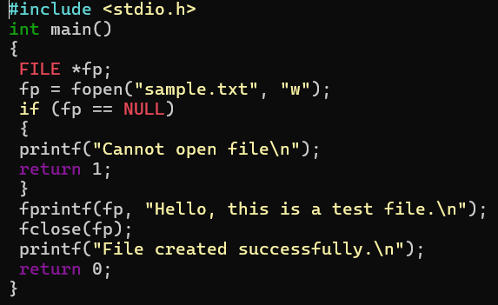

OUTPUT :
