PRACTIAL_3

1: CREATE TABLE
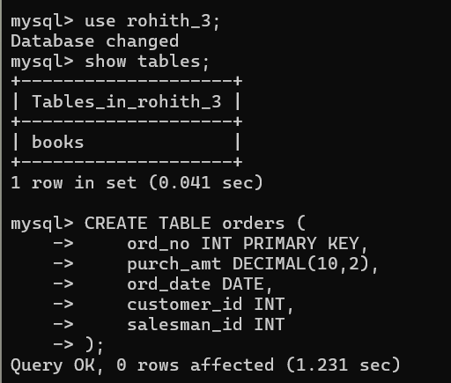

2: INSERT DATA
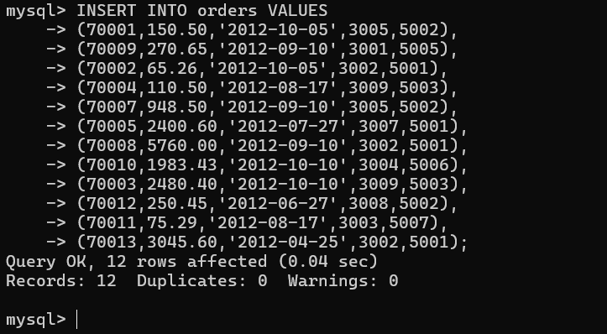

QUESTION 1 - WHERE CLAUSE
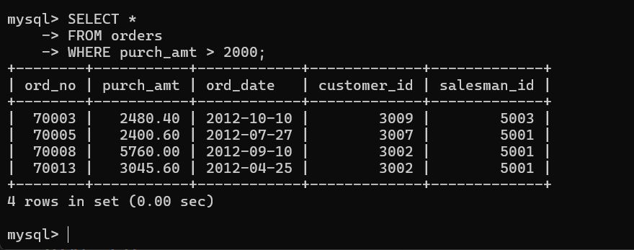

QUESTION 2 - WHERE CLAUSE
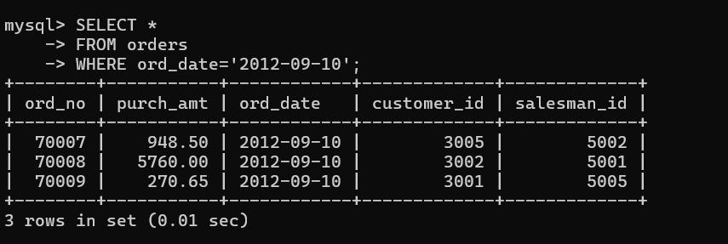

QUESTION 3 - WHERE CLAUSE
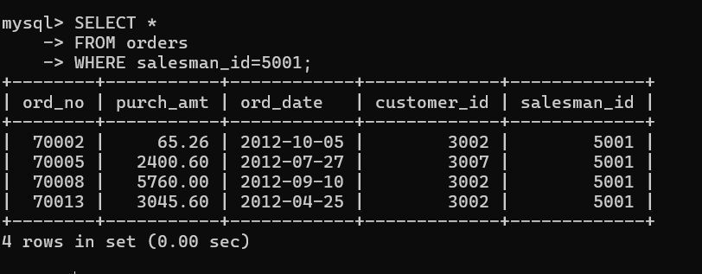

QUESTION 4 - ORDER BY
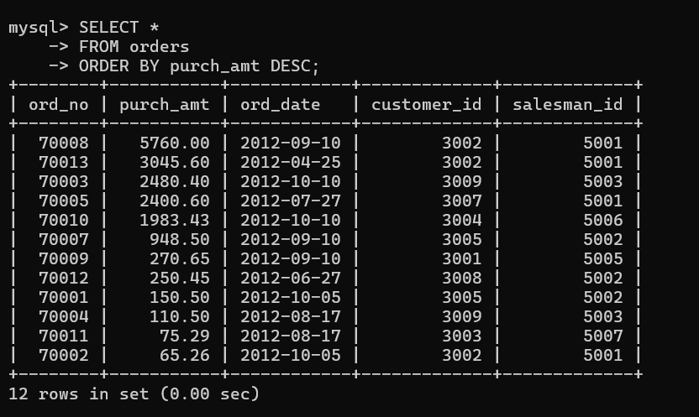

QUESTION 5 - ORDER BY
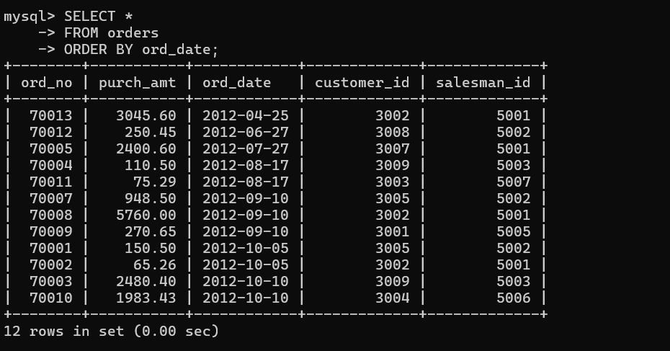

QUESTION 6 - SUM()
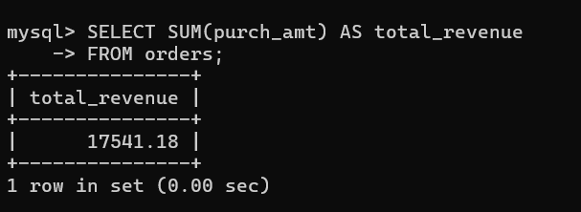

QUESTION 7 - AVG()
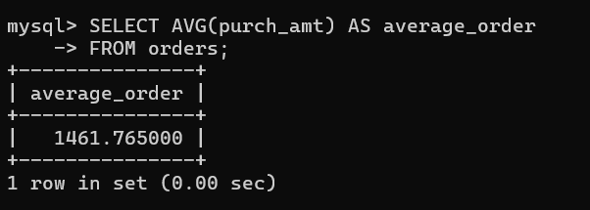

QUESTION 8 - MAX()
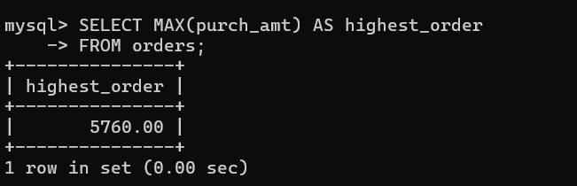

QUESTION 9 - MIN()
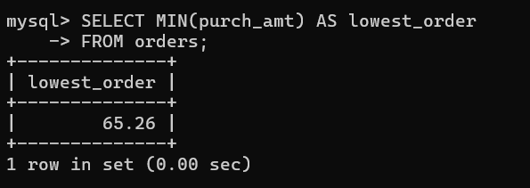

QUESTION 10 - COUNT()
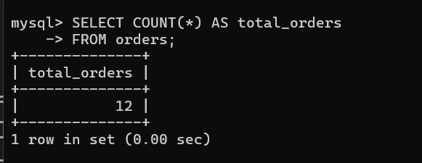

QUESTION 11 - GROUP BY
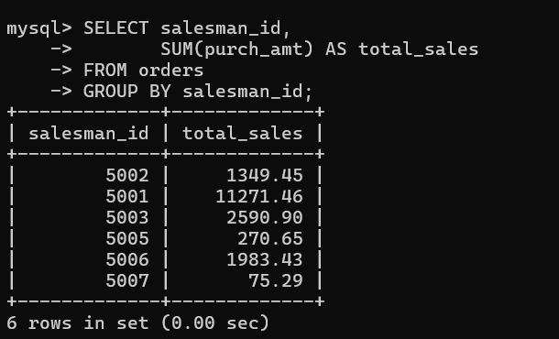

QUESTION 12 - GROUP BY
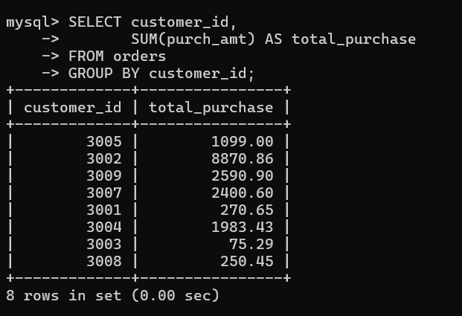

QUESTION 13 - GROUP BY + MAX()
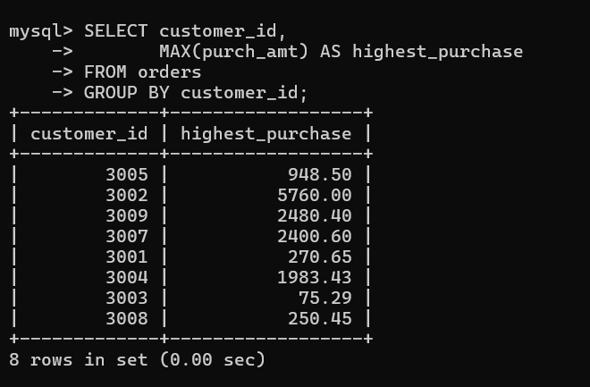

QUESTION 14 - GROUP BY + HAVING
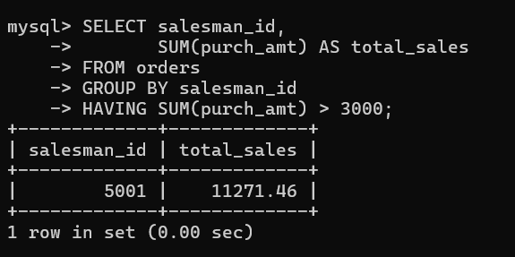

QUESTION 15 - GROUP BY + HAVING
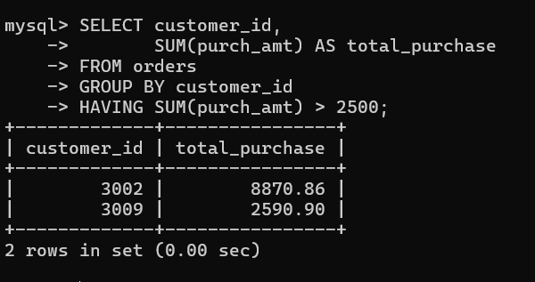

QUESTION 16 - GROUP BY + HAVING
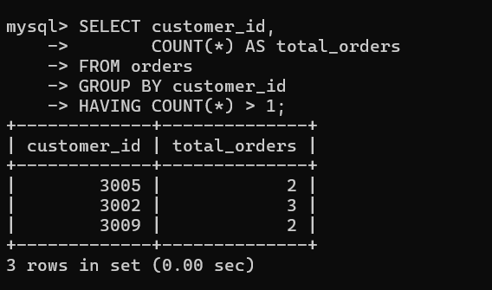

QUESTION 17 - GROUP BY + HAVING + ORDER BY
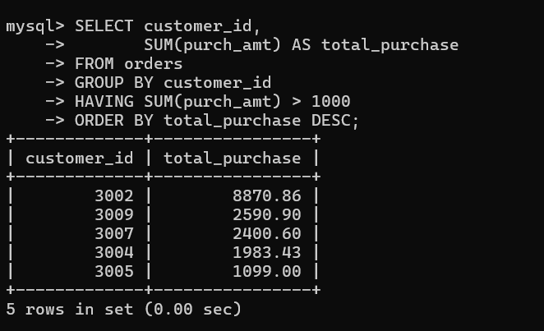

QUESTION 18 - BETWEEN + HAVING
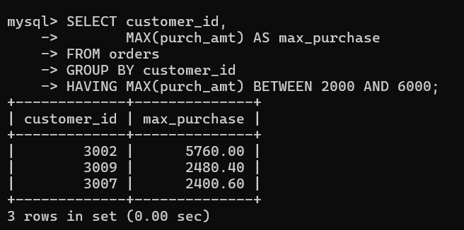

QUESTION 19 - COUNT + HAVING
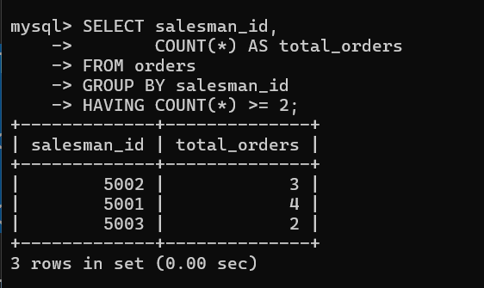

QUESTION 20 - MAX + GROUP BY + HAVING
