PRACTICAL_4

STEP 1: CREATE PHYSICIAN TABLE
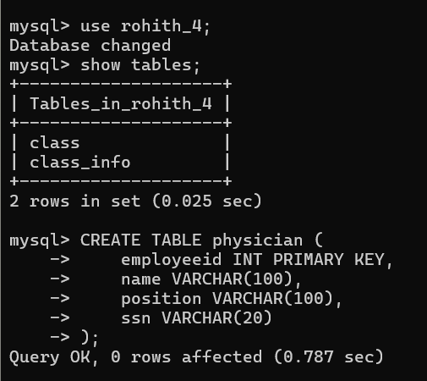

STEP 2: INSERT DATA INTO PHYSICIAN
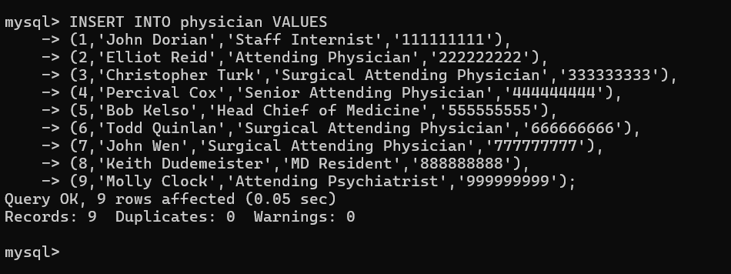

STEP 3: CREATE DEPARTMENT TABLE
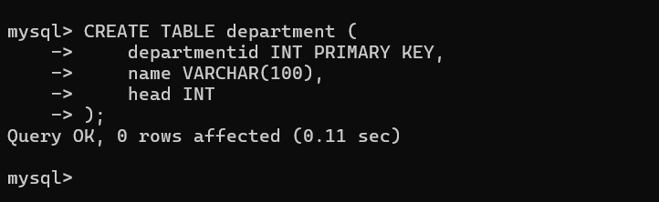

STEP 4: INSERT DATA INTO DEPARTMENT
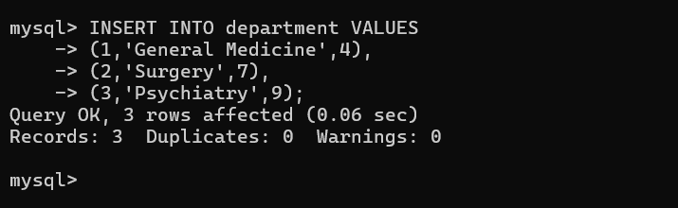

QUESTION 1 - INNER JOIN
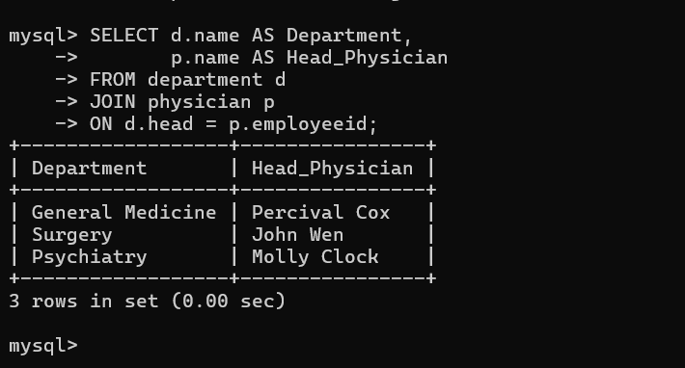

QUESTION 2 - WHERE CLAUSE
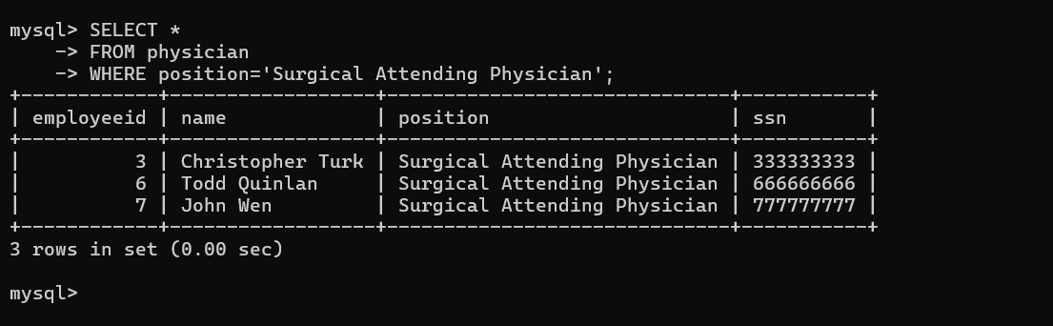

QUESTION 3 - WHERE + LIKE
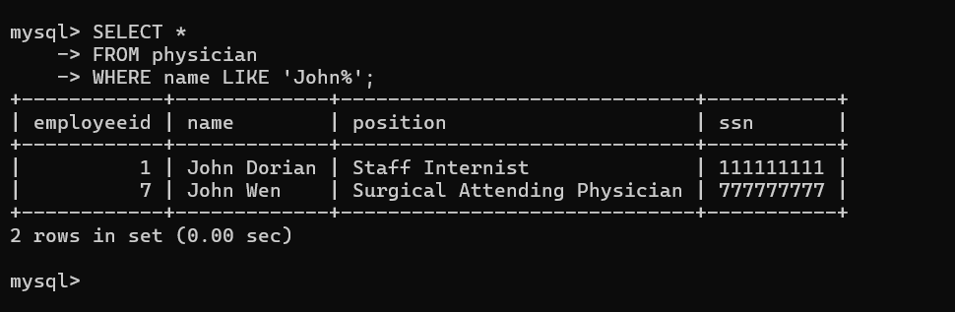

QUESTION 4 - COUNT()
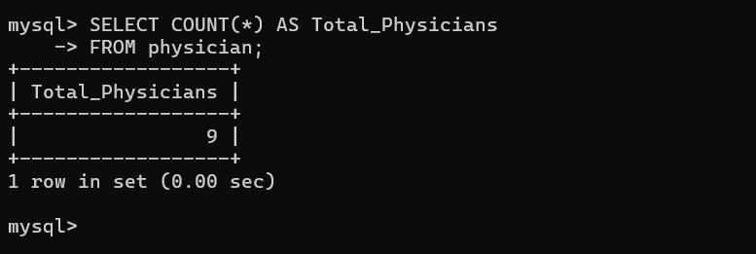

QUESTION 5 - COUNT DISTINCT
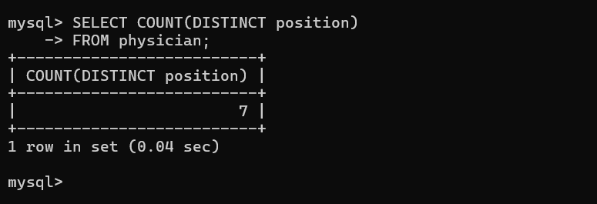

QUESTION 6 - GROUP BY
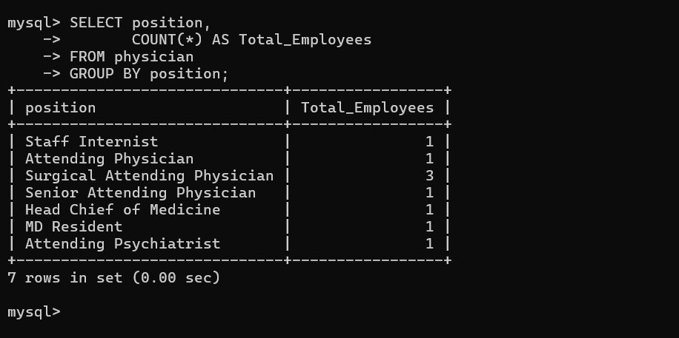

QUESTION 7 - GROUP BY + HAVING
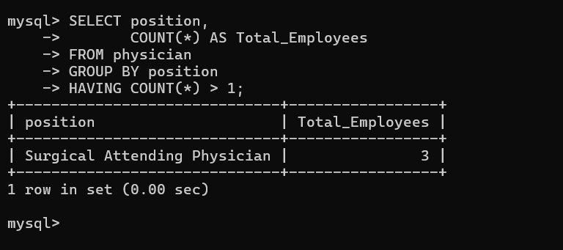

QUESTION 8 - ORDER BY
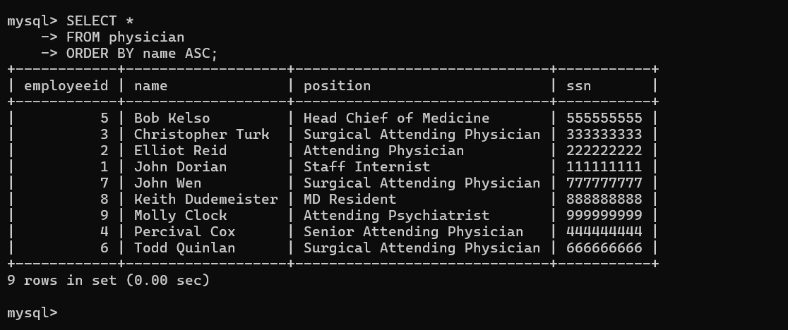

QUESTION 9 - ORDER BY DESC
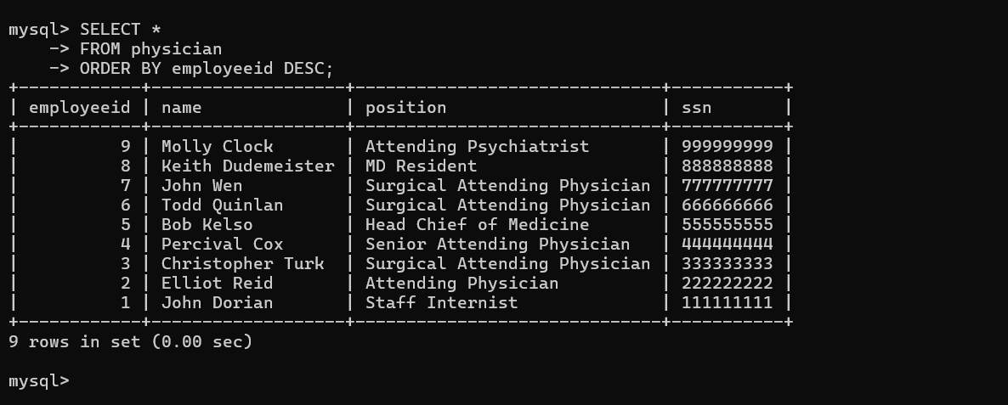

QUESTION 10 - WHERE + IN
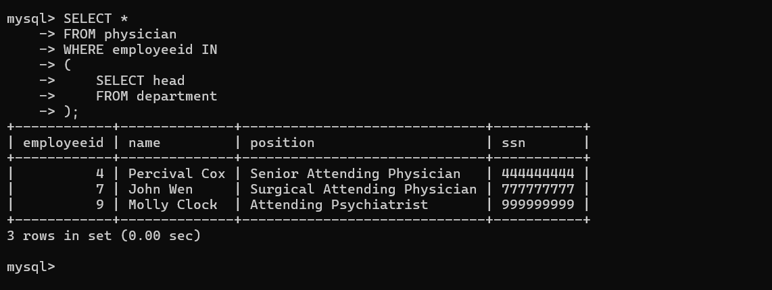

QUESTION 11 – SUBQUERY
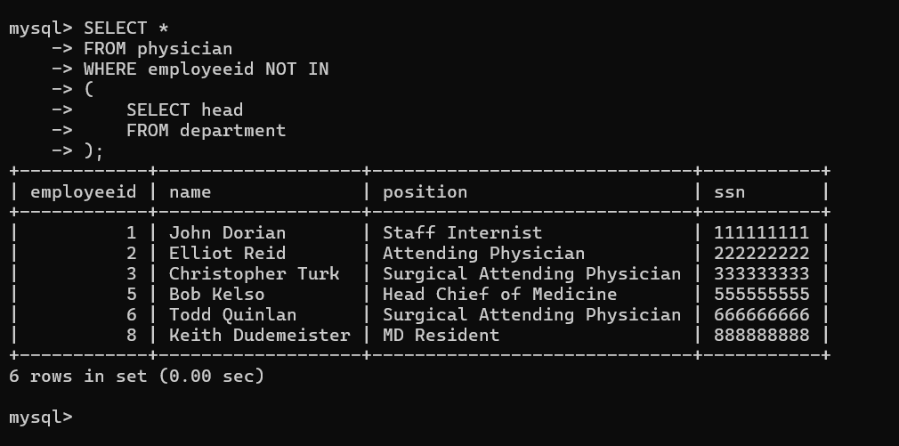

QUESTION 12 - GROUP BY + ORDER BY
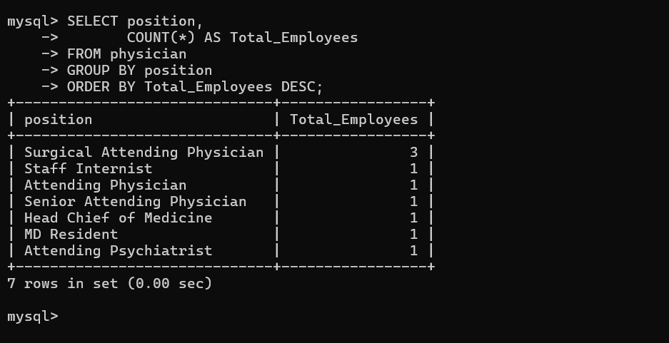

QUESTION 13 - WHERE + LIKE
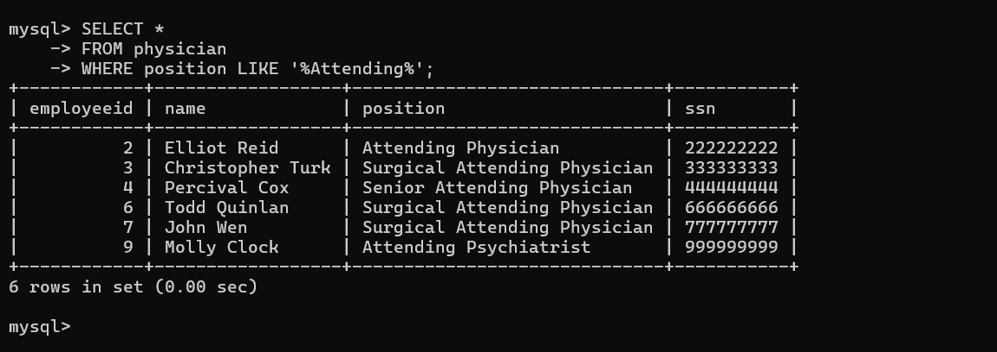

QUESTION 14 - JOIN + WHERE
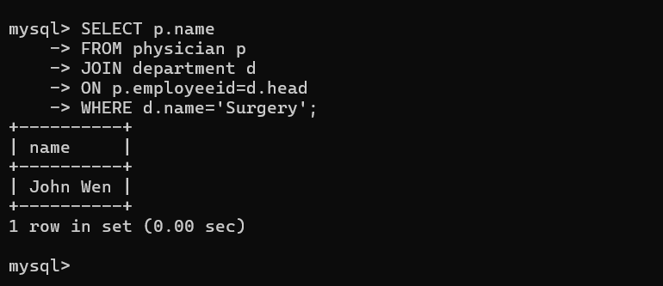

QUESTION 15 - JOIN + ORDER BY
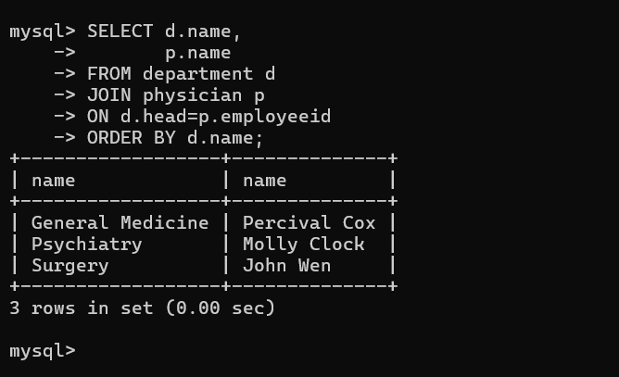

QUESTION 16 - WHERE + NOT LIKE
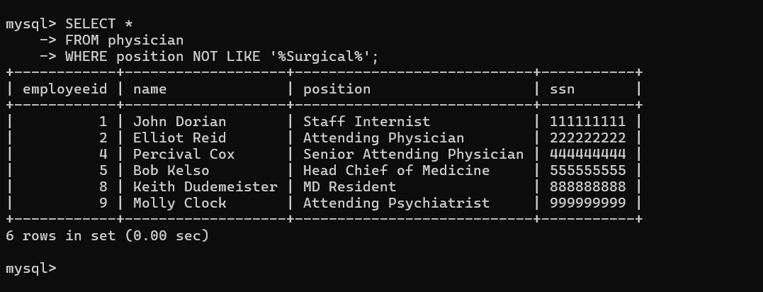

QUESTION 17 - COUNT + HAVING
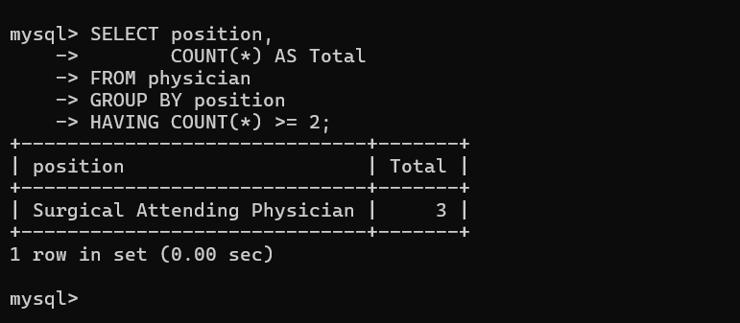

QUESTION 18 – EXISTS
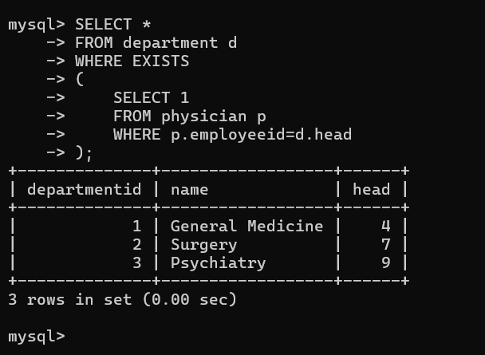

QUESTION 19 - MAX()
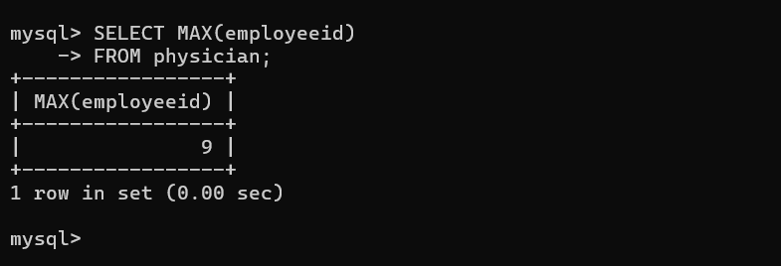

QUESTION 20 - MIN()
