DATABASE SYSTEMS ENGINEERING AND DISTRIBUTED BACKEND DEVELOPMENT

TOPIC: JOINS AND SET OPERATIONS

PART 1: CROSS JOIN :
STEP 1: CREATE TABLES

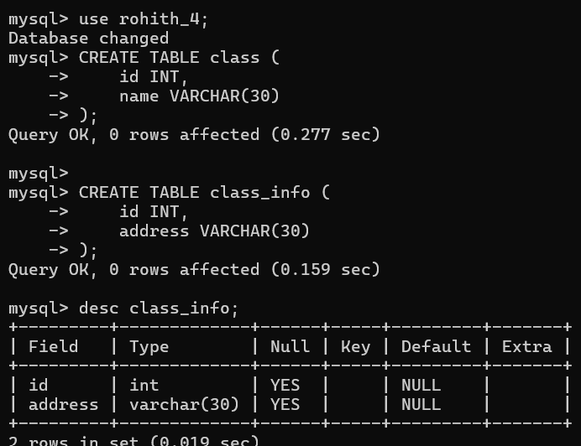
STEP 2: INSERT DATA :
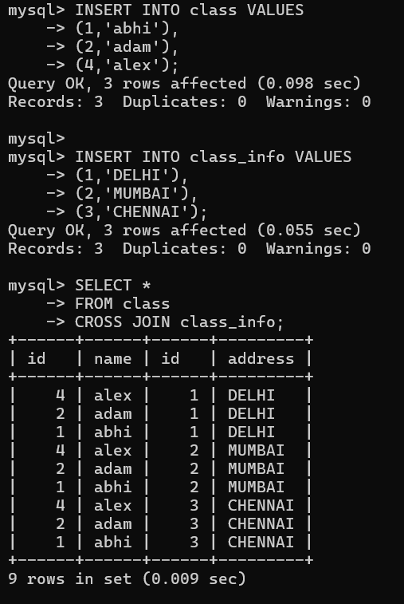
PART 2: INNER JOIN :
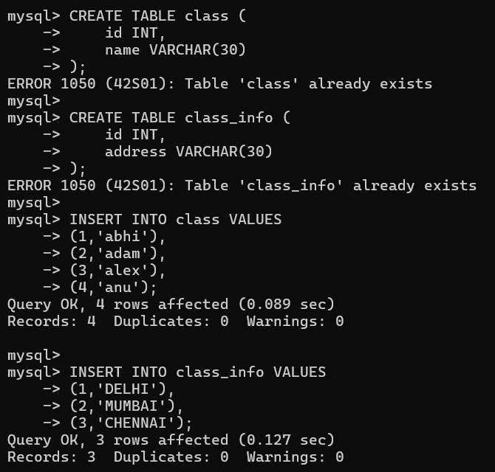
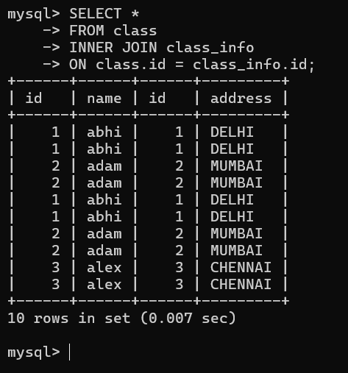
QUESTION 3 - INNER JOIN :
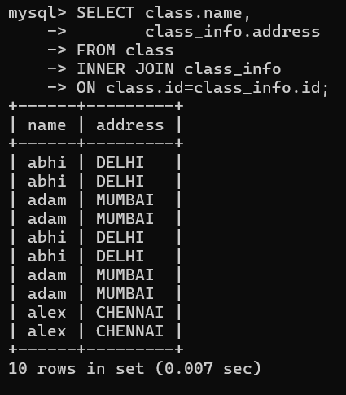

PART 3: NATURAL JOIN :
QUESTION 4 - NATURAL JOIN :
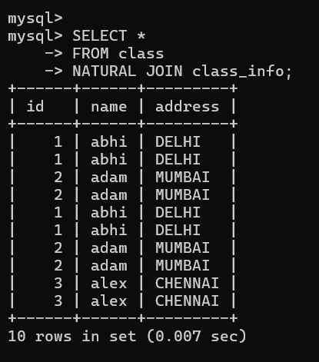
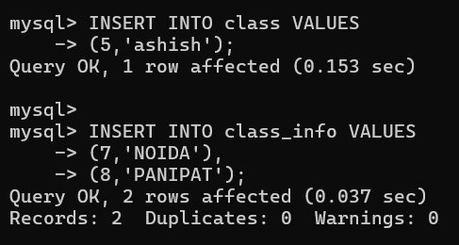
QUESTION 5 - LEFT JOIN :
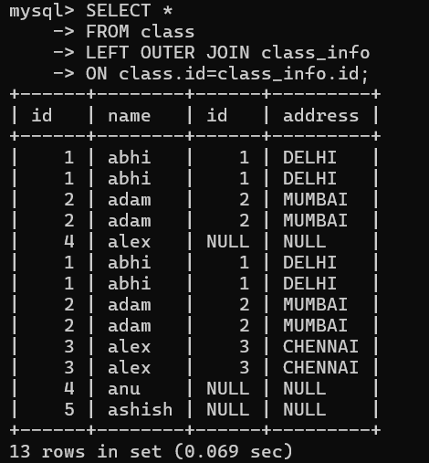
QUESTION 6 - LEFT JOIN :
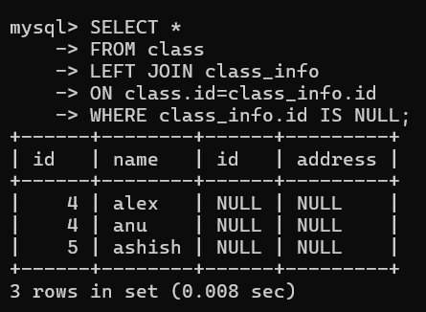
PART 5: RIGHT OUTER JOIN :
QUESTION 7 - RIGHT JOIN
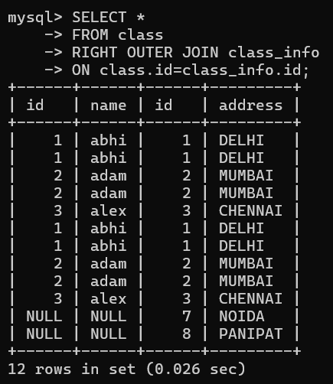
QUESTION 8 - RIGHT JOIN :
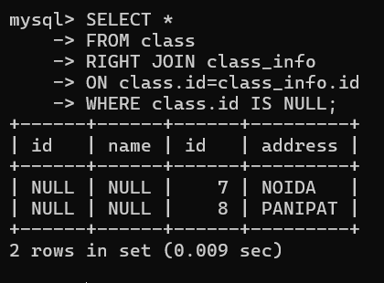
PART 6: FULL OUTER JOIN :
QUESTION 9 - FULL OUTER JOIN :
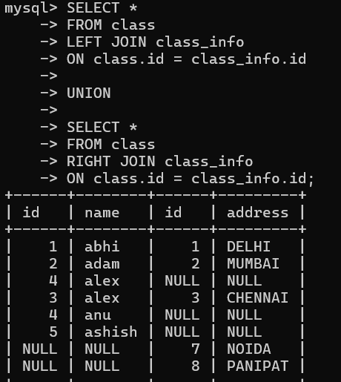
QUESTION 10 - FULL OUTER JOIN :
