|  |
| --- |
| Infosys Ltd. |
| Software Requirements Specification |
| Interactive 3D Game Development |
|  |
| **Utkarsh Sinha(523384), Varun Agrawal(523385),**  **Priyanka Anand(523386), Mousumi Kundu(523387)** |
| **Date: 10th May, 2015** |

|  |
| --- |
|  |

| **Ver.Rev** | **Date** | **Authors** | **Description** |
| --- | --- | --- | --- |
| 1.0 | 10th May | Utkarsh(523384),Varun(523385), Priyanka(523386), Mousumi(523387) | Final Draft |

Table of Conte nts

1. BUSINESS OF THE CUSTOMER 3

2. PROJECT/PRODUCT OVERVIEW 3

3. FUNCTIONAL REQUIREMENTS 4

3.1 REQUIREMENTS IN SCOPE 4

3.2 REQUIREMENTS OUT OF SCOPE 4

3.3 USER INTERFACE 5

4. EXTERNAL SYSTEM INTERFACE REQUIREMETNS 7

5. NON FUNCTIONAL REQUIREMENTS 7

5.1 Security 7

5.2 Audit Trail 7

5.3 Error logging 7

5.4 Multi language Support 7

5.5 Performance 7

5.6 Scalability 7

5.7 Availability / reliability 7

5.8 Data migration 7

5.9 Data Retention 7

5.10 Legal/ regulatory requirements 7

6. HARDWARE AND SOFTWARE REQUIREMENTS 7

6.1 Deployment Environment Requirements 7

6.2 Development Environment Requirements 7

7. REFERENCES 8

# BUSINESS OF THE CUSTOMER

Unity 3Dis a cross-platform game engine with a built-in IDE developed by Unity Technologies. It is used to develop video games for web plugins, desktop platforms, consoles and mobile devices. This is an offline Gaming Portal consisting of seven fun mini games that can be played by people of all ages – chidren and elderly alike. It brings an enjoyable experience to the game lovers and instills thrill and relaxation during leisure time. Therefore, this project results in a successful development of a functional PC Based Gaming Portal Application.

# PROJECT/PRODUCT OVERVIEW

The objective of the project is to create an interactive offline Gaming Portal using Unity Engine as the platform for game development. This portal will consist of seven mini games which can be played upon user’s selection. The games include Pong Game, Maze Roll, Snake Bite, Copter Crash, Droplet Collector, Brick Breaker and Space Fighter.

* Pong Game– The main idea behind this **multiplayer game** is to make sure the opponent misses hitting the ball using his racket. This can be done by making the ball land on specific parts of racket which deflects the ball in different directions.
* Maze Roll – The objective of this **3D game** is to make sure the ball gathers all the collectibles before the timer runs out.
* Snake Bite – The purpose of this game is to help the snake catch all its prey in order **to grow**, without touching the boundaries or itself.
* Copter Crash – This **side scrolling** game requires the player to move the copter through the logs without crashing into them and reaching the end within the time limit.
* Droplet Collector – The objective of the game is to collect as many droplets **falling randomly** from the cloud. The player should avoid catching thunder as it would lead to decrease in lives.
* Brick Breaker – The main idea behind this game is to **break the bricks** and do not allow the ball to fall off the racket and score by breaking maximum bricks.
* Space Fighter –The purpose of this game is to kill the enemies by shooting them and save the rocket from the enemies. This game uses **special effects** like smoke effect as well as animations.

The games are made up of individual components or parts that can be pieced together in a modular fashion. The features that are incorporated in the project are rendering, scripting and physics which makes it a real life like game.

# FUNCTIONAL REQUIREMENTS

## REQUIREMENTS IN SCOPE

|  |  |  |
| --- | --- | --- |
| **Req. Id** | **Description** | **Classification(Hardware/Software)** |
| FR1 | The user should be able to select the desired game from the Gaming Portal. | Software |
| FR2 | All the buttons should render and function properly. | Software |
| FR3 | The user should be able to select appropriate options from the Main Menu of the chosen game. | Software |
| FR4 | The game is either single or multi player. | Software |
| FR5 | The games are either 2D/3D with real life-like graphics. | Software |
| FR6 | Player can go through the instructions to know about the objective of the game. | Software |
| FR7 | Player should keep track of different game elements like score/timer/lives while playing the game. | Software |
| FR8 | There should be no backend database. | Software |
| FR9 | The games should have interactive sounds. | Software |

## REQUIREMENTS OUT OF SCOPE

The project scope does not include:

* Different difficulty modes.
* Maintaining individual user profiles.
* Artificial Intelligence is not included.

## USER INTERFACE

The UI will consist of the following screens:

### Main Menu –

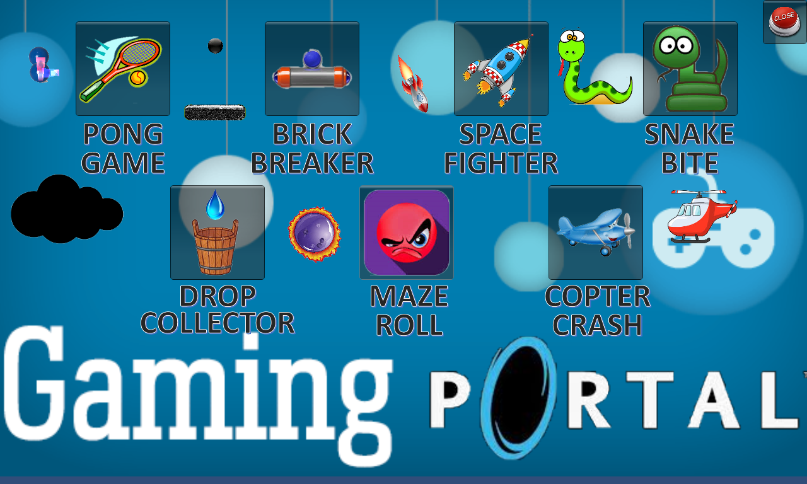

### Maze Roll Main Menu –

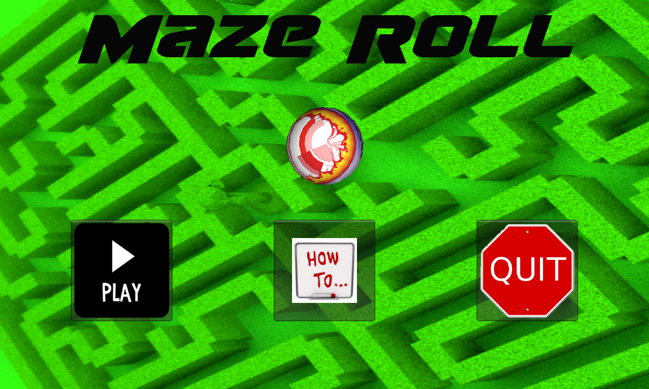

### Maze Roll Instructions –

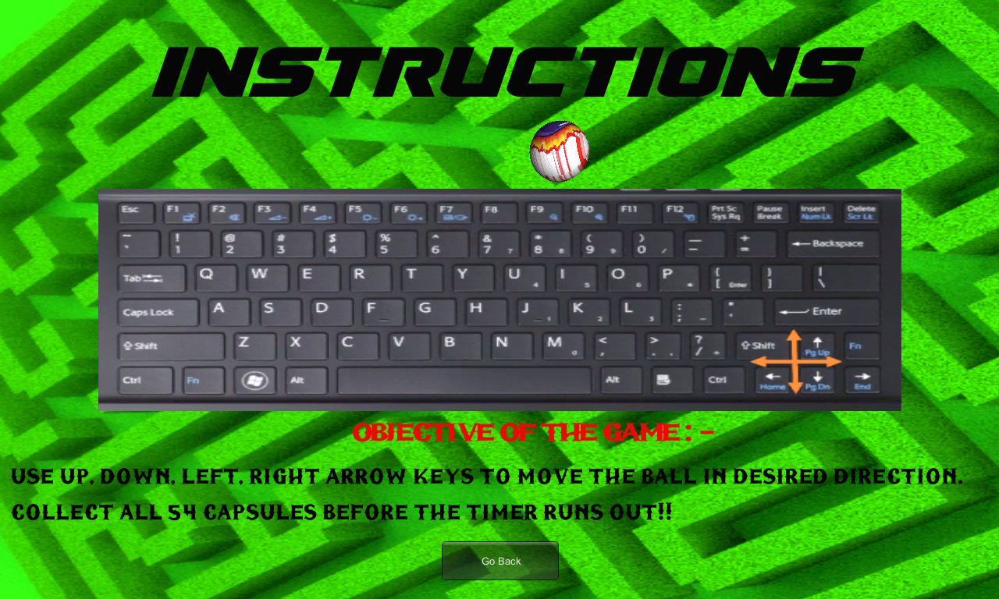

### Maze Roll Game Scene –

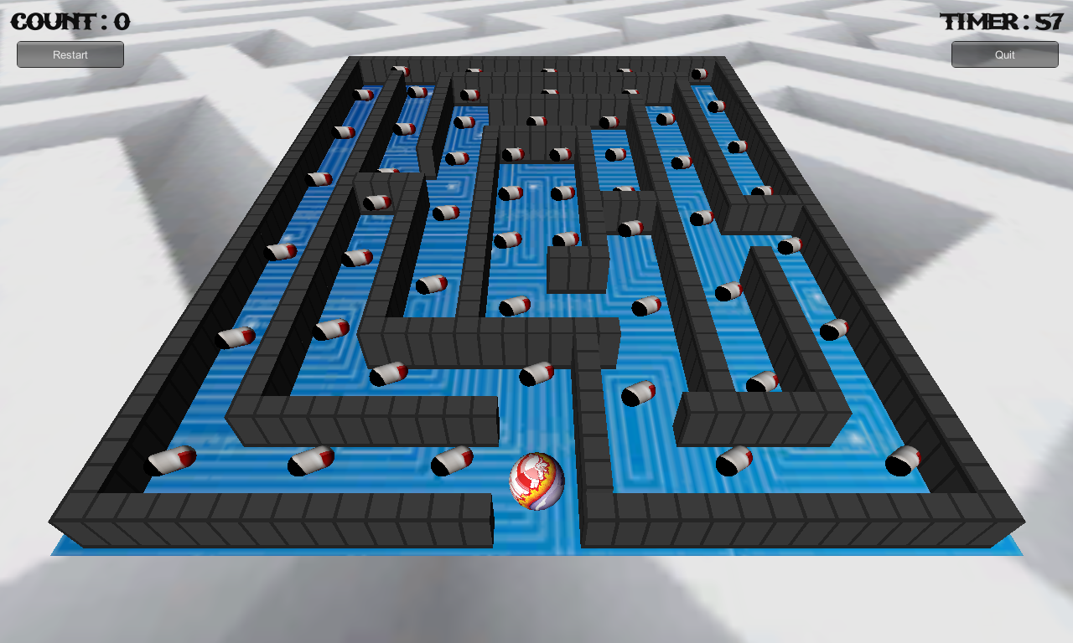

# NON FUNCTIONAL REQUIREMENTS

## Security - NA

## Audit Trail - NA

## Error logging – NA

## Multi language Support - NA

## Performance – Smooth (should load in 2 seconds based on the system)

## Scalability – Extra features can be added.

## Availability / reliability – Should not freeze/crash.

## Data migration - NA

## Data Retention - NA

## Legal/ regulatory requirements - NA

# HARDWARE AND SOFTWARE REQUIREMENTS

## Deployment Environment Requirements

**Hardware requirements**

Processor/RAM/HDD : Windows XP and above/1GB

Web server : NA

Database Server : NA

**Software requirements**

OS for Web server : NA

OS for Database Server : NA

DBMS : NA

Third Party S/Ws : Direct X9 and above

## Development Environment Requirements

**Hardware requirements**

IDE : Unity 3D

Processor/RAM/HDD : Windows XP and above/2GB

Web/Database Server : NA

**Software requirements**

OS for Web/Database server : NA

DBMS : NA

Third Party S/Ws : Direct X9 and above

# REFERENCES

* [http://www.makeuseof.com/tag/programming-game-unity-beginners-guide/](http://www.makeuseof.com/tag/programming-game-unity-beginners-guide/%20)
* [http://en.wikipedia.org/wiki/Unity](http://en.wikipedia.org/wiki/Unity%20)
* <http://docs.unity3d.com/Manual/UnityBasics.html>
* <https://unity3d.com/learn/tutorials/modules/beginner/live-training-archive/editor-basics>
* <http://www.digitaltutors.com/tutorial/572-Beginners-Guide-to-Unity>
* https://cgcookie.com/unity/cgc-courses/unity-basics-introduction-beginners/